
www.ilyn.global
Government of the People’s Republic of Bangladesh
National Board of Revenue
Tax Invoice
[See Clauses (Gha) and (Cha) of Sub-Rule (1) of Rule 40]
Central BIN: 003835728-0208
Mushak-6.3
Served by Online Platform
INVOICE
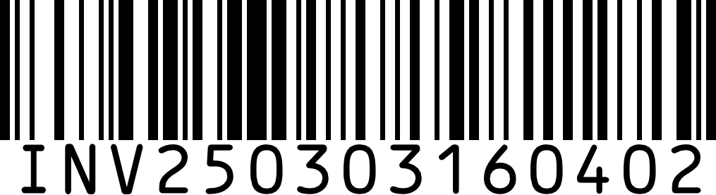
Order Details

Order Date:
Invoice Date: Order No:
Invoice No:

March 3, 2025 6:39 PM March 3, 2025 6:39 PM SO250303350403
INV250303160402

Shipping Address
Shamim Iqbal
78/23/2 Bou Bazar, Dabanol songsod soror,East Rampura,Dhaka, Dhaka, Ramoura -1209
8801717455727
Gift Box, | Amount (BDT) | VAT (BDT)
 | 0.00 | 0.00
9251007(White/Silver) , 1 | 3,650.00 | 182.50
Unit(s) x 0.00
Premium Panjabi, 240148 (M),
1 Unit(s) x 3,650.00
Sub Total | 3,650.00 | 182.50
Total | 3,650.00 | 182.50
Shipping Cost | 0.00 | 00.00
Total Payable Amount | 3,832.50 | -9.13
Digital Payment Discount | -182.50
(5%)
Net Payable Amount |  | 3,640.88
Rounded |  | 3,641.00
Payment By BKASH |  | 3,641.00
Paid Amount |  | 3,641.00
Total Due |  | 0.00
PAID
Total Savings | 191.63
Loyalty Program

Status:
Current Order Points: Total Remaining Points:
Delivery Location

SILVER
+36
759

Inside Dhaka - Standard Delivery
KX Transports, Bangladesh
Exchange & Refund Policy
To report a damaged, or missing product, please share
an unboxing video for verification.
Exchange or Refund within 7 days from the date of
delivery.
The product must be unused and intact with tags.
Additional terms and conditions may apply.
Service Center
☏ 09666774577 (10:00am - 10:00pm)
✉ support@ilyn.global
THANK YOU FOR CHOOSING ILLIYEEN


www.ilyn.global
Government of the People’s Republic of Bangladesh
National Board of Revenue
Tax Invoice
[See Clauses (Gha) and (Cha) of Sub-Rule (1) of Rule 40]
Central BIN: 003835728-0208
Mushak-6.3
Served by Online Platform
INVOICE

Order Details

Order Date:
Invoice Date: Order No:
Invoice No:

March 3, 2025 6:39 PM March 3, 2025 6:39 PM SO250303350403
INV250303160402

Shipping Address
Shamim Iqbal
78/23/2 Bou Bazar, Dabanol songsod soror,East Rampura,Dhaka, Dhaka, Ramoura -1209
8801717455727
Gift Box, | Amount (BDT) | VAT (BDT)
 | 0.00 | 0.00
9251007(White/Silver) , 1 | 3,650.00 | 182.50
Unit(s) x 0.00
Premium Panjabi, 240148 (M),
1 Unit(s) x 3,650.00
Sub Total | 3,650.00 | 182.50
Total | 3,650.00 | 182.50
Shipping Cost | 0.00 | 00.00
Total Payable Amount | 3,832.50 | -9.13
Digital Payment Discount | -182.50
(5%)
Net Payable Amount |  | 3,640.88
Rounded |  | 3,641.00
Payment By BKASH |  | 3,641.00
Paid Amount |  | 3,641.00
Total Due |  | 0.00
PAID
Total Savings | 191.63
Loyalty Program

Status:
Current Order Points: Total Remaining Points:
Delivery Location

SILVER
+36
759

Inside Dhaka - Standard Delivery
KX Transports, Bangladesh
Exchange & Refund Policy
To report a damaged, or missing product, please share
an unboxing video for verification.
Exchange or Refund within 7 days from the date of
delivery.
The product must be unused and intact with tags.
Additional terms and conditions may apply.
Service Center
☏ 09666774577 (10:00am - 10:00pm)
✉ support@ilyn.global
THANK YOU FOR CHOOSING ILLIYEEN

