SQL ASSIGNMENT 1
Name: Sufian Khan
Instructor: Muhammad Umair Ashraf
Roll Number: MCDE-927417

Part 1: Querying Data (SELECT)

1.1 Display all columns and all rows from the Customers table.

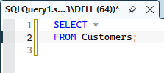
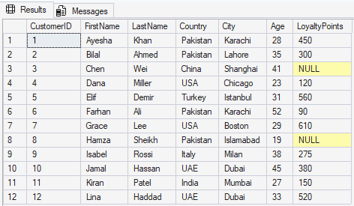

1.2 Display only FirstName, LastName and Country of all customers.

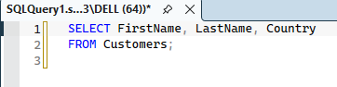
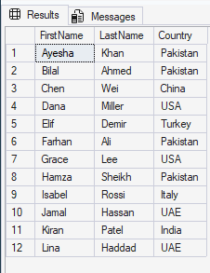

1.3 Display ProductName and Price of all products. Rename the output columns as Product and UnitPrice.

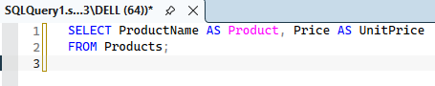
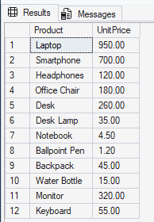

1.4 Display the list of countries where customers live. Each country must appear only once.
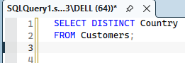
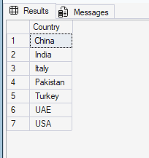

1.5 Display each employee's FirstName, Salary and SalaryAfterRaise showing salary increased by 10%.

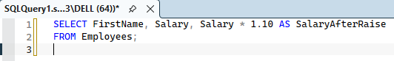
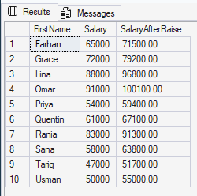

Part 2: Filtering Data (WHERE)

2.1 Display all customers who live in Pakistan.
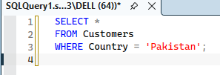
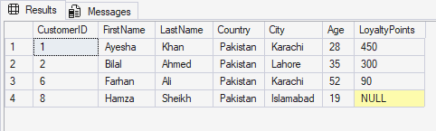

2.2 Display ProductName and Price of products that cost more than 100.
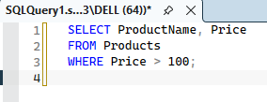
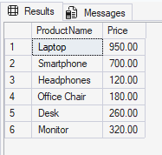

2.3 Display FirstName, Department and Salary of employees who earn 60000 or less.

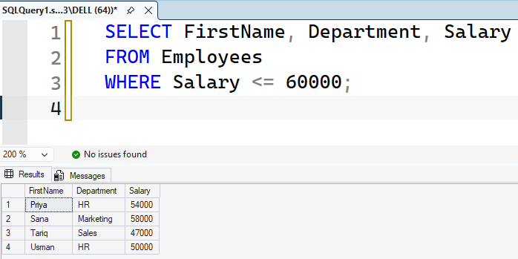2.4 Display all orders whose Status is not 'Cancelled'.

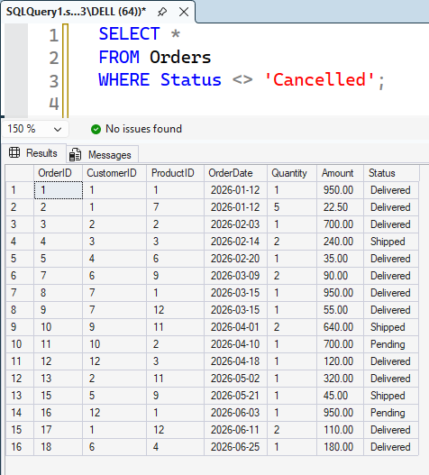

2.5 Display FirstName and LastName of customers whose LoyaltyPoints value is missing (NULL).

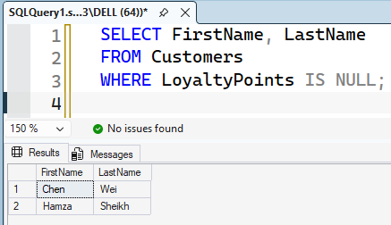

Part 3: Sorting Data (ORDER BY)

3.1 Display ProductName and Price of all products, sorted from lowest price to highest.

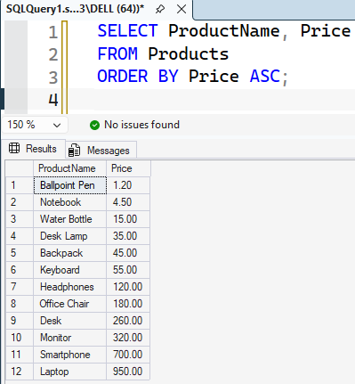

3.2 Display FirstName and Age of all customers, sorted from oldest to youngest.

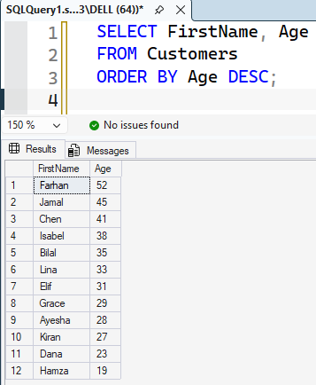

3.3 Display all employees sorted alphabetically by LastName (A to Z).

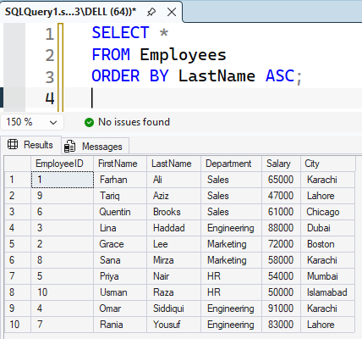

3.4 Display FirstName, Country and LoyaltyPoints of customers sorted by Country A to Z and LoyaltyPoints highest to lowest within each country.

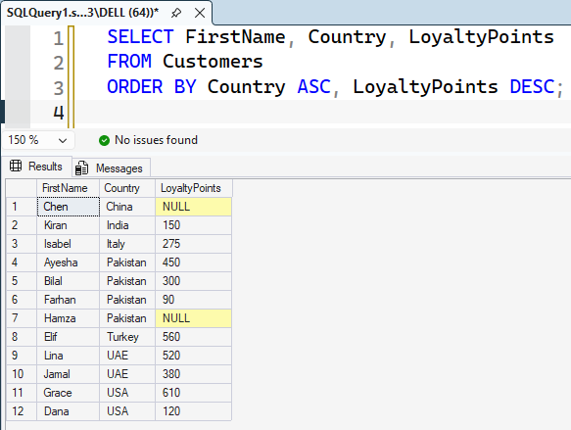

3.5 Display OrderID, OrderDate and Amount of delivered orders, most recent first.
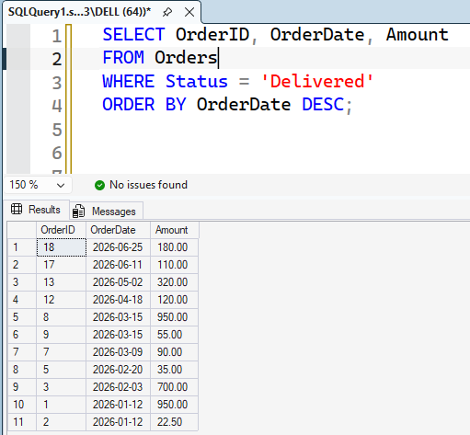

Part 4: AND, OR and NOT

4.1 Display customers who live in Pakistan AND are older than 30.

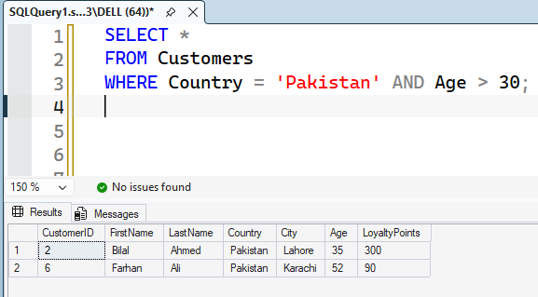

4.2 Display products in the Furniture category OR costing less than 10.

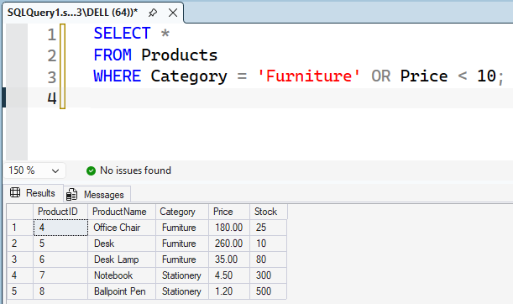

4.3 Display employees in Sales AND earning more than 50000.

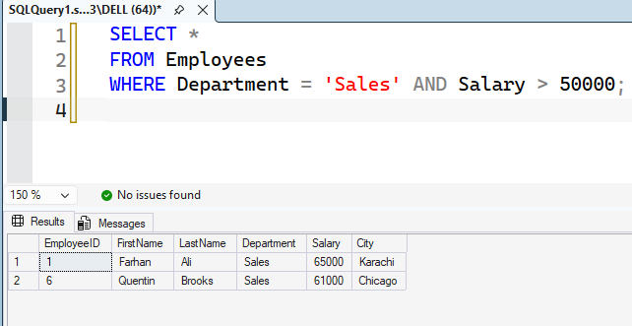

4.4 Display customers who do NOT live in Pakistan. Use NOT.

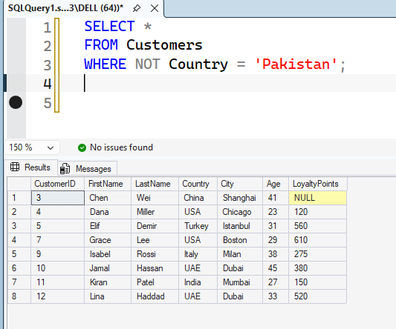

4.5 Display customers who live in the USA or UAE and have more than 400 LoyaltyPoints. Use brackets.
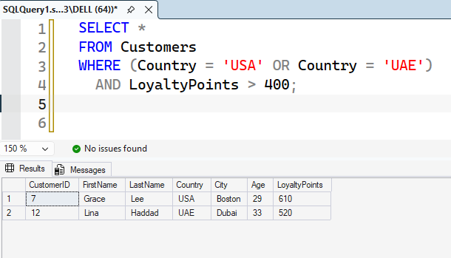

Part 5: TOP

5.1 Display the first 3 rows of Customers.

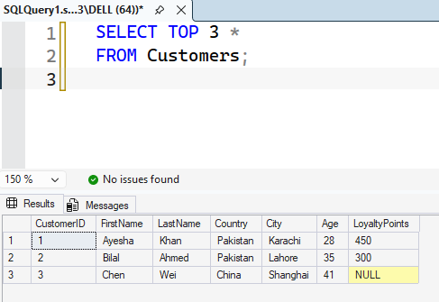

5.2 Display ProductName and Price of the 5 most expensive products.

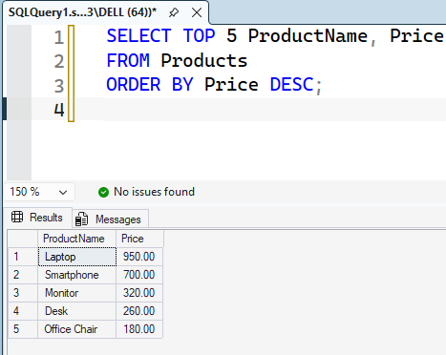

5.3 Display FirstName and Age of the 3 youngest customers.
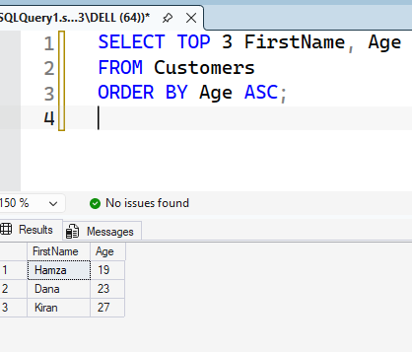

5.4 Display FirstName, LastName and Salary of the highest-paid employee, only one row.

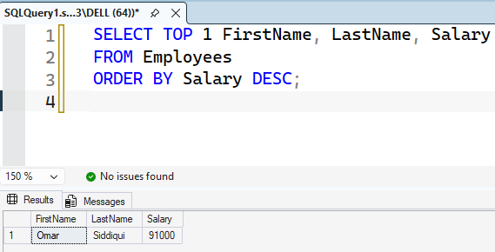

5.5 Display OrderID, OrderDate and Amount of the 2 most recent delivered orders.

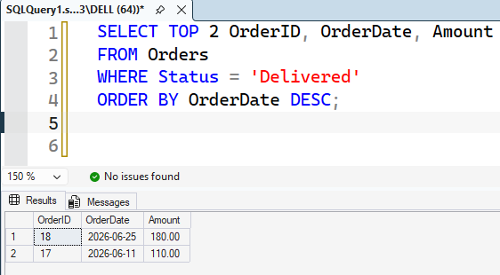

Part 6: SET Operators

6.1 Use UNION to combine FirstName and LastName of all customers and employees, showing a person appearing in both tables only once.

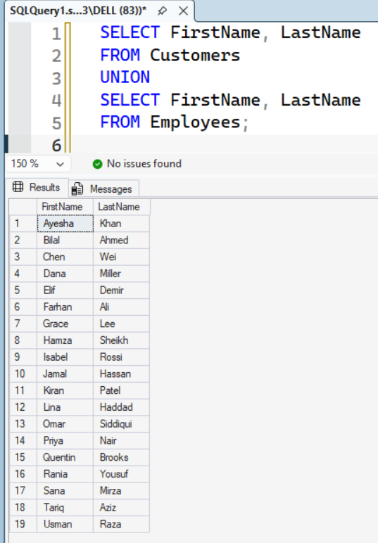

6.2 Use UNION ALL for the same combined list. Explain how many more rows and why.
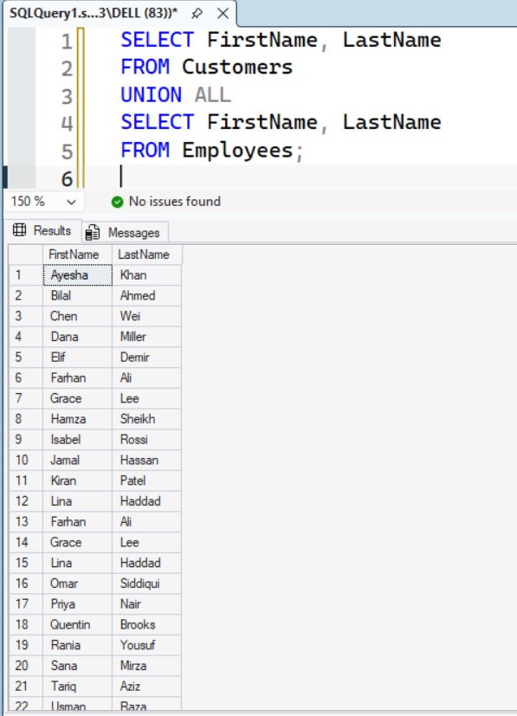

6.3 Use INTERSECT to display people who are both customers and employees.

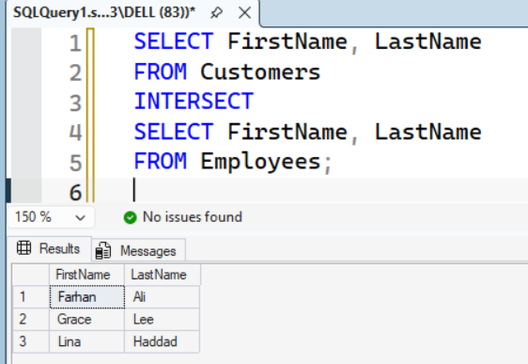

6.4 Use EXCEPT to display customers who are not employees.

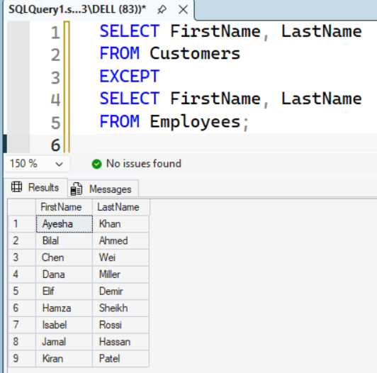

6.5 Use UNION ALL to show FirstName, LastName and PersonType, then sort by FirstName.

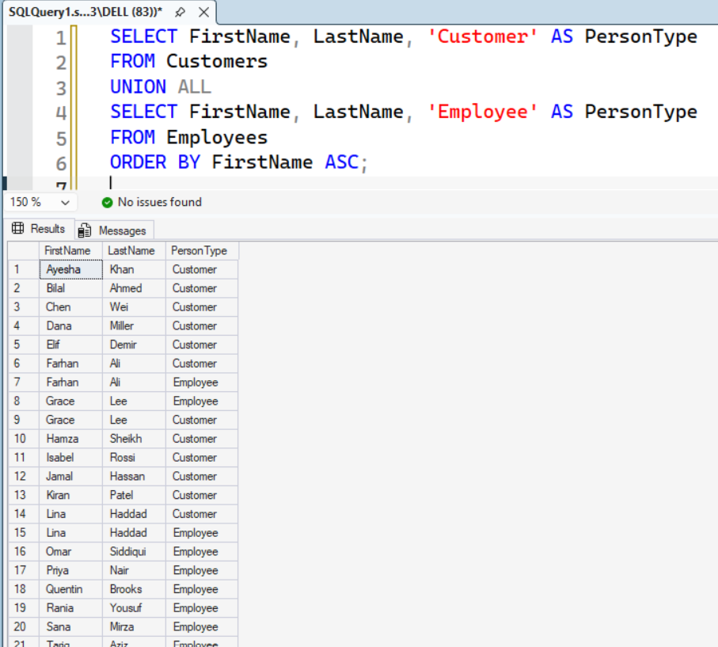

Part 7: IN and NOT IN

7.1 Display customers who live in Pakistan, UAE or India. Use IN.

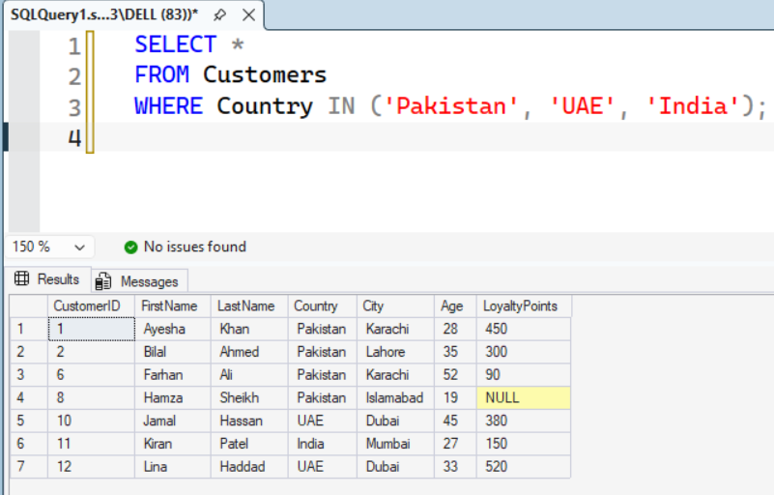

7.2 Display ProductName and Category of products in Stationery or Accessories. Use IN.

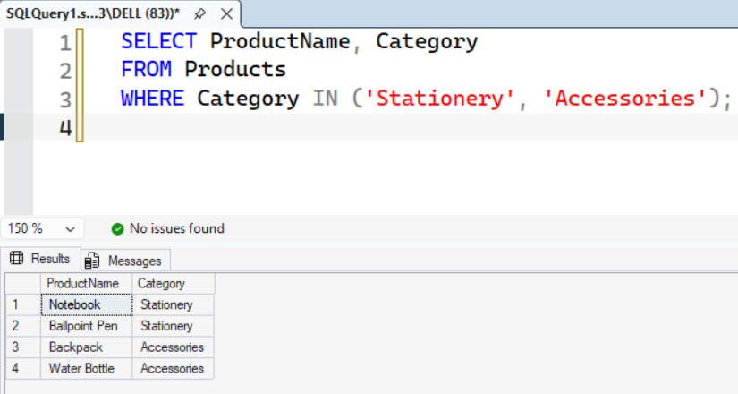

7.3 Display customers who do not live in the USA, China or Italy. Use NOT IN.

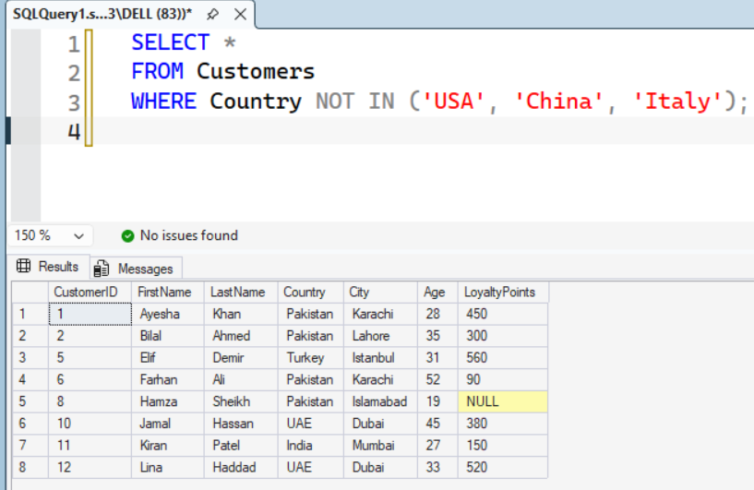

7.4 Display FirstName, Department and Salary of employees in HR or Marketing, highest salary first.

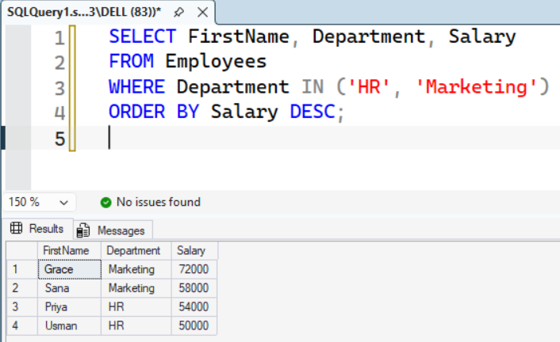

7.5 Display orders whose Status is neither Cancelled nor Pending. Use NOT IN.

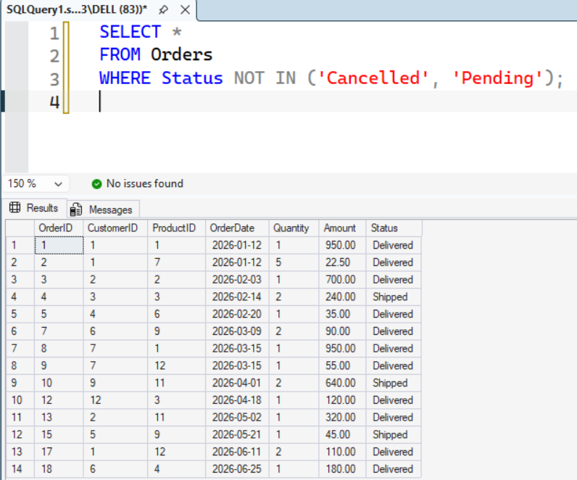

Part 8: JOINs

8.1 Display OrderID, customer's FirstName and OrderDate for every order.
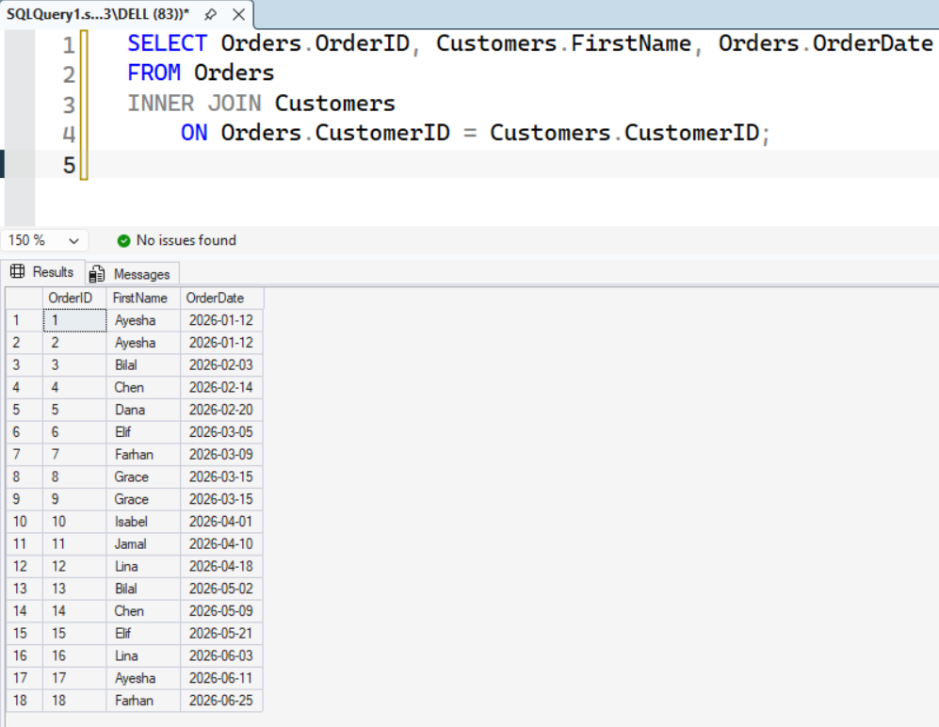

8.2 Display every customer's FirstName and OrderID. Customers who never ordered must also appear with NULL OrderID.

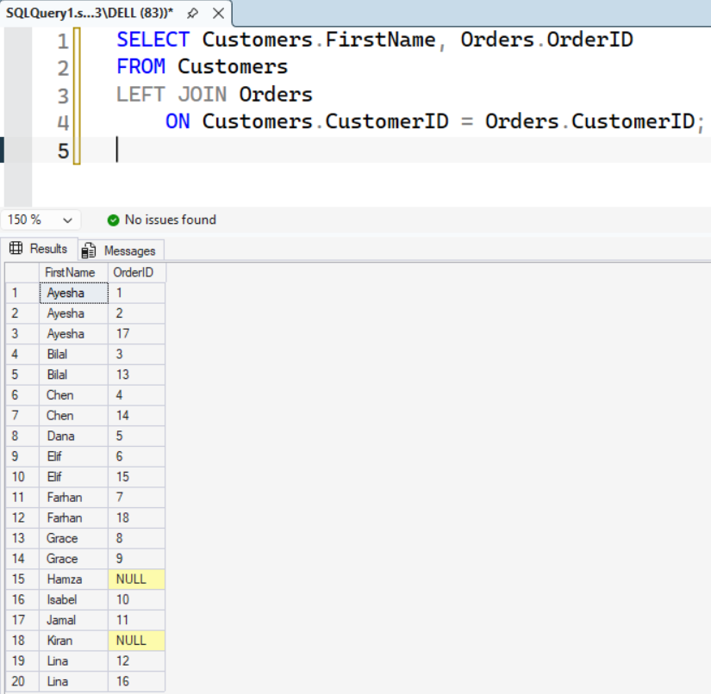

8.3 Display every product's ProductName and OrderID, including products never ordered. Use RIGHT JOIN and start from Orders.

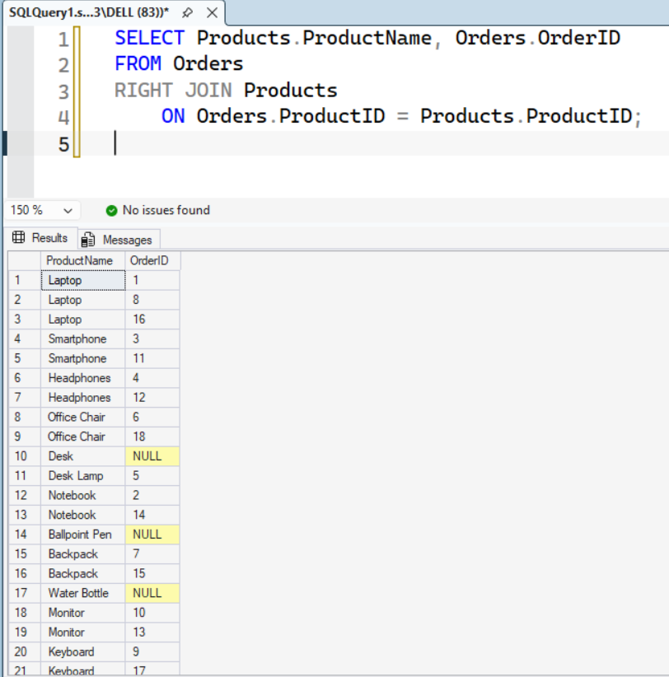

8.4 Display FirstName and LastName of customers who have never placed an order.

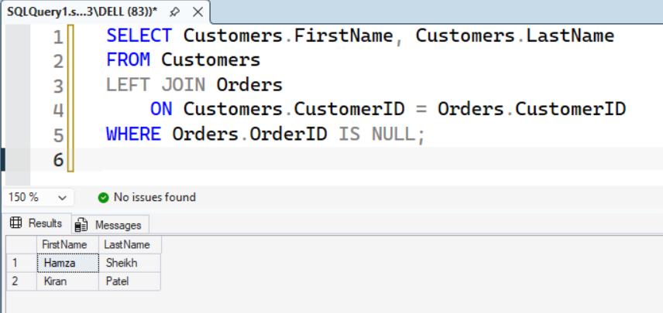

8.5 For delivered orders, display customer's FirstName, ProductName, OrderDate and Quantity using three tables.

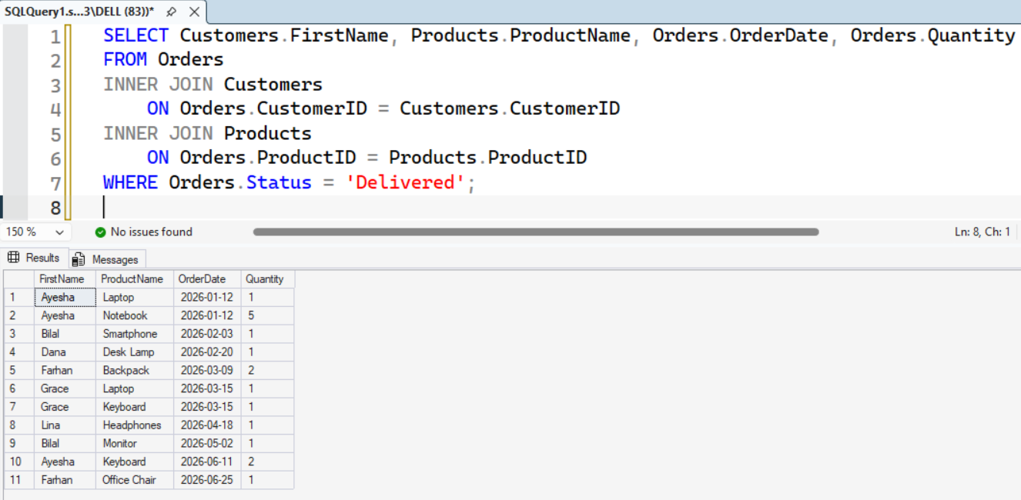

Part 9: Subqueries

9.1 Display ProductName and Price of products costing more than Desk Lamp, using a subquery to find its price.

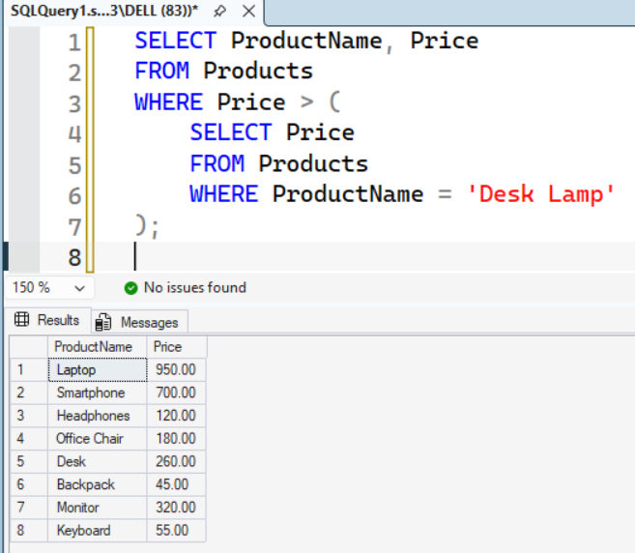

9.2 Display products costing more than the average price of all products.

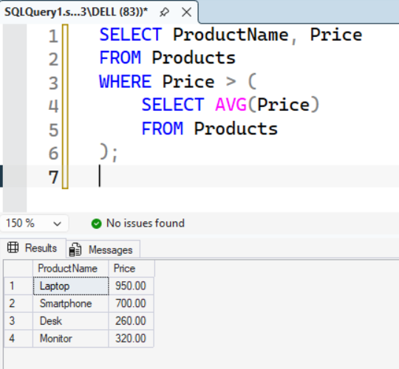

9.3 Display FirstName and LastName of customers who have placed at least one order. Use IN with a subquery.

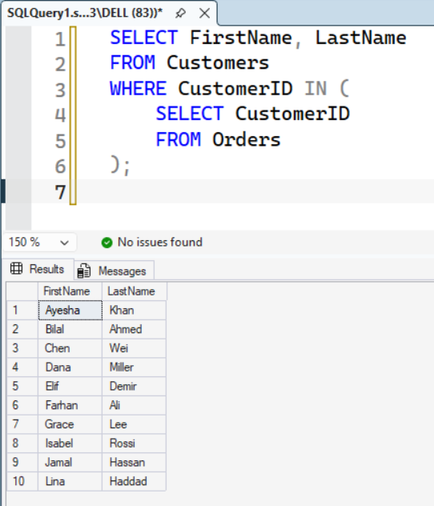

9.4 Display ProductName of products never ordered. Use NOT IN with a subquery.

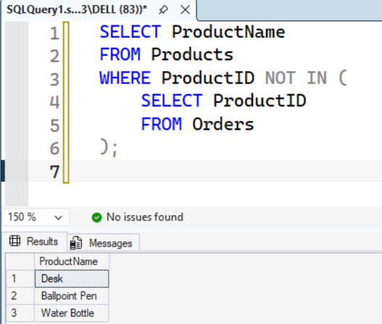

9.5 Display FirstName and LastName of customers who ordered at least one product from Electronics. Use a subquery inside a subquery.
