SOFTWARE REQUIREMENTS SPECIFICATION (SRS)
Marks Entry Checker System
Course: Software Quality Engineering
Lab: 03
Department: Software Engineering
University: DHA Suffa University

1. Introduction
The Marks Entry Checker System is a simple examination system designed to validate student marks entered by a user. It checks whether the entered marks fall within the permitted range of 0 to 100. The system is tested using black-box testing techniques to verify that it behaves according to the specified requirements.

2. Purpose
The purpose of this document is to define the functional and non-functional requirements of the Marks Entry Checker System. It also provides a foundation for designing test cases using Equivalence Partitioning and Boundary Value Analysis.

3. Scope
The system allows a user to enter student examination marks and checks whether the entered value is valid.
- Accept student marks as input.
- Validate marks against the permitted range.
- Accept marks between 0 and 100, including both boundaries.
- Reject marks below 0.
- Reject marks above 100.
- Display an appropriate validation message.

4. Definitions and Abbreviations
Term | Description
SRS | Software Requirements Specification
SQE | Software Quality Engineering
EP | Equivalence Partitioning
BVA | Boundary Value Analysis
Black-Box Testing | Testing software through inputs and outputs without examining its internal code
Valid Input | Marks between 0 and 100, inclusive
Invalid Input | Marks below 0 or above 100
Test Case | A set of inputs and expected results used to verify system behaviour

5. Overall Description
The Marks Entry Checker System is a command-line Java application. The user enters examination marks, and the system processes the input according to the defined validation rules. The system provides feedback indicating whether the entered marks are valid or invalid. The application is intended for basic examination marks validation and software testing exercises.

6. User Classes and Characteristics

6.1 Teacher
The teacher enters student examination marks into the system and checks whether the marks are within the permitted range.

6.2 Tester
The tester provides different input values to verify the system's behaviour and identifies defects through black-box testing techniques.

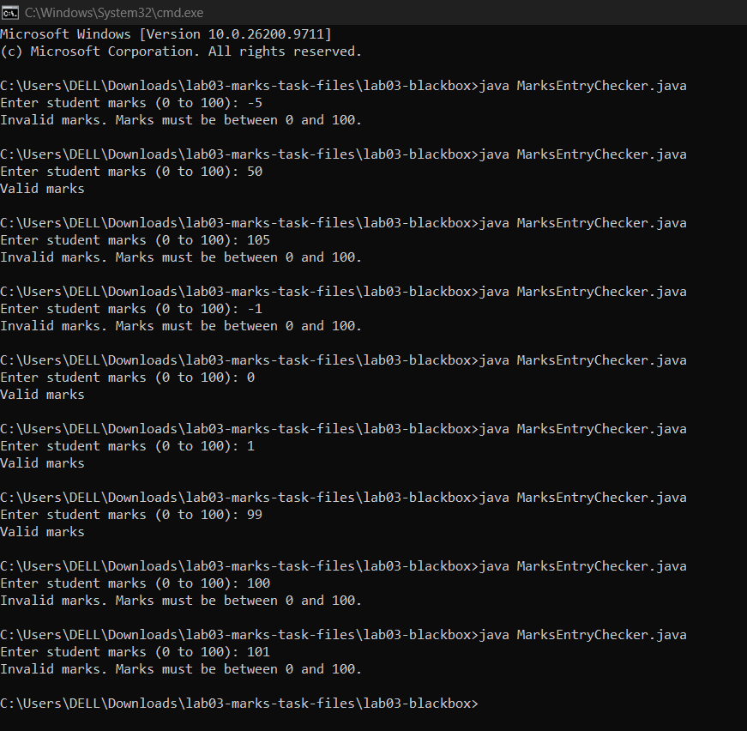

7. Operating Environment
- Operating System: Windows 10 or Windows 11
- Programming Language: Java
- Java Development Kit: JDK 17
- Code Editor: Visual Studio Code
- Execution Environment: VS Code Integrated Terminal or Windows Command Prompt
- Testing Documentation: Microsoft Excel
- Version Control: Git and GitHub

8. Functional Requirements
FR-01: The system shall accept examination marks as user input.
FR-02: The system shall accept marks equal to 0.
FR-03: The system shall accept marks equal to 100.
FR-04: The system shall accept all marks between 0 and 100.
FR-05: The system shall reject marks below 0.
FR-06: The system shall reject marks above 100.
FR-07: The system shall display "Valid marks" when the entered marks are within the permitted range.
FR-08: The system shall display an appropriate error message when the entered marks are outside the permitted range.

9. External Interface Requirements

9.1 User Interface
The system shall provide a command-line interface where users can enter marks through the keyboard.

9.2 Software Interface
The application shall use Java and its standard input and output facilities to receive user input and display validation results.

9.3 Hardware Interface
The system requires a computer with a keyboard and display to enter marks and view the results.

10. Non-Functional Requirements

10.1 Usability
The system should be simple and easy to use.

10.2 Performance
The system should validate entered marks and display the result without unnecessary delay.

10.3 Reliability
The system should consistently produce the correct validation result for valid and invalid inputs.

10.4 Maintainability
The application should be easy to modify and maintain.

10.5 Portability
The application should be executable on systems that support the required Java version.

11. Assumptions and Constraints

11.1 Assumptions
- The user enters examination marks as whole numbers.
- The permitted marks range is 0 to 100.
- Both 0 and 100 are considered valid.
- The user has Java installed and configured correctly.

11.2 Constraints
- The application is developed using Java.
- The application uses a command-line interface.
- The system is limited to validating marks.
- The system does not store student records or examination results in a database.
- The system does not calculate grades or percentages.

