**Task No 1:**

<!DOCTYPE html>

<html lang="en">

<head>

    <meta charset="UTF-8">

    <meta name="viewport" content="width=device-width, initial-scale=1.0">

    <title>Document</title>

</head>

<body>

    <body bgcolor=yellow></body>

    <h1> This is about me ..

    </h1>

    <li>

        My name is SUFYAN MALIK <br>

     </li>

    <li> My roll number is 21F-9197 <br> </li>

    <li>I want to study node JS and react JS as well <br> </li>

</body>

</html>

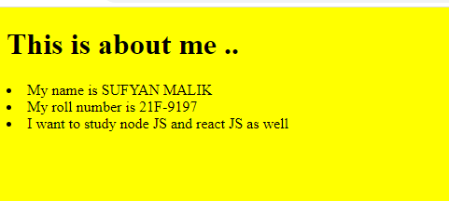

**Task No 2:**

<!DOCTYPE html>

<html lang="en">

<head>

    <meta charset="UTF-8">

    <meta name="viewport" content="width=device-width, initial-scale=1.0">

    <title>Document</title>

</head>

<body>

     <h1> This text is bold

    </h1>

    <h2> This text is strong

    </h2>

<p>

    This text is big <br>

    <em>This text is Italic </em> <br>

    <em> This text is emphasied </em> <br>

    <output>This is a computer output</output>

    <sup> This is superscript </sup> <sub> This is subscript</sub>

</body>

</html>

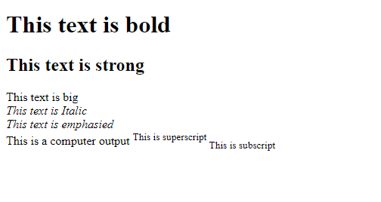

**Task no 3:**

<!DOCTYPE html>

<html lang="en">

<head>

    <meta charset="UTF-8">

    <meta name="viewport" content="width=device-width, initial-scale=1.0">

    <title>Document</title>

</head>

<body>

    <img src="C:\Users\f219197\Desktop\images.png" alt="Italian Trulli" width="500" height="500">

</body>

</html>



**Task No 4:**

**Image link:**



**By clicking :**

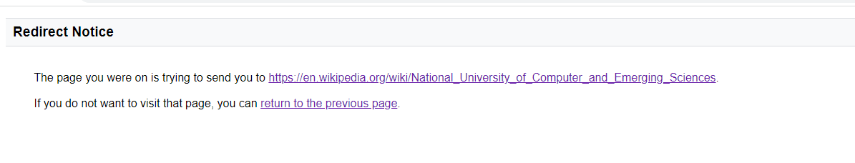

<!DOCTYPE html>

<html lang="en">

<head>

    <meta charset="UTF-8">

    <meta name="viewport" content="width=device-width, initial-scale=1.0">

    <title>Document</title>

</head>

<body>

    <p><a href="https://www.google.com/url?sa=i&url=https%3A%2F%2Fen.wikipedia.org%2Fwiki%2FNational_University_of_Computer_and_Emerging_Sciences&psig=AOvVaw3R21W49xmmtlJdberhaJiB&ust=1706866493551000&source=images&cd=vfe&opi=89978449&ved=0CBUQjhxqFwoTCNDj16rriYQDFQAAAAAdAAAAABAI"><img src="C:\Users\f219197\Desktop\images.png" style="width:50px;height:50px;"></a></p>

</body>

</html>

**Task No 5:**

<!DOCTYPE html>

<html lang="en">

<head>

    <meta charset="UTF-8">

    <meta name="viewport" content="width=device-width, initial-scale=1.0">

    <title>Document</title>

</head>

<body>

    <h1> Unorder list </h1>

    <ul> <li>Oracle </li>

        <li> java </li>

            <li>HTML </li>

                <li>CSS </li>

        </ul>

        <ol>

            <h2> Order list </h2>

            <li> Download the software </li>

            <li>Extract the software </li>

            <li>Double click the executable to tun </li>

        </ol>

   </body>

</html>

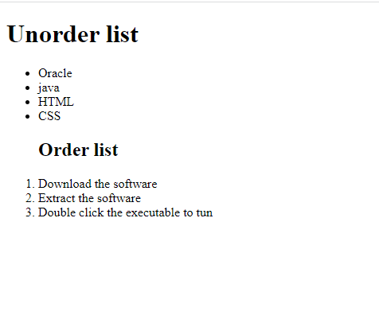

**Task No 6:**

<!DOCTYPE html>

<html>

<style>

table, th, td {

  border:1px solid black;

}

</style>

<body>

<h2>I am making a table </h2>

<table style="width:100%">

  <tr>

    <td>April</td>

    <td colspan="2"></td>

  </tr>

  <tr>

    <td></td>

    <td> </td>

    <td></td>

  </tr>

  <tr>

    <td>  </td>

    <td> </td>

    <td></td>

  </tr>

</table>

</body>

</html>

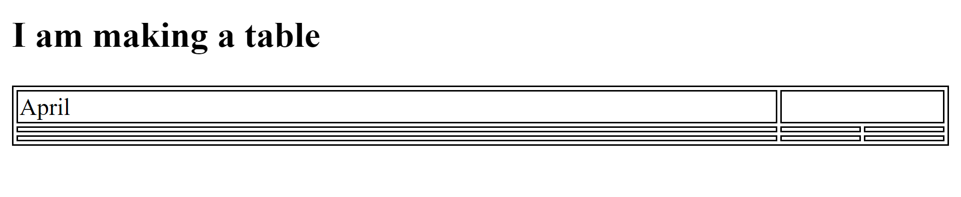

**Task No 7:**

<!DOCTYPE html>

<html lang="en">

<head>

    <meta charset="UTF-8">

    <meta name="viewport" content="width=device-width, initial-scale=1.0">

    <title>Table</title>

    <style>

        table, th, td {

            border: 1px solid black;

            border-collapse: collapse;

        }

        th, td {

            padding: 10px;

            text-align: left;

        }

    </style>

</head>

<body>

<h2>2022 FIESTA Table</h2>

<table style="width:50%">

  <tr>

    <th colspan="3">2022</th>

  </tr>

  <tr>

    <td colspan="3">FIESTA</td>

  </tr>

  <tr>

    <td></td>

    <td></td>

    <td></td>

  </tr>

</table>

</body>

</html>

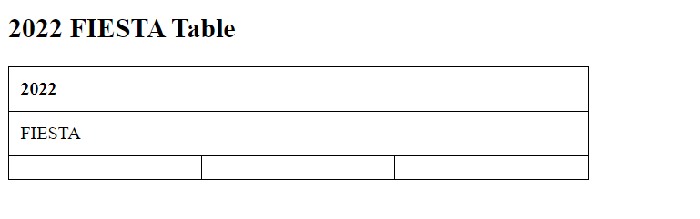

**Task No 8:**

<!DOCTYPE html>

<html>

<head>

    <title>Sign Up Form</title>

    <style>

        form {

            display: flex;

            flex-direction: column;

            align-items: center;

        }

        input[type="text"], input[type="email"], input[type="password"] {

            margin: 10px;

            padding: 5px;

            width: 200px;

            border-radius: 5px;

            border: none;

            box-shadow: 1px 1px 1px grey;

        }

        input[type="submit"], input[type="reset"] {

            margin: 10px;

            padding: 5px;

            width: 100px;

            border-radius: 5px;

            border: none;

            box-shadow: 1px 1px 1px grey;

            background-color: #4CAF50;

            color: white;

            cursor: pointer;

        }

        input[type="submit"]:hover, input[type="reset"]:hover {

            background-color: #3e8e41;

        }

    </style>

</head>

<body>

    <form>

        <label for="username">User Name:</label>

        <input type="text" id="username" name="username" required>

        <label for="email">Email:</label>

        <input type="email" id="email" name="email" required>

        <label for="password">Password:</label>

        <input type="password" id="password" name="password" required>

        <label for="confirm_password">Confirm Password:</label>

        <input type="password" id="confirm_password" name="confirm_password" required>

        <input type="submit" value="Submit">

        <input type="reset" value="Reset">

    </form>

</body>

</html>

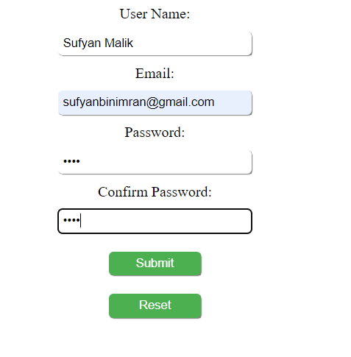

**Task No 9:**

<!DOCTYPE html>

<html lang="en">

<head>

    <meta charset="UTF-8">

    <meta name="viewport" content="width=device-width, initial-scale=1.0">

    <title>Pete's Pizza Delivery Online Order Form</title>

</head>

<body>

<h1>Pete's Pizza Delivery</h1>

<h2>Online Order Form</h2>

<form action="/submit-order" method="post">

    <label for="name">*Name:</label><br>

    <input type="text" id="name" name="name" required><br><br>

    <label for="address">*Address:</label><br>

    <input type="text" id="address" name="address" required><br><br>

    <label for="townCity">*Town/city:</label><br>

    <input type="text" id="townCity" name="townCity" required><br><br>

    <label for="postcode">*Postcode:</label><br>

    <input type="text" id="postcode" name="postcode" required><br><br>

    <label for="tel">*Tel:</label><br>

    <input type="tel" id="tel" name="tel" required><br><br>

    <label for="email">*Email:</label><br>

    <input type="email" id="email" name="email" required><br><br>

    <h3>Topping</h3>

    <input type="radio" name="topping" value="Margherita"> Margherita

    <input type="radio" name="topping" value="Four Seasons"> Four Seasons

    <input type="radio" name="topping" value="Meat Feast"> Meat Feast

    <h3>Size</h3>

    <input type="radio" name="size" value="Small"> Small

    <input type="radio" name="size" value="Medium"> Medium

    <input type="radio" name="size" value="Large"> Large

    <h3>Extras</h3>

    <input type="checkbox" name="extras" value="Mushrooms"> Mushrooms

    <input type="checkbox" name="extras" value="Green peppers"> Green peppers

    <input type="checkbox" name="extras" value="Anchovies"> Anchovies

    <input type="checkbox" name="extras" value="Extra cheese"> Extra cheese

    <h3>Preferred delivery time:</h3>

    <select name="delivery-time">

        <option value="ASAP">ASAP</option>

        <option value="1-hour">1 hour</option>

        <option value="2-hour">2 hours</option>

        <option value="3-hour">3 hours</option>

    </select>

    <br>

    <br>

    <label for="delivery-instructions">Delivery instructions:</label><br>

    <textarea id="delivery-instructions" name="delivery-instructions" rows="4" cols="50"></textarea>

    <br>

    <br>

    <input type="submit" value="Submit Order">

</form>

</body>

</html>



