initial tests
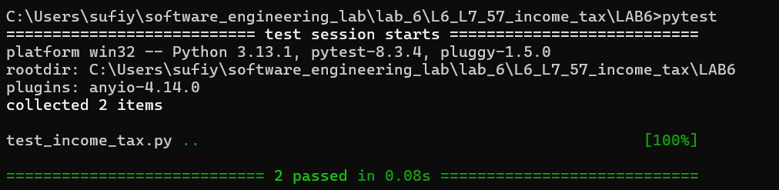
initial line/code coverage
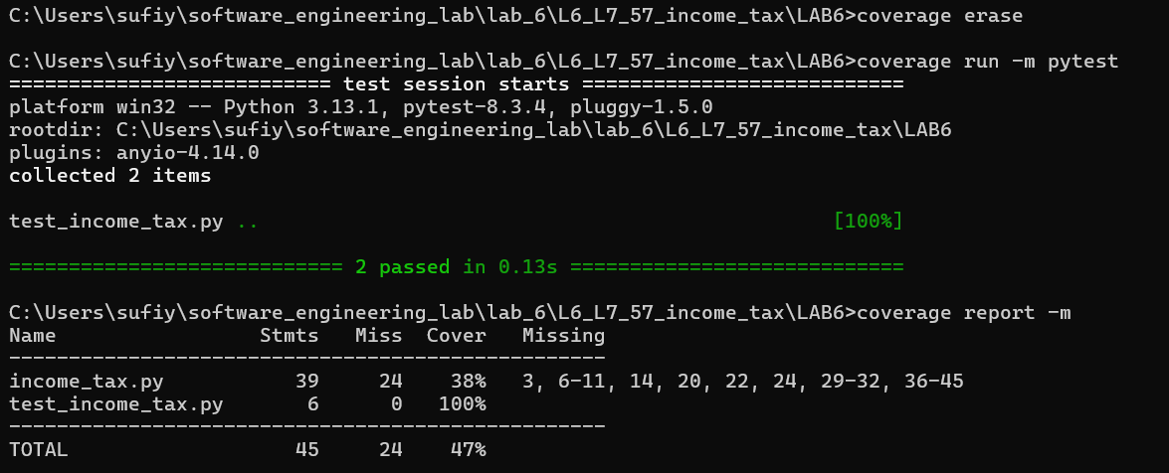
initial branch coverage
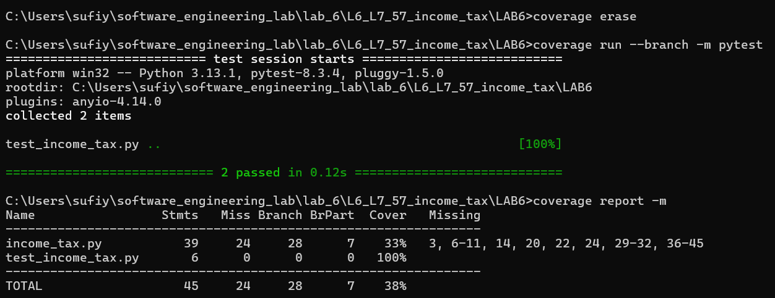

modified line/code coverage
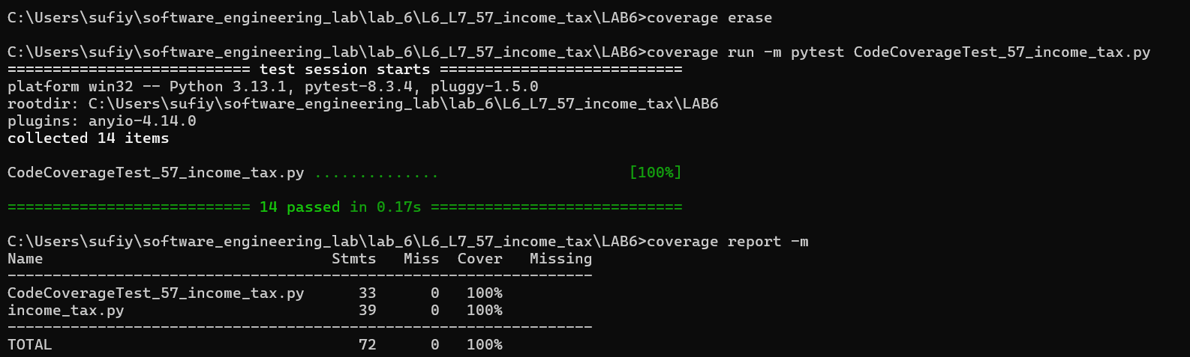
modified branch coverage
