**1. Project Overview**

This project demonstrates the setup and deployment of an **Application Load Balancer (ALB)** in **AWS**, serving a static website using **HTML** and **CSS**. The load balancer distributes incoming traffic across multiple EC2 instances to ensure high availability and reliability.

**2. Technologies Used**

* Amazon Web Services (AWS)
* EC2 Instances
* Application Load Balancer (ALB)
* Target Groups
* HTML & CSS

**3. Features Implemented**

* Created and configured **three EC2 instances**.
* Deployed a **static HTML & CSS website** on each instance.
* Created a **Target Group** and added all three EC2 instances.
* Set up an **Application Load Balancer** and connected it to the target group.
* Verified the setup using the **Load Balancer DNS name**.
* All three instances show as **healthy** in the load balancer dashboard.

**4. Load Balancer URL**

* <http://suffuload-1202380866.us-east-1.elb.amazonaws.com/>

**5. Conclusion**

* 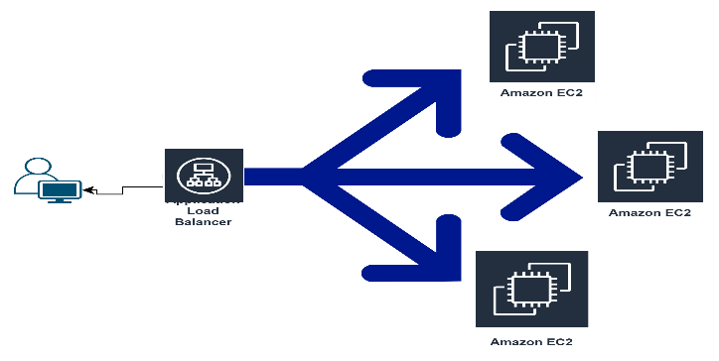This project effectively demonstrates how to deploy and manage a scalable and fault-tolerant application infrastructure using AWS. By distributing traffic across multiple instances with a Load Balancer, high availability and reliability are ensured. This is a foundational approach for deploying production-ready applications on the cloud.