**1. Project Overview**

**SuffuTube** is a cloud-deployable video streaming and sharing platform designed for scalability and high availability. The project demonstrates containerized deployment, orchestration with Kubernetes, CI/CD automation, and serverless integrations.

**Key Highlights:**

* Streamlined video streaming and management
* Dockerized for portability
* Kubernetes deployment on AWS EC2
* Automated CI/CD pipeline with GitHub Actions
* Serverless notifications using AWS Lambda & SNS

**2. Technology Stack**

| **Component** | **Technology / Tool** |
| --- | --- |
| Containerization | Docker |
| Orchestration | Kubernetes (kubeadm) |
| Cloud Infrastructure | AWS EC2 (t3.medium nodes) |
| CI/CD | GitHub Actions |
| Serverless | AWS Lambda & SNS |
| Web Frontend | HTML, CSS, JavaScript |

**3. System Architecture**

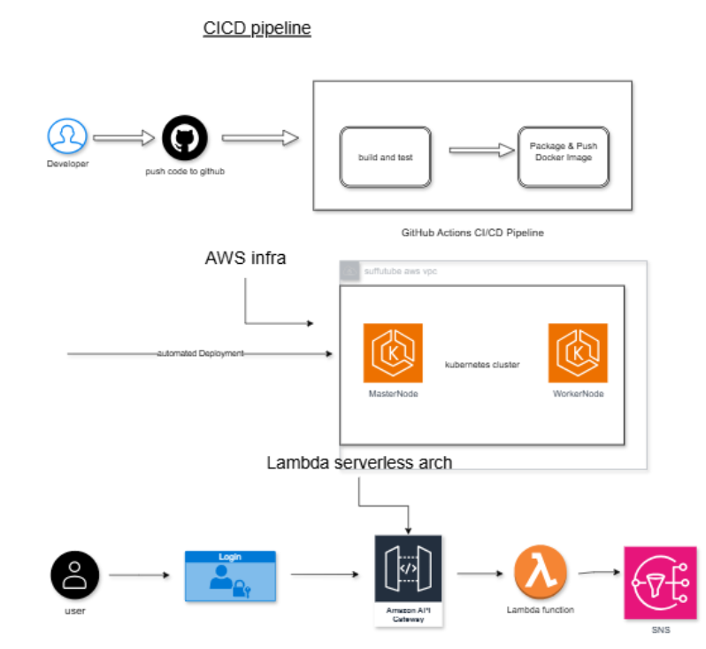

▼

**Explanation:**

* Users access the web frontend to interact with the platform.
* The frontend is hosted in **Docker containers** managed by **Kubernetes**.
* **CI/CD pipelines** automatically build, push, and deploy Docker images upon code changes.
* **AWS Lambda** provides serverless notifications (e.g., video upload alerts).

**4. Deployment Workflow**

**Step 1: Kubernetes Setup**

* EC2 instances are configured as **master and worker nodes**.
* Kubernetes cluster is initialized using kubeadm.
* Docker containers are orchestrated across nodes for scalability.

**Step 2: Namespace Management**

* A dedicated namespace is created for the application:

kubectl create namespace suffutube

**Step 3: Application Deployment**

* Application containers are deployed using Kubernetes **Deployments** and exposed via **Services** (NodePort/LoadBalancer).
* Kubernetes ensures automatic scaling and self-healing of pods.

**Step 4: CI/CD Integration**

* **GitHub Actions** automatically:
  + Builds Docker images from the repository
  + Pushes the image to Docker Hub
  + Deploys updated containers to the Kubernetes cluster
* This ensures **continuous delivery and minimal downtime**.

**Step 5: Serverless Notifications**

* AWS Lambda functions handle asynchronous events such as user actions or content updates.
* Notifications are sent using **SNS topics**, providing real-time updates.

**5. Key Benefits**

* **Portability:** Docker ensures the application can run anywhere.
* **Scalability:** Kubernetes orchestrates containers for high availability.
* **Automation:** CI/CD pipeline minimizes manual deployment effort.
* **Serverless Integration:** AWS Lambda enables event-driven notifications without extra server overhead.
* **Cloud-Ready:** Fully compatible with AWS infrastructure, ready for production deployment.

**6. Future Enhancements**

* Add user authentication and role-based access control.
* Integrate cloud storage for media files (e.g., S3).
* Implement analytics and reporting dashboards.
* Introduce subscription and notification management for end-users.
* Optimize container orchestration for cost-efficiency and autoscaling.

**7. Conclusion**

SuffuTube is a **modern, cloud-native video streaming platform** built for scalability, automation, and maintainability. The project demonstrates proficiency in containerization, orchestration, CI/CD, and serverless architecture, making it a strong candidate for real-world deployment and portfolio showcase.