How the TCC desk works today
Validus · Investor Services Operations · written by the desk lead for new joiners · October 2026 · synthetic material; AMCs and people are fictional
What the desk does  Checks purchase, SIP, redemption and bank-change requests that can't go straight through, before they are processed, for 14 AMCs (this pack: Narmada MF and Tungabhadra MF). | How much  About 1,800 requests a day (2,600 at month-end). Maker about 11 min, checker about 3 min each. 22% need a second touch. | What comes out  One of six outcomes with reason codes, a reply to the sender, a case-log row, and sometimes a referral to the AMC. | Who signs  Maker alone for PROCEED / PEND / INVALID_REQUEST. Checker for PROCEED_MODIFIED / REJECT. Operations Manager for holds; the AMC decides on referrals.

1. The flow today
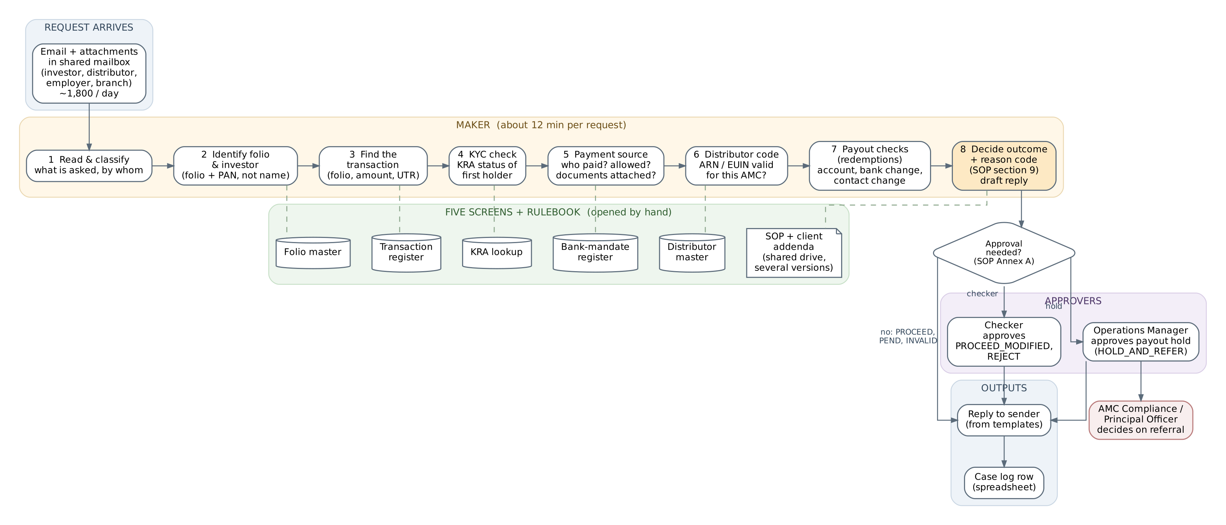
Figure 1. A request goes through eight maker steps; each step means opening a screen or the rulebook by hand. Dashed lines show which screen each step uses.

2. The six outcomes
Outcome | Used when | Who signs
PROCEED | Every check passes | Maker (checker samples 10%)
PROCEED_MODIFIED | Can go ahead with a change the SOP requires (e.g. switched to Direct plan) | Checker
PEND | Waiting for a document, a re-check or a period | Maker
REJECT | Not acceptable under the SOP; money refunded | Checker
HOLD_AND_REFER | Payout held and request referred to the AMC | Operations Manager, then AMC Compliance
INVALID_REQUEST | Folio or investor cannot be identified, or details conflict | Maker

3. The five screens
Screen | Extract in data/ | What the maker reads there
Folio master | folio_master.csv | Holders, holding mode, tax status, guardian and minor's DOB, contact changes, flags
Transaction register | transactions.csv | The transaction behind the request (PENDING_TCC) and the folio's history
KRA lookup | kra_kyc_snapshot.csv | KYC status of each PAN (refreshed daily 06:00)
Bank-mandate register | bank_mandates.csv | Registered accounts, their holders, default flag, validation status, bank-change requests
Distributor master | distributor_master.csv | ARN/EUIN validity and status; empanelment with each AMC
Rulebook | policies/ | The SOP and any client addendum

4. Worked example: one request, start to finish
This request came in last month and is closed. Its records are in data/, so you can follow every step. Nothing was wrong with it, and most requests are like that: the time goes into the lookups, not the decision.
INPUT — the email
From: Ramesh Kedia <operations@kediawealth.example> Sent: Tuesday, 22 September 2026 11:05 AM
To: TCC Desk <tcc.desk@validus-rta.example> Subject: Additional purchase - Ravi Kumar Bhat - Narmada Large Cap

Dear Team, Our client Mr. Ravi Kumar Bhat has invested Rs. 75,000/- in Narmada Large Cap Fund - Regular - Growth, folio no. 4016645093, by NEFT today from his Konkan Mercantile Bank account ending 5475 (UTR VNDYN2609229076583). ARN-145023 / EUIN E289730. Kindly process. Regards, Ramesh Kedia, Kedia Wealth Partners

STEPS — what the maker did
# | Where | Looked for | Found | Step result
1 | The email | What is asked, by whom, which folio | Additional purchase ₹75,000, Regular plan, from the distributor; folio written without the '/' | Request type: additional purchase
2 | Folio master | Folio, first holder, flag | 40166450/93, NMF, single holder Ravi Kumar Bhat, PAN YBZPB**44W, flag NONE | Identified by folio + PAN
3 | Transaction register | The transaction | T260900518: ₹75,000, 22-09-2026, NEFT, UTR matches, remitter a/c XXXXXXXX5475, name 'R K BHAT' | Found
4 | KRA lookup | KYC of first holder | YBZPB**44W: code 307, KYC Validated | PASS · SOP 4.2
5 | Bank-mandate register | Does the paying account belong to the first holder? | XXXXXXXX5475 registered, VALIDATED, holders 'RAVI KUMAR BHAT;SHOBHA BHAT' (first holder is a holder; the short name in the bank feed doesn't matter) | PASS · SOP 5.1
6 | Distributor master | ARN/EUIN valid for this AMC? | ARN-145023 ACTIVE to 2028-03-31, empanelled NMF; EUIN E289730 valid | PASS · SOP 7.1
7 | — | Payout checks | Not a redemption | N/A
8 | SOP section 9, Annex A | Outcome and approval | All checks passed | PROCEED, no approval needed

OUTPUT — what was recorded and sent
date | request | folio | maker | checks done | outcome | reason code | checker | reply sent
22-09-2026 | Kedia Wealth, Rs 75,000 add. purchase | 40166450/93 | M-07 | KYC ok, bank ok (joint a/c), ARN ok | PROCEED | — | not sampled | Y

Reply sent to the distributor
Dear Mr. Kedia, Your client's additional purchase of Rs. 75,000 in Narmada Large Cap Fund - Regular - Growth (folio 40166450/93) has been checked and released for processing at the applicable NAV. A confirmation will be sent to the investor's registered email. Regards, TCC Desk, Validus

Time taken: 12 minutes. About 9 went on opening the five screens and matching records, 2 on the decision and record, and 1 on the reply.

5. Where it hurts
- Time goes on looking things up, not deciding: five screens and the rulebook for every request.
- Rules move. The SOP changed three times in 18 months, and several versions sit in the shared folder. Each AMC can add its own addendum.
- Two makers can reach different outcomes on the same request. Replies are written from scratch and vary.
- The case log doesn't record which document or version a decision relied on. When an AMC asks 'why?', the answer is rebuilt from emails.
- Month-end backlog: same-day SLA missed on 9 of the last 60 business days. Three new AMCs go live next quarter.
Request mix (last quarter) | Share
Payment-source questions on purchases and SIPs | 46%
KYC-related | 18%
Redemptions and payouts | 17%
Distributor codes | 9%
Change of bank | 6%
Other | 4%

6. Glossary
Term | Meaning
AMC / RTA | Fund house / registrar and transfer agent (Validus) that services its investors and transactions
Folio | An investor's account with one AMC
First holder | First-named holder; payment and KYC rules key off this person
Holding mode | SI single; JO joint; AS anyone or survivor
Guardian | Parent or court-appointed guardian operating a minor's folio
KRA | KYC Registration Agency (CVL, NDML, CAMS, KFin, DOTEX)
Third-party payment | Money paid from an account the first holder does not hold
Bank mandate / COB | Bank account registered on a folio / change-of-bank request
ARN / EUIN | Distributor registration number / employee ID of the distributor's salesperson
Regular / Direct | Plans with / without distributor commission
SIP / NACH | Systematic investment plan / bank auto-debit that collects it
UTR | Bank transfer reference
Pend (abeyance) | Kept waiting for a document, a re-check or a period
Maker / Checker | Does the work / verifies and approves it

