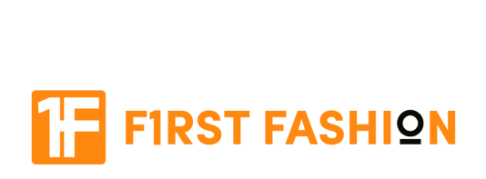

**LAKMÉ 9 TO 5 PRIMER + MATTE LIP COLOR**

With a smooth application and an intense colour payoff, the Lakmé 9to5 Primer + Matte Lip Colors come with a built-in primer that sets a flawless matte base and evens out your lips. Available in 35 highlight pigmented and work-ready shades that last up to 12 hours, touch-ups are now a thing of the past.

MRP inclusive of all taxes on all products  
Net Quantity:3.6 g

Expiry date: Feb, 2023

Commodity: Lip Color  
Company Name : Hindustan Unilever Limited  
Company Address : Hindustan Unilever Ltd, Unilever House, B D Sawant Marg, Chakala Andheri East - 400099  
Country of Origin : India

***Shipping:***

* Free Shipping over RS 1500 order in all over Pakistan
* Shipping will take average 3 to 5 days depending on your city

***Warranty:***

* All items can be exchanged within 30 days of the delivery date. Simply fill out the Customer Care form with your order ID within 3 days of delivery to start the exchange process.

