**Full stack development**

One leading gujarat news company wants to manage them internal portal for the gathering news from the local reporter of the state.

Admin:

* Only Admin can create a user. When he creates user credential go to user’s mail for the portal
* And when user login , OTP verification should be there through mail via mail
* User password store in the hash format only in email he can see his password but stored password in database should be in hashed format.
* Admin can approve the news h get.
* Admin also can edit delete and add news for the news.

Default Admin Screen when user login

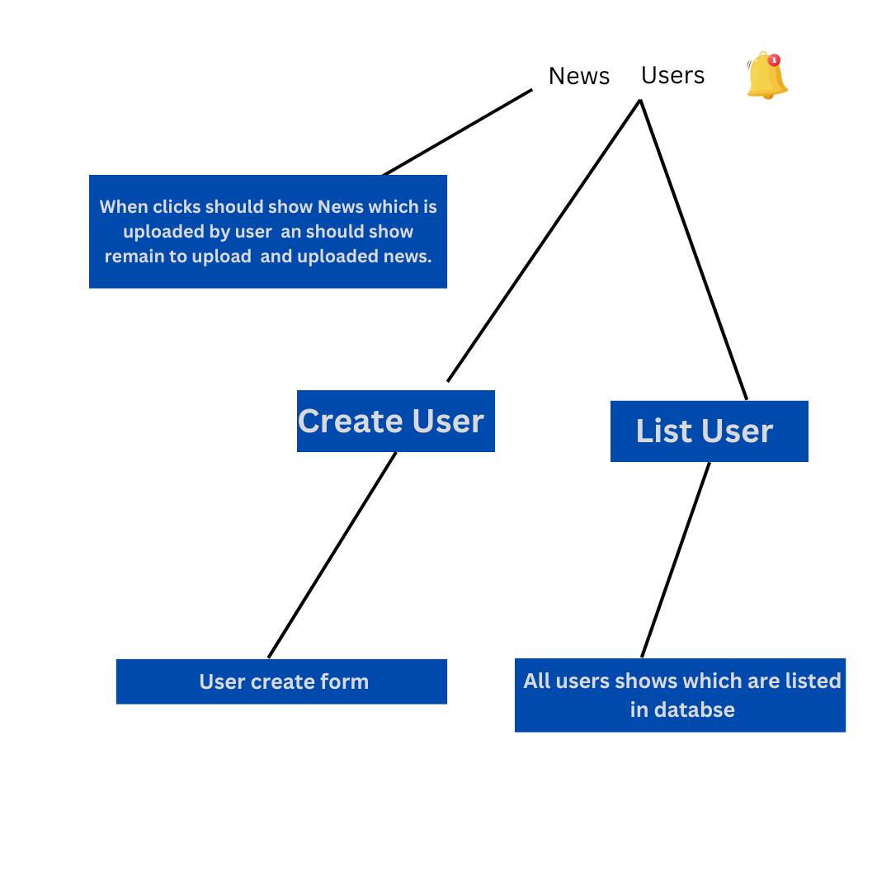

Admin News Screen:

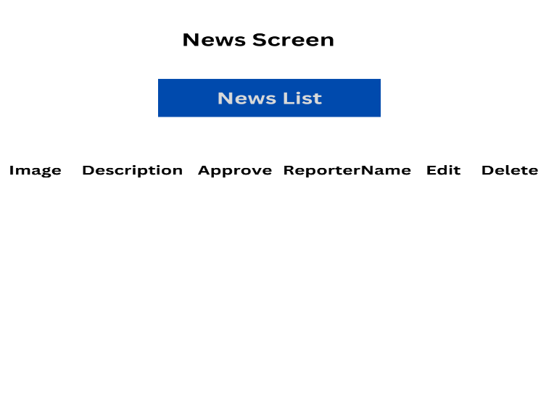

Admin can create User:

* User create form has below fields.

First Name: min: 3, max 20, required.

Middle Name: Min 3, max 20, required.

Last Name: min 3, max 20, required.

Email: email validation and required,

Register date: by default, today.

Created by: Admin name

City: cities of gujarat

Area: Area of that city

Profile picture: should upload on s3

User

* User can post short video or the image of the news with description of the particular image.
* Once user upload the news one notification should go to the admin via email or show in his dashboard that new approval request is pending for the news
* Once admin approve that request then user side news can be shown
* User can get list of all news with reporter name.
* User only can edit his own news.
* User can’t delete the things once he uploaded news.
* Also, can see his uploaded news on the different tab.
* User can see news with

User Screen 1:

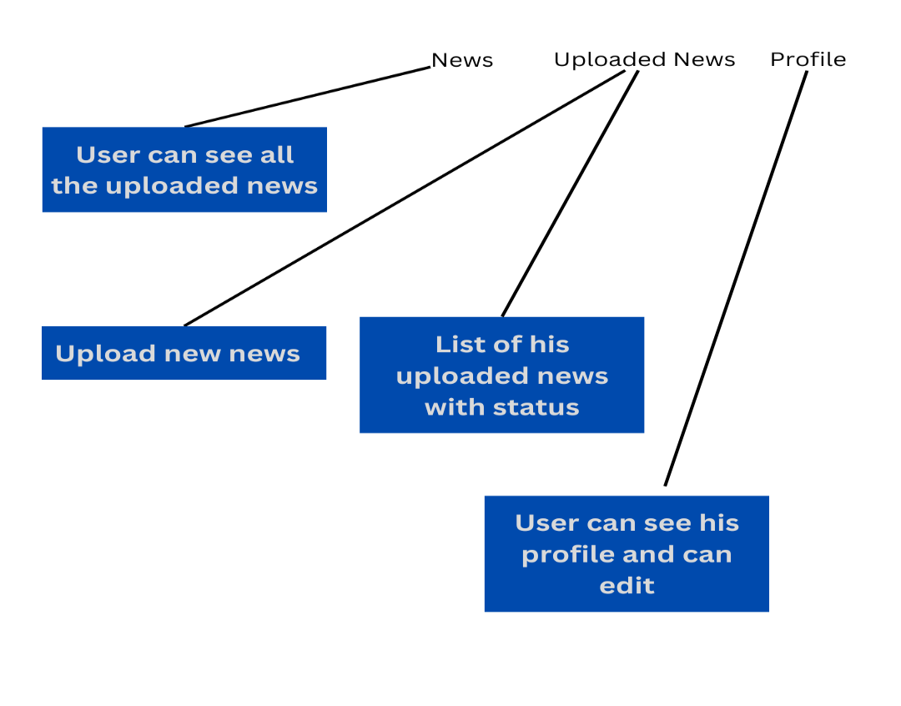

New news Update form:

Reporter Name: Can get from his login.

News Photo/Video: Should upload in the s3 and

Description: Text area and login

Date and time of news Event: by default, today.

Type Of New: Breaking, Normal, Important

Note* Breaking news are only that news which are created in last 2 hour.

* When user see breaking news then it’s background colour should be red
* When user find Important news then it’s background colour should be green
* For Normal news background colour should be yellow.