RETAIL ANALYTICS DIVISION

Customer Shopping Behavior
An End-to-End Data Analytics Report

Prepared using Python, MySQL & Power BI
Data Analytics Team
July 2026

Table of Contents
1. Executive Summary 3
2. Business Objectives 3
3. Data & Methodology 4
3.1 Data Source 4
3.2 Analytics Pipeline 4
3.3 Data Cleaning & Preparation 5
3.4 Tools Used 5
4. Revenue & Demographic Analysis 6
4.1 Revenue by Product Category 6
4.2 Revenue by Gender 6
4.3 Revenue by Age Group 6
5. Customer Loyalty & Segmentation 8
5.1 Subscribers vs. Non-Subscribers 8
5.2 Repeat Buyers and Subscription Likelihood 8
5.3 Customer Segmentation 9
6. Product Performance 11
6.1 Highest-Rated Products 11
6.2 Top 3 Products per Category 11
6.3 Discount Penetration by Product 12
6.4 Discount Impact on Spend 12
7. Operational & Seasonal Patterns 13
7.1 Shipping Method and Order Value 13
7.2 Seasonal Revenue 13
7.3 Geographic & Payment Distribution 13
8. Power BI Dashboard 14
9. Recommendations 14
10. Conclusion 14
Appendix A — Business Questions Answered 16
Appendix B — Data Dictionary (Key Fields) 16
Appendix C — Python Data Cleaning & Feature Engineering 17
Appendix D — SQL Analysis Queries 19

1. Executive Summary
This report presents an end-to-end analysis of customer shopping behavior across a sample of 3,900 transactions, covering demographics, product performance, pricing and promotions, shipping preferences, and customer loyalty. The analysis was built on a three-stage pipeline: data cleaning and feature engineering in Python (pandas), business-question querying in MySQL, and an interactive Power BI dashboard for ongoing monitoring.
The dataset represents $233,081 in total revenue across 3,900 customers, an average order value of $59.76, and an average product review rating of 3.75 out of 5. Clothing is the leading category by revenue, male customers drive roughly two-thirds of total spend, and only 27% of customers are enrolled in a subscription program despite subscribers and non-subscribers spending at a near-identical average order value — highlighting subscription growth as the single largest untapped lever in this dataset.
$233,081  TOTAL REVENUE | 3,900  TOTAL CUSTOMERS | $59.76  AVG. ORDER VALUE | 3.75 / 5  AVG. REVIEW RATING

43.0%  ORDERS DISCOUNTED | 27.0%  SUBSCRIBER RATE | 80.0%  LOYAL CUSTOMERS* | 4  PRODUCT CATEGORIES

*Loyal = customers with more than 10 previous purchases. See Section 5.3 for segmentation methodology.

2. Business Objectives
The analysis was scoped to answer ten core business questions defined ahead of the investigation, spanning four themes:
- Revenue drivers — which customers, products, and channels generate the most value.
- Pricing & promotions — how discounting behavior relates to spend and which products rely on it most.
- Customer loyalty — how repeat purchase behavior relates to subscription enrollment, and how to segment the base.
- Operational preferences — shipping method economics and seasonal / demographic demand patterns.
These questions directly inform decisions on marketing spend allocation, subscription program design, inventory planning by category, and discount strategy.

3. Data & Methodology

3.1 Data Source
The source dataset (customer_shopping_behavior.csv) contains 3,900 rows and 18 columns, with one row per transaction. Fields include customer demographics (age, gender, location), product attributes (item, category, size, color, season), transaction detail (purchase amount, discount applied, promo code used, payment method, shipping type), and behavioral history (previous purchases, purchase frequency, subscription status, review rating).

3.2 Analytics Pipeline
A three-stage pipeline was used, mirroring a typical production analytics workflow:
- Python / pandas — data profiling, null handling, column standardization, feature engineering, and load into MySQL via SQLAlchemy.
- MySQL — a dedicated customer_behaviour database was created to host the cleaned table (customer_shopping) and run the ten analytical business questions using aggregate, window, and CTE-based queries.
- Power BI — a connected dashboard (Customer_behaviour_Dashboard.pbix) was built on top of the same table for interactive, self-serve exploration by non-technical stakeholders.
The full Python cleaning script and all ten SQL analysis queries are reproduced in Appendix C and Appendix D for technical reference.

3.3 Data Cleaning & Preparation
The following preparation steps were applied before analysis:
- Missing values: 37 of 3,900 Review Rating values (0.9%) were missing. Rather than impute with a single global median, missing ratings were filled with the median rating within each product category, preserving category-level rating differences.
- Column standardization: column headers were lower-cased and reformatted to snake_case for consistent SQL compatibility (e.g. "Purchase Amount (USD)" → purchase_amount).
- Redundant field removal: promo_code_used was found to be identical to discount_applied in every row and was dropped to avoid duplicating the same signal.
- Feature engineering: an age_group field was derived using quartile binning (Young Adults, Adults, Middle Aged, Senior); a frequency_purchase_days field was derived by mapping each purchase-frequency label (e.g. "Weekly", "Quarterly") to an approximate number of days, to support future recency/frequency modeling.

3.4 Tools Used
Layer | Tool | Purpose
Data preparation | Python (pandas, SQLAlchemy) | Cleaning, feature engineering, load to database
Data storage & querying | MySQL | Structured querying against the ten business questions
Visualization | Power BI | Interactive dashboard for business stakeholders
Reporting | This document | Consolidated findings & recommendations

4. Revenue & Demographic Analysis

4.1 Revenue by Product Category
Clothing is the dominant category, generating $104,264 (44.7% of total revenue), followed by Accessories at $74,200 (31.8%). Footwear and Outerwear together account for the remaining 23.5%, suggesting inventory and marketing budgets remain reasonably weighted toward the top two categories.
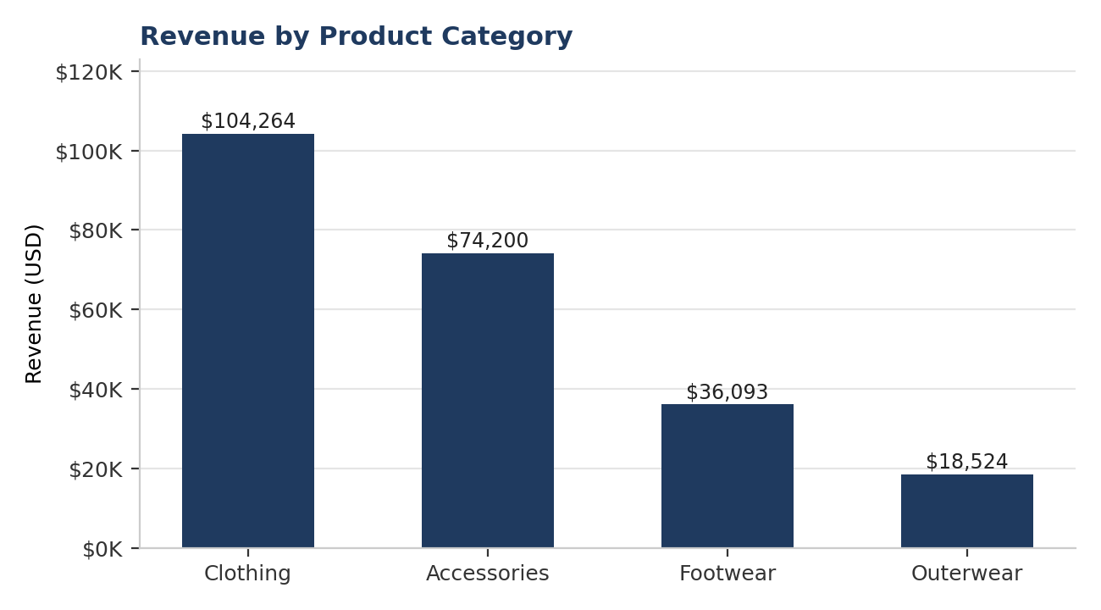
Figure 1. Total revenue by product category (USD).
▸ Insight: Clothing and Accessories together account for over three-quarters of all revenue — these two categories should anchor category-level promotional calendars.

4.2 Revenue by Gender
Male customers account for $157,890 in revenue (68%) versus $75,191 (32%) for female customers — a split that is more skewed than the underlying customer count (2,652 male vs. 1,248 female, a 68/32 split by headcount as well), meaning the gender revenue gap is driven primarily by the size of the customer base rather than a material difference in per-customer spend.
▸ Insight: Average order value is comparable across genders; the revenue imbalance is a customer-acquisition question, not a spend-per-customer question — female-customer acquisition is a clear growth opportunity.

4.3 Revenue by Age Group
Revenue is evenly distributed across the four age quartiles, with Young Adults contributing the most ($62,143) and Seniors the least ($55,763) — a spread of only about 10% between the highest and lowest group. Age is therefore not a strong differentiator of total spend in this dataset.
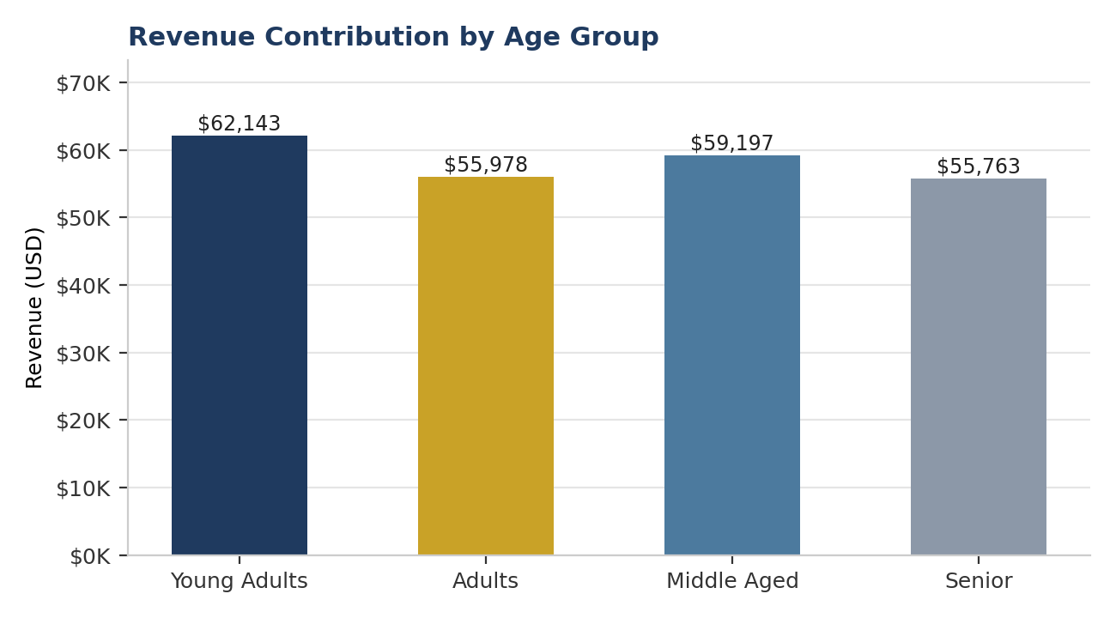
Figure 2. Revenue contribution by age group (quartile-based segmentation).

5. Customer Loyalty & Segmentation

5.1 Subscribers vs. Non-Subscribers
Only 1,053 of 3,900 customers (27.0%) are enrolled in the subscription program. Contrary to the common assumption that subscribers are higher-value customers, subscribers spend a near-identical average of $59.49 per order compared to $59.87 for non-subscribers — a difference of less than 1%.
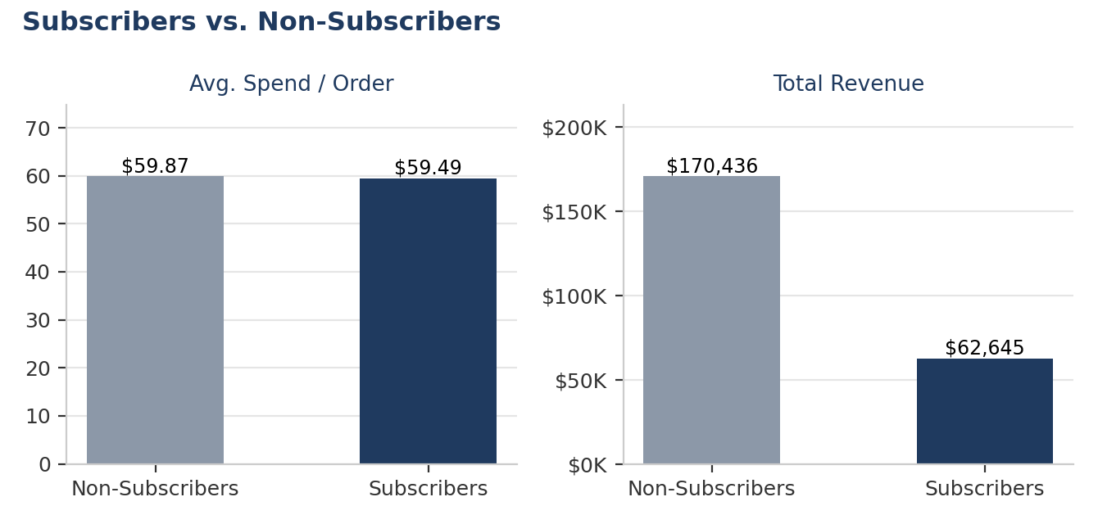
Figure 3. Average order value and total revenue: subscribers vs. non-subscribers.
▸ Insight: Subscription status does not currently correlate with higher spend per order. The subscription program's value today is in retention and predictable revenue, not basket size — messaging and incentives should be recalibrated around that framing.

5.2 Repeat Buyers and Subscription Likelihood
Among the 3,476 customers with more than 5 previous purchases, only 27.6% are currently subscribed, while 72.4% remain non-subscribers. This is nearly identical to the subscription rate across the full customer base (27.0%), indicating that purchase frequency alone is not currently driving customers into the subscription funnel.
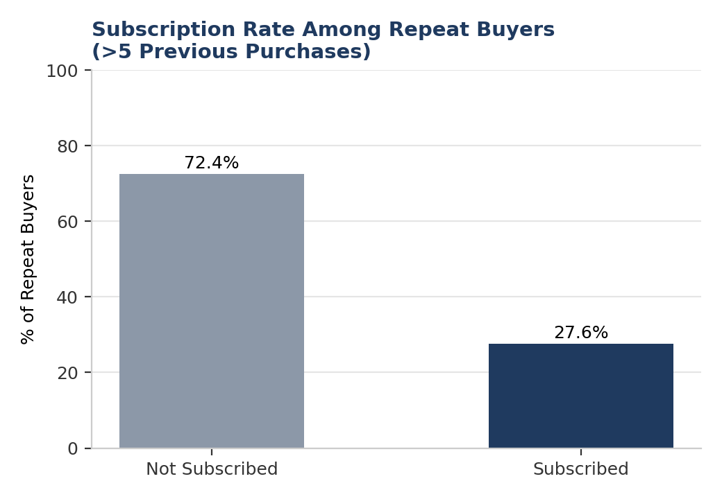
Figure 4. Subscription rate among customers with more than 5 previous purchases.
▸ Insight: A large pool of proven repeat buyers (over 2,500 customers) are not subscribed — this is the highest-propensity segment for a targeted subscription conversion campaign.

5.3 Customer Segmentation
Customers were segmented by total previous purchases into three tiers: New (0–2 prior purchases), Returning (3–10), and Loyal (11+). The base skews heavily toward Loyal customers (3,116, or 79.9%), with far fewer Returning (629, 16.1%) and New (155, 4.0%) customers.
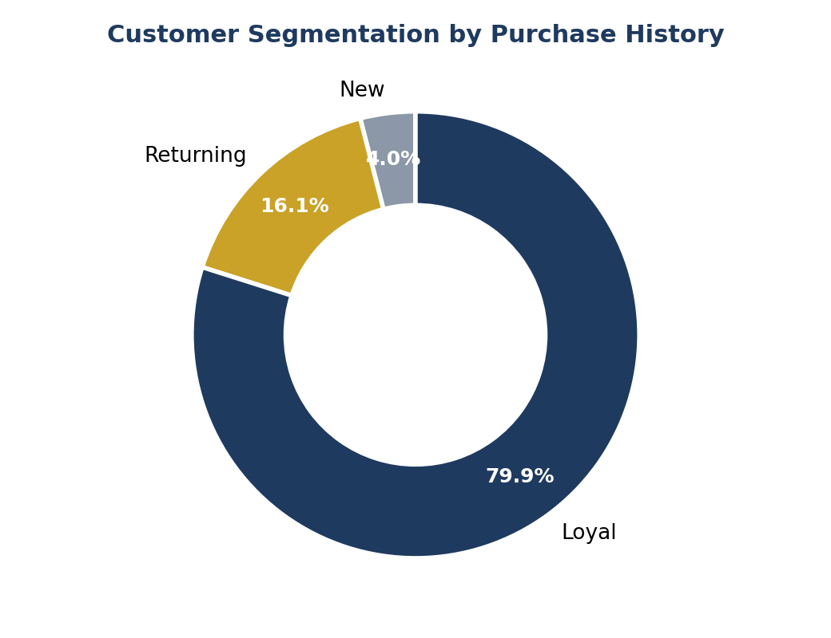
Figure 5. Customer distribution by loyalty segment.
▸ Insight: The customer base is mature and loyalty-heavy. New-customer acquisition volume appears comparatively low and should be reviewed against the same window used to define "previous purchases."

6. Product Performance

6.1 Highest-Rated Products
Gloves (3.86), Sandals (3.84), Boots (3.82), Hat (3.80), and Skirt (3.78) received the highest average review ratings, all modestly above the overall average of 3.75.
Rank | Product | Avg. Review Rating
1 | Gloves | 3.86
2 | Sandals | 3.84
3 | Boots | 3.82
4 | Hat | 3.80
5 | Skirt | 3.78

6.2 Top 3 Products per Category (by Order Volume)
Category | Rank 1 | Rank 2 | Rank 3
Accessories | Jewelry (171) | Belt (161) | Sunglasses (161)
Clothing | Blouse (171) | Pants (171) | Shirt (169)
Footwear | Sandals (160) | Shoes (150) | Sneakers (145)
Outerwear | Jacket (163) | Coat (161) | —

Order volumes are tightly clustered within each category (typically within 10–15 orders of one another), indicating broad-based demand across the assortment rather than dependence on one or two hero SKUs.

6.3 Discount Penetration by Product
Hat (50.0%), Sneakers (49.7%), Coat (49.1%), Sweater (48.2%), and Pants (47.4%) have the highest share of orders sold with a discount applied — all close to half of all transactions for those items.
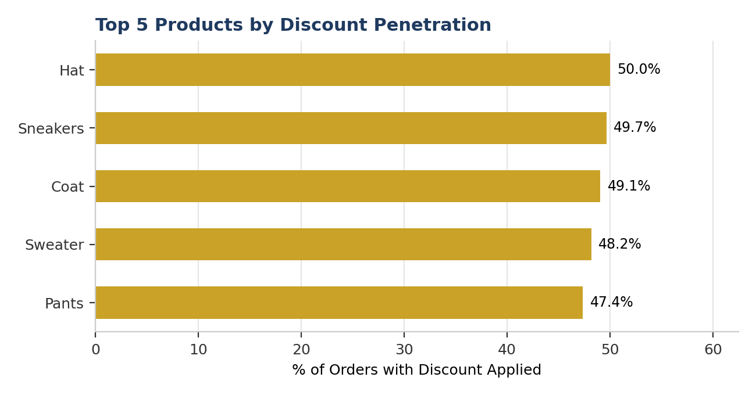
Figure 6. Top 5 products by percentage of orders with a discount applied.
▸ Insight: Discount reliance is concentrated in a specific set of products rather than spread evenly across the catalog — these items warrant a margin review to confirm discounting is driving incremental volume rather than eroding margin on units that would sell regardless.

6.4 Discount Impact on Spend
Of the 1,677 discounted orders (43.0% of all orders), 839 (50.0%) were still above the overall average order value of $59.76 — confirming that discounting is not confined to lower-value baskets and is used broadly across the price spectrum.

7. Operational & Seasonal Patterns

7.1 Shipping Method and Order Value
Average order value is remarkably consistent across shipping methods, ranging narrowly from $58.46 (Standard) to $60.73 (2-Day Shipping) — a spread of less than 4%. Customers do not appear to select premium shipping options based on basket size.
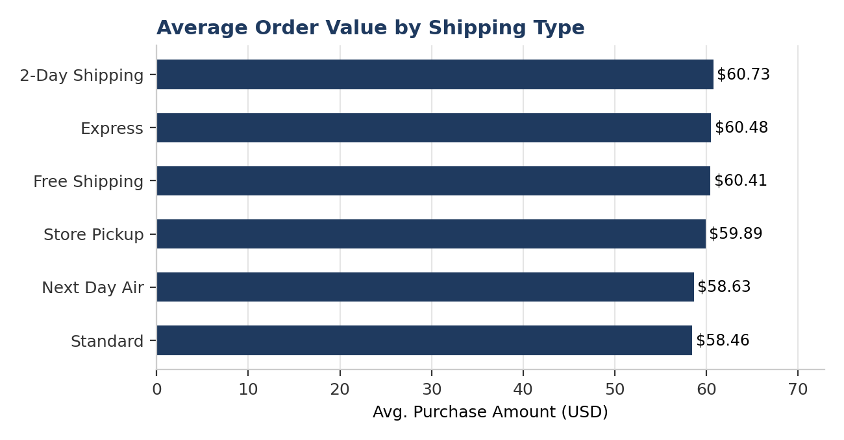
Figure 7. Average order value by shipping type.

7.2 Seasonal Revenue
Revenue is broadly balanced across seasons: Fall ($60,018), Spring ($58,679), Winter ($58,607), and Summer ($55,777, the lowest). The gap between the strongest and weakest season is under 8%, indicating limited seasonality in this dataset relative to typical apparel retail patterns.

7.3 Geographic & Payment Distribution
Revenue is well-distributed geographically, with the top five states by revenue — Montana ($5,784), Illinois ($5,617), California ($5,605), Idaho ($5,587), and Nevada ($5,514) — each contributing only 2–2.5% of total revenue, with no single market dominating. Payment method usage is similarly balanced across PayPal, Credit Card, Cash, Debit Card, Venmo, and Bank Transfer, each representing roughly 16–17% of transactions.

8. Power BI Dashboard
A companion Power BI dashboard (Customer_behaviour_Dashboard.pbix) was built on the cleaned customer_shopping table to give business stakeholders a self-serve, interactive view of the metrics covered in this report. The dashboard is designed to be filtered live by category, gender, age group, and season, and is intended to be refreshed on a recurring schedule as new transactions are loaded into the underlying MySQL database.
Recommended dashboard pages: (1) Executive Overview — the KPI set in Section 1; (2) Product Performance — category and item-level revenue, ratings, and discount penetration; (3) Customer Loyalty — subscription and segmentation views from Section 5; (4) Operations — shipping and seasonal trends from Section 7.

9. Recommendations
9.1 Convert proven repeat buyers into subscribers
Over 2,500 customers with more than 5 previous purchases remain unsubscribed. A targeted campaign (e.g., a limited-time subscriber discount or free premium shipping) aimed specifically at this segment is likely to convert at a materially higher rate than a blanket campaign.
9.2 Re-evaluate the subscription value proposition
Since subscribers do not currently spend more per order, the subscription program should be repositioned and measured around retention, purchase frequency, and lifetime value rather than basket size.
9.3 Audit discount economics on high-penetration products
Hat, Sneakers, Coat, Sweater, and Pants are discounted in roughly half of all transactions. A controlled test (e.g., holding out a small population from discount eligibility) would clarify whether the discount is driving incremental purchases or simply reducing margin on sales that would occur regardless.
9.4 Prioritize acquisition of female customers
Female customers spend at a comparable average order value to male customers but represent a smaller share of the base (32%). Acquisition marketing aimed at closing this gap has a clear, quantifiable revenue upside.
9.5 Treat shipping tier as a service decision, not a revenue lever
Because order value does not vary meaningfully by shipping method, shipping options should be optimized purely for cost-to-serve and customer satisfaction rather than expected to influence basket size.

10. Conclusion
This analysis shows a mature, loyalty-heavy customer base generating balanced revenue across categories, demographics, seasons, and geographies — with no single dimension dominating performance. The most actionable finding is the disconnect between purchase frequency and subscription enrollment: a large, already-loyal customer segment represents the clearest, lowest-risk opportunity to grow recurring revenue. The accompanying Power BI dashboard should be adopted as the ongoing monitoring tool to track progress against the recommendations above.

Appendix A — Business Questions Answered
# | Business Question
Q1 | Which discounted orders exceeded the average purchase amount?
Q2 | What is total revenue by gender?
Q3 | Which are the top 5 products with the highest average review rating?
Q4 | Compare average purchase amount between shipping types.
Q5 | Do subscribed customers spend more than non-subscribers?
Q6 | Which 5 products have the highest percentage of discounted purchases?
Q7 | Segment customers into New, Returning, and Loyal tiers.
Q8 | What are the top 3 most purchased products within each category?
Q9 | Are repeat buyers (>5 previous purchases) more likely to subscribe?
Q10 | What is the revenue contribution of each age group?

Appendix B — Data Dictionary (Key Fields)
Field | Description
customer_id | Unique transaction / customer identifier
age / age_group | Customer age, and derived quartile-based age segment
category / item_purchased | Product category and specific item
purchase_amount | Transaction value in USD
discount_applied | Whether a discount was applied to the order
subscription_status | Whether the customer is enrolled in the subscription program
previous_purchases | Count of prior purchases by the customer
frequency_of_purchases / frequency_purchase_days | Stated purchase cadence, and derived day-count equivalent
review_rating | Customer product rating (1–5 scale)

Appendix C — Python Data Cleaning & Feature Engineering
The script below reflects the actual cleaning pipeline used on the raw dataset in Jupyter Notebook, from initial load through to loading the cleaned table into MySQL via SQLAlchemy.
1. Load the raw dataset
import pandas as pd

df = pd.read_csv("customer_shopping_behavior.csv")
df.shape # (3900, 18)
df.info()
df.describe()
df.isnull().sum()
2. Handle missing values (category-aware, not a blanket median)
# Review Rating is tied to product category, so impute using the
# median rating *within* each category rather than a single global median
df['Review Rating'] = (
df.groupby('Category')['Review Rating']
.transform(lambda x: x.fillna(x.median()))
)
3. Standardize column names for SQL compatibility
df.columns = df.columns.str.lower()
df.columns = df.columns.str.replace(' ', '_')
df = df.rename(columns={'purchase_amount_(usd)': 'purchase_amount'})
4. Feature engineering — age segments
labels = ['Young Adults', 'Adults', 'Middle Aged', 'Senior']
df['age_group'] = pd.qcut(df['age'], q=4, labels=labels)
5. Feature engineering — purchase frequency to day-count
frequency_mapping = {
'Fortnightly': 14,
'Weekly': 7,
'Monthly': 30,
'Bi-Weekly': 14,
'Quarterly': 90,
'Annually': 365,
'Every 3 Months': 90
}
df['frequency_purchase_days'] = df['frequency_of_purchases'].map(frequency_mapping)
6. Remove redundant columns
# discount_applied and promo_code_used are identical in every row
(df['discount_applied'] == df['promo_code_used']).all() # True
df = df.drop('promo_code_used', axis=1)
7. Load cleaned data into MySQL
from sqlalchemy import create_engine

engine = create_engine("mysql+pymysql://<user>:<password>@localhost/customer_behaviour")

df.to_sql(
name="customer_shopping",
con=engine,
if_exists="replace",
index=False
)

Appendix D — SQL Analysis Queries
The following queries were run against the customer_behaviour MySQL database to answer the ten business questions defined in Section 2, using aggregation, CASE logic, subqueries, CTEs, and window functions.
Q1 — Discounted orders above the average purchase amount
SELECT customer_id, purchase_amount, discount_applied
FROM customer_shopping
WHERE discount_applied = "Yes"
AND purchase_amount >= (
SELECT AVG(purchase_amount) FROM customer_shopping
);
Q2 — Total revenue by gender
SELECT gender, SUM(purchase_amount) AS revenue
FROM customer_shopping
GROUP BY gender;
Q3 — Top 5 products by average review rating
SELECT item_purchased, ROUND(AVG(review_rating), 2) AS avg_rating
FROM customer_shopping
GROUP BY item_purchased
ORDER BY avg_rating DESC
LIMIT 5;
Q4 — Average purchase amount by shipping type
SELECT shipping_type, ROUND(AVG(purchase_amount), 2) AS avg_purchase
FROM customer_shopping
GROUP BY shipping_type
ORDER BY avg_purchase DESC;
Q5 — Subscribers vs. non-subscribers: spend comparison
SELECT
subscription_status,
COUNT(customer_id) AS total_customers,
ROUND(AVG(purchase_amount),2) AS avg_purchase,
SUM(purchase_amount) AS total_purchase
FROM customer_shopping
GROUP BY subscription_status;
Q6 — Top 5 products by % of orders discounted
SELECT
item_purchased,
ROUND(
SUM(CASE WHEN discount_applied = "Yes" THEN 1 ELSE 0 END)
/ COUNT(*) * 100, 2
) AS discount_percentage
FROM customer_shopping
GROUP BY item_purchased
ORDER BY discount_percentage DESC
LIMIT 5;
Q7 — Customer segmentation (New / Returning / Loyal)
WITH customer_type AS (
SELECT
customer_id,
previous_purchases,
CASE
WHEN previous_purchases <= 2 THEN 'New'
WHEN previous_purchases BETWEEN 3 AND 10 THEN 'Returning'
ELSE 'Loyal'
END AS customer_segment
FROM customer_shopping
)
SELECT customer_segment, COUNT(*) AS number_of_customers
FROM customer_type
GROUP BY customer_segment;
Q8 — Top 3 most purchased products within each category
WITH item_counts AS (
SELECT
category,
item_purchased,
COUNT(customer_id) AS total_orders,
ROW_NUMBER() OVER (
PARTITION BY category
ORDER BY COUNT(customer_id) DESC
) AS item_rank
FROM customer_shopping
GROUP BY category, item_purchased
)
SELECT item_rank, category, item_purchased, total_orders
FROM item_counts
WHERE item_rank <= 3;
Q9 — Repeat buyers (>5 previous purchases): subscription likelihood
SELECT subscription_status, COUNT(customer_id) AS repeat_buyers
FROM customer_shopping
WHERE previous_purchases > 5
GROUP BY subscription_status;
Q10 — Revenue contribution by age group
SELECT age_group, SUM(purchase_amount) AS total_revenue
FROM customer_shopping
GROUP BY age_group
ORDER BY total_revenue DESC;

