**Display Formula Student.**

Website from dash used in 2014 : <https://jgtao.me/content/10-10-14/>

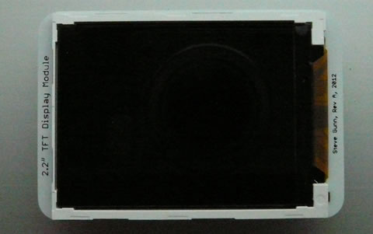Possible to use the 2.2 inch display seen below made by Professor Steve Gunn and can be used in tandem with any of the Micro Arcana Series of boards.

We have spoken to Professor Steve Gunn and he has given us permission to use the display and has said he can find the components we need.

Link to documents for Display: <https://secure.ecs.soton.ac.uk/notes/ellabs/1/x2r/>

There are two versions of the Display and they only differ with different control chips.

Display type A: SDT022ATFT has the control chip ILI9340 link - <https://secure.ecs.soton.ac.uk/notes/ellabs/1/x2r/ILI9340.pdf>

Display type B: DT022BTFT has the control chip ILI9341 link - <https://secure.ecs.soton.ac.uk/notes/ellabs/1/x2r/ILI9341.pdf>

For display B some simple specifications:

Response time = 20-30ms

Resolution 320x240 pixels – Quarter VGA

Transmissive display mode has 4 LED backlights, Supports 262k Colours

Dimensions – 40.30mm W x 55.23mm (H) x 2.45mm(D)  
Operating temp -20 to 70 C

Input voltage of 3.3V

The chip of ILI9341 Should have a significantly fast data transfer speed to do Realtime updates for the Dash. No specific refresh rate on the datasheet for the dash.

Additional link for other screen by same company <https://www.seacomp.com/product/2-2-inch-tft-lcd-dt022ctft>

I think the typical refresh rate is anywhere from 30-60hz and can be configured but I need more time to confirm this. Must be configured correctly.

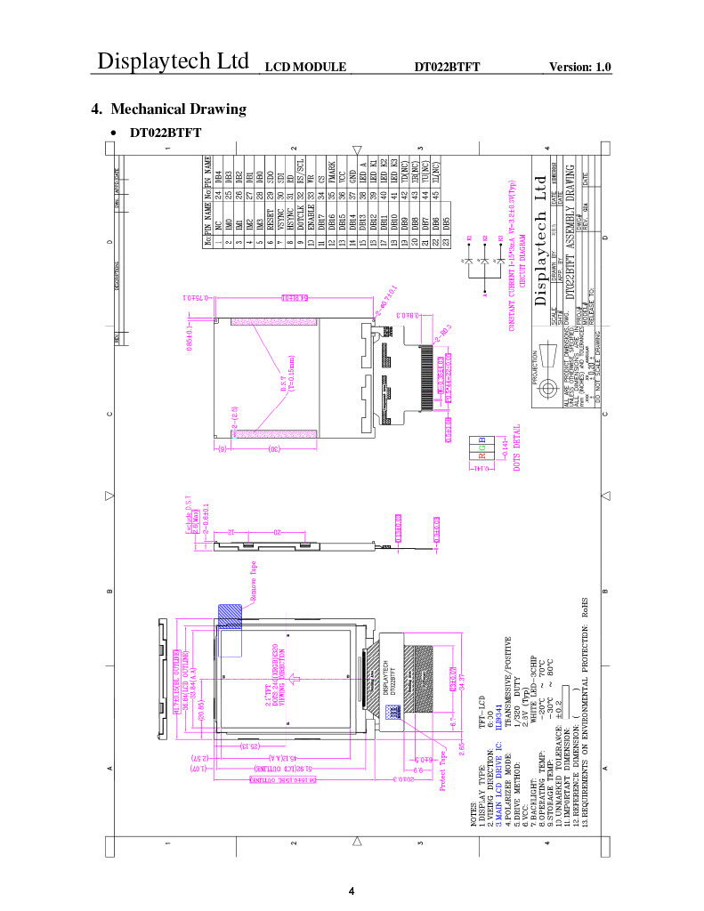Drawing of B

# Good boards we could use

<https://www.adafruit.com/product/2719>

• 128x64 OLED pixel display, monochrome

• Has commands to configure automatic pointer moving, which allows pixels to be filled up to x2 faster

• In SPI mode it only supports writing, but that is fine. It uses 4 lines: clock, data in, chip select and command/data signal.