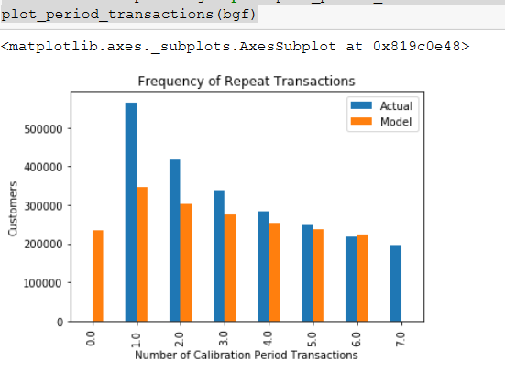

penalizer_coef=0.00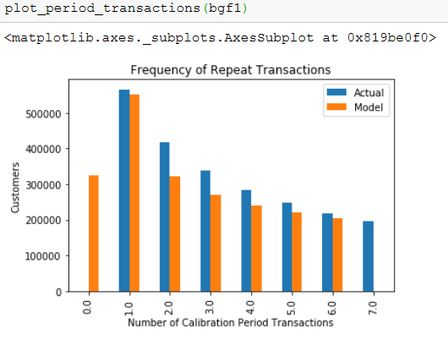

penalizer_coef=0.05 (look like better)