Yue:

I simplified the steps from Senthill instruction. You miht follow the following steps to set up SAS Studio or SAS Enterprise

1. Please [sign in SAS OnDemand for Academics](https://welcome.oda.sas.com/login) > Don't have a SAS Profile
2. Use infosys email to Create profile > Check your email to activate your account
3. Use your email and password to [sign in SAS OnDemand for Academics](https://welcome.oda.sas.com/login) > Select your Home region > Check your email
4. [sign in SAS OnDemand for Academics](https://welcome.oda.sas.com/login) > select SAS Studio or SAS Enterprise

Access SAS Studio or SAS Enterprise from Senthill

1. Go to the SAS website, select country.

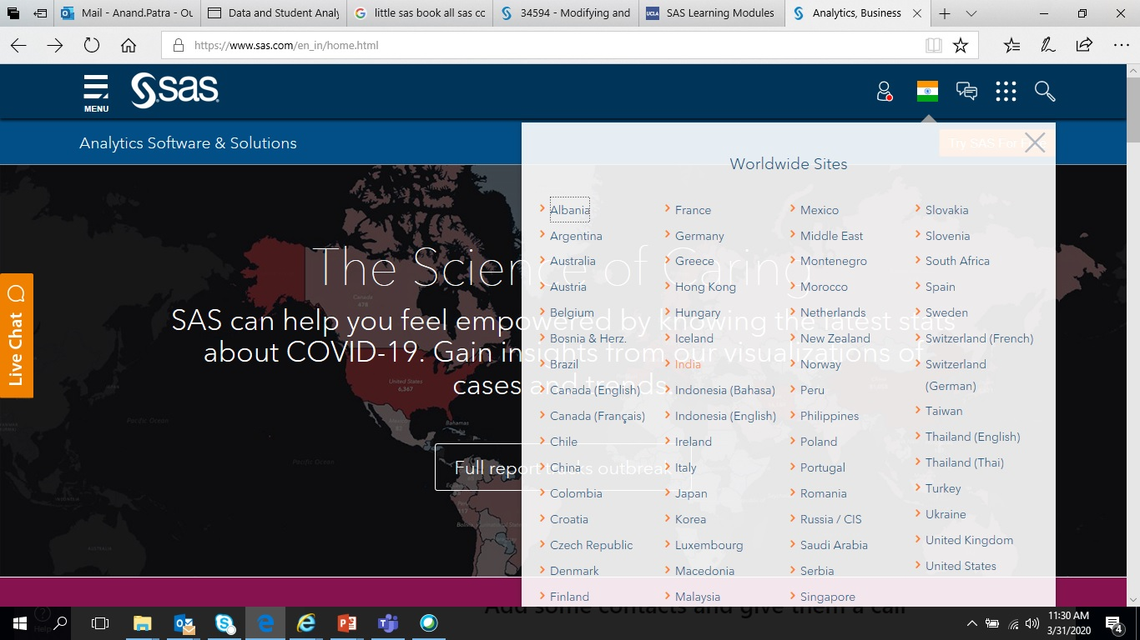

1. Create a SAS profile

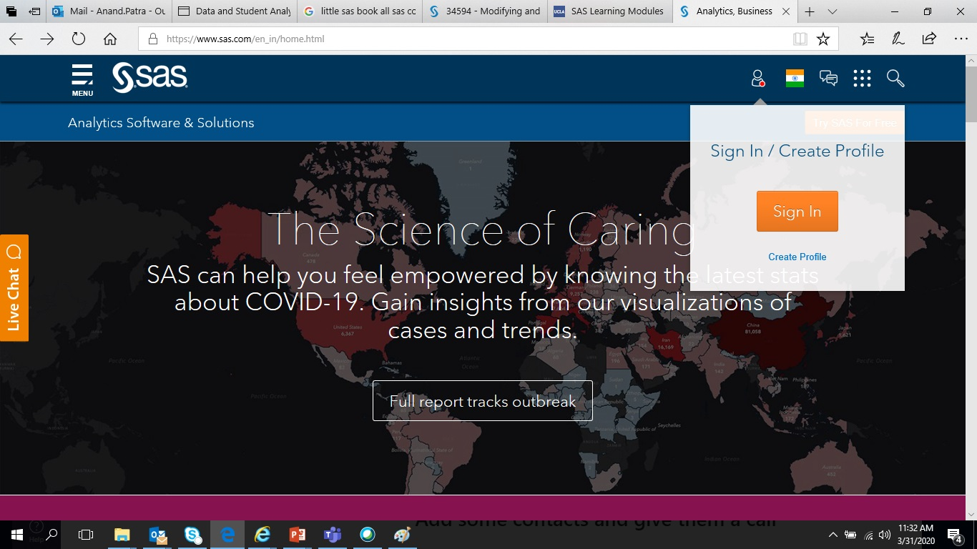

1. Use Infy email id for profile/id creation

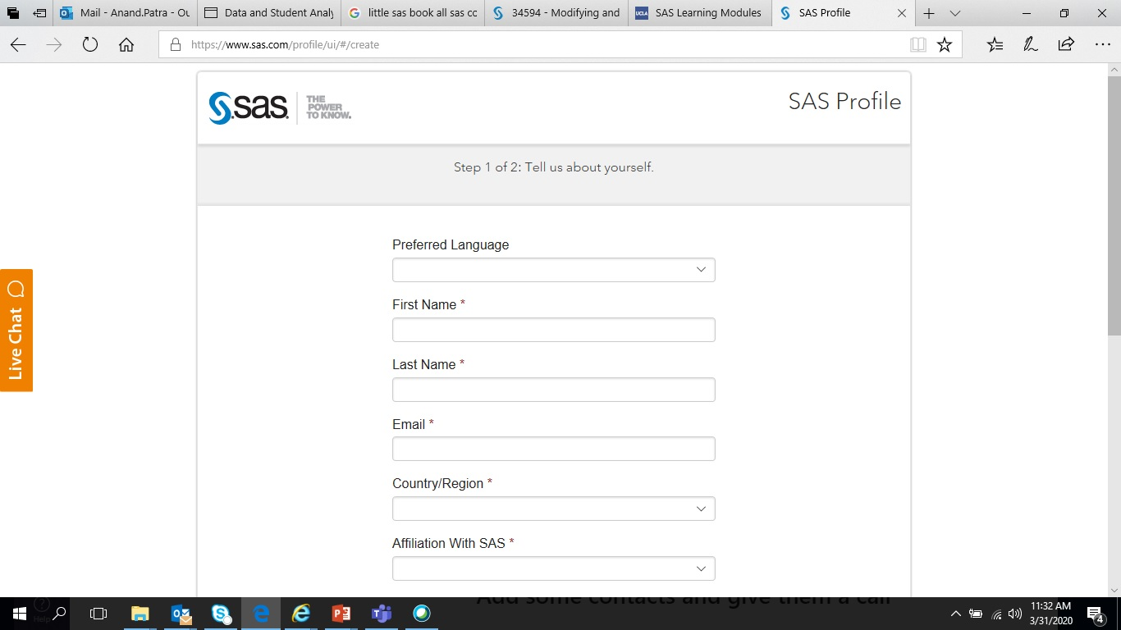

1. Sign in using the newly created SAS login ID

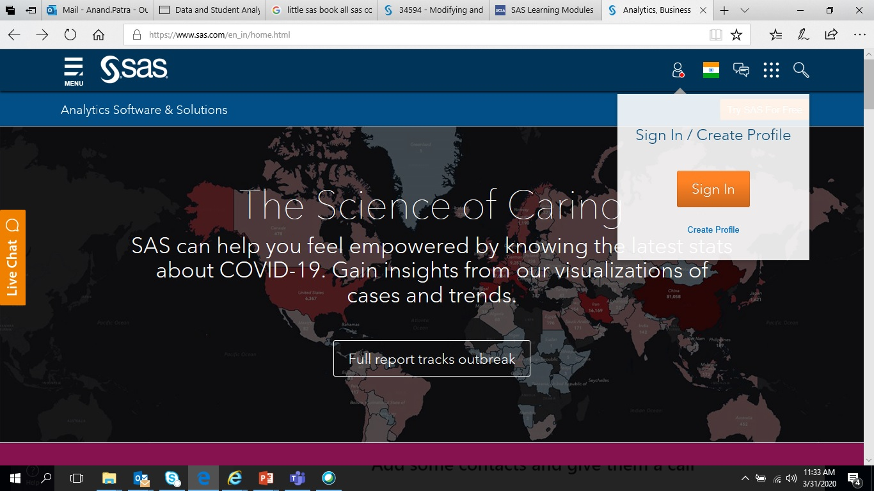

5.

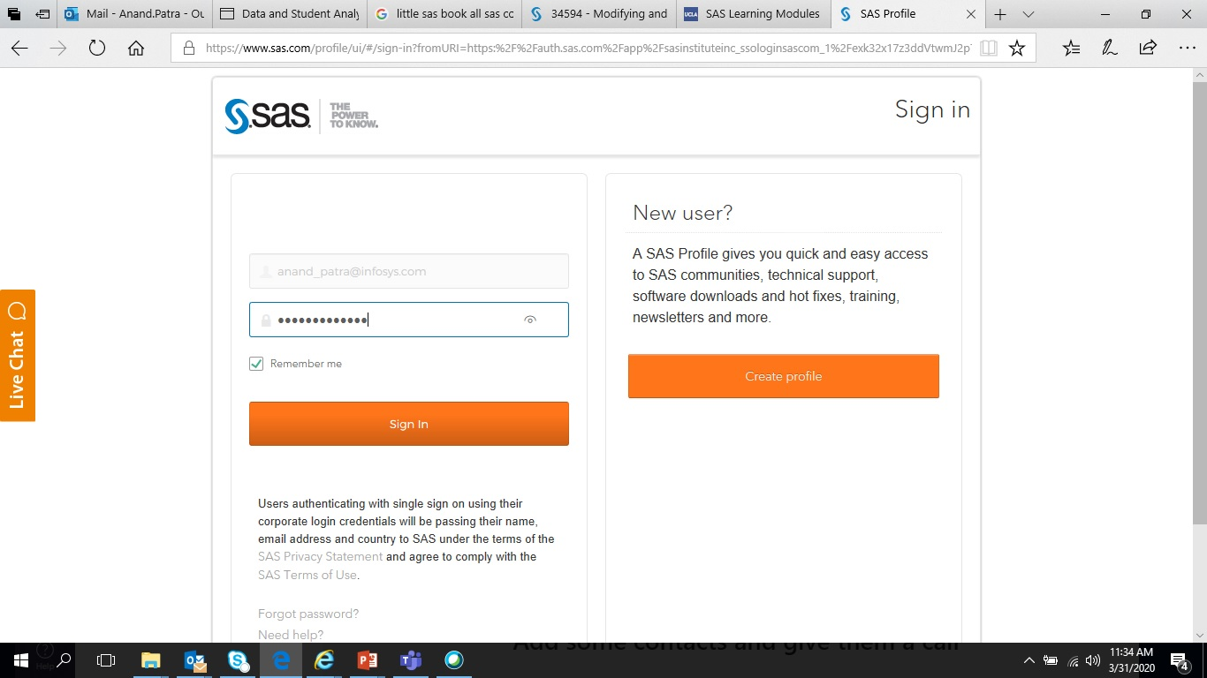

6. Go to Free Academic Software under the Academics list

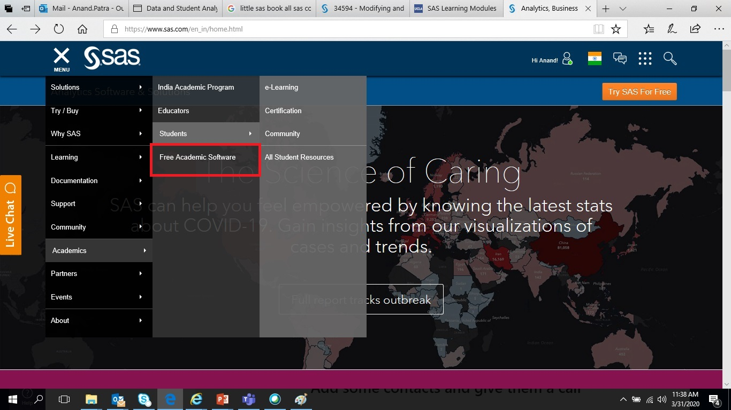

7. Go to SAS OnDemand for Academics

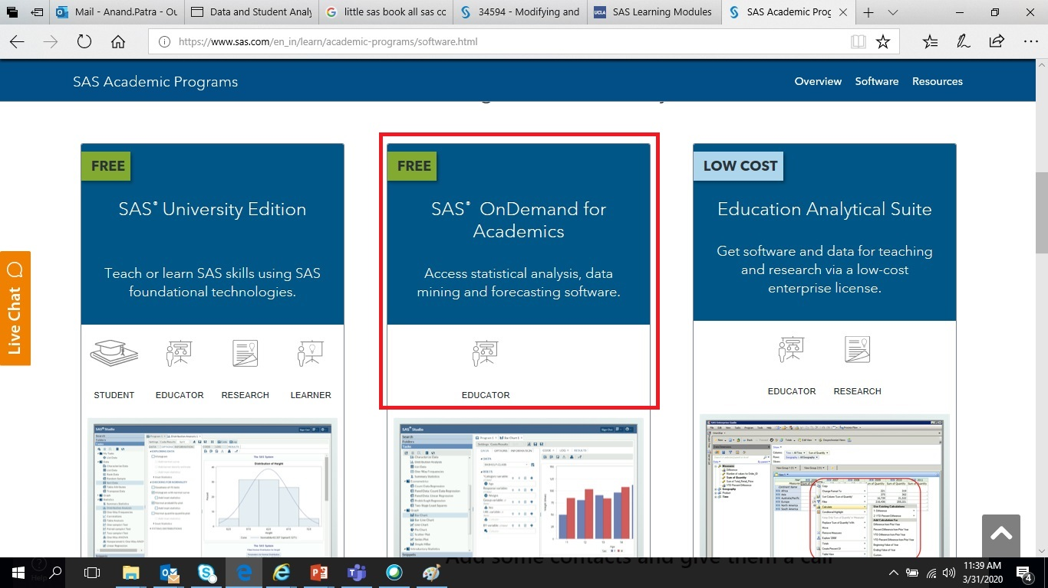

8. Go to Access Now

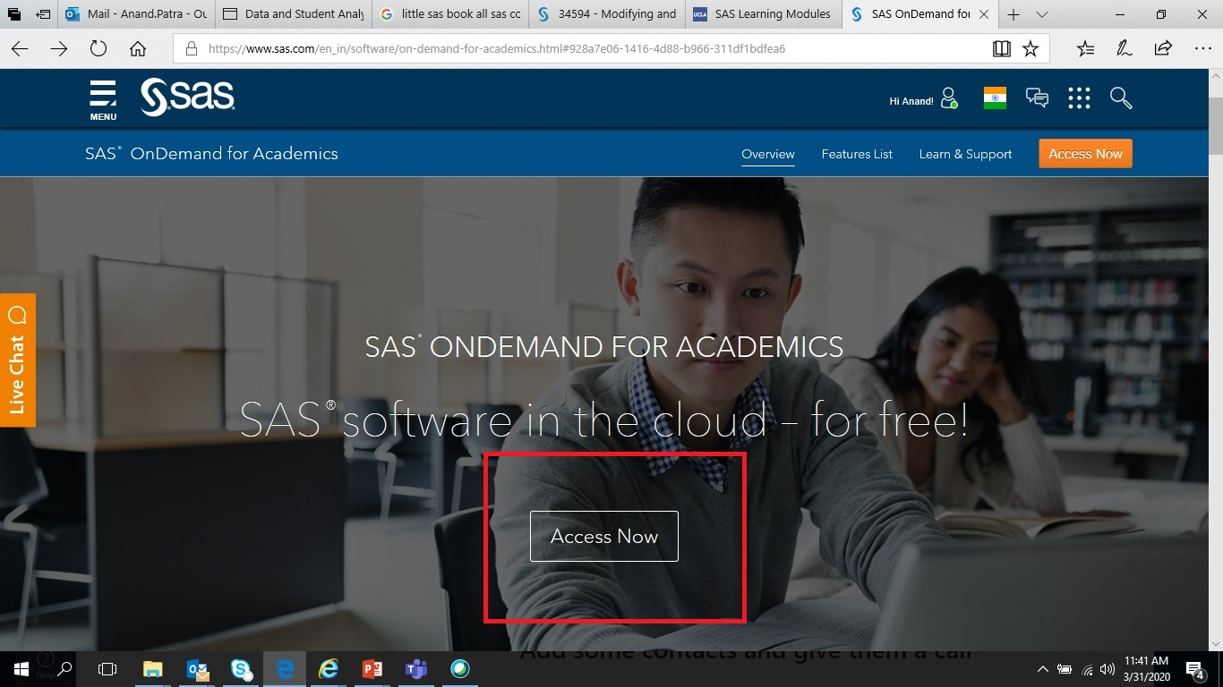

9. Go to Registration Application

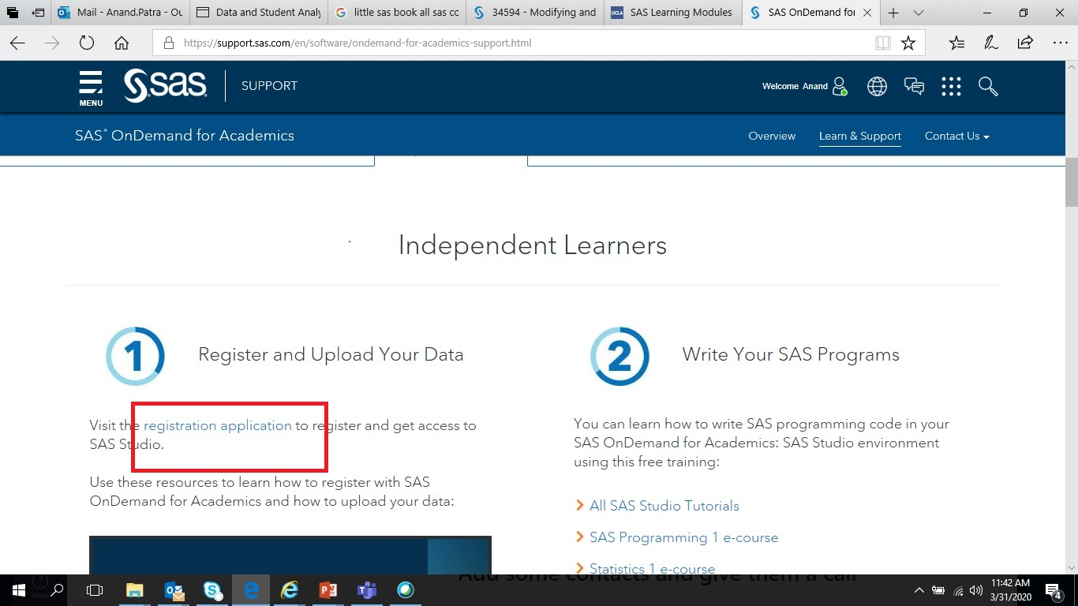

10.

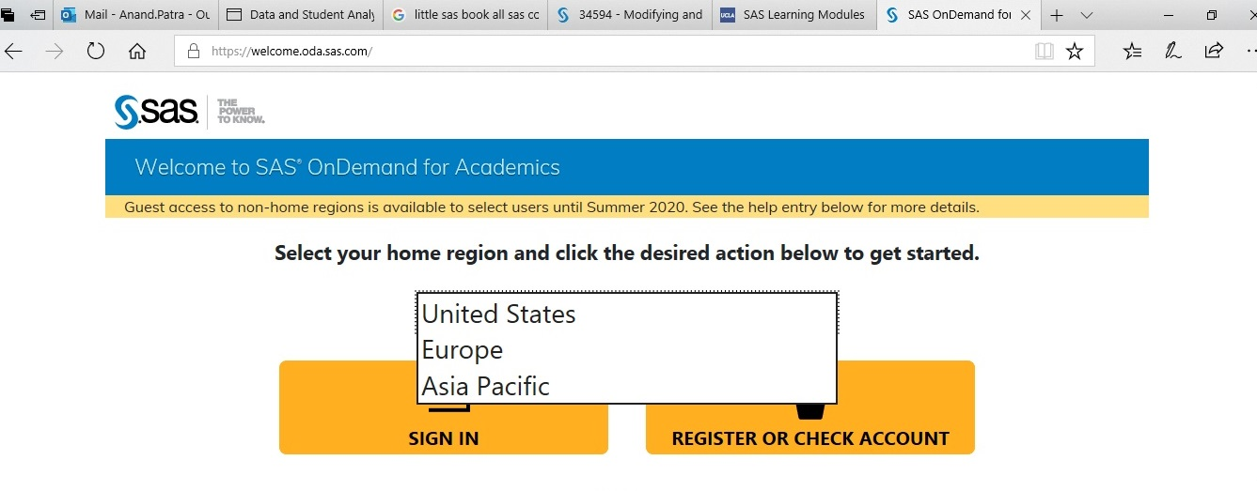

11. Login using previous webpage after conforming your email address

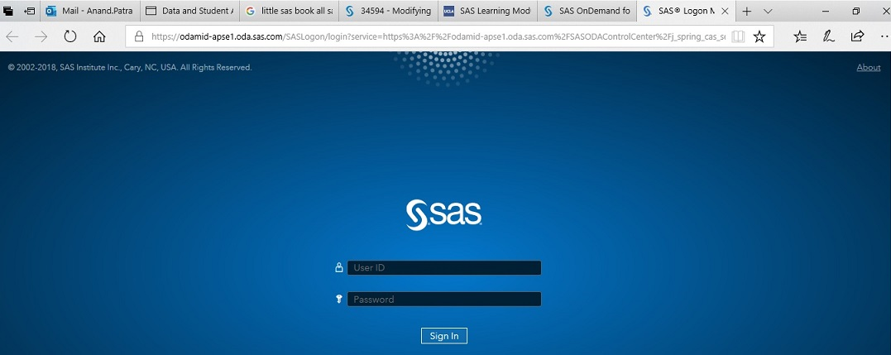

12. Follow tutorial on uploading data (this is on the same webpage depicting Step 9)

