**Roll No: 2003085**

**Lab Final [2]**

**Lab Task Q[1]**

**Question:**

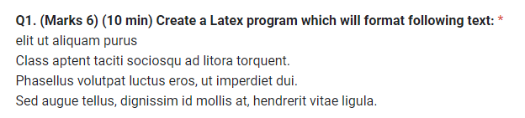

**Solution (Latex Code):**

|  |
| --- |
| %--- Roll - 2003085 --------  %LE_Q1  \documentclass{article}  \begin{document}  \flushleft  \textbf{elit ut aliquam purus}  \begin{itemize}  \item Class aptent taciti sociosqu ad litora torquent.  \item Phasellus volutpat luctus eros, ut imperdiet dui.  \item Sed augue tellus, dignissim id mollis at, hendrerit vitae ligula.  \end{itemize}  \end{document} |

**Output (Screen/SnapShot of Generated PDF):**

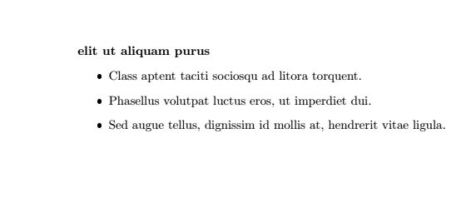

**Question: 2**

**Solution (Latex Code):**

|  |
| --- |
| %--- Roll - 2003085 --------  %LE_Q2  \documentclass{article}  \usepackage{tabularx}  \begin{document}      \begin{table}[!hbt]          \begin{tabular}{|c|c|}              \hline Dummy Text & Dummy Text \\              \hline Dummy Text & {                  \begin{tabularx}{|c|c|}                      Dummy Text & Dummy Text\\                  \end{tabularx}}              \hline              \hline Dummy Text & {                  \begin{tabularx}{|c|c|}                      Dummy Text & Dummy Text\\                  \end{tabularx}              }              \hline              \hline Dummy Text & {                  \begin{tabularx}{|c|c|}                      Dummy Text & Dummy Text\\                  \end{tabularx}}              \hline          \end{tabular}      \end{table}  \end{document} |

**Output (Screen/SnapShot of Generated PDF):**

**Question: 3**

**Solution (Latex Code):**

|  |
| --- |
| \documentclass{beamer}  \usetheme{JuanLesPins}  \usepackage[sort]{natbib}  \usepackage{tabularx}  \begin{document}    \begin{frame}{1 Introduction to LATEX}      \begin{itemize}          \item 1 Introduction to LATEX          \item Definition of LATEX          \item Resources on LATEX      \end{itemize}  \end{frame}  \end{document} |

**Output (Screen/SnapShot of Generated PDF):**

**Question: 4**



**Solution (Latex Code):**

|  |
| --- |
| \documentclass{beamer}  \usepackage{graphicx}  % Theme  \usetheme{Madrid}  %Package  \usepackage[linesnumbered,ruled,vlined]{algorithm2e}  \usepackage{tikz}  % Begin document  \begin{document}  % Outline slide  \begin{frame}{Outline}    \tableofcontents  \end{frame}  % Welcome slide  \section{Answer the Question no 1}  \begin{frame}[fragile]  \frametitle{ Answer the Question no 1}  \flushleft  \textbf{**elit ut aliquam purus**}  \begin{itemize}      \item Class aptent taciti sociosqu ad litora torquent.      \item Phasellus volutpat luctus eros, ut imperdiet dui.      \item Sed augue tellus, dignissim id mollis at, hendrerit vitae ligula.  \end{itemize}  \end{frame}  \section{Answer the Question no 1}  \begin{frame}[fragile]  \frametitle{ Answer the Question no 1}  \flushleft  \textbf{**elit ut aliquam purus**}  \begin{itemize}      \item Class aptent taciti sociosqu ad litora torquent.      \item Phasellus volutpat luctus eros, ut imperdiet dui.      \item Sed augue tellus, dignissim id mollis at, hendrerit vitae ligula.  \end{itemize}  \end{frame}  \section{Answer the Question no 2}  \begin{frame}[fragile]  \frametitle{ Answer the Question no 2}  \begin{table}[!hbt]      \begin{tabular}{|c|c|}          \hline Dummy Text & Dummy Text \\          \hline Dummy Text & {              \begin{tabularx}{|c|c|}                  Dummy Text & Dummy Text\\              \end{tabularx}}          \hline          \hline Dummy Text & {              \begin{tabularx}{|c|c|}                  Dummy Text & Dummy Text\\              \end{tabularx}          }          \hline          \hline Dummy Text & {              \begin{tabularx}{|c|c|}                  Dummy Text & Dummy Text\\              \end{tabularx}}          \hline      \end{tabular}  \end{table}  \end{frame}  \section{Answer the Question no 3}  \begin{frame}[fragile]  \frametitle{ Answer the Question no 3}  \begin{itemize}      \item 1 Introduction to LATEX      \item Definition of LATEX      \item Resources on LATEX  \end{itemize}  \end{frame}  \end{document} |

**Output (Screen/SnapShot of Generated PDF):**