 | Assignment No. 3  Semester: Spring 2019  CS201 – Introduction to Programming |  | Total Marks: 20  Due Date: 11/07/2019
Instructions
Please read the following instructions carefully before submitting assignment:
It should be clear that your assignment will not get any credit if:

- Assignment is submitted after due date.
- Submitted assignment does not open or file is corrupt.
- Assignment is copied (From internet/students).

Recommended software for assignment development:
- Dev C++

Objectives:
To enable students to understand and practice the concepts of:
- Variables and operators
- Loops / Repetition Structures
- Switch Statement
- Functions
- String Manipulation Functions
- Structures

Assignment Submission Instructions
You have to submit only .cpp file on the Assignments interface of CS201 at VULMS. Assignment submitted in any other format will not be accepted and will be graded with zero marks.

Assignment

Problem:
Structures are used to overcome the shortcomings of arrays. Basically arrays are used to store more than one data values of a single datatype.
Ex : int a[100] stores integer datatype values
Whereas if you want to make students result database including student_id (int), student_name (char), marks (float) of more than one student, you cannot use array. Here comes the use of structures. Structures are user defined datatypes which allows you to store data of different types.
Example:
struct Student
{
int student_id;
char student_name[50];
float marks;
}s[10];

Assignment Statement:
Write a menu based system in C++ for “Library Book Record System” that will take input from user for the following menu. You will create a structure and perform the following operations on the structure.
Press 1 To Enter a Book Record.
Press 2 To Display all Records of Books Available in Library.
Press 3 To Search Books by Author Name.
Press 4 To Count Total Books in Library.
Press 5 To Exit from the System.

*System will take following inputs from user to enter a book record:
- Book ID
- Book Title
- Author of Book
- Cost of Book

Solution Instructions:
➔ Use switch statement for the menu based system.
➔You can use user defined functions for each of the task mentioned above to manage your code.

To Enter a Book Record | Add_Book();
To Display all Records of Books Available in Library | Display_Books();
To Search Books by Author Name | Book_Author();
Count Total Books in Library | Count_Books();

*Note:
- Restrict your system that it do not allow to add more than 5 books and on try of adding books more than limit show message i.e. “No more space in System for another book”.
- Use strcmp function to search books by author name in Book_Author(); function.

Sample output:
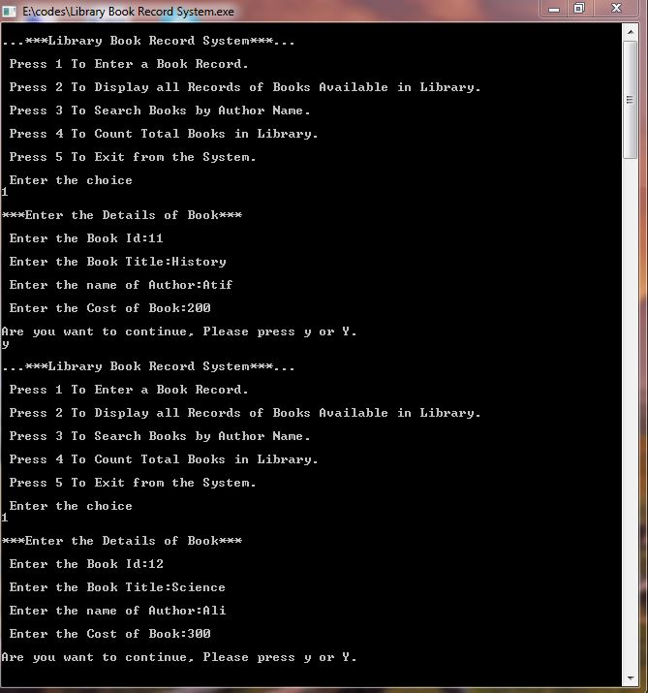

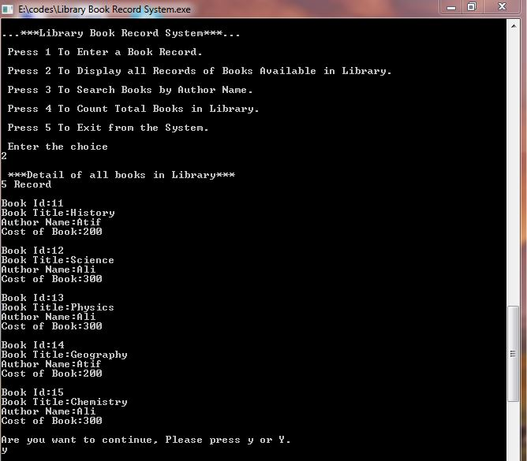

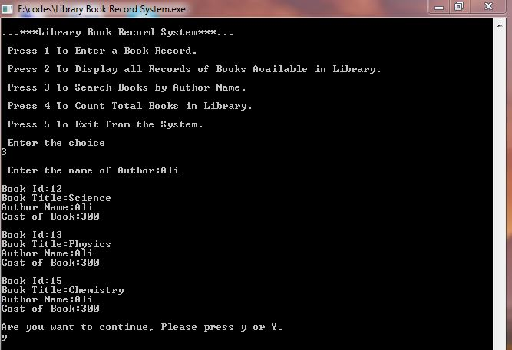

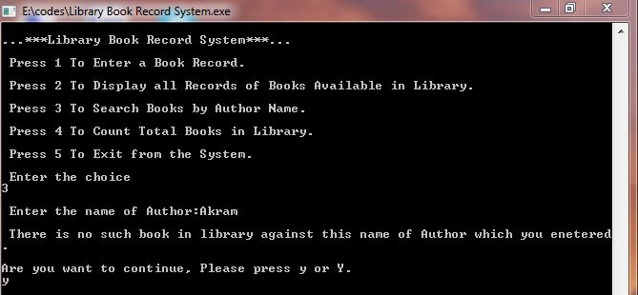

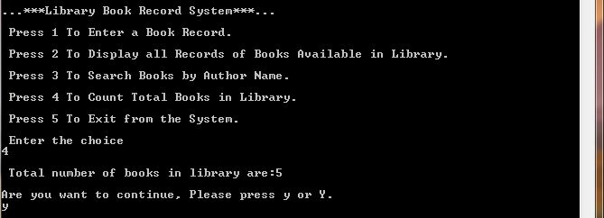

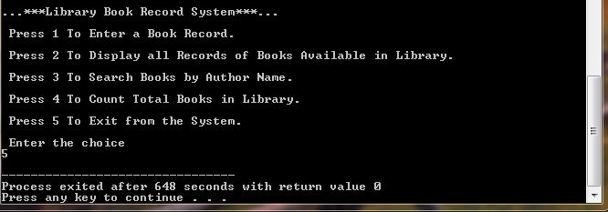

Lectures Covered: This assignment covers lectures 16 -25.
Deadline: The deadline to submit your assignment solution is Thursday, July 11, 2019. Your assignment must be submitted within the due date through VULMS. No assignment will be accepted through email after the due date.

