# 5.1 Test Cases Specification

Test cases specification below is arranged in reference to functional requirements.

# 5.1.1 Login

|  |  |
| --- | --- |
| **Positive Test Case** | |
| **ID** | **TC_1** |
| **Name** | **Login** |
| **Description** | Login to access the Super Admin/Admin Panel |
| **Purpose** | To check admin is login. |
| **Pre-condition** | * System is online * Super Admin/Admin must have active login. * Super Admin/Admin has internet access. |
| **Input** | * User ID * Password |
| **Expected result** | Successfully enters the system and main home page opens. |
| **Status** | Pass |
| **Remarks** | Done |

**Table 5.1**

|  |  |
| --- | --- |
| **Negative Test Case** | |
| **ID** | **TC_1** |
| **Name** | **Login** |
| **Description** | Login to access the Super Admin/Admin Panel |
| **Purpose** | To check admin is login. |
| **Pre-condition** | * System is online * Super Admin/Admin must have active login. * Super Admin/Admin has internet access. |
| **Input** | * Incorrect User ID or password. |
| **Expected result** | Does not allow access to system features and notifies the error. |
| **Status** | Pass |
| **Remarks** | Done |

**Table 5.2**

# 5.1.2 Add Administration

|  |  |
| --- | --- |
| **Positive Test Case** | |
| **ID** | **TC_2** |
| **Name** | **Add Administration** |
| **Description** | Add Admin |
| **Purpose** | To add sub admin to manage and perform functions. |
| **Pre-condition** | * Successfully logged into the system * Must have Super Admin/Admin privileges. |
| **Input** | Valid entry of name, id, email address, contact etc |
| **Expected result** | If all fields are filled with valid information, sub.admin is added to the system database |
| **Status** | Pass |
| **Remarks** | Done |

**Table 5.3**

|  |  |
| --- | --- |
| **Negative Test Case** | |
| **ID** | **TC_2** |
| **Name** | **Add Administration** |
| **Description** | Add Admin |
| **Purpose** | To add sub admin to manage and perform functions. |
| **Pre-condition** | * Successfully logged into the system * Must have Super Admin/Admin privileges. |
| **Input** | Invalid entry of name, id, email address, contact etc |
| **Expected result** | if all or any fields are filled with invalid information, Super Admin/Admin is not added to the system database and error is shown. If empty fields are submitted, will also show error |
| **Status** | Pass |
| **Remarks** | Done |

**Table 5.4**

# 5.1.3 Remove Administration

|  |  |
| --- | --- |
| **Positive Test Case** | |
| **ID** | **TC_3** |
| **Name** | **Remove Administration** |
| **Description** | Remove Administration |
| **Purpose** | To Remove Administration |
| **Pre-condition** | * Successfully logged into the system * Must have Super Admin/Admin privileges. |
| **Input** | Click “Remove Employee” button |
| **Expected result** | Details of sub admin are deleted. |
| **Status** | Pass |
| **Remarks** | Done |

**Table 5.5**

|  |  |
| --- | --- |
| **Negative Test Case** | |
| **ID** | **TC_3** |
| **Name** | **Remove Administration** |
| **Description** | Remove Administration |
| **Purpose** | To Remove Administration |
| **Pre-condition** | * Successfully logged into the system * Must have Super Admin/Admin privileges. |
| **Input** | Does not clicks delete button. |
| **Expected result** | Details of sub admin are deleted. |
| **Status** | Pass |
| **Remarks** | Done |

**Table 5.6**

# 5.1.4 Add Salesmen

|  |  |
| --- | --- |
| **Positive Test Case** | |
| **ID** | **TC_4** |
| **Name** | **Add Salesmen** |
| **Description** | Add Salesmen |
| **Purpose** | To add Salesmen to take and manage orders |
| **Pre-condition** | * Successfully logged into the system * Must have Super Admin/Admin privileges. |
| **Input** | Valid entry of name, id, email address, contact etc |
| **Expected result** | If all fields are filled with valid information, salemen is added to the system database |
| **Status** | Pass |
| **Remarks** | Done |

**Table 5.7**

|  |  |
| --- | --- |
| **Negative Test Case** | |
| **ID** | **TC_4** |
| **Name** | **Add Salesmen** |
| **Description** | Add Salesmen |
| **Purpose** | To add Salesmen to take and manage orders |
| **Pre-condition** | * Successfully logged into the system * Must have Super Admin/Admin privileges. |
| **Input** | Invalid entry of name, id, email address, contact etc |
| **Expected result** | if all or any fields are filled with invalid information, salesmen is not added to the system database and error is shown. If empty fields are submitted, will also show error |
| **Status** | Pass |
| **Remarks** | Done |

**Table 5.8**

# 5.1.5 Remove Salesmen

|  |  |
| --- | --- |
| **Positive Test Case** | |
| **ID** | **TC_5** |
| **Name** | **Remove Salesman** |
| **Description** | Remove Salesmen |
| **Purpose** | To Remove Salesmen |
| **Pre-condition** | * Successfully logged into the system * Must have Super Admin/Admin privileges. |
| **Input** | Click “Remove Salesmen” button |
| **Expected result** | Details of salesmen are deleted. |
| **Status** | Pass |
| **Remarks** | Done |

**Table 5.9**

|  |  |
| --- | --- |
| **Negative Test Case** | |
| **ID** | **TC_3** |
| **Name** | **Remove Salesmen** |
| **Description** | Remove Salesmen |
| **Purpose** | To Remove Salesmen |
| **Pre-condition** | * Successfully logged into the system * Must have Super Admin/Admin privileges. |
| **Input** | Does not clicks delete button. |
| **Expected result** | Details of Salesmen are deleted. |
| **Status** | Pass |
| **Remarks** | Done |

**Table 5.10**

# 5.1.6 Add Product

|  |  |
| --- | --- |
| **Positive Test Case** | |
| **ID** | **TC_6** |
| **Name** | **Add Product** |
| **Description** | Add Product |
| **Purpose** | To add Product |
| **Pre-condition** | * Successfully logged into the system * Must have Super Admin/Admin privileges. |
| **Input** | Valid entry of name, id, quantity, category etc |
| **Expected result** | If all fields are filled with valid information, product is added to the system database |
| **Status** | Pass |
| **Remarks** | Done |

**Table 5.11**

|  |  |
| --- | --- |
| **Negative Test Case** | |
| **ID** | **TC_6** |
| **Name** | **Add Product** |
| **Description** | Add Product |
| **Purpose** | To add Product |
| **Pre-condition** | * Successfully logged into the system * Must have Super Admin/Admin privileges. |
| **Input** | Invalid entry of name, id, quantity, category etc |
| **Expected result** | if all or any fields are filled with invalid information,Product is not added to the system database and error is shown. If empty fields are submitted, will also show error |
| **Status** | Pass |
| **Remarks** | Done |

**Table 5.12**

# 5.1.7 Remove Product

|  |  |
| --- | --- |
| **Positive Test Case** | |
| **ID** | **TC_7** |
| **Name** | **Remove Product** |
| **Description** | Remove Product |
| **Purpose** | To Remove Product |
| **Pre-condition** | * Successfully logged into the system * Must have Super Admin/Admin privileges. |
| **Input** | Click “Remove Product” button |
| **Expected result** | Details of Product are deleted. |
| **Status** | Pass |
| **Remarks** | Done |

**Table 5.13**

|  |  |
| --- | --- |
| **Negative Test Case** | |
| **ID** | **TC_7** |
| **Name** | **Remove Product** |
| **Description** | Remove Product |
| **Purpose** | To Remove Product |
| **Pre-condition** | * Successfully logged into the system * Must have Super Admin/Admin privileges. |
| **Input** | Does not clicks delete button. |
| **Expected result** | Details of Product are deleted. |
| **Status** | Pass |
| **Remarks** | Done |

**Table 5.14**

# 5.1.8 Add Supplier

|  |  |
| --- | --- |
| **Positive Test Case** | |
| **ID** | **TC_8** |
| **Name** | **Add Supplier** |
| **Description** | Add Supplier |
| **Purpose** | To add Supplier |
| **Pre-condition** | * Successfully logged into the system * Must have Super Admin/Admin privileges. |
| **Input** | Valid entry of name, id, contact, address etc |
| **Expected result** | If all fields are filled with valid information, Supplier is added to the system database |
| **Status** | Pass |
| **Remarks** | Done |

**Table 5.15**

|  |  |
| --- | --- |
| **Negative Test Case** | |
| **ID** | **TC_8** |
| **Name** | **Add Supplier** |
| **Description** | Add Supplier |
| **Purpose** | To add Supplier |
| **Pre-condition** | * Successfully logged into the system * Must have Super Admin/Admin privileges. |
| **Input** | Invalid entry of name, id, contact, address etc |
| **Expected result** | if all or any fields are filled with invalid information, Supplier is not added to the system database and error is shown. If empty fields are submitted, will also show error |
| **Status** | Pass |
| **Remarks** | Done |

**Table 5.16**

# 5.1.9 Remove Supplier

|  |  |
| --- | --- |
| **Positive Test Case** | |
| **ID** | **TC_9** |
| **Name** | **Remove Supplier** |
| **Description** | Remove Supplier |
| **Purpose** | To Remove Product |
| **Pre-condition** | * Successfully logged into the system * Must have Super Admin/Admin privileges. |
| **Input** | Click “Remove Supplier” button |
| **Expected result** | Details of Supplier t are deleted. |
| **Status** | Pass |
| **Remarks** | Done |

**Table 5.17**

|  |  |
| --- | --- |
| **Negative Test Case** | |
| **ID** | **TC_9** |
| **Name** | **Remove Supplier** |
| **Description** | Remove Supplier |
| **Purpose** | To Remove Supplier |
| **Pre-condition** | * Successfully logged into the system * Must have Super Admin/Admin privileges. |
| **Input** | Does not clicks delete button. |
| **Expected result** | Details of Supplier are deleted. |
| **Status** | Pass |
| **Remarks** | Done |

**Table 5.18**

# 5.1.10 Update inventory of products

|  |  |
| --- | --- |
| **Positive Test Case** | |
| **ID** | **TC_10** |
| **Name** | **Update inventory of products** |
| **Description** | Update inventory of products |
| **Purpose** | To Update inventory of products |
| **Pre-condition** | * Successfully logged into the system * Must have Super Admin/Admin privileges. |
| **Input** | Valid entry of name, id, quantity , category etc |
| **Expected result** | If all fields are filled with valid information, Product is updated in system database |
| **Status** | Pass |
| **Remarks** | Done |

**Table 5.19**

|  |  |
| --- | --- |
| **Negative Test Case** | |
| **ID** | **TC_10** |
| **Name** | **Update inventory of products** |
| **Description** | Update inventory of products |
| **Purpose** | To Update inventory of products |
| **Pre-condition** | * Successfully logged into the system * Must have Super Admin/Admin privileges. |
| **Input** | Invalid entry of name, id, category, quantity etc |
| **Expected result** | if all or any fields are filled with invalid information, Product will not be updated to the system database and error is shown. If empty fields are submitted, will also show error |
| **Status** | Pass |
| **Remarks** | Done |

**Table 5.20**

# 5.1.11 Receive Order

|  |  |
| --- | --- |
| **Positive Test Case** | |
| **ID** | **TC_11** |
| **Name** | **Receive Orders** |
| **Description** | Receive Orders |
| **Purpose** | To Receive Orders |
| **Pre-condition** | * Successfully logged into the system * Must have Super Admin/Admin privileges. |
| **Input** | Valid entry of retailer id, product quantity , products id ,discount on price etc |
| **Expected result** | If all fields are filled with valid information, Order will be received to the system database |
| **Status** | Pass |
| **Remarks** | Done |

**Table 5.21**

|  |  |
| --- | --- |
| **Negative Test Case** | |
| **ID** | **TC_11** |
| **Name** | **Receive Orders** |
| **Description** | Receive Orders |
| **Purpose** | To Receive Orders |
| **Pre-condition** | * Successfully logged into the system * Must have Super Admin/Admin privileges. |
| **Input** | Invalid entry of retailer id, product quantity , products id ,discount on price etc |
| **Expected result** | if all or any fields are filled with invalid information, order will not be received to the system database and error is shown. If empty fields are submitted, will also show error |
| **Status** | Pass |
| **Remarks** | Done |

**Table 5.22**

# 5.1.12 Make Orders

|  |  |
| --- | --- |
| **Positive Test Case** | |
| **ID** | **TC_12** |
| **Name** | **Make Orders** |
| **Description** | Make Orders |
| **Purpose** | To Make Orders |
| **Pre-condition** | * Successfully logged into the system * Must have Super admin/Admin/Salesman privileges. * Order quantity must be smaller or equal to available quantity |
| **Input** | Valid entry of retailer id, product quantity , products id ,discount on price etc |
| **Expected result** | If all fields are filled with valid information, Order will be stored to the system database |
| **Status** | Pass |
| **Remarks** | Done |

**Table 5.23**

|  |  |
| --- | --- |
| **Negative Test Case** | |
| **ID** | **TC_12** |
| **Name** | **Make Orders** |
| **Description** | Make Orders |
| **Purpose** | To Make Orders |
| **Pre-condition** | * Successfully logged into the system * Must have Super admin/Admin/Salesman privileges. * Order quantity must be smaller or equal to available quantity |
| **Input** | Invalid entry of retailer id, product quantity , products id ,discount on price etc |
| **Expected result** | if all or any fields are filled with invalid information, order will not be stored to the system database and error is shown. If empty fields are submitted, will also show error |
| **Status** | Pass |
| **Remarks** | Done |

**Table 5.24**

# 5.1.13 Remove Orders

|  |  |
| --- | --- |
| **Positive Test Case** | |
| **ID** | **TC_13** |
| **Name** | **Remove Orders** |
| **Description** | Remove Orders |
| **Purpose** | To Remove Orders |
| **Pre-condition** | * Successfully logged into the system * Must have Super admin/Admin/Salesman privileges. |
| **Input** | Click “Remove ORDER” Button |
| **Expected result** | Order is Removed from the system database |
| **Status** | Pass |
| **Remarks** | Done |

**Table 5.25**

|  |  |
| --- | --- |
| **Negative Test Case** | |
| **ID** | **TC_13** |
| **Name** | **Remove Orders** |
| **Description** | Remove Orders |
| **Purpose** | To Remove Orders |
| **Pre-condition** | * Successfully logged into the system * Must have Super admin/Admin/Salesman privileges. |
| **Input** | Does not clicks delete button. |
| **Expected result** | Order is Removed from the system database |
| **Status** | Pass |
| **Remarks** | Done |

**Table 5.26**

# 5.1.14 Update Orders

|  |  |
| --- | --- |
| **Positive Test Case** | |
| **ID** | **TC_14** |
| **Name** | **Update Order** |
| **Description** | Update Order |
| **Purpose** | To Update Order |
| **Pre-condition** | * Successfully logged into the system * Must have Super admin/Admin/Salesman privileges. * Order quantity must be smaller or equal to available quantity |
| **Input** | Valid entry of retailer id, product quantity , products id ,discount on price etc |
| **Expected result** | If all fields are filled with valid information, Order will be updated to the system database |
| **Status** | Pass |
| **Remarks** | Done |

**Table 5.27**

|  |  |
| --- | --- |
| **Negative Test Case** | |
| **ID** | **TC_14** |
| **Name** | **Update Order** |
| **Description** | Update Order |
| **Purpose** | Update Order |
| **Pre-condition** | * Successfully logged into the system * Must have Super admin/Admin/Salesman privileges. * Order quantity must be smaller or equal to available quantity |
| **Input** | Invalid entry of retailer id, product quantity , products id ,discount on price etc |
| **Expected result** | if all or any fields are filled with invalid information, order will not be updated to the system database and error is shown. If empty fields are submitted, will also show error |
| **Status** | Pass |
| **Remarks** | Done |

**Table 5.28**

# 5.1. 15 View Activity Report

|  |  |
| --- | --- |
| **Positive Test Case** | |
| **ID** | **TC_15** |
| **Name** | **View Activity Report** |
| **Description** | View Activity Report |
| **Purpose** | To View Activity Report |
| **Pre-condition** | * Successfully logged into the system * Must have Super Admin/Admin privileges. |
| **Input** | Click “View Report” Button |
| **Expected result** | View Activity Reports of Different Salesman |
| **Status** | Pass |
| **Remarks** | Done |

**Table 5.29**

|  |  |
| --- | --- |
| **Negative Test Case** | |
| **ID** | **TC_15** |
| **Name** | **View Activity Report** |
| **Description** | View Activity Report |
| **Purpose** | View Activity Report |
| **Pre-condition** | * Successfully logged into the system * Must have Super Admin/Admin privileges. |
| **Input** | Does not clicks View report button. |
| **Expected result** | View Activity Reports of Different Salesman |
| **Status** | Pass |
| **Remarks** | Done |

**Table 5.30**

# 5.1.16 View Orders Report

|  |  |
| --- | --- |
| **Positive Test Case** | |
| **ID** | **TC_16** |
| **Name** | **View Orders Report** |
| **Description** | View Orders Report |
| **Purpose** | To View Orders Report |
| **Pre-condition** | * Successfully logged into the system * Must have Super Admin/Admin privileges. |
| **Input** | Click “View Order Report” Button |
| **Expected result** | Show Orders Report |
| **Status** | Pass |
| **Remarks** | Done |

**Table 5.31**

|  |  |
| --- | --- |
| **Negative Test Case** | |
| **ID** | **TC_16** |
| **Name** | **View Orders Report** |
| **Description** | View Orders Report |
| **Purpose** | To View Orders Report |
| **Pre-condition** | * Successfully logged into the system * Must have Super Admin/Admin privileges. |
| **Input** | Does not clicks View order report button. |
| **Expected result** | Show Orders Report |
| **Status** | Pass |
| **Remarks** | Done |

**Table 5.32**

# 5.1.17 View monthly/Weekly Sales Report

|  |  |
| --- | --- |
| **Positive Test Case** | |
| **ID** | **TC_17** |
| **Name** | **View monthly/Weekly Sales Report** |
| **Description** | View monthly/Weekly Sales Report |
| **Purpose** | To View monthly/Weekly Sales Report |
| **Pre-condition** | * Successfully logged into the system * Must have Super Admin/Admin privileges. |
| **Input** | Click “View Sales Report” Button |
| **Expected result** | Show Sales Report |
| **Status** | Pass |
| **Remarks** | Done |

**Table 5.33**

|  |  |
| --- | --- |
| **Negative Test Case** | |
| **ID** | **TC_17** |
| **Name** | **View monthly/Weekly Sales Report** |
| **Description** | View monthly/Weekly Sales Report |
| **Purpose** | To View monthly/Weekly Sales Report |
| **Pre-condition** | * Successfully logged into the system * Must have Super Admin/Admin privileges. |
| **Input** | Does not clicks View sales report button. |
| **Expected result** | Show sale Report |
| **Status** | Pass |
| **Remarks** | Done |

**Table 5.34**

# 5.1.18 View monthly/Weekly Salesman Report

|  |  |
| --- | --- |
| **Positive Test Case** | |
| **ID** | **TC_18** |
| **Name** | **View monthly/Weekly Salesman Report** |
| **Description** | View monthly/Weekly Salesman Report |
| **Purpose** | View monthly/Weekly Salesman Report |
| **Pre-condition** | * Successfully logged into the system * Must have Super Admin/Admin privileges. |
| **Input** | Click “View Salesman Report” Button |
| **Expected result** | Show Salesman Report |
| **Status** | Pass |
| **Remarks** | Done |

**Table 5.35**

|  |  |
| --- | --- |
| **Negative Test Case** | |
| **ID** | **TC_18** |
| **Name** | **View monthly/Weekly Salesman Report** |
| **Description** | View monthly/Weekly Salesman Report |
| **Purpose** | To View monthly/Weekly Salesman Report |
| **Pre-condition** | * Successfully logged into the system * Must have Super Admin/Admin privileges. |
| **Input** | Does not clicks View salesman report button. |
| **Expected result** | Show salesman Report |
| **Status** | Pass |
| **Remarks** | Done |

**Table 5.36**

# 5.1.1. 19 Generate Orders Delivery Schedule

|  |  |
| --- | --- |
| **Positive Test Case** | |
| **ID** | **TC_19** |
| **Name** | **Generate Orders Delivery Schedule** |
| **Description** | Generate Orders Delivery Schedule |
| **Purpose** | To Generate Orders Delivery Schedule |
| **Pre-condition** | * Successfully logged into the system * Must have Super Admin/Admin privileges. |
| **Input** | Valid entry of retailer id, product quantity , products id ,discount on price, delivery date, delivery time, order date etc |
| **Expected result** | Delivery Schedule Is generated |
| **Status** | Pass |
| **Remarks** | Done |

**Table 5.37**

|  |  |
| --- | --- |
| **Negative Test Case** | |
| **ID** | **TC_19** |
| **Name** | **Generate Orders Delivery Schedule** |
| **Description** | Generate Orders Delivery Schedule |
| **Purpose** | To Generate Orders Delivery Schedule |
| **Pre-condition** | * Successfully logged into the system * Must have Super Admin/Admin privileges. |
| **Input** | Invalid entry of retailer id, product quantity , products id ,discount on price, delivery date, delivery time, order date etc |
| **Expected result** | Delivery Schedule Is generated |
| **Status** | Pass |
| **Remarks** | Done |

**Table 5.38**

# 5.1.20 View Orders Delivery Schedule

|  |  |
| --- | --- |
| **Positive Test Case** | |
| **ID** | **TC_20** |
| **Name** | **View Orders Delivery Schedule** |
| **Description** | View Orders Delivery Schedule |
| **Purpose** | To View Orders Delivery Schedule |
| **Pre-condition** | * Successfully logged into the system * Must have Super Admin/Admin privileges. |
| **Input** | Click “View Orders Delivery Schedule” Button |
| **Expected result** | Show Orders Delivery Schedule Report |
| **Status** | Pass |
| **Remarks** | Done |

**Table 5.39**

|  |  |
| --- | --- |
| **Negative Test Case** | |
| **ID** | **TC_20** |
| **Name** | **View Orders Delivery Schedule** |
| **Description** | View Orders Delivery Schedule |
| **Purpose** | To View Orders Delivery Schedule |
| **Pre-condition** | * Successfully logged into the system * Must have Super Admin/Admin privileges. |
| **Input** | Does not clicks View Orders Delivery Schedule report button. |
| **Expected result** | Show Orders Delivery Schedule Report |
| **Status** | Pass |
| **Remarks** | Done |

**Table 5.40**

# 5.1. 21 Edit Orders Delivery Schedule

|  |  |
| --- | --- |
| **Positive Test Case** | |
| **ID** | **TC_21** |
| **Name** | **Edit Orders Delivery Schedule** |
| **Description** | Edit Orders Delivery Schedule |
| **Purpose** | To Edit Orders Delivery Schedule |
| **Pre-condition** | * Successfully logged into the system * Must have Super Admin/Admin privileges. |
| **Input** | Valid entry of retailer id, product quantity , products id ,discount on price, delivery date, delivery time, order date etc |
| **Expected result** | Delivery Schedule Is Updated to system database |
| **Status** | Pass |
| **Remarks** | Done |

**Table 5.41**

|  |  |
| --- | --- |
| **Negative Test Case** | |
| **ID** | **TC_21** |
| **Name** | **Edit Orders Delivery Schedule** |
| **Description** | Edit Orders Delivery Schedule |
| **Purpose** | To Edit Orders Delivery Schedule |
| **Pre-condition** | * Successfully logged into the system * Must have Super Admin/Admin privileges. |
| **Input** | Invalid entry of retailer id, product quantity , products id ,discount on price, delivery date, delivery time, order date etc |
| **Expected result** | Delivery Schedule Is Updated to system database |
| **Status** | Pass |
| **Remarks** | Done |

**Table 5.42**

# 5.1.22 Logout

|  |  |
| --- | --- |
| **Positive Test Case** | |
| **ID** | **TC_22** |
| **Name** | **Logout** |
| **Description** | Logout from Super Admin/Admin Panel |
| **Purpose** | To Logout from Super Admin/Admin Panel |
| **Pre-condition** | * System is online * Super Admin/Admin/Salesman logged in to the system. |
| **Input** | Click Logout Button |
| **Expected result** | Successfully Logout from System |
| **Status** | Pass |
| **Remarks** | Done |

**Table 5.43**

|  |  |
| --- | --- |
| **Negative Test Case** | |
| **ID** | **TC_22** |
| **Name** | **Logout** |
| **Description** | Logout from Super Admin/Admin Panel |
| **Purpose** | To Logout from Super Admin/Admin Panel |
| **Pre-condition** | * System is online * Super Admin/Admin/Salesman is logged in to the system. |
| **Input** | Does not clicks logout button. |
| **Expected result** | Successfully Logout from System |
| **Status** | Pass |
| **Remarks** | Done |

**Table 5.44**

# 5.1.23 Edit Profile

|  |  |
| --- | --- |
| **Positive Test Case** | |
| **ID** | **TC_23** |
| **Name** | **Edit Profile** |
| **Description** | Edit Profile |
| **Purpose** | To Edit Profile |
| **Pre-condition** | * Successfully logged into the system * Must have Super admin/Admin/Salesman privileges. |
| **Input** | Valid entry of id, name, address ,contact etc |
| **Expected result** | Profile is updated to the system database |
| **Status** | Pass |
| **Remarks** | Done |

**Table 5.45**

|  |  |
| --- | --- |
| **Negative Test Case** | |
| **ID** | **TC_23** |
| **Name** | **Edit Profile** |
| **Description** | Edit Profile |
| **Purpose** | To Edit Profile |
| **Pre-condition** | * Successfully logged into the system * Must have Super admin/Admin/Salesman privileges. |
| **Input** | Invalid entry of id, name, address ,contact etc |
| **Expected result** | Profile is updated to the system database |
| **Status** | Pass |
| **Remarks** | Done |

**Table 5.46**

# 5.2 Black Box Test Cases

Black box testing is the Software testing method which is used to test the software without knowing the internal structure of code or program.

Black.box testing attempts to find errors in the following categories:

* Incorrect or missing functions
* Interface errors
* Errors in data structures or external database access
* Behavior or performance errors
* Initialization and termination errors

Typical black.box test design techniques include:

* Equivalence Partitioning (EP)
* Decision Table Testing
* State Transition Tables

## 5.2.1 Equivalence Partition

The equivalence class partition is the black box test case design technique used for writing test cases. This approach is use to reduce huge set of possible inputs to small but equally effective inputs. This is done by dividing inputs into the classes and gets one value from each class. Such method is used when exhaustive testing is most wanted and to avoid the redundancy of inputs (ISTQB).

### 

# 5.2.1.1 Admin Login

|  |  |  |  |  |
| --- | --- | --- | --- | --- |
| FIELD  NAME | DATA  TYPE | INVALID  PARTITION | VALID  PARTITION | INVALID  PARTITION |
| **ID** | Varchar | Zero | **1** to **191** | greater than **191** |
| **Password** | Varchar | Less than **8** | **8** to **25** | greater than **25** |

**Table 5.47**

# 5.2.1.2 Add User

|  |  |  |  |  |
| --- | --- | --- | --- | --- |
| FIELD  NAME | DATA  TYPE | INVALID  PARTITION | VALID  PARTITION | INVALID  PARTITION |
| **Name** | Varchar | Zero | **1** to **255** | Greater than **255** |
| **ID** | Varchar | Zero | **1** to **191** | greater than **191** |
| **Password** | Varchar | Under 18 | 18.60 | 60 above |
| **Address** | Text | Numeric | Text | Operators |
| **Contact Number** | Varchar | Less than 11 | **11** | Greater than **11** |
| **Gender** |  |  | **M/F** |  |

**Table 5.48**

# 5.2.1.3 Update User

|  |  |  |  |  |
| --- | --- | --- | --- | --- |
| FIELD  NAME | DATA  TYPE | INVALID  PARTITION | VALID  PARTITION | INVALID  PARTITION |
| **Name** | Varchar | Zero | **1** to **255** | Greater than **255** |
| **ID** | Varchar | Zero | **1** to **191** | greater than **191** |
| **Password** | Varchar | Under 18 | 18.60 | 60 above |
| **Address** | Text | Numeric | Text | Operators |
| **Contact Number** | Varchar | Less than 11 | **11** | Greater than **11** |
| **Gender** |  |  | **M/F** |  |

**Table 5.49**

# 5.2.1.4 Add Product

|  |  |  |  |  |
| --- | --- | --- | --- | --- |
| FIELD  NAME | DATA  TYPE | INVALID  PARTITION | VALID  PARTITION | INVALID  PARTITION |
| **Name** | Varchar | Zero | **1** to **255** | Greater than **255** |
| **ID** | Varchar | Zero | **1** to **191** | greater than **191** |
| **Quantity** | Integer | Under 0 | greater or equal to 1 | Below zero |
| **Supplier ID** | Varchar | Zero | **1** to **191** | greater than **191** |
| **Contact Number** | Varchar | Less than 11 | **11** | Greater than **11** |
| **Category ID** | Varchar | Zero | **1** to **191** | greater than **191** |

**Table 5.50**

# 5.2.1.5 Update Product

|  |  |  |  |  |
| --- | --- | --- | --- | --- |
| FIELD  NAME | DATA  TYPE | INVALID  PARTITION | VALID  PARTITION | INVALID  PARTITION |
| **Name** | Varchar | Zero | **1** to **255** | Greater than **255** |
| **ID** | Varchar | Zero | **1** to **191** | greater than **191** |
| **Quantity** | Integer | Under 0 | greater or equal to 1 | Below zero |
| **Supplier ID** | Varchar | Zero | **1** to **191** | greater than **191** |
| **Contact Number** | Varchar | Less than 11 | **11** | Greater than **11** |
| **Category ID** | Varchar | Zero | **1** to **191** | greater than **191** |

**Table 5.51**

# 5.2.1.6 Add Order

|  |  |  |  |  |
| --- | --- | --- | --- | --- |
| FIELD  NAME | DATA  TYPE | INVALID  PARTITION | VALID  PARTITION | INVALID  PARTITION |
| **ID** | Varchar | Zero | **1** to **191** | greater than **191** |
| **Product Quantity** | Integer | Under 0 | greater or equal to 1 | Below zero |
| **Retailer ID** | Varchar | Zero | greater or equal to 1 | Below zero |
| **Price** | Integer | Under 0 | **11** | Greater than **11** |
| **Product ID** | Varchar | Zero | **1** to **191** | greater than **191** |

**Table 5.52**

# 5.2.1.7 Update Order

|  |  |  |  |  |
| --- | --- | --- | --- | --- |
| FIELD  NAME | DATA  TYPE | INVALID  PARTITION | VALID  PARTITION | INVALID  PARTITION |
| **ID** | Varchar | Zero | **1** to **191** | greater than **191** |
| **Product Quantity** | Integer | Under 0 | greater or equal to 1 | Below zero |
| **Retailer ID** | Varchar | Zero | greater or equal to 1 | Below zero |
| **Price** | Integer | Under 0 | **11** | Greater than **11** |
| **Product ID** | Varchar | Zero | **1** to **191** | greater than **191** |

**Table 5.53**

## 

# 5.2.2 Decision Table

Decision table testing is black box test design technique to determine the test scenarios for complex business logic. It is a structured exercise to prepare requirements when dealing with complex business rules.

# 5.2.2.1 Login

|  |  |  |  |  |
| --- | --- | --- | --- | --- |
| **ID** | **Valid Username** | **Valid Password** | **Expected Result** | **Status** |
| TC_LOGIN_SUCCESS | Y | Y | Success | Tested |
| TC_LOGIN_FAILURE | N | Y | Fail | Tested |
| TC_LOGIN_FAILURE | Y | N | Fail | Tested |
| TC_LOGIN_FAILURE | N | N | Fail | Tested |

**Table 5.54**

# 5.2.2.2 Add Administration

|  |  |  |  |  |
| --- | --- | --- | --- | --- |
| **ID** | **Valid Input** | **No Empty Field** | **Expected Result** | **Status** |
| TC_ Add ADMIN_SUCCESS | Y | Y | Success | Tested |
| TC_ Add ADMIN_FAILURE | N | Y | Fail | Tested |
| TC_ Add ADMIN_FAILURE | Y | N | Fail | Tested |
| TC_ Add ADMIN_FAILURE | N | N | Fail | Tested |

**Table 5.55**

# 5.2.2.3 Remove Administration

|  |  |  |  |  |
| --- | --- | --- | --- | --- |
| **ID** | **Role Must Be Super Admin** | **Must Press The Intended Admin’s Remove Button** | **Expected Result** | **Status** |
| TC_ REMOVE ADMIN_SUCCESS | Y | Y | Success | Tested |
| TC_ REMOVE ADMIN_FAILURE | N | Y | Fail | Tested |
| TC_ REMOVE ADMIN_FAILURE | Y | N | Fail | Tested |
| TC_ REMOVE ADMIN_FAILURE | N | N | Fail | Tested |

**Table 5.56**

# 5.2.2.4 Add Salesmen

|  |  |  |  |  |
| --- | --- | --- | --- | --- |
| **ID** | **Valid Input** | **No Empty Field** | **Expected Result** | **Status** |
| TC_ Add SALESMEN_SUCCESS | Y | Y | Success | Tested |
| TC_ Add SALESMEN_FAILURE | N | Y | Fail | Tested |
| TC_ Add SALESMEN_FAILURE | Y | N | Fail | Tested |
| TC_ Add SALESMEN_FAILURE | N | N | Fail | Tested |

**Table 5.57**

# 5.2.2.5 Remove Salesmen

|  |  |  |  |  |
| --- | --- | --- | --- | --- |
| **ID** | **Role Must Be Super Admin/Admin or admin** | **Must Press The Intended Salesmen’s Remove Button** | **Expected Result** | **Status** |
| TC_ REMOVE SALESMEN_SUCCESS | Y | Y | Success | Tested |
| TC_ REMOVE SALESMEN_FAILURE | N | Y | Fail | Tested |
| TC_ REMOVE SALESMEN_FAILURE | Y | N | Fail | Tested |
| TC_ REMOVE SALESMEN_FAILURE | N | N | Fail | Tested |

**Table 5.58**

# 5.2.2.6 Add Product

|  |  |  |  |  |
| --- | --- | --- | --- | --- |
| **ID** | **Valid Input** | **No Empty Field** | **Expected Result** | **Status** |
| TC_ Add PRODUCT_SUCCESS | Y | Y | Success | Tested |
| TC_ Add PRODUCT_FAILURE | N | Y | Fail | Tested |
| TC_ Add PRODUCT_FAILURE | Y | N | Fail | Tested |
| TC_ Add PRODUCT_FAILURE | N | N | Fail | Tested |

**Table 5.59**

# 5.2.2.7 Remove Product

|  |  |  |  |  |
| --- | --- | --- | --- | --- |
| **ID** | **Role Must Be Super Admin**  **or admin** | **Must Press The Intended Product’s Remove Button** | **Expected Result** | **Status** |
| TC_ REMOVE PRODUCT_SUCCESS | Y | Y | Success | Tested |
| TC_ REMOVE PRODUCT_FAILURE | N | Y | Fail | Tested |
| TC_ REMOVE PRODUCT_FAILURE | Y | N | Fail | Tested |
| TC_ REMOVE PRODUCT_FAILURE | N | N | Fail | Tested |

**Table 5.60**

# 5.2.2.8 Add Supplier

|  |  |  |  |  |
| --- | --- | --- | --- | --- |
| **ID** | **Valid Input** | **No Empty Field** | **Expected Result** | **Status** |
| TC_ Add SUPPLIER_SUCCESS | Y | Y | Success | Tested |
| TC_ Add SUPPLIER_FAILURE | N | Y | Fail | Tested |
| TC_ Add SUPPLIER_FAILURE | Y | N | Fail | Tested |
| TC_ Add SUPPLIER_FAILURE | N | N | Fail | Tested |

**Table 5.61**

# 5.2.2.9 Remove Supplier

|  |  |  |  |  |
| --- | --- | --- | --- | --- |
| **ID** | **Role Must Be Super Admin**  **or admin** | **Must Press The Intended Supplier’s Remove Button** | **Expected Result** | **Status** |
| TC_ REMOVE SUPPLIER_SUCCESS | Y | Y | Success | Tested |
| TC_ REMOVE SUPPLIER_FAILURE | N | Y | Fail | Tested |
| TC_ REMOVE SUPPLIER_FAILURE | Y | N | Fail | Tested |
| TC_ REMOVE SUPPLIER_FAILURE | N | N | Fail | Tested |

**Table 5.62**

# 5.2.2.10 Update inventory of products

|  |  |  |  |  |
| --- | --- | --- | --- | --- |
| **ID** | **Valid Input** | **No Empty Field** | **Expected Result** | **Status** |
| TC_ UPDATE_THE  PRODUCT_SUCCESS | Y | Y | Success | Tested |
| TC_ UPDATE_THE  PRODUCT_ FAILURE | N | Y | Fail | Tested |
| TC_ UPDATE_THE  PRODUCT_ FAILURE | Y | N | Fail | Tested |
| TC_ UPDATE_THE  PRODUCT_ FAILURE | N | N | Fail | Tested |

**Table 5.63**

# 5.2.2.11 Receive Orders

|  |  |  |  |  |
| --- | --- | --- | --- | --- |
| **ID** | **Valid Input** | **No Empty Field** | **Expected Result** | **Status** |
| TC_RECEICVE  ORDER_SUCCESS | Y | Y | Success | Tested |
| TC_RECEICVE  ORDER_FAILURE | N | Y | Fail | Tested |
| TC_RECEICVE  ORDER_FAILURE | Y | N | Fail | Tested |
| TC_RECEICVE  ORDER_FAILURE | N | N | Fail | Tested |

**Table 5.64**

# 5.2.2.12 Make Orders

|  |  |  |  |  |
| --- | --- | --- | --- | --- |
| **ID** | **Valid Input** | **No Empty Field** | **Expected Result** | **Status** |
| TC_MAKE  ORDER_SUCCESS | Y | Y | Success | Tested |
| TC_ MAKE  ORDER_FAILURE | N | Y | Fail | Tested |
| TC_ MAKE  ORDER_FAILURE | Y | N | Fail | Tested |
| TC_ MAKE  ORDER_FAILURE | N | N | Fail | Tested |

**Table 5.65**

# 5.2.2.13 Remove Orders

|  |  |  |  |  |
| --- | --- | --- | --- | --- |
| **ID** | **Role Must Be Super Admin**  **or admin or salesman** | **Must Press The Intended Order’s Remove Button** | **Expected Result** | **Status** |
| TC_ REMOVE ORDER_SUCCESS | Y | Y | Success | Tested |
| TC_ REMOVE ORDER_FAILURE | N | Y | Fail | Tested |
| TC_ REMOVE ORDER_FAILURE | Y | N | Fail | Tested |
| TC_ REMOVE ORDER_FAILURE | N | N | Fail | Tested |

**Table 5.66**

# 5.2.2.14 Update Orders

|  |  |  |  |  |
| --- | --- | --- | --- | --- |
| **ID** | **Valid Input** | **No Empty Field** | **Expected Result** | **Status** |
| TC_UPDATE  ORDER_SUCCESS | Y | Y | Success | Tested |
| TC_ UPDATE  ORDER_FAILURE | N | Y | Fail | Tested |
| TC_ UPDATE  ORDER_FAILURE | Y | N | Fail | Tested |
| TC_ UPDATE  ORDER_FAILURE | N | N | Fail | Tested |

**Table 5.67**

# 5.2.2.15 View Activity Report

|  |  |  |  |  |
| --- | --- | --- | --- | --- |
| **ID** | **Role Must Be Super Admin**  **or admin** | **Must Press The Intended View Reports’ Button** | **Expected Result** | **Status** |
| TC_VIEW_ACTIVITY  REPORT_SUCCESS | Y | Y | Success | Tested |
| TC_VIEW_ACTIVITY  REPORT_FAILURE | N | Y | Fail | Tested |
| TC_VIEW_ACTIVITY  REPORT_FAILURE | Y | N | Fail | Tested |
| TC_VIEW_ACTIVITY  REPORT_FAILURE | N | N | Fail | Tested |

**Table 5.68**

# 5.2.2.16 View Orders Report

|  |  |  |  |  |
| --- | --- | --- | --- | --- |
| **ID** | **Role Must Be Super Admin**  **or admin** | **Must Press The Intended View Order Reports’ Button** | **Expected Result** | **Status** |
| TC_VIEW_ACTIVITY  ORDER_REPORT_SUCCESS | Y | Y | Success | Tested |
| TC_VIEW_ACTIVITY  ORDER_REPORT_FAILURE | N | Y | Fail | Tested |
| TC_VIEW_ACTIVITY  ORDER_REPORT_FAILURE | Y | N | Fail | Tested |
| TC_VIEW_ACTIVITY  ORDER_REPORT_FAILURE | N | N | Fail | Tested |

**Table 5.69**

# 5.2.2.17 View monthly/Weekly Sales Report

|  |  |  |  |  |
| --- | --- | --- | --- | --- |
| **ID** | **Role Must Be Super Admin/Admin or admin** | **Must Press The Intended View Sale Reports’ Button** | **Expected Result** | **Status** |
| TC_VIEW_SALE  REPORT_SUCCESS | Y | Y | Success | Tested |
| TC_VIEW_SALE  REPORT_ FAILURE | N | Y | Fail | Tested |
| TC_VIEW_SALE  REPORT_ FAILURE | Y | N | Fail | Tested |
| TC_VIEW_SALE  REPORT_ FAILURE | N | N | Fail | Tested |

**Table 5.70**

# 5.2.2.18 View monthly/Weekly Salesman Report

|  |  |  |  |  |
| --- | --- | --- | --- | --- |
| **ID** | **Role Must Be Super Admin/Admin or admin** | **Must Press The Intended View Salesman Reports’ Button** | **Expected Result** | **Status** |
| TC_VIEW_SALEMAN  REPORT_SUCCESS | Y | Y | Success | Tested |
| TC_VIEW_SALEMAN  REPORT_ FAILURE | N | Y | Fail | Tested |
| TC_VIEW_SALEMAN  REPORT_ FAILURE | Y | N | Fail | Tested |
| TC_VIEW_SALEMAN  REPORT_ FAILURE | N | N | Fail | Tested |

**Table 5.71**

# 5.2.2.19 Generate Orders Delivery Schedule

|  |  |  |  |  |
| --- | --- | --- | --- | --- |
| **ID** | **Valid Input** | **No Empty Field** | **Expected Result** | **Status** |
| TC_GENERATE_ORDER_DELIVERY  SCHEDULE_ SUCCESS | Y | Y | Success | Tested |
| TC_GENERATE_ORDER_DELIVERY  SCHEDULE_ FAILURE | N | Y | Fail | Tested |
| TC_GENERATE_ORDER_DELIVERY  SCHEDULE_ FAILURE | Y | N | Fail | Tested |
| TC_GENERATE_ORDER_DELIVERY  SCHEDULE_ FAILURE | N | N | Fail | Tested |

**Table 5.72**

# 5.2.2.20 View Orders Delivery Schedule

|  |  |  |  |  |
| --- | --- | --- | --- | --- |
| **ID** | **Role Must Be Super Admin/Admin or admin** | **Must Press The Intended View Order Delivery Schedule’s Button** | **Expected Result** | **Status** |
| TC_VIEW_ORDERS_DELIVERY  SCHEDULE_SUCCESS | Y | Y | Success | Tested |
| TC_VIEW_ORDERS_DELIVERY  SCHEDULE_ FAILURE | N | Y | Fail | Tested |
| TC_VIEW_ORDERS_DELIVERY  SCHEDULE_ FAILURE | Y | N | Fail | Tested |
| TC_VIEW_ORDERS_DELIVERY  SCHEDULE_ FAILURE | N | N | Fail | Tested |

**Table 5.73**

# 5.2.2. 21 Edit Orders Delivery Schedule

|  |  |  |  |  |
| --- | --- | --- | --- | --- |
| **ID** | **Valid Input** | **No Empty Field** | **Expected Result** | **Status** |
| TC_EDIT_ORDER_DELIVERY  SCHEDULE_ SUCCESS | Y | Y | Success | Tested |
| TC_ EDIT _ORDER_DELIVERY  SCHEDULE_ FAILURE | N | Y | Fail | Tested |
| TC_ EDIT _ORDER_DELIVERY  SCHEDULE_ FAILURE | Y | N | Fail | Tested |
| TC_ EDIT _ORDER_DELIVERY  SCHEDULE_ FAILURE | N | N | Fail | Tested |

**Table 5.74**

# 5.2.2.22 Logout

|  |  |  |  |  |
| --- | --- | --- | --- | --- |
| **ID** | **Role Must Be Super Admin/Admin or admin or salesman** | **Must Press The Intended Logout’s Button** | **Expected Result** | **Status** |
| TC_LOGOUT_SUCCESS | Y | Y | Success | Tested |
| TC_LOGOUT_ FAILURE | N | Y | Fail | Tested |
| TC_LOGOUT_ FAILURE | Y | N | Fail | Tested |
| TC_LOGOUT_ FAILURE | N | N | Fail | Tested |

**Table 5.75**

# 5.2.2.23 Edit Profile

|  |  |  |  |  |
| --- | --- | --- | --- | --- |
| **ID** | **Valid Input** | **No Empty Field** | **Expected Result** | **Status** |
| TC_EDIT_ PROFILE_ SUCCESS | Y | Y | Success | Tested |
| TC_EDIT_ PROFILE_ FAILURE | N | Y | Fail | Tested |
| TC_EDIT_ PROFILE_ FAILURE | Y | N | Fail | Tested |
| TC_EDIT_ PROFILE_ FAILURE | N | N | Fail | Tested |

**Table 5.76**

# 5.2.3 State Transition Testing

State Transition is a dynamic testing technique, which is used when the system is defined in terms of a finite number of states and the transitions between the states is governed by the rules of the system.

# 5.2.2.1 Login

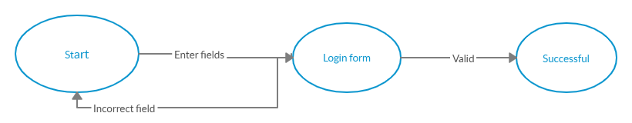

Figure 5.1

# 5.2.2.2 Add User

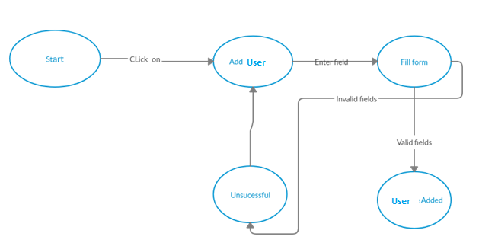

Figure 5.2

# 5.2.2.3 Update User

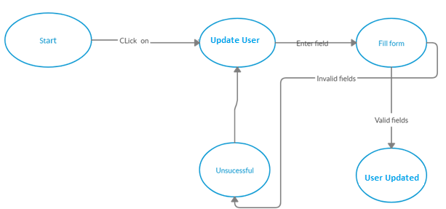

Figure 5.3

# 5.2.2.4 Delete User

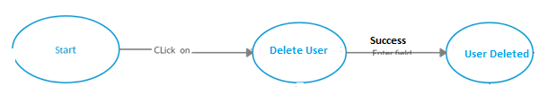 Figure 5.4

# 5.2.2.5 Add Product

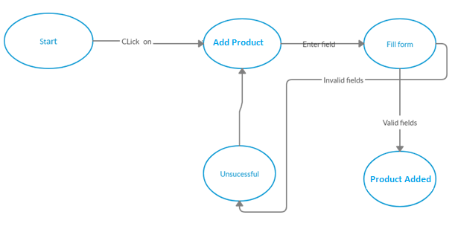 Figure 5.5

# 5.2.2.6 Update Product

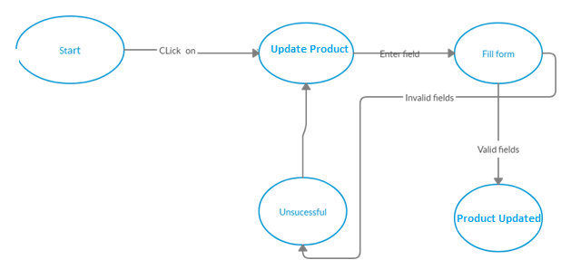 Figure 5.6

# 5.2.2.7 Delete Product

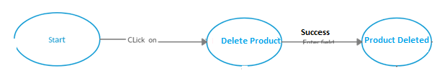 Figure 5.7

# 5.2.2.8 Add Order

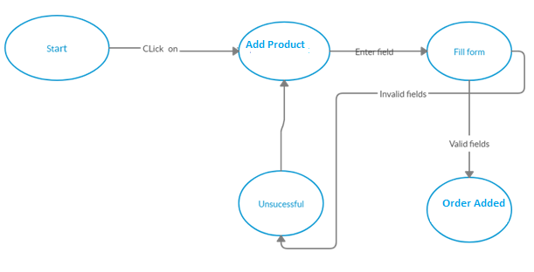 Figure 5.8

# 5.2.2.9 Update Order

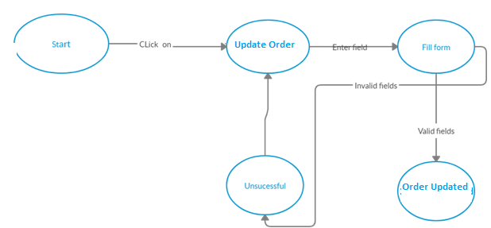 Figure 5.9

# 5.2.2.10 Delete Order

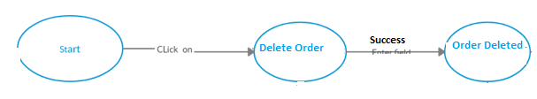

Figure 5.10

# 5.2.2.11 View Report

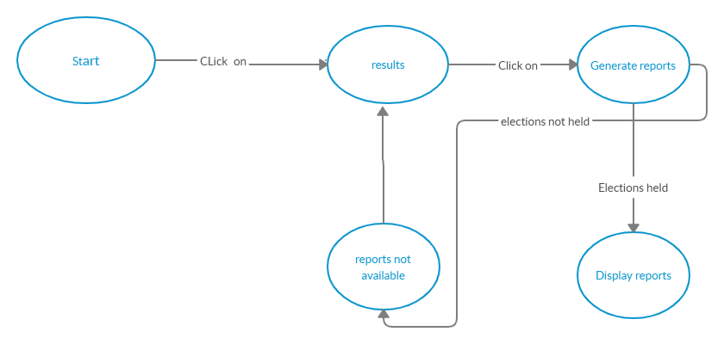 Figure 5.11

# 5.2.2.12 Logout

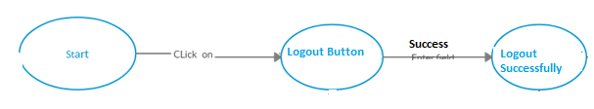

Figure 5.12

# 5.3 White Box Testing

White Box Testing based on an analysis of the internal structure of the component or system. In this method of testing the test cases are designed on the basis of analysis internal structure of the system based on Code coverage, branches coverage, paths coverage, condition Coverage etc. White box testing involves the testing by looking at the internal structure of the code and when you completely aware of the internal structure of the code then you can run your test cases and check whether the system meet requirements mentioned in the specification document. In this testing method user has to go beyond the user interface to find the correctness of the system.

## 

# 5.3.1 Cyclomatic

Cyclomatic complexity oftware metric that provides a quantitative measure of the logical complexity of a program. When used in the context of the basis path testing method, the value computed for cyclomatic complexity defines the number of independent paths in the basis set of a program and provides you with an upper bound for the number of tests that must be conducted to ensure that all statements have been executed at least once.

General rule to find Complexity is defined as:

**M = E –N + 2P**

E = Number of edges of the graph

N = Number of nodes of the graph

P = Number of connected components

|  |  |
| --- | --- |
| **Cyclomatic Complexity** | **Cyclomatic Complexity** |
| 1 to 10 | A simple program without very much risk |
| 11 to 20 | A more complex program, moderate risk |
| 21 to 50 | A complex, high risk program |
| >50 | An untested program (Very high risk) |

# 5.3.3 Performance Testing

Software Performance testing is type of testing perform to determine the performance of system to major the measure, validate or verify quality attributes of the system like responsiveness, stability under variety of load conditions. In software engineering, performance testing is in general testing performed to determine how a system performs in term of responsiveness and stability under a particular work load. It can also serve to investigate measure, validate or verify other quality attribute of the system.

# 5.3.4. Load Testing:

Load Testing is type of performance testing to check system with constantly increasing the load on the system until the time load is reaches to its threshold value. Here Increasing load means increasing number of concurrent users, transactions & check the behavior of application under test.

# 5.3.5 Stress Testing

A simulation technique used on asset and liability portfolios to determine their reactions to different financial situations. Stress tests are also used to gauge how certain stressors will affect a company or industry. They are usually computer generated simulation models that test hypothetical scenarios. This is also known as a "stress test". Stress testing is normally used to understand the upper limits of capacity within the system. This kind of test is done to determine the system’s robustness in term of extreme load and helps application administrators to determine if the system will perform sufficiently if the current load goes well above the expected maximum.

# Chapter 6: Tools and Techniques

Languages used in the system:

* Web Development
* Laravel
* JavaScript
* JQuery
* Programing Languages included
* Php for Super Admin/Admin panel
* Php for Admin pane
* XML for Mobile Application
* Java for Mobile Application
* MySQL for database

Tools Used for implementation:

* Android Studio 3.4.1
* Adobe XD
* Xampp 4.1.2
* Sublime Text
* Search Engine (google, yahoo, ask me)
* Web browser (chrome, Firefox, Opera)

# CHAPTER: 8 USER MANUAL

# 8.1 Login

This is the login authentication screen from where the admin shall log in to the system.

Steps

1. Choose role

2. Enter id and password

3. Click login

4. Done



# 8.3 Main Page

After successful login the user will redirect to main page.

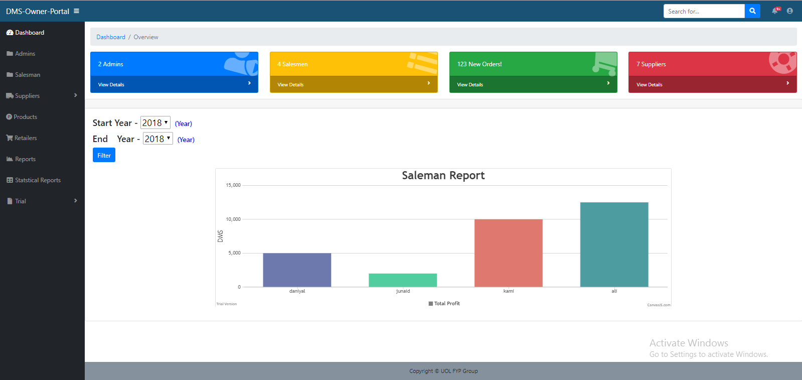

# 8.3 Add Admin

Steps

1. Click on admin option in the side bar

2. Click add admin button

3. Modal will pop up and fill the required fields

4. Press add button, the admin will created

5. Done

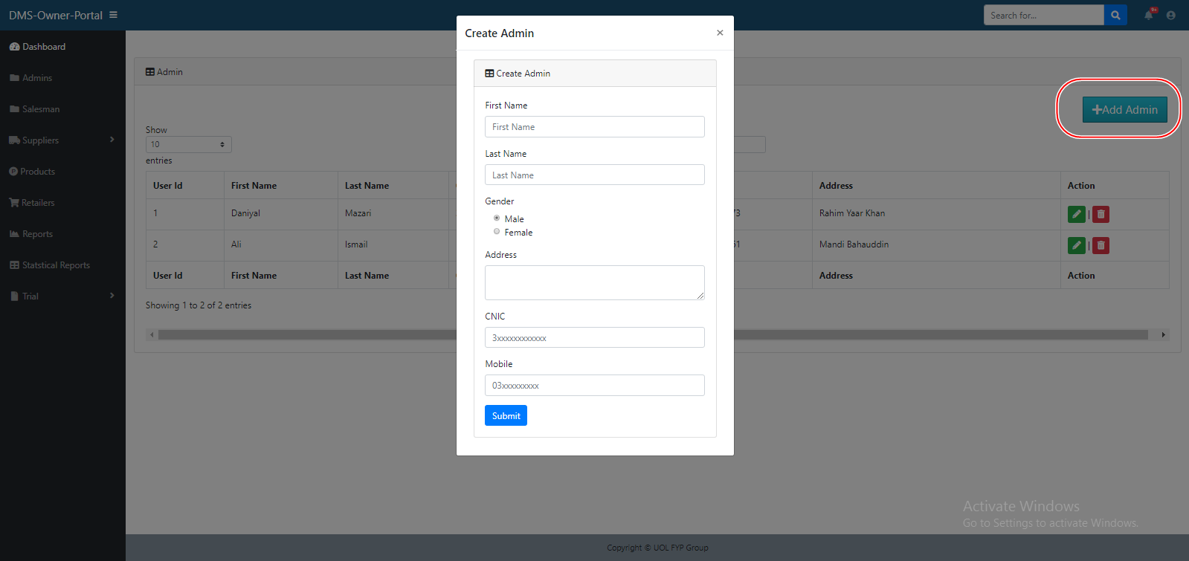

# 8.4 Update Admin

Steps

1. Click on admin option in the side bar

2. Click on the update admin button in the action column of a table of a specific user

3. Modal will pop up and update the required fields

4. Press update button, the admin will updated

5. Done

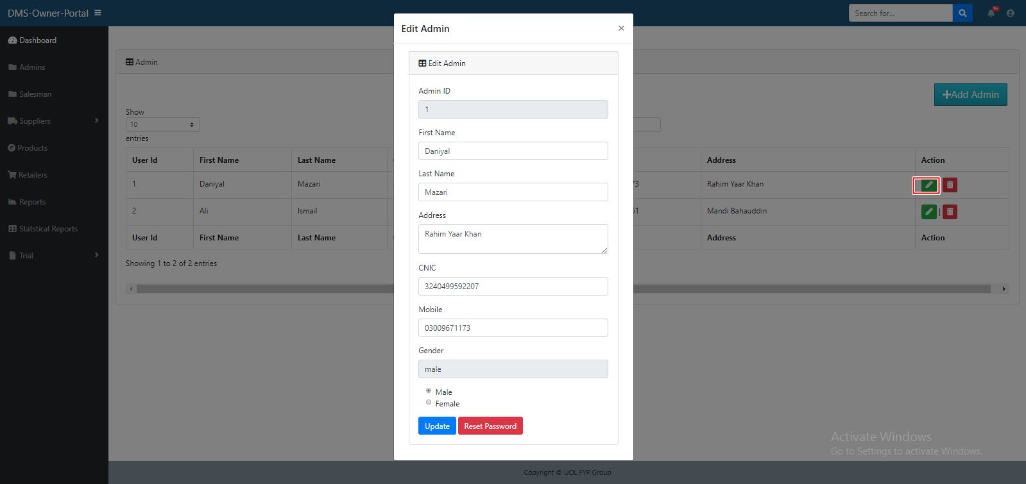

# 8.5 Remove Admin

Steps

1. Click on admin option in the side bar

2. Click on the delete admin button in the action column of a table of a specific user

3. The admin will removed

4. Done

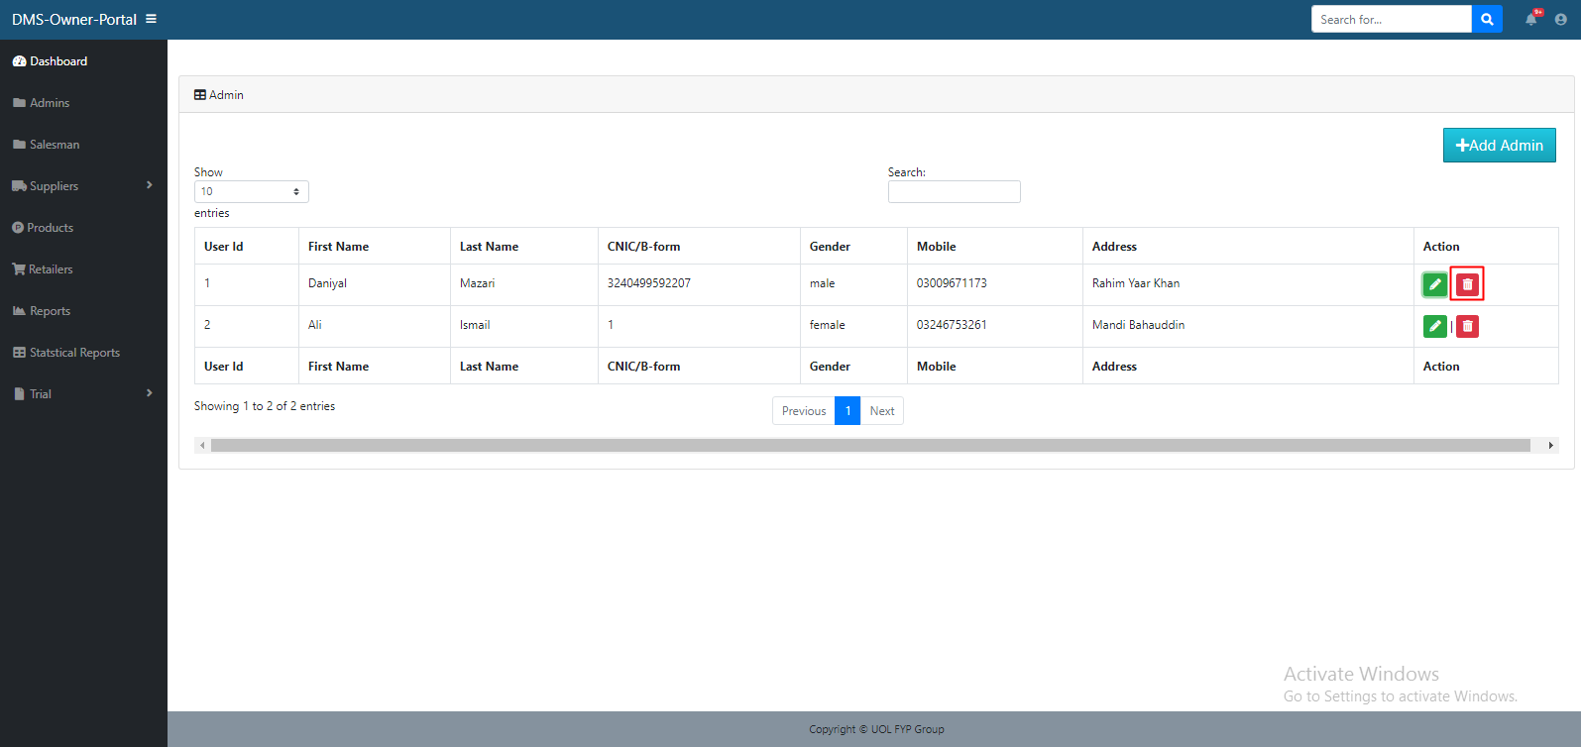

# 8.6 Add Salesman

Steps

1. Click on salesman option in the side bar

2. Click add salesman button

3. Modal will pop up and fill the required fields

4. Press add button, the salesman will created

5. Done

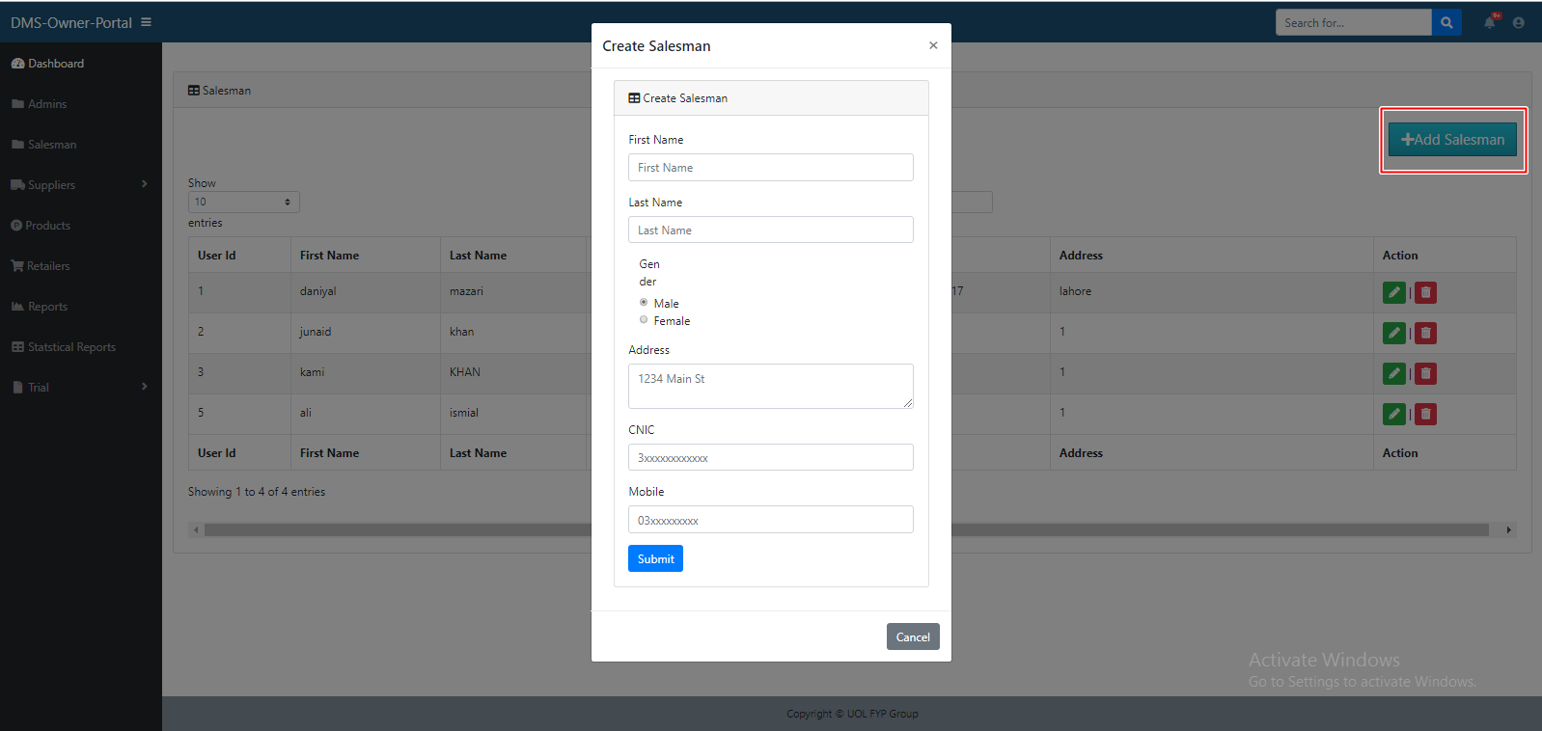

# 8.7 Update Salesman

Steps

1. Click on salesman option in the side bar

2. Click on the update salesman button in the action column of a table of a specific user

3. Modal will pop up and update the required fields

4. Press update button, the admin will updated

5. Done

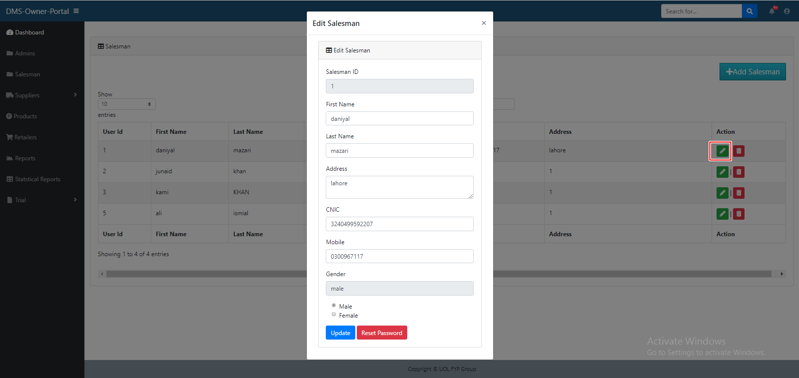

# 8.8 Remove Salesman

Steps

1. Click on salesman option in the side bar

2. Click on the delete salesman button in the action column of a table of a specific user

3. The salesman will removed

4. Done

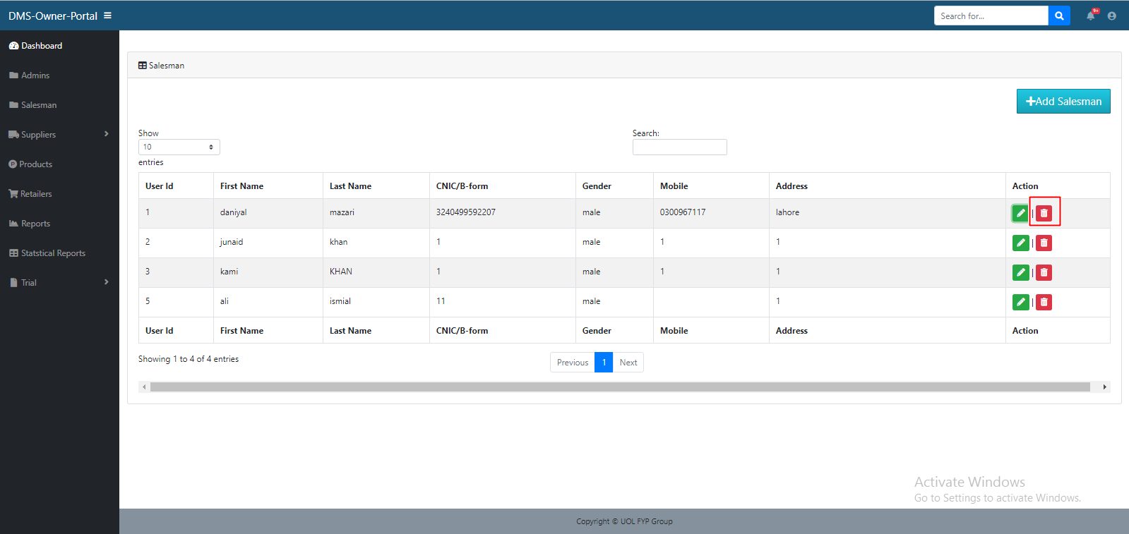

# 8.9 Add Category

Steps

1. Click on Supplier option in the side bar

2. Click on manage category in the side bar

3. Click add category button

4. Modal will pop up and fill the required fields

5. Press add button, the category will created

6. Done

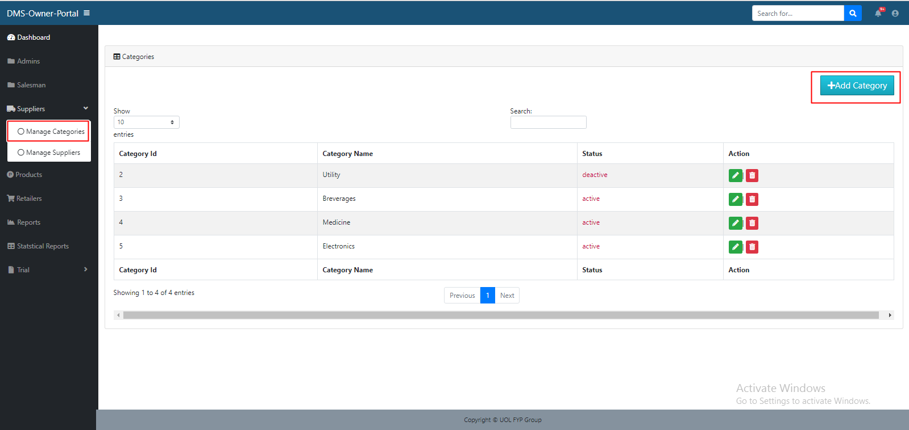

# 8.10 Update Category

Steps

1. Click on Supplier option in the side bar

2. Click on manage category in the side bar

3. Click on the update category button in the action column of a table of a specific user

4. Modal will pop up and update the required fields

5. Press update button, the category will updated

6. Done

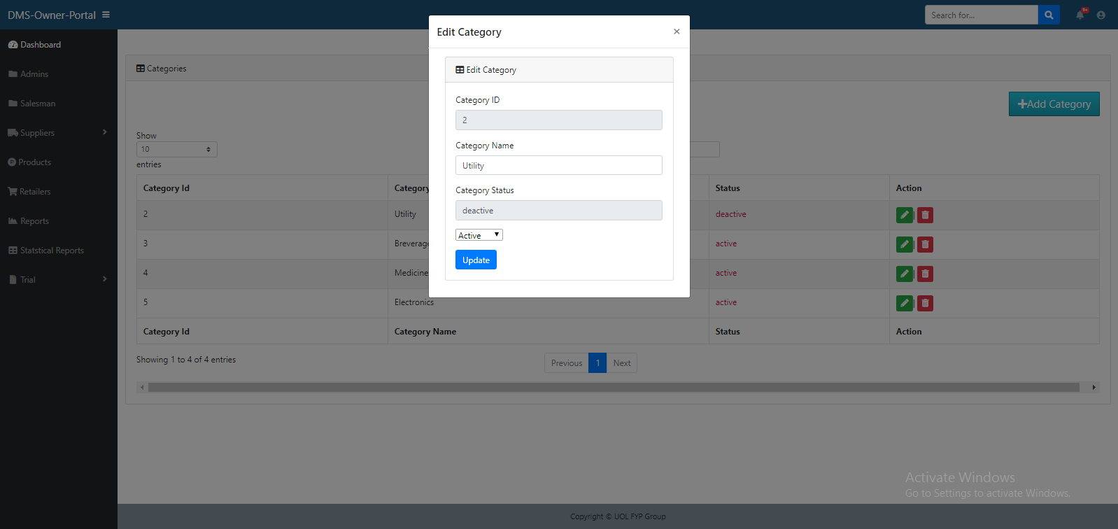

# 8.11 Remove Category

Steps

1. Click on Supplier option in the side bar

2. Click on manage category in the side bar

3. Click on the delete category button in the action column of a table of a specific user

4. The category will removed

5. Done

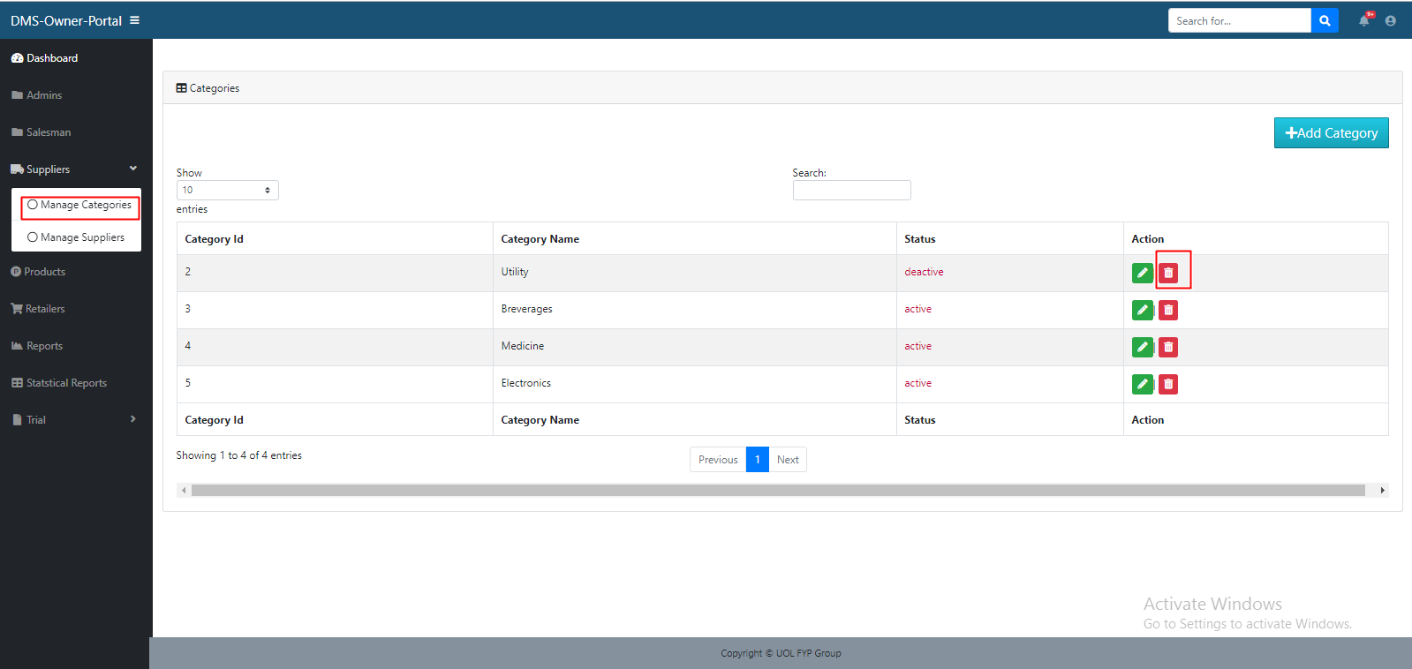

# 8.12 Add Supplier

Steps

1. Click on Supplier option in the side bar

2. Click on manage supplier in the side bar

3. Click add supplier button

4. Modal will pop up and fill the required fields

5. Press add button, the supplier will created

6. Done

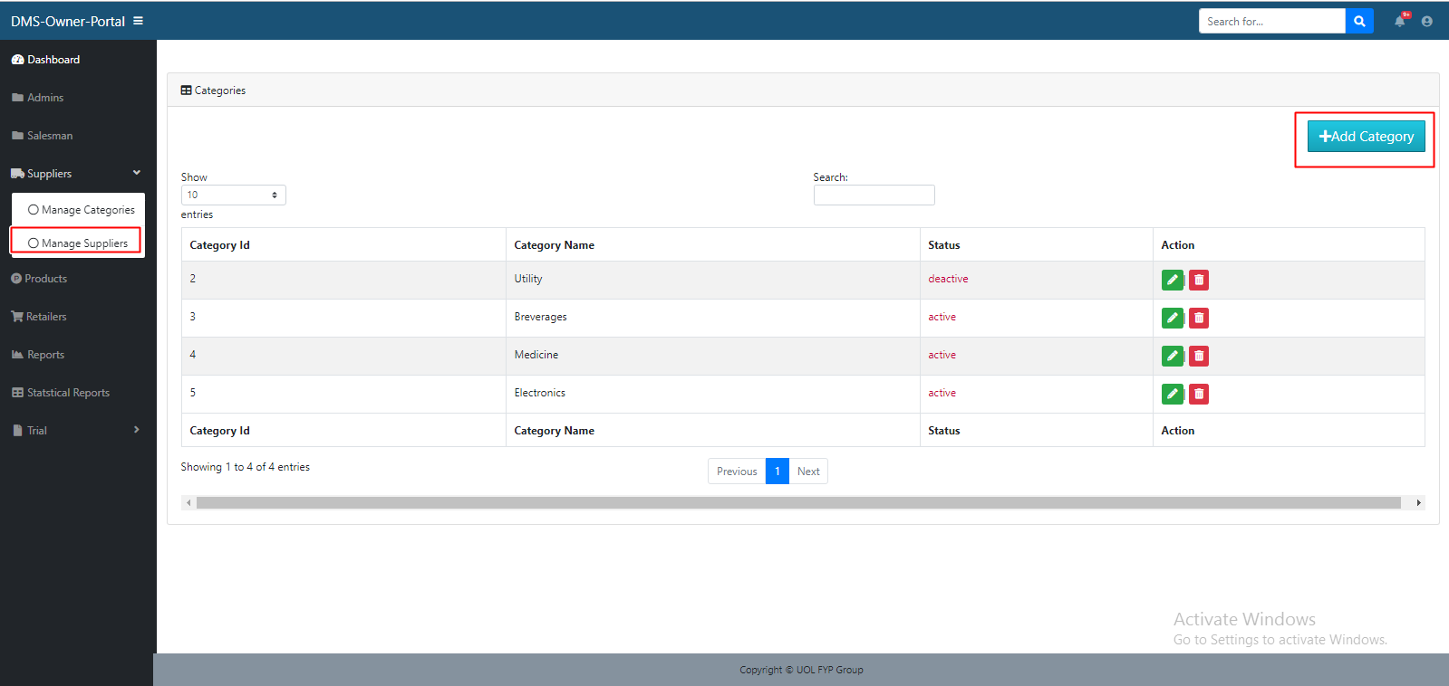

# 8.13 Update Supplier

Steps

1. Click on Supplier option in the side bar

2. Click on manage supplier in the side bar

3. Click on the update supplier button in the action column of a table of a specific user

4. Modal will pop up and update the required fields

5. Press update button, the supplier will updated

6. Done

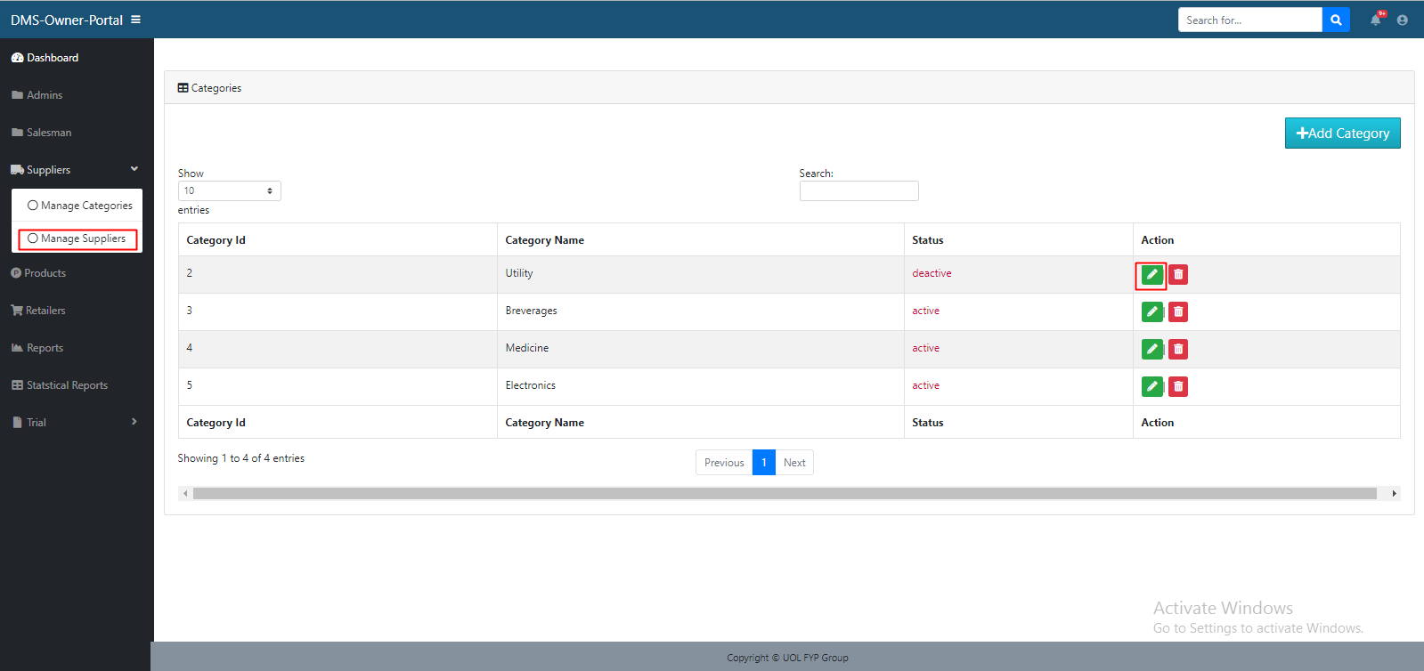

# 8.14 Remove Category

Steps

1. Click on Supplier option in the side bar

2. Click on manage category in the side bar

3. Click on the delete category button in the action column of a table of a specific user

4. The category will removed

5. Done



# 8.15 Add Product

Steps

1. Click on product option in the side bar

2. Click add product button

3. Modal will pop up and fill the required fields

4. Press add button, the product will created

5. Done

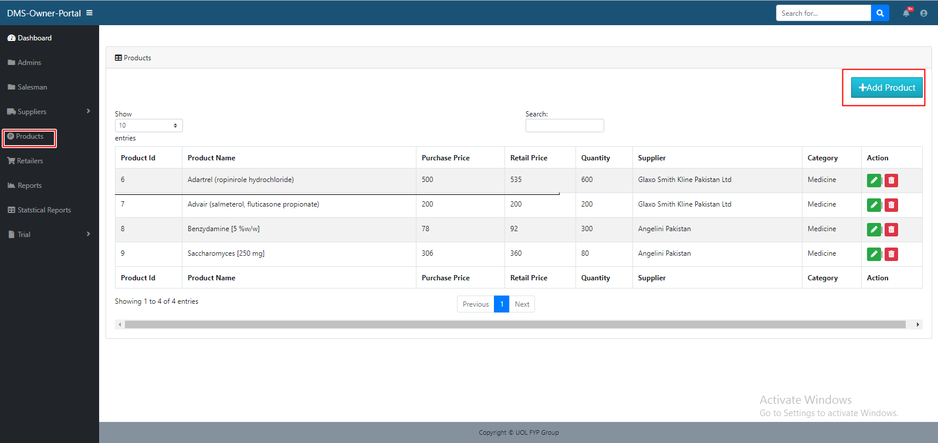

# 8.16 Update Product

Steps

1. Click on product option in the side bar

2. Click on the update product button in the action column of a table of a specific user

3. Modal will pop up and update the required fields

4. Press update button, the product will updated

5. Done

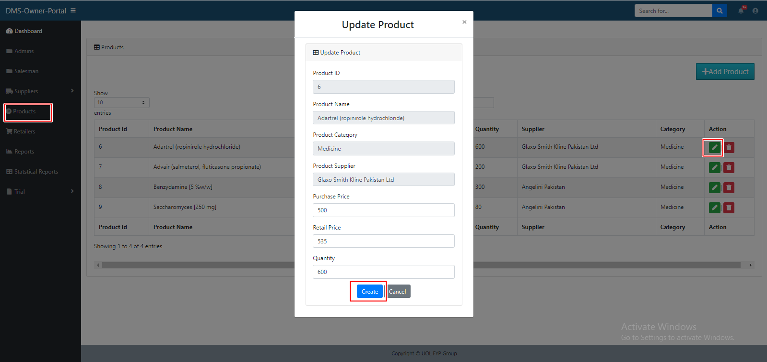

# 8.17 Remove Product

Steps

1. Click on product option in the side bar

2. Click on the delete product button in the action column of a table of a specific user

3. The product will removed

4. Done

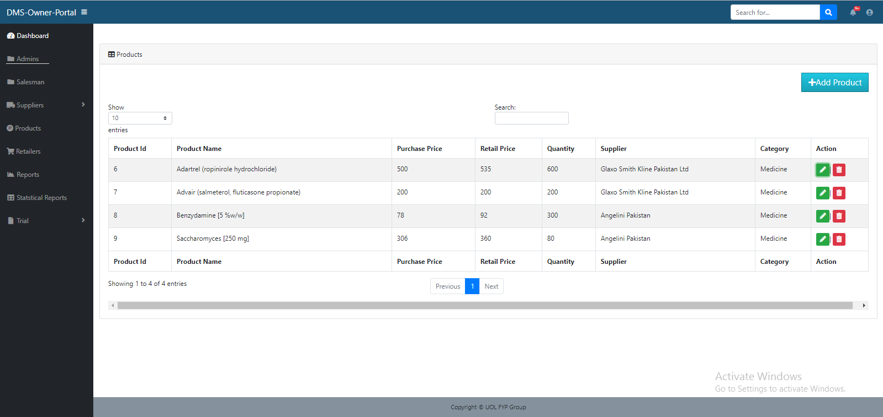

# 8.18 Add Retailer

Steps

1. Click on retailer option in the side bar

2. Click add retailer button

3. Modal will pop up and fill the required fields

4. Press add button, the retailer will created

5. Done

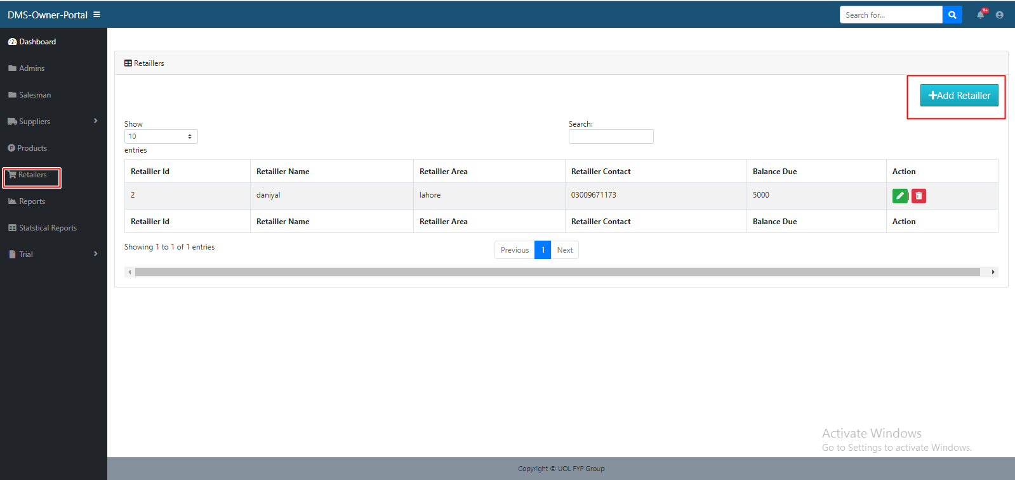

# 8.19 Update Retailer

Steps

1. Click on retailer option in the side bar

2. Click on the update retailer button in the action column of a table of a specific user

3. Modal will pop up and update the required fields

4. Press update button, the retailer will updated

5. Done

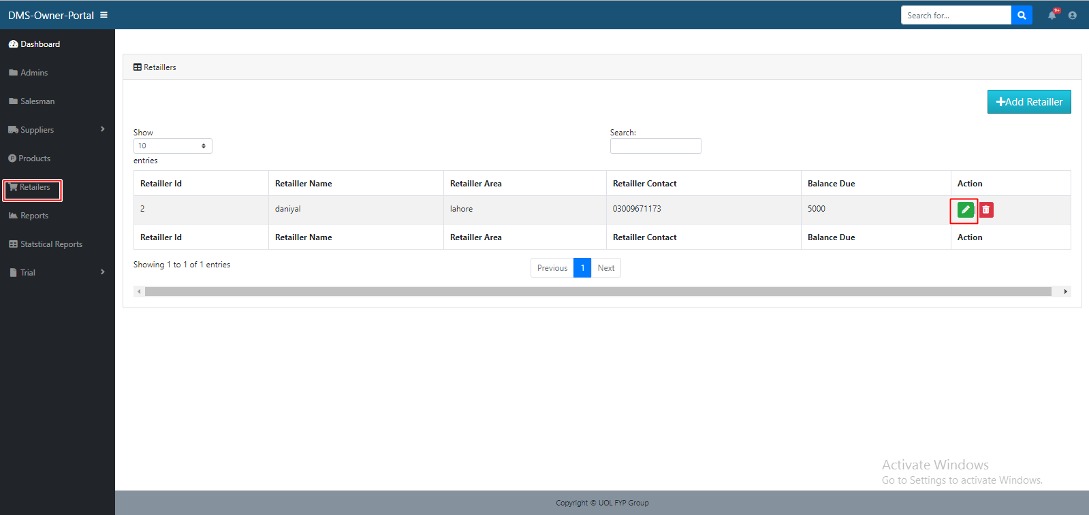

# 8.20 Remove Retailer

Steps

1. Click on retailer option in the side bar

2. Click on the delete retailer button in the action column of a table of a specific user

3. The retailer will removed

4. Done

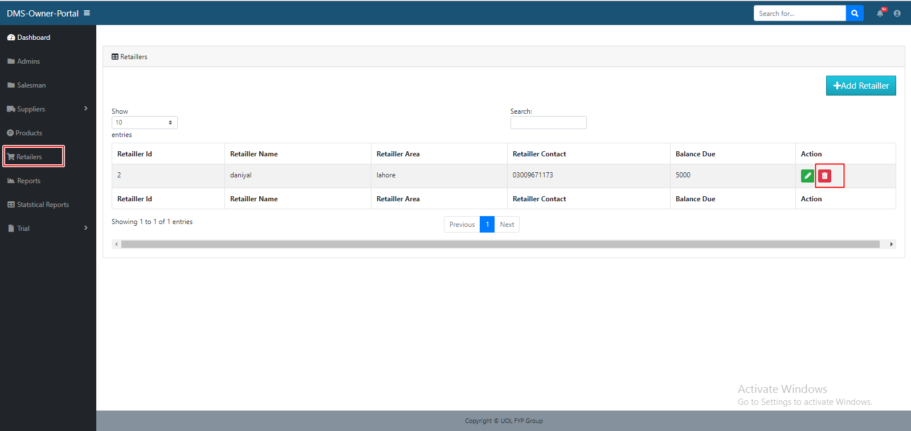

# 8.21 View Salesman Report

Steps

1. Select the start year

2. Select the end year

3. Press the filter button

4. The graph will show the report of salesman

4. Done

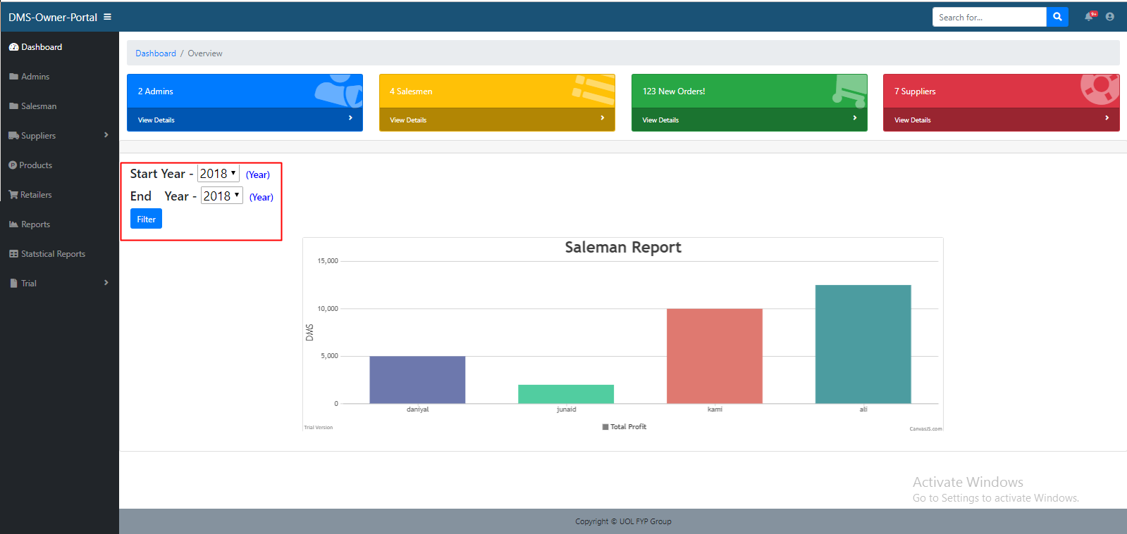

# 8.21 Profile Setting

Steps

1. Press the user icon on the right side of nav.

2. Press the profile setting menu

3. Fill the required field in modal

4. Press update button, updated successfully

5. Done

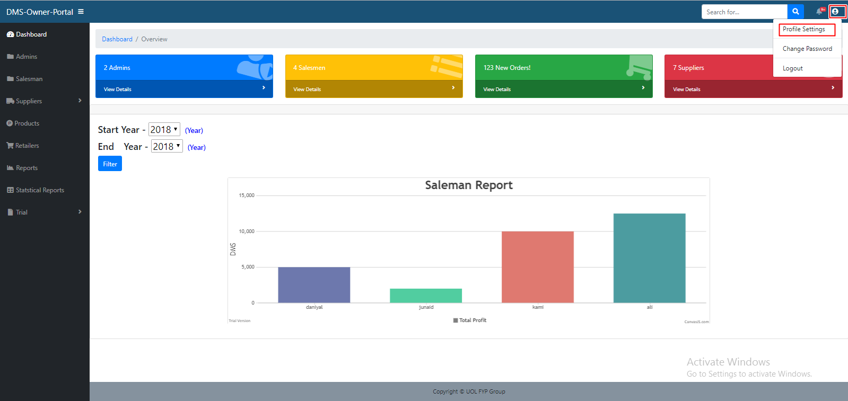

# 8.22 Change Password

Steps

1. Press the user icon on the right side of nav.

2. Press the change password menu

3. Fill the required field in modal

4. Press update button, updated successfully

5. Done

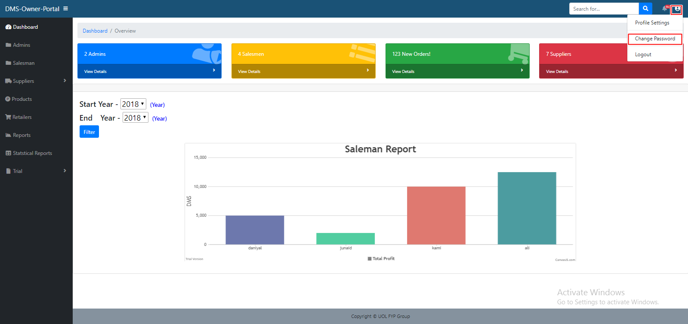

# 8.23 Logout

Steps

1. Press the user icon on the right side of nav.

2. Press the logout menu

3. Press logout button, logout successfully

4. Done

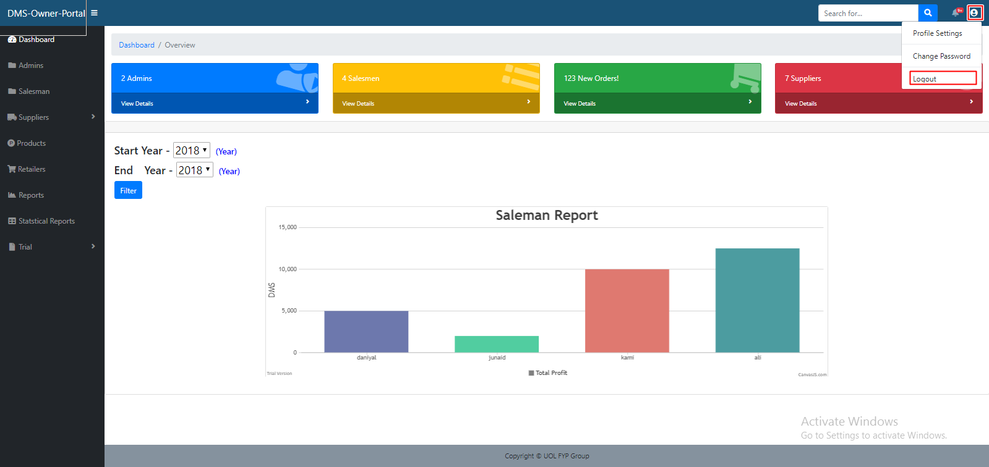

# 8.25 Salesman Login

This is the login authentication screen from where the admin shall log in to the system.

Steps

1. Enter id and password

2. Click login

3. Done

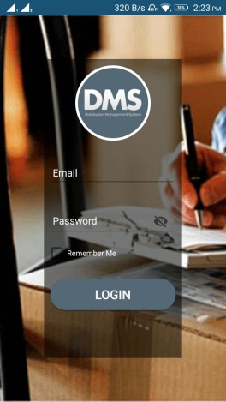

# 8.26 Salesman Main Page

After successful login the user will redirect to main page.

# 

# 8.27 Salesman Make Order

Steps

1. Click the Make Order menu

2. Add Products and its quantity

3. Click continue button

4. Order is created

4. Done

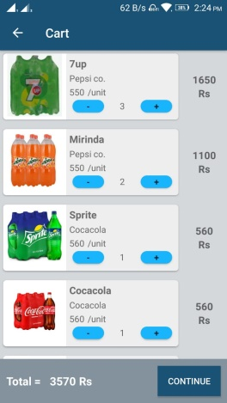

# 8.28 Salesman Make Order

Steps

1. Click the view Order menu

2. Orders are displayed

2. Done

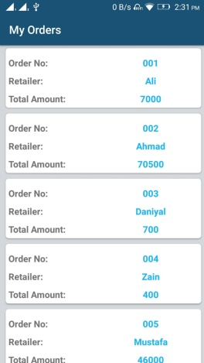

# 8.29 Salesman Profile Setting

Steps

1. Click the Edit Profile menu

2. Fill the Required fields

3. Click save button

4. User profile is upgraded

5. Done

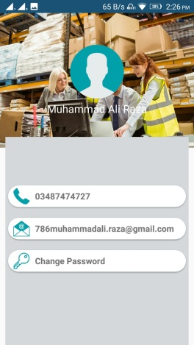

# 8.30 Salesman Logout

Steps

1. Click the logout menu

2. User is successfully logout

3. Done

