Result and Oupts:

We apply different algorithm RandomForest Regression ,Arima, LSTM(Neural Network ) But the best was LSTM. Long Short Term Memory networks – usually just called “LSTMs” – are a special kind of RNN, capable of learning long-term dependencies. LSTMs are explicitly designed to avoid the long-term dependency problem. Remembering information for long periods of time is practically their default behavior, not something they struggle to learn. A long short-term memory network (LSTM) is one of the most commonly used neural networks for time series analysis. The ability of LSTM to remember previous information makes it ideal for such tasks.we apply epochs on our training data.we get following results:-

**At 500 Epochs**

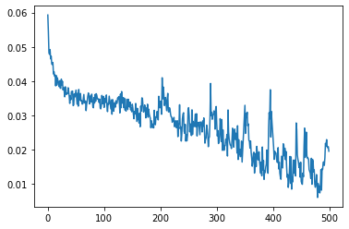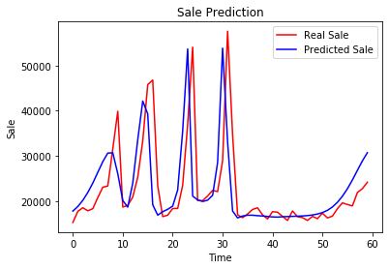

**At 1000 Epochs**

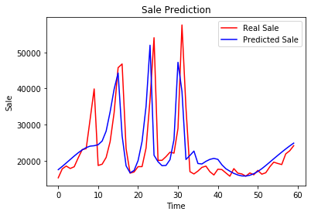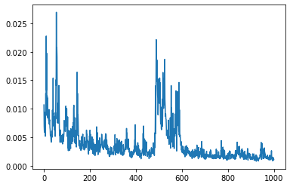

**At 1500 Epochs**

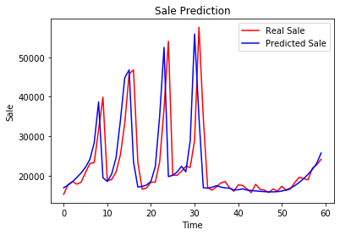

The Picture with only blue line is representing loss, as we increasing the epochs the loss value is decreasing gradually.In the output, the blue line represents the actual Sale prices while the red line represents the predicted Sale prices. You can clearly see that our algorithm has been able to capture the overall trend. The predicted prices also see a bullish trend at the beginning followed by a bearish or downwards trend at the end.

At the end we try it on our Pos and these are the results :

