Lab 05

Objective
The objective of this lab is to implement and train ADALINE (ADAptive LInear NEuron) and MADALINE (Multiple ADAptive LInear NEurons) networks, understand the delta rule and mean-squared-error learning objective, and evaluate trained models on a logic-gate task and a real dataset.

Activity Outcomes
The activities provide hands-on practice with the following topics:
- Explain the architecture and learning principle of ADALINE and MADALINE.
- Derive and apply the ADALINE delta rule using the linear net input and mean-squared error.
- Train an ADALINE model to learn the AND logic gate.
- Describe the MADALINE architecture and the basic idea of MADALINE Rule II (MRII).
- Train a small MADALINE-style binary classifier on the Iris dataset and interpret training/validation loss curves.
- Evaluate model performance and complete the graded practical tasks.

Required software: Python, NumPy, Matplotlib, and scikit-learn.

5) Useful Concepts

Part A — ADALINE Neural Network
1.1 What is ADALINE?
ADALINE stands for ADAptive LInear NEuron. It was introduced by Bernard Widrow and Marcian Hoff. ADALINE is a single-layer neural model whose weights are learned by minimizing a continuous error signal. Unlike the perceptron learning rule, which updates weights using a thresholded class prediction, ADALINE calculates its training error from the linear net input.
1.2 Architecture and Diagram
For inputs x₁, x₂, …, xₙ, the net input is z = b + Σ(wᵢxᵢ). During training, z is compared directly with the target t. A threshold may be applied to z after training to produce a binary class.
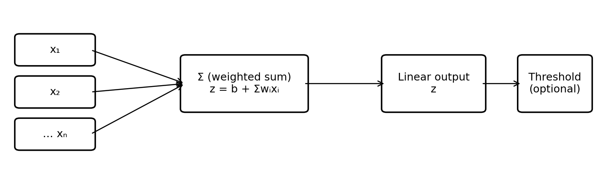
Figure 1: ADALINE architecture — weighted sum, linear output, optional threshold.
1.3 Important Equations
- Net input: z = b + wᵀx
- Squared error for one example: E = ½(t − z)²
- Batch mean-squared error: MSE = (1/N) Σ(t − z)²
- Delta-rule updates for one example: wᵢ ← wᵢ + η(t − z)xᵢ; b ← b + η(t − z), where η is the learning rate.
- For batch gradient descent, average the gradient across the training examples before updating the parameters.
1.4 ADALINE Training Algorithm (Online Delta Rule)
1. Initialize weights and bias to small values (or zeros); select learning
rate η and number of epochs.
2. For each training pair (x, t), compute linear output z = b + wᵀx.
3. Compute continuous error e = t − z.
4. Update each weight: wᵢ ← wᵢ + η e xᵢ, and update bias: b ← b + ηe.
5. After each epoch, calculate MSE over the training set.
6. Stop when MSE is sufficiently small or the epoch limit is reached.
7. For binary prediction, apply a threshold to the final linear output.
1.5 ADALINE versus Perceptron
Feature | ADALINE | Perceptron
Training error | Uses continuous linear output | Uses thresholded prediction
Learning method | Delta rule / gradient descent on squared error | Perceptron update rule
Decision | Threshold applied for classification | Step function is part of prediction
Strength | Smooth error objective | Simple online linear classifier

Part B — MADALINE Neural Network
2.1 What is MADALINE?
MADALINE stands for Multiple ADAptive LInear NEurons. It combines multiple ADALINE units, typically arranged as a hidden layer followed by an output unit. The additional units allow the network to form more complex decision regions than a single linear neuron.
2.2 Architecture and Diagram
A typical MADALINE has an input layer, a layer of ADALINE units, and an output unit. Each hidden unit computes a weighted sum and applies a bipolar sign activation (−1 or +1). The output combines hidden-unit decisions. Different MADALINE variants use different output rules and learning procedures.
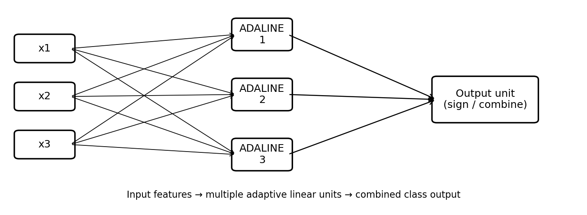
Figure 2: MADALINE architecture — input features → multiple adaptive linear units → combined class output.
2.3 MADALINE Learning: Key Ideas
- MADALINE is a family of networks and learning rules; the exact update depends on the variant.
- MADALINE Rule I (MRI) uses a particular error-correction strategy for hidden-unit/output behavior.
- MADALINE Rule II (MRII) adjusts selected hidden ADALINE units when the network output is incorrect, often choosing units whose net inputs are closest to the decision boundary.
- MRIII is another historical learning-rule variant.
- The classic rules use bipolar targets and threshold/sign outputs. A practical implementation must state its chosen rule and coding convention.
2.4 Simplified MRII-Style Learning Algorithm
The solved activity below uses a compact MRII-inspired procedure for a binary Iris task: two hidden ADALINE units, bipolar hidden/output signs, and hidden-unit adjustments selected by closeness to the boundary. It is an educational implementation, not a claim to reproduce every historical MADALINE variant exactly.
1. Encode binary class labels as −1 and +1; standardize input features
using training-set statistics only.
2. Initialize input-to-hidden weights and hidden biases; choose a
learning rate.
3. For each sample, compute hidden net inputs and bipolar hidden
outputs.
4. Combine hidden outputs into the network output and compare it with
the target.
5. If correct, leave weights unchanged. If incorrect, select a hidden
unit whose net input is closest to zero and whose adjustment can
move the output toward the target.
6. Update the selected hidden unit using an error-correction step;
repeat over epochs.
7. Track training and validation loss using the continuous output
score, and evaluate classification accuracy using the sign of the
score.

6) Solved Lab Activities
Sr. No. | Allocated Time (min) | Level of Complexity | CLO Mapping
1 | 30 | Medium | CLO-5
2 | 45 | High | CLO-6

Activity 1: Train ADALINE for the AND Gate
Objective:
Train a one-neuron ADALINE on the AND truth table. Inputs and targets are coded as 0/1. The model learns the linear output using squared error; a 0.5 threshold converts output to a binary prediction.
Truth Table
x₁ | x₂ | Target
0 | 0 | 0
0 | 1 | 0
1 | 0 | 0
1 | 1 | 1

Complete Solved Code
import numpy as np
import matplotlib.pyplot as plt

# AND gate dataset
X = np.array([[0, 0], [0, 1], [1, 0], [1, 1]], dtype=float)
y = np.array([0, 0, 0, 1], dtype=float)

# Reproducible initialization
rng = np.random.default_rng(7)
w = rng.normal(0, 0.1, size=2)
b = 0.0
learning_rate = 0.1
epochs = 300

loss_history = []

for epoch in range(epochs):
# Online ADALINE updates
for xi, target in zip(X, y):
output = np.dot(xi, w) + b # linear output (not thresholded)
error = target - output
w += learning_rate * error * xi
b += learning_rate * error

# MSE after the epoch
outputs = X @ w + b
mse = np.mean((y - outputs) ** 2)
loss_history.append(mse)

print("Weights:", w)
print("Bias:", b)
print("\nInput | Linear output | Predicted | Target")
for xi, target, output in zip(X, y, X @ w + b):
predicted = int(output >= 0.5)
print(xi.astype(int), f"{output:.3f}", predicted, int(target))

plt.plot(loss_history)
plt.xlabel("Epoch")
plt.ylabel("Training MSE")
plt.title("ADALINE on AND Gate — Learning Curve")
plt.grid(True)
plt.show()
A. Final Parameters
The reported run after 300 epochs produced the following learned parameters:
- Weight 1: 0.5556
- Weight 2: 0.5278
- Bias: −0.2778
B. Classification Results
Final classification accuracy: 100% (4 out of 4 samples). The ADALINE model successfully learns the AND gate.
Input X₁ | Input X₂ | Linear Output | Predicted | Target
0 | 0 | −0.278 | 0 | 0
0 | 1 | 0.250 | 0 | 0
1 | 0 | 0.278 | 0 | 0
1 | 1 | 0.806 | 1 | 1

C. Learning Curve
The training mean squared error (MSE) decreases during training. Reported values: initial MSE ≈ 0.1401; final MSE ≈ 0.0637.
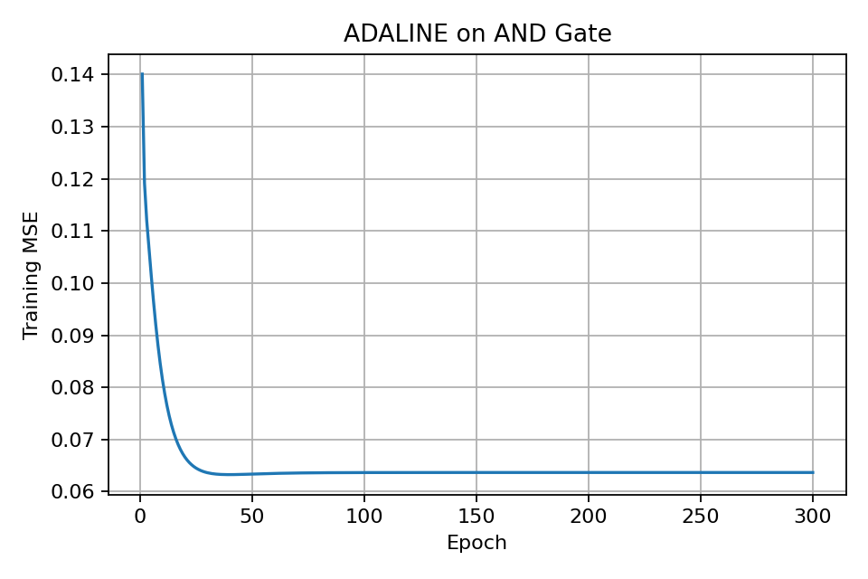
Figure 3: ADALINE on AND gate — training MSE per epoch.
How to Interpret the Result
- The output table should show predicted labels matching 0, 0, 0, 1 after successful convergence.
- The training MSE should generally decrease and then level off.
- ADALINE can learn AND because the AND classes are linearly separable.
Note: Online updates can make the loss curve non-monotonic. A learning rate that is too large may cause oscillation. If needed, reduce the learning rate and increase the epoch count.
Check Your Understanding
- Why is the raw linear output used to calculate the ADALINE error?
- What role does the learning rate play?
- Why can a single ADALINE learn AND but not XOR?

Activity 2: MADALINE-Style Classifier on Iris Dataset
Objective:
Use the Iris dataset for binary classification: Iris-setosa (−1) versus the other two species (+1). Four flower measurements are used as input features. A stratified train/validation/test split is used, and both training and validation loss are plotted.
Why binary? The classic MADALINE sign-output rules are naturally binary. Multiclass Iris classification requires an explicitly designed multiclass extension or one-vs-rest collection of binary MADALINE models.
Complete Solved Code
import numpy as np
import matplotlib.pyplot as plt
from sklearn.datasets import load_iris
from sklearn.model_selection import train_test_split
from sklearn.preprocessing import StandardScaler

# 1) Load Iris: setosa=-1, versicolor/virginica=+1
iris = load_iris()
X = iris.data.astype(float)
y = np.where(iris.target == 0, -1.0, 1.0)

# 2) Split: 60% train, 20% validation, 20% test
X_train, X_temp, y_train, y_temp = train_test_split(
X, y, test_size=0.40, random_state=42, stratify=y
)
X_val, X_test, y_val, y_test = train_test_split(
X_temp, y_temp, test_size=0.50, random_state=42, stratify=y_temp
)

# Fit scaler ONLY on training data to avoid data leakage
scaler = StandardScaler()
X_train = scaler.fit_transform(X_train)
X_val = scaler.transform(X_val)
X_test = scaler.transform(X_test)

class SimpleMadaline:
# Educational MRII-inspired binary network: two hidden ADALINE units.
def __init__(self, n_features, n_hidden=2, lr=0.02, seed=12):
rng = np.random.default_rng(seed)
self.W = rng.normal(0, 0.15, (n_features, n_hidden))
self.bh = np.zeros(n_hidden)
self.v = np.ones(n_hidden) # hidden-to-output combination
self.bo = 0.0
self.lr = lr

def forward(self, X):
hidden_net = X @ self.W + self.bh
hidden = np.where(hidden_net >= 0, 1.0, -1.0)
# Continuous score for loss; sign gives class
score = hidden @ self.v + self.bo
return hidden_net, hidden, score

def predict(self, X):
_, _, score = self.forward(X)
return np.where(score >= 0, 1.0, -1.0)

def fit(self, X, y, X_val, y_val, epochs=100):
train_losses, val_losses = [], []
for epoch in range(epochs):
for xi, target in zip(X, y):
nets, hidden, score = self.forward(xi.reshape(1, -1))
nets, hidden, score = nets[0], hidden[0], float(score[0])

pred = 1.0 if score >= 0 else -1.0
if pred != target:
# Select hidden unit closest to threshold (MRII-inspired)
j = int(np.argmin(np.abs(nets)))
# Move selected unit's net input toward target sign.
# A small margin avoids updates that stop exactly at zero.
desired = 0.5 * target
error = desired - nets[j]
self.W[:, j] += self.lr * error * xi
self.bh[j] += self.lr * error

# Keep the output combination aligned with target
self.v[j] = target
self.bo += self.lr * (target - score) * 0.1

# Continuous-score MSE for monitoring (not thresholded 0/1 loss)
tr_score = self.forward(X)[2]
va_score = self.forward(X_val)[2]
train_losses.append(np.mean((y - tr_score) ** 2))
val_losses.append(np.mean((y_val - va_score) ** 2))

return train_losses, val_losses

model = SimpleMadaline(n_features=X_train.shape[1], n_hidden=2, lr=0.02)
train_loss, val_loss = model.fit(
X_train, y_train, X_val, y_val, epochs=100
)

# 3) Evaluate
train_acc = np.mean(model.predict(X_train) == y_train)
val_acc = np.mean(model.predict(X_val) == y_val)
test_acc = np.mean(model.predict(X_test) == y_test)
print(f"Train accuracy: {train_acc:.3f}")
print(f"Validation accuracy: {val_acc:.3f}")
print(f"Test accuracy: {test_acc:.3f}")

# 4) Learning curves
plt.plot(train_loss, label="Training loss")
plt.plot(val_loss, label="Validation loss")
plt.xlabel("Epoch")
plt.ylabel("Mean squared error (continuous score)")
plt.title("MADALINE-style Iris Classifier: Learning Curves")
plt.legend()
plt.grid(True)
plt.show()
A. Dataset Information
Binary classification setup:
- Class −1: Iris-setosa
- Class +1: Iris-versicolor and Iris-virginica
Dataset Split | Samples
Training | 90
Validation | 30
Testing | 30
Total | 150

B. Classification Results
Dataset | Accuracy
Training | 100%
Validation | 100%
Testing | 100%

C. Learning Curve and Loss
Loss is computed as mean squared error between bipolar targets (−1/+1) and continuous output scores.
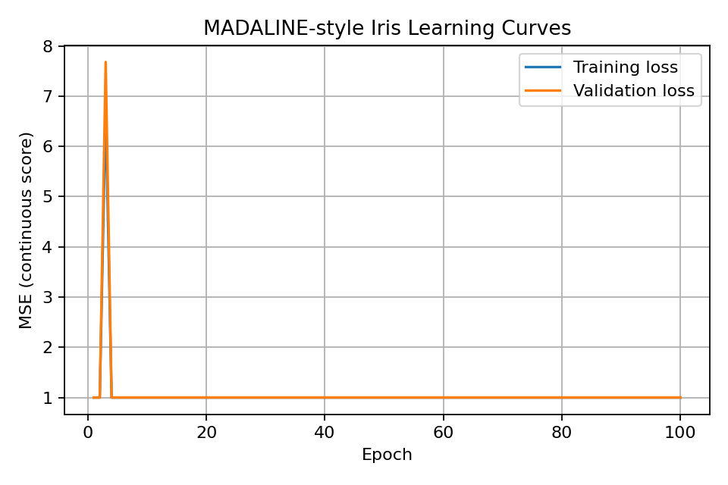
Figure 4: MADALINE-style Iris classifier — training and validation loss curves.
Reported final values:
Metric | Final Loss
Training Loss | 0.9995
Validation Loss | 1.0009

Interpretation: Accuracy can be high while this particular score-based MSE remains around 1.0 because the simplified implementation uses hard-threshold hidden activations and does not optimize a conventional differentiable loss.
Interpretation of the Learning Curves
- Training loss reflects the mean squared error between bipolar targets (−1/+1) and the continuous network score.
- Validation loss measures the same quantity on unseen validation examples. It is not cross-entropy.
- If training loss decreases while validation loss rises, the model may be overfitting.
- If both losses remain high, the architecture or learning procedure may be underfitting or failing to converge.
- Compare test accuracy only after model choices are finalized. Do not tune repeatedly on the test set.
Important limitation: This compact implementation is MRII-inspired for teaching the core idea of adjusting hidden ADALINE units. It is not a canonical, rigorously validated implementation of the original MADALINE Rule II. For research-grade results, specify and implement a particular published MADALINE variant precisely.
Troubleshooting
- If the curve is unstable, lower the learning rate (for example, 0.01).
- If predictions collapse to one class, inspect class encoding, output sign convention, and hidden-unit updates.
- Because hard-threshold networks have discontinuous outputs, their loss curves can be flat or jumpy.
- Results can vary with initialization; run several random seeds and report mean and standard deviation for a more reliable experiment.

7) Graded Lab Tasks

Graded Task 1 — ADALINE
Task: Implement ADALINE from scratch to learn the OR gate using the bipolar coding convention (inputs and targets −1/+1). Do not use a neural-network library for the weight updates.
Requirement | What to submit | Marks
Dataset and coding | Truth table for OR using bipolar values | 5
Algorithm | Correct net input, error, and delta-rule updates | 15
Training evidence | MSE per epoch and a learning curve | 10
Evaluation | Final weights/bias and predictions for all four inputs | 10
Discussion | Explain convergence and compare AND/OR separability with XOR | 10
Total |  | 50

Graded Task 2 — MADALINE
Task: Extend the MADALINE-style Iris experiment by changing the hidden-unit count and comparing two settings (for example, 2 and 4 hidden ADALINE units). Keep the same stratified split and training-only scaling. Clearly identify the learning-rule variant used.
Requirement | What to submit | Marks
Data preparation | Explain binary target encoding and split; prevent leakage | 10
Model implementation | Architecture and documented update rule | 15
Learning curves | Training and validation loss curves for both settings | 10
Evaluation | Validation and test accuracy with confusion matrix | 10
Discussion | Compare hidden-unit settings and explain limitations | 5
Total |  | 50

Submission Checklist
- Python source code with comments and reproducible random seeds.
- Truth table / dataset preparation details.
- Plots with axis labels, legends, and descriptive titles.
- Final metrics and a brief interpretation of results.

