**SOFTWARE PROJECT-3**

**Academic Performance Evaluation System**



***MASTER’S DEGREE IN COMPUTER APPLICATIONS (M.C.A.)***

***GUJARAT TECHNOLOGICAL UNIVERSITY***

**UNDER THE GUIDANCE OF**

**Prof. Anjum Mansuri**

**DEVELOPED BY**

**Sufyan Mansuri [205170694116]**

**Roshan Chachre [205170694014]**

**GROUP NO: -** MCA\_4\_74

**L. J. INSTITUTE OF COMPUTER APPLICATIONS**

**(*Affiliated to Gujarat Technological University)***

**Nr. Nagdev Kalyan Mandir, Nr. Sarkhej Cross Roads, Sarkhej-Gandhinagar Highway, Ahmedabad – 382210.**

***Acknowledgement***

It is our privilege to express our sincerest regards to our faculty and project guide, **[Prof. / Dr.] Anjum Mansuri**, for their valuable inputs, able guidance, encouragement, whole-hearted cooperation and constructive criticism throughout the duration of our project. We deeply express our sincere thanks to our Director Dr. Bhavin Shah for encouraging and allowing us to present the project on the topic “**Academic Performance Evaluation System**.” at our department premises for the partial fulfilment of the requirements leading to the award of Masters of Computer Application (MCA) degree. We take this opportunity to thank all our lecturers who have directly or indirectly helped in our project. Last but not the least we express our thanks to our friends for their cooperation and support.

**Mansuri Mohammed Sufyan Mohammed Taufiq**

**Roshan Rajendra Chachre**

**L.J. INSTITUTE OF COMPUTER APPLICATIONS**

Near Nagdev Kalyan Mandir, Near Sarkhej Cross Roads,

Sarkhej-Gandhinagar Highway, Ahmedabad - 382210  
Ph. No.: 079 29296364



***CERTIFICATE***

**Enrollment No**: **205170694116**

This is to certify that Mr. / Ms. **Mansuri Mohammed Sufyan Mohammed Taufiq** studying in Master of Computer Applications, Semester IV, Roll No **32** has satisfactorily completed his/her Project Titled **Academic Performance Evaluation System** under the supervision of

**Prof. Anjum Mansuri** **Signature**

**Date of Submission:**

**Director**

**L.J. INSTITUTE OF COMPUTER APPLICATIONS**

Near Nagdev Kalyan Mandir, Near Sarkhej Cross Roads,

Sarkhej-Gandhinagar Highway Ahmedabad - 382210  
Ph. No.: 079 29296364



***CERTIFICATE***

**Enrollment No**: **205170694014**

This is to certify that Mr. / Ms. **Roshan Rajendra Chachre** studying in Master of Computer Applications, Semester IV, Roll No **10** has satisfactorily completed his/her Project Titled **Academic Performance Evaluation System** under the supervision of

**Prof. Anjum Mansuri** **Signature**

**Date of Submission:**

**Director**

**INDEX**

**SR. NO. CONTENTS PAGE**

1. Introduction 6
   1. Existing System 6
   2. Need for The New System 7
   3. Objective of the New System 7
   4. Problem Definition 8
   5. Core Components 8
   6. Project Profile 9
   7. Assumptions & Constraints 10
   8. Advantages & Limitation of the Proposed System
2. Requirement Determination & Analysis 12
   1. Requirement Determination 12
   2. Targeted Users 12
3. System Design 13
   1. Use Case Diagram 13
   2. Class Diagram 14
   3. Sequence Diagram 15
   4. Activity Diagram 18
   5. Data Dictionary 20
4. Development 23
   1. Coding Standards 23
   2. Screenshots 24
5. Agile Documentation 31
   1. Agile Project Charter 31
   2. Agile Project Plan 32
   3. Agile User Story 33
   4. Agile Release Plan 34
   5. Agile Test Plan 36
   6. Burn Chart 38
6. Proposed Enhancements 39
7. Conclusion 40
8. Bibliography 41
9. **Introduction**

* Student Performance with Graph & Academic Project Work Reporting System is a web-based application developed using MERN Stack and PowerBI. This application provides an easy way to student and teacher in searching the details of their academic attendance, marks percentage and Academic Performance based on attendance, marks (grades) details with graph.
  1. **Existing System**
* Student performance means their actions when the students are completing some tasks, roles or obligation. That is related to the word “students’ performance” and now when it comes to the word “evaluation”, it means the examination, judgment, appraisal and assignment a value of a particular performance.
* Currently all this is done using pen & paper. The student assignment submission, attendance and exam results are all stored on a sheet of paper. The teacher then evaluates the student based on these parameters and puts marks.
  1. **Need for The New System**
* As we saw that the entire process is done using pen & paper which can be difficult to manage sometimes. Also, there’s a chance of the paper sheet getting destroyed or lost.
* In the proposed system all this problem will be solved as there will be no paper involved in the new system and the data cannot be lost as it is stored in a secure remote database.
  1. **Scope and Objective**
* The proposed system provides the faculty an easy and accurate data about attendance reports and Academic percentages reports and Students details reports.
* The proposed system provides the student an easy and accurate data about attendance and academic percentages. Students can view all the information in just one click which saves a lot of time and effort. The proposed system maintains a database to store all the information. In this system, there is no chance of losing data. Adding and searching the information is very easy which does not take much time and physical effort.
  1. **Problem Definition**
* The goal of the project is to analyse and visualize student details, attendance, faculty details and student performance in a useful and meaningful way.
* This can be achieved by using PowerBI which is a business integration tool developed by Microsoft.
* Before the visualization of the data, it needs to be noise free that is dataset needs to be cleaned which can be done in PowerBI.
  1. **Core Components**
* **Faculty Module**
  + Authentication
  + Manage Student Attendance
  + Manage Student Performance
  + Manage Profile
  + View Reports
* **Student Module**
  + Authentication
  + View Attendance
  + View Performance
* **Admin Module**
  + Authentication/Authorization
  + Manage Users
  + Manage Students
  + Manage Results Details
  + Manage Profile
  + View Reports
  1. **Project Profile**
     + **Name: Academic Performance Evaluation System**
* **Technologies**
  + **Front-end (ReactJS)**
    - HTML
    - CSS
    - JavaScript
  + **Back-end**
    - NodeJS
    - PowerBI
    - MongoDB
    - Express
    - AdminJS
  1. **Assumptions & Constraints**
     1. **Assumptions**
* All group members have required skills.
* All of the PC/Laptops are in good conditions.
* All needed resources will be available.
* Active internet connection is available to all members.
  + 1. **Constraints**
* Project needs to completed in the given timeline.
* Group members need to learn MERN (MongoDB, Express, ReactJS and NodeJS) stack as well as Power Bi (Data Cleaning & Visualization).
* Requirements for the installation of PowerBI
  + Windows 8.1 or Later
  + .NET 4.6.2 or later
  1. **Advantages & Limitations of the Proposed System**
     1. **Advantages**
     + This evaluation system is more accurate than conventional methods.
     + Student Information uploaded once should not be lost and errors can be corrected.
     + This system is very beneficial for education institutes or universities for academic performance evaluation of student efficiently.
     1. **Limitations**
* Wrong data entry for attendance or marks may causes problems in accuracy of academic performance.

1. **Requirement Determination & Analysis**
   1. **Requirement Determination**

* To develop a web application with the tools to handle all the tasks that are needed for student’s academic performance evaluation as well as visualize the data in a meaningful way so that the user can analyze it easily.
* The application should be very easy to use enabling even a novice person to use it.
* Our team determined that the application can be built using the combination MERN and PowerBI.
  1. **Targeted Users**
     + Students
     + Faculty
     + Admin

1. **System Design**
   1. **Use Case Diagram**

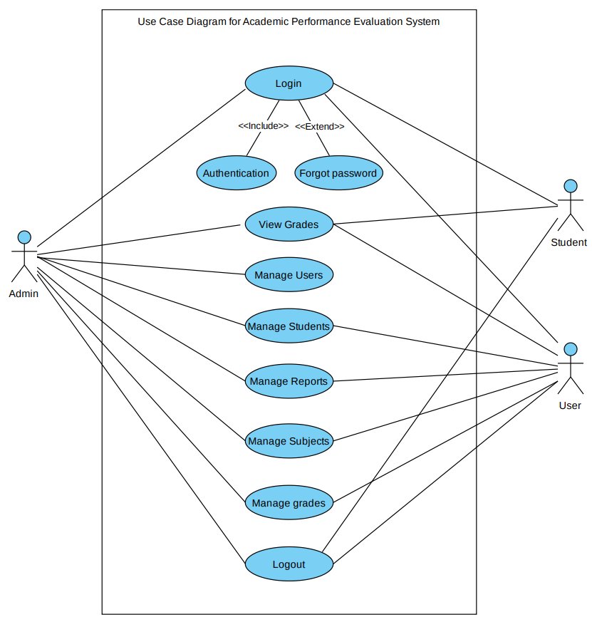

* 1. **Class Diagram**

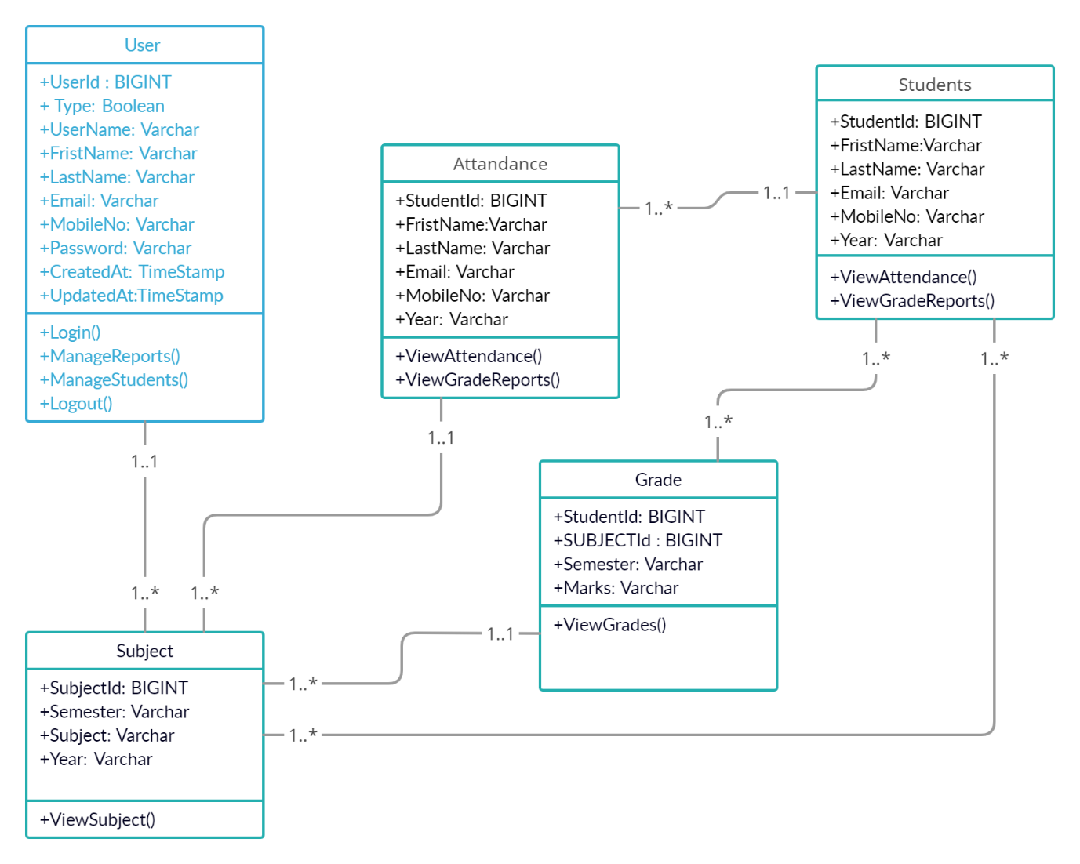

* 1. **Interaction Diagram**

**Login**

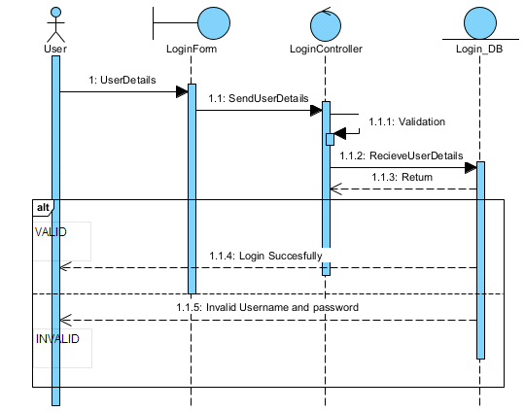

**Register**

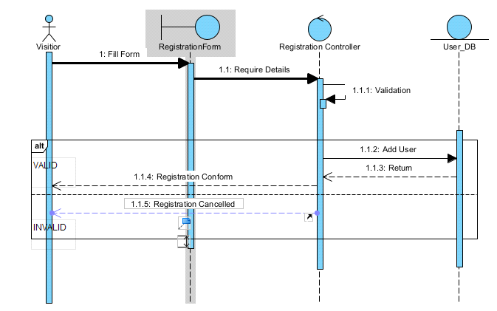

**Manage Grades**

**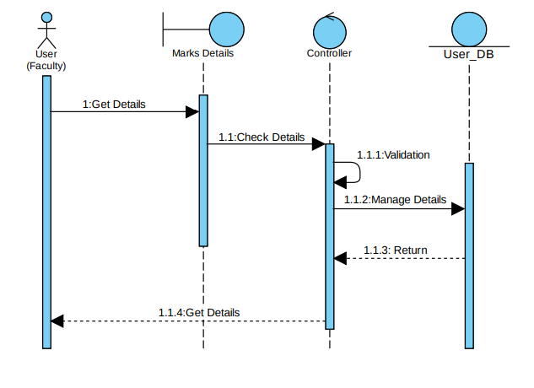**

* 1. **Activity Diagram**

**Admin**

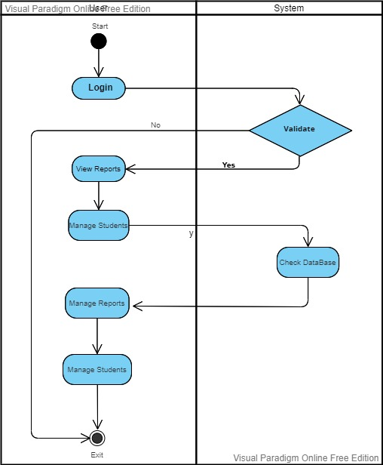

**Student**

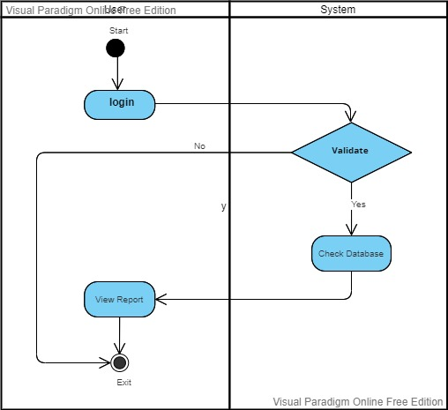

* 1. **Data Dictionary**
* Table: **User**
* Description: Stores user & login details.
* Primary Key: **UserId**

|  |  |  |  |  |
| --- | --- | --- | --- | --- |
| Field | Type | Constraints | Description | Sample Data |
| UserId | BIGINT (15) | PRIMARY KEY | Id of user | 1 |
| Type | BOOLEAN (1) | NOTNULL | 1: user  0: admin | 1 |
| Username | VARCHAR (50) | NOT NULL,  UNIQUE | Website Name of User | SufyanMansuri |
| FirstName | VARCHAR (50) | - | Name of User | Sufyan |
| LastName | VARCHAR (50) | - | Last Name of User | Mansuri |
| Email | VARCHAR (320) | NOT NULL,  UNIQUE | Email of User | sufi@gmail.com |
| MobileNo | VARCHAR (13) | UNIQUE | Mobile No of user | +919687557156 |
| Password | VARCHAR (120) | NOTNULL | Password of User account | pbkdf2\_sha256$260000… |
| CreatedAt | TIMESTAMP | NOTNULL | Date & Time of User Created | 2022-03-25T18:39:41.694+00:00 |
| UpdatedAt | TIMESTAMP | NOTNULL | Date & Time of User Created | 2022-03-25T18:39:41.694+00:00 |

* + Table: **Student**
  + Description: Stores student details.
  + Primary Key: **StudentId**

|  |  |  |  |  |
| --- | --- | --- | --- | --- |
| Column | Type | Constraints | Description | Sample Data |
| StudentId | BIGINT (15) | PRIMARYKEY | Id of user | 1 |
| FirstName | VARCHAR (50) | - | Frist Name of User | Roshan |
| LastName | VARCHAR (50) | - | Last Name of User | Rajendra |
| Email | VARCHAR (320) | NOT NULL,  UNIQUE | Email of User | sufi@gmail.com |
| MobileNo | VARCHAR (13) | UNIQUE | Mobile No of user | +919687557156 |
| Semester | VARCHAR (5) | - | Semester Details | Sem-1 |
| Year | VARCHAR (10) | - | Enrolled Year | 2022 |

* Table: **Subject**
* Description: Stores subject information and the term that they belong to.
* Primary Key: **SubjectId**

|  |  |  |  |  |
| --- | --- | --- | --- | --- |
| Column | Type | Constraints | Description | Sample Data |
| SubjectId | BIGINT (15) | NOTNULL | Id of Subjects | 1 |
| Semester | VARCHAR (5) | - | Semester Details | Sem-1 |
| Subject | VARCHAR (50) | - | Name of Subject | Java |
| Year | VARCHRE (10) | - | Year details | 2022 |

* Table: **Grades**
* Description: Stores grades/marks of students in individual subjects.
* Primary Key: **StudentId + SubjectId**

|  |  |  |  |  |
| --- | --- | --- | --- | --- |
| Column | Type | Constraints | Description | Sample Data |
| StudentId | BIGINT (15) | FOREIGNKEY | Id of student | 1 |
| SubjectId | BIGINT (15) | FOREIGNKEY | Id of Subjects | 1 |
| Semester | VARCHAR (5) | - | Semester Details | Sem-1 |
| Marks | VARCHAR (3) | - | Marks of Students | 76 |

* Table: **Attendance**
* Description: Stores student’s attendance details.
* Primary Key: **StudentId + SubjectId**

|  |  |  |  |  |
| --- | --- | --- | --- | --- |
| Column | Type | Constraints | Description | Sample Data |
| StudentId | BIGINT (15) | FOREIGNKEY | Id of Student | 1 |
| SubjectId | BIGINT (15) | FOREIGNKEY | Id of Subjects | 1 |
| Semester | VARCHAR (5) | - | Semester Details | Sem-1 |
| Attendance | DECIMAL (5,2) | NOTNULL,  MIN: 0, MAX: 100 | Attendance Percent | 81.00 |

1. **Development**
   1. **Coding Standards**

* Coding standard of this projects were
  + At Least one blank line between functions.
  + At least two blank lines between classes.
  + Proper Indentation in every type of file.
  + Single space before and after operators, except in parameters.
  + Every item on new line.
  + Every word should be case sensitive in variable and function names.
  1. **Screenshots**

**Login Page**

**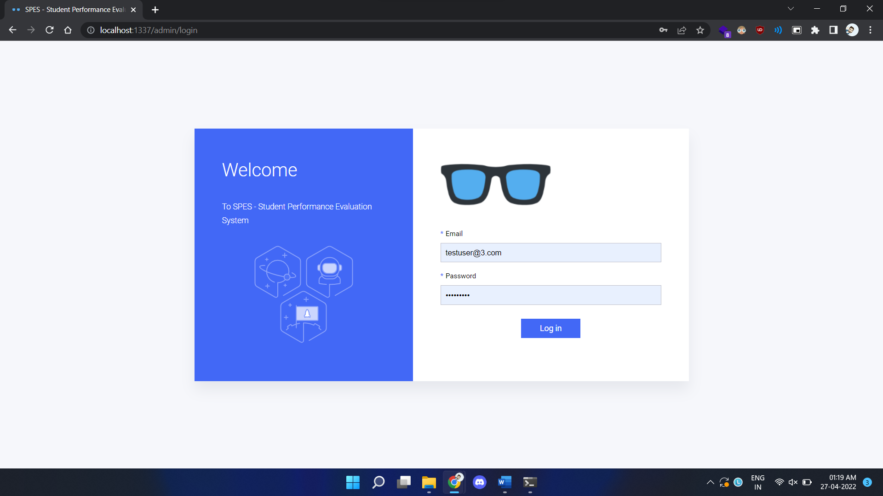**

**Login Page** ➜ **Validations**

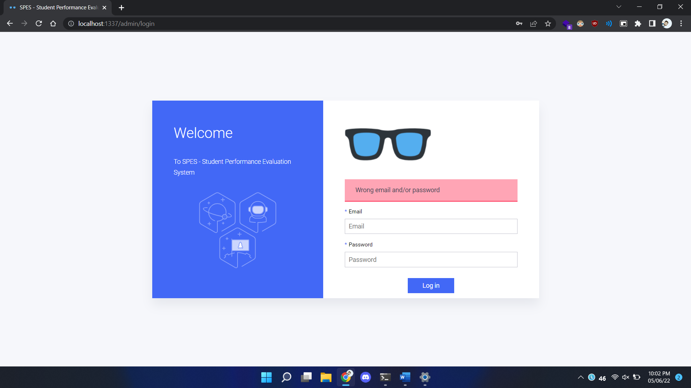

**Admin Panel** ➜ **Users**

**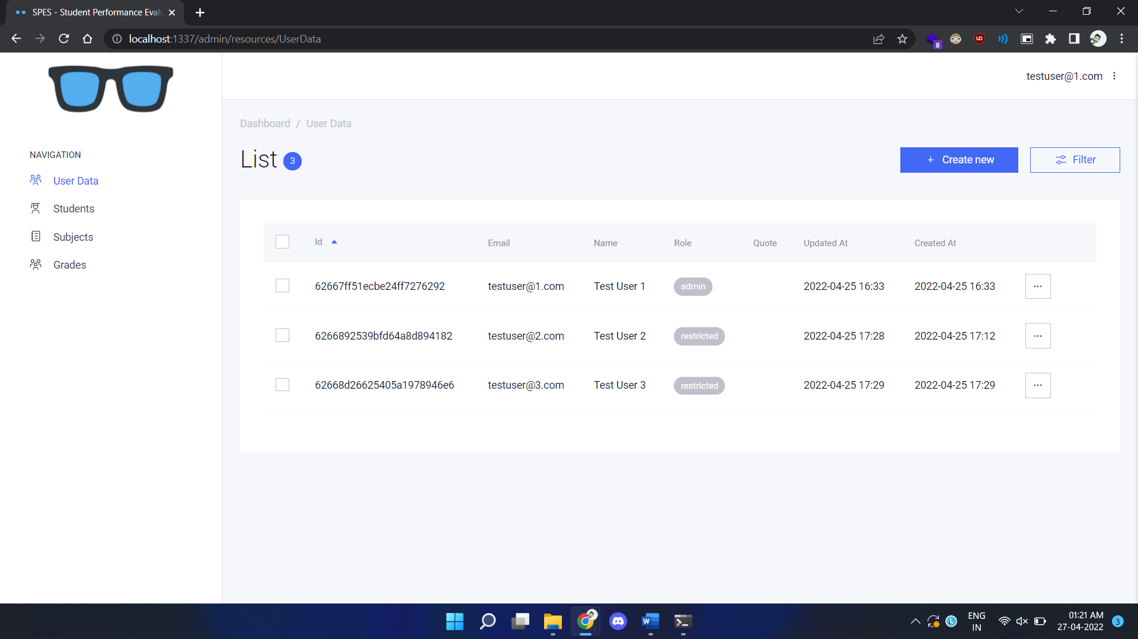**

**Show User Details**

**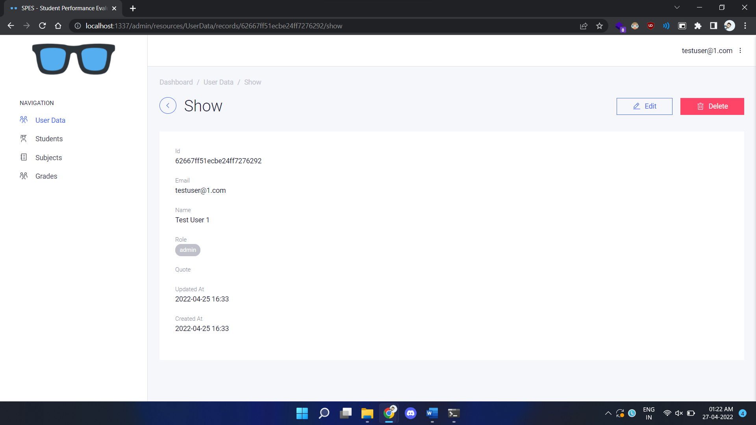**

**Add New User**

**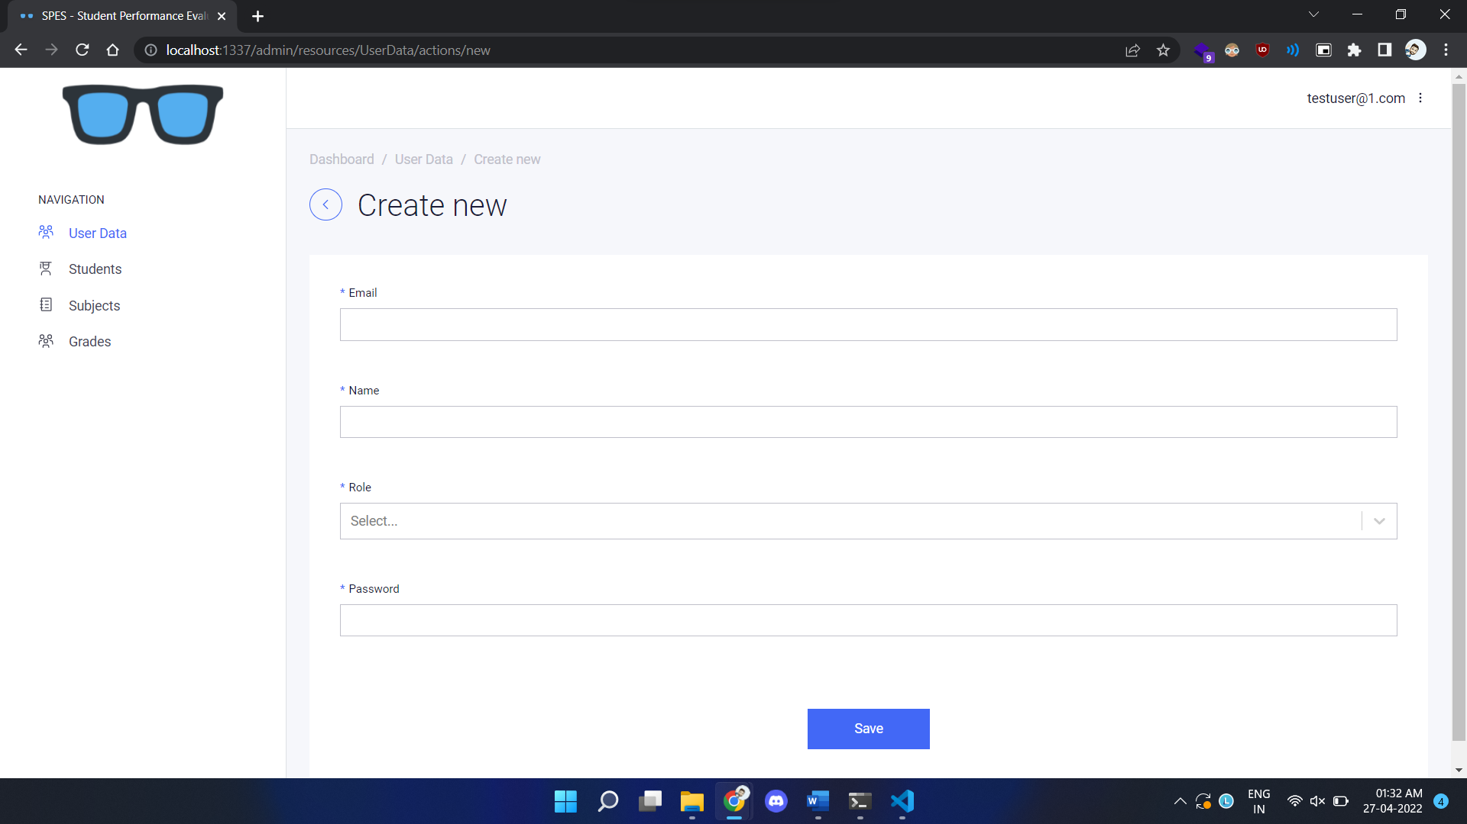**

**Add New User** ➜ **Validations**

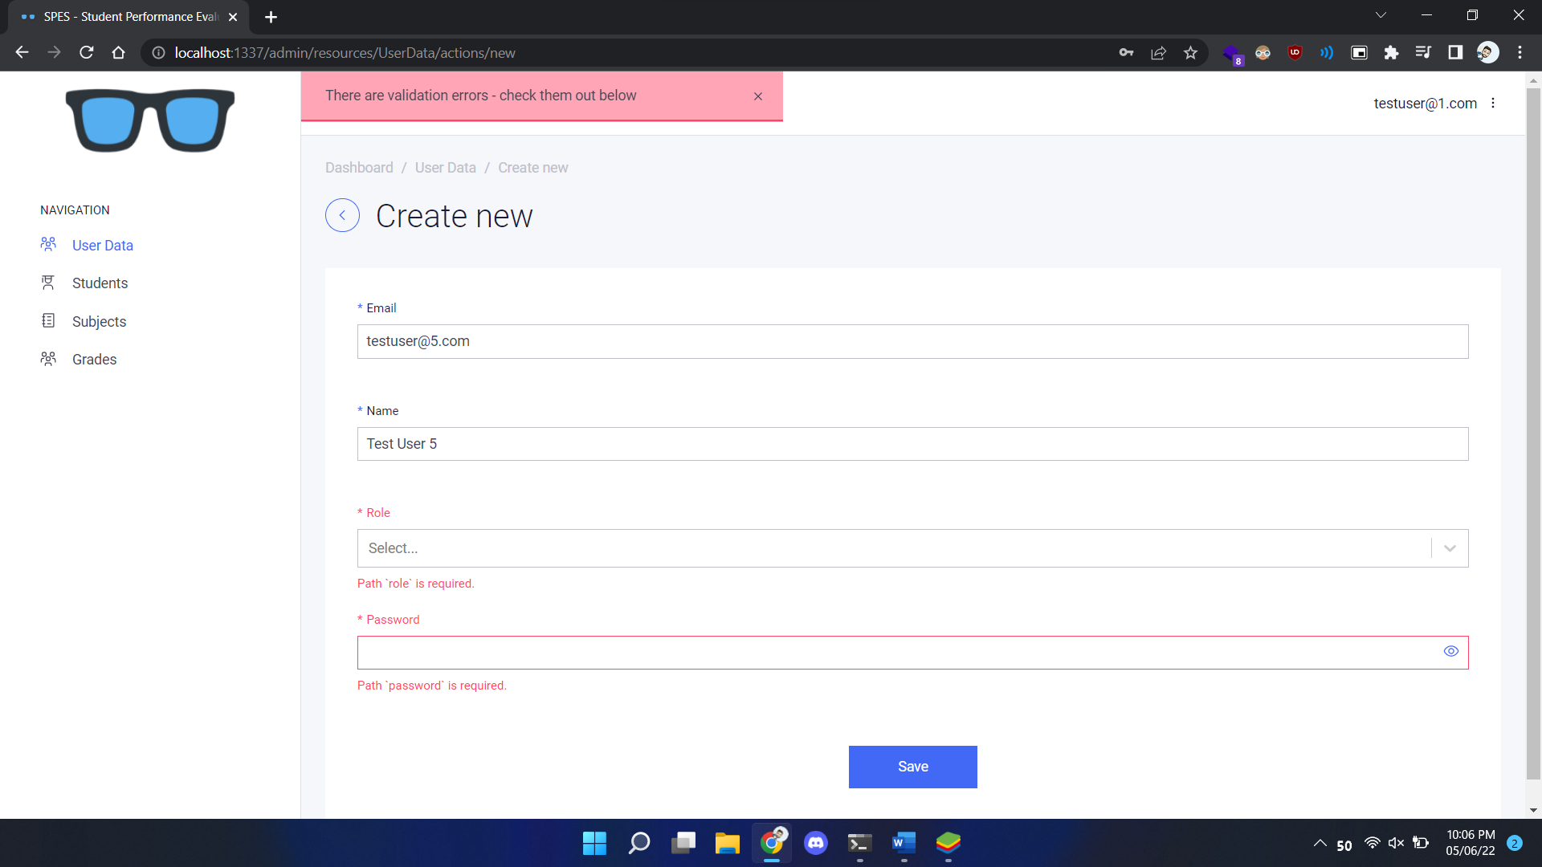

**Edit a user**

**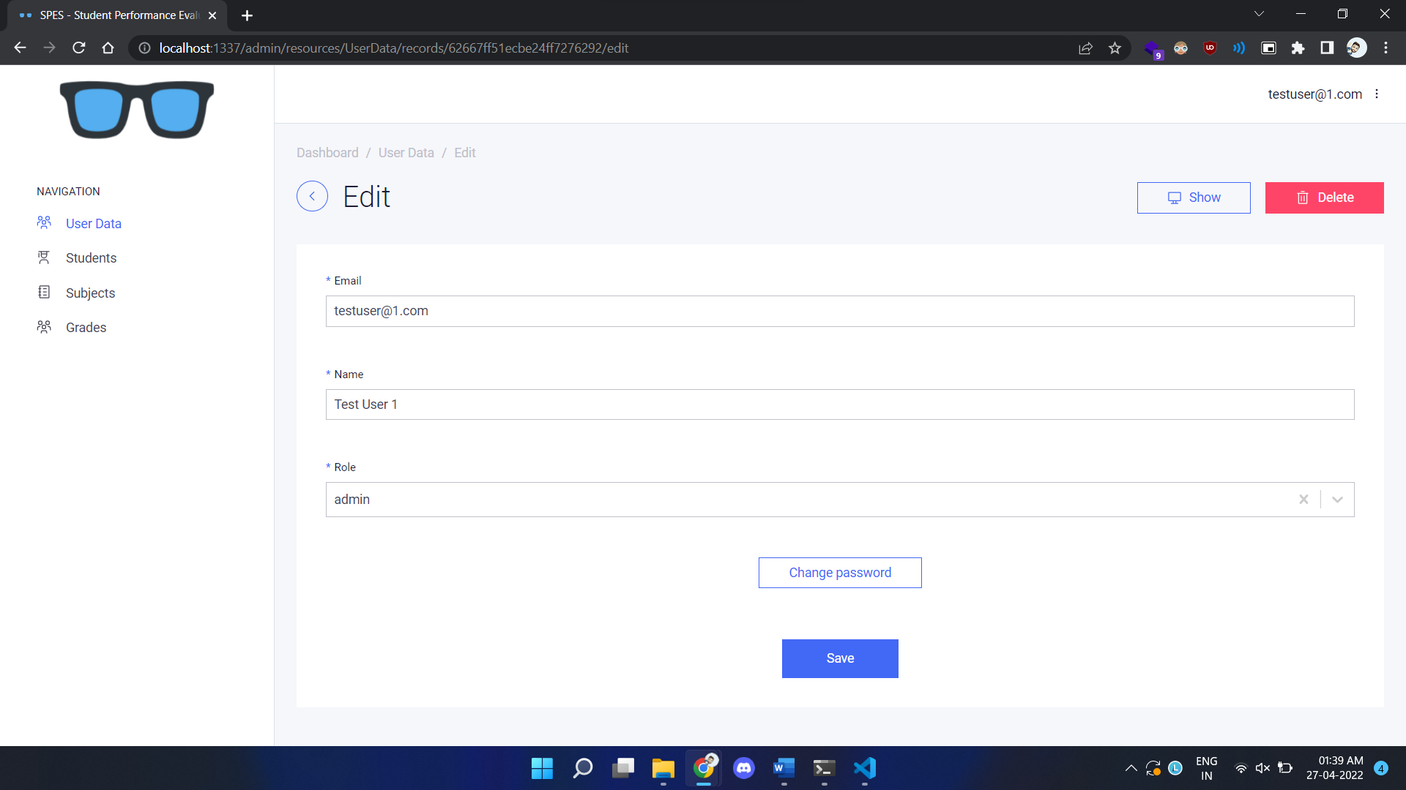**

**Change password**

**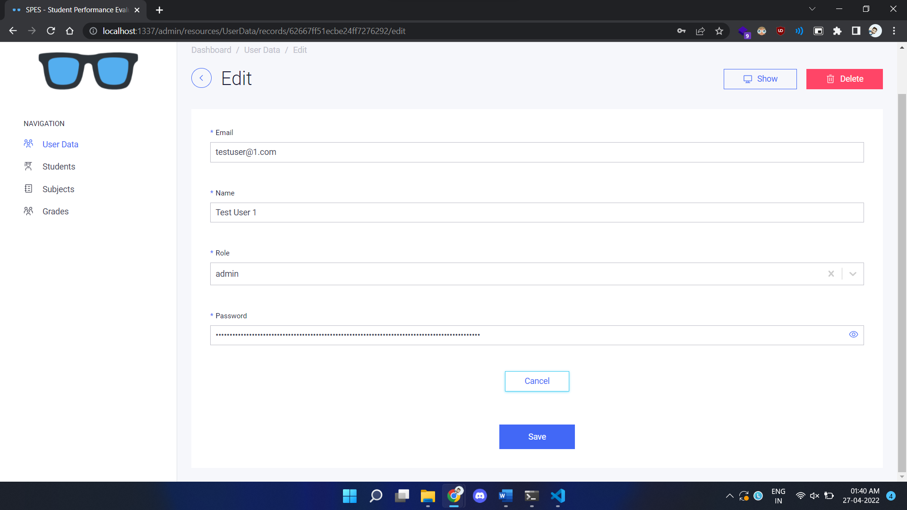**

**Admin Panel** ➜ **Student**

**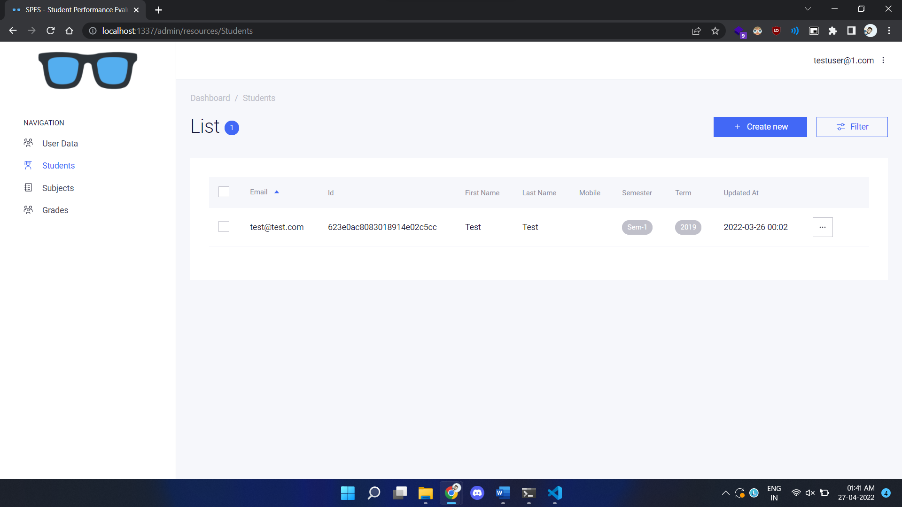**

**Admin Panel** ➜ **Subject**

**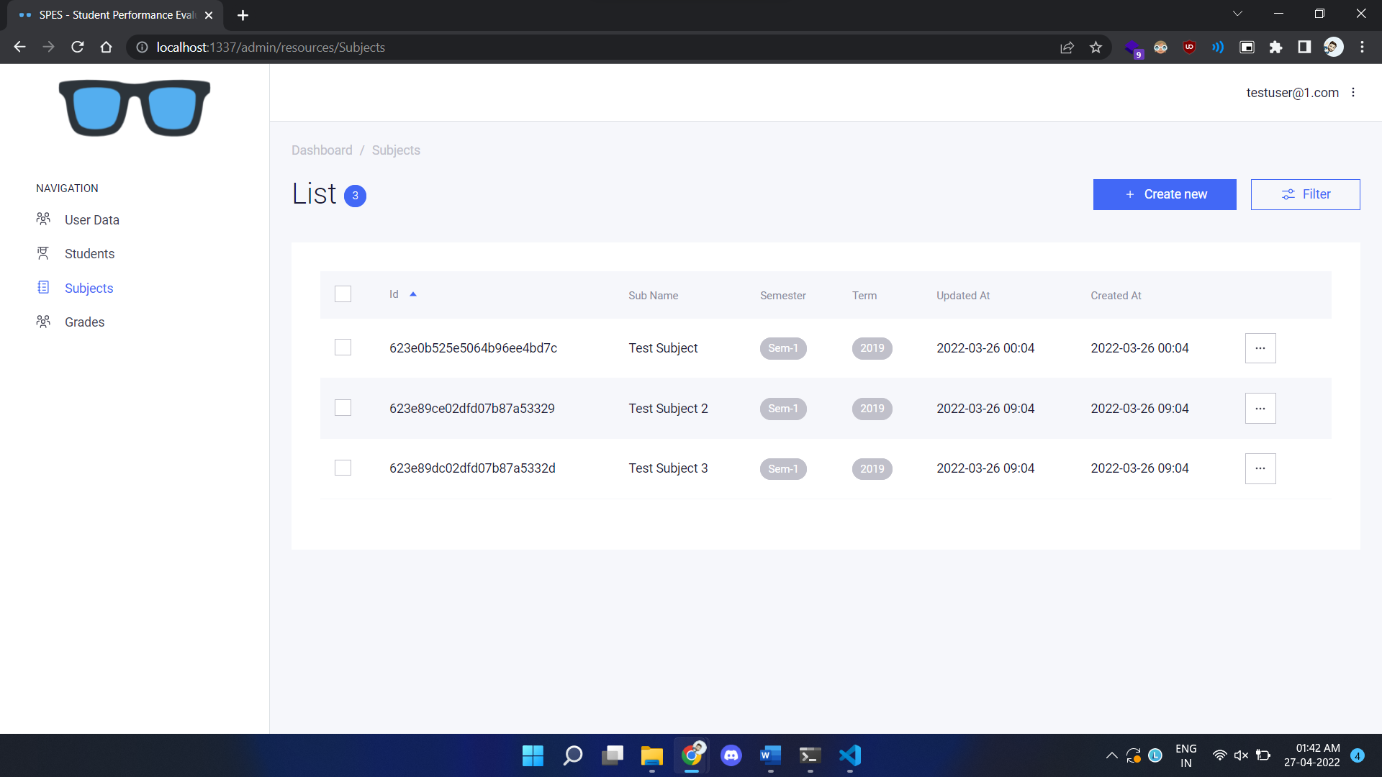**

**Admin Panel** ➜ **Grades**

**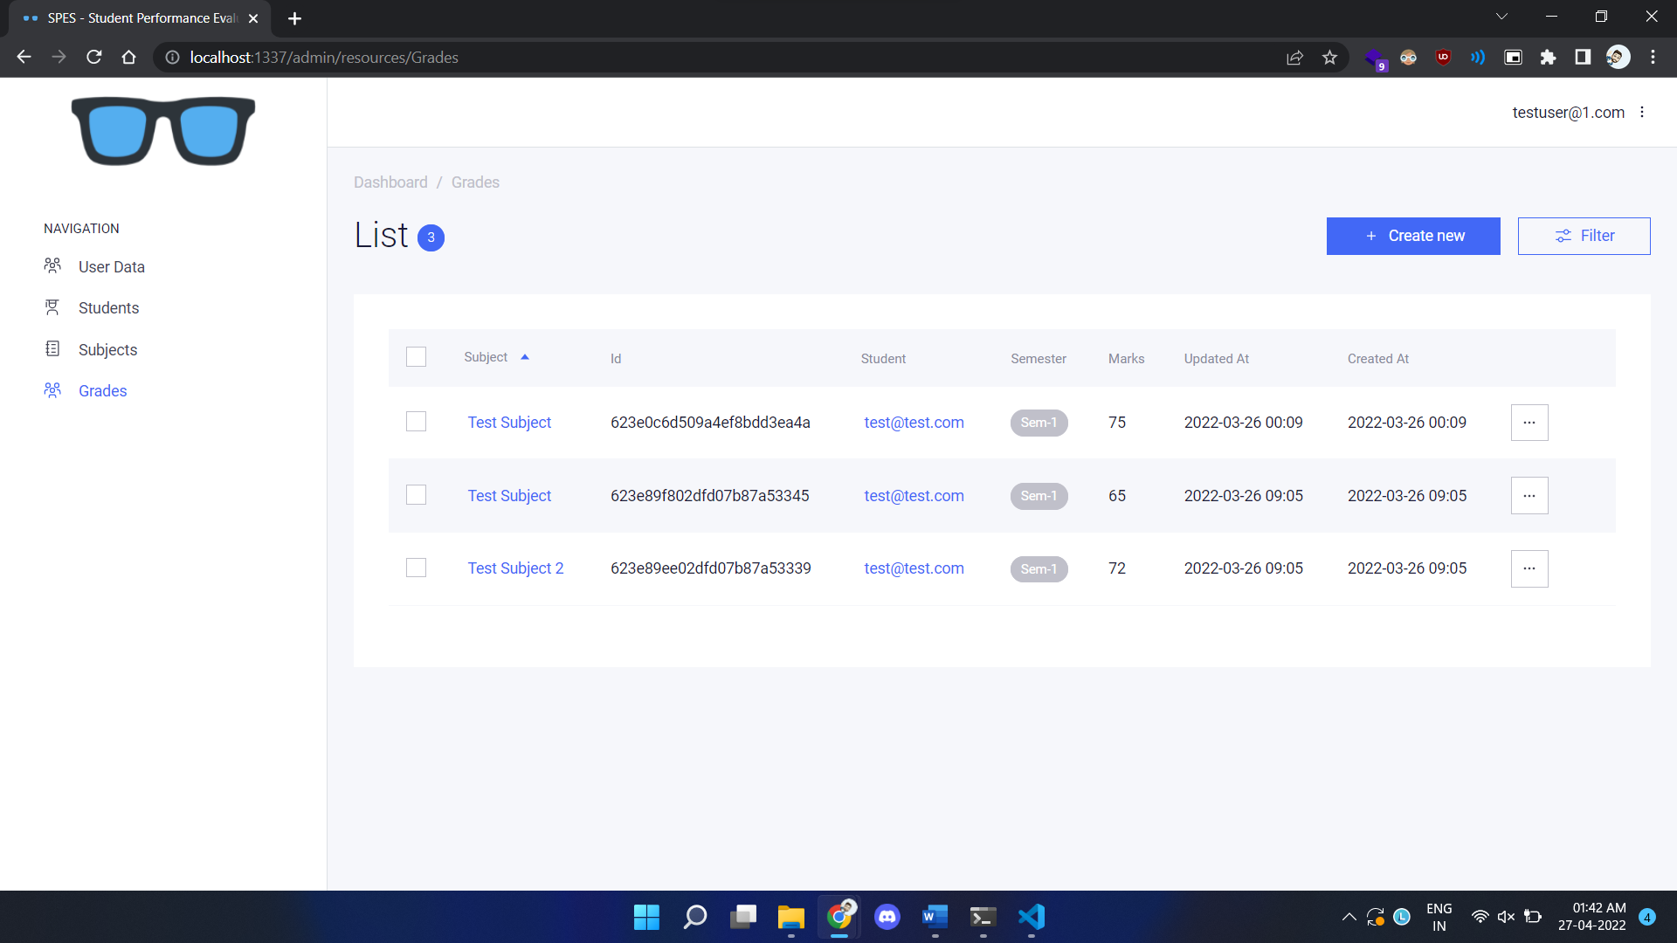**

**Admin Panel** ➜ **Report**

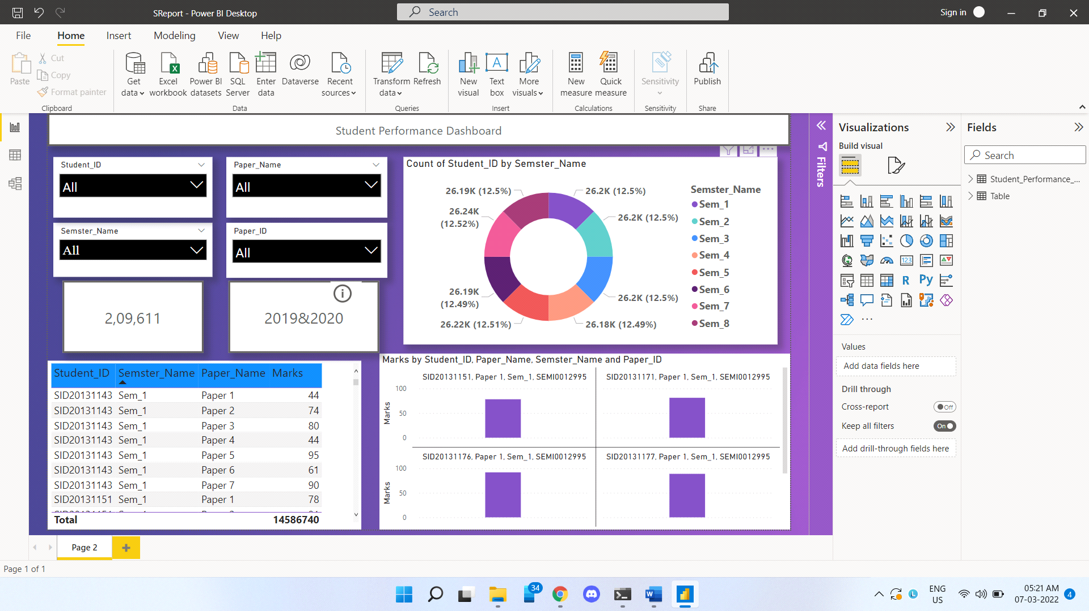

**Logout**

**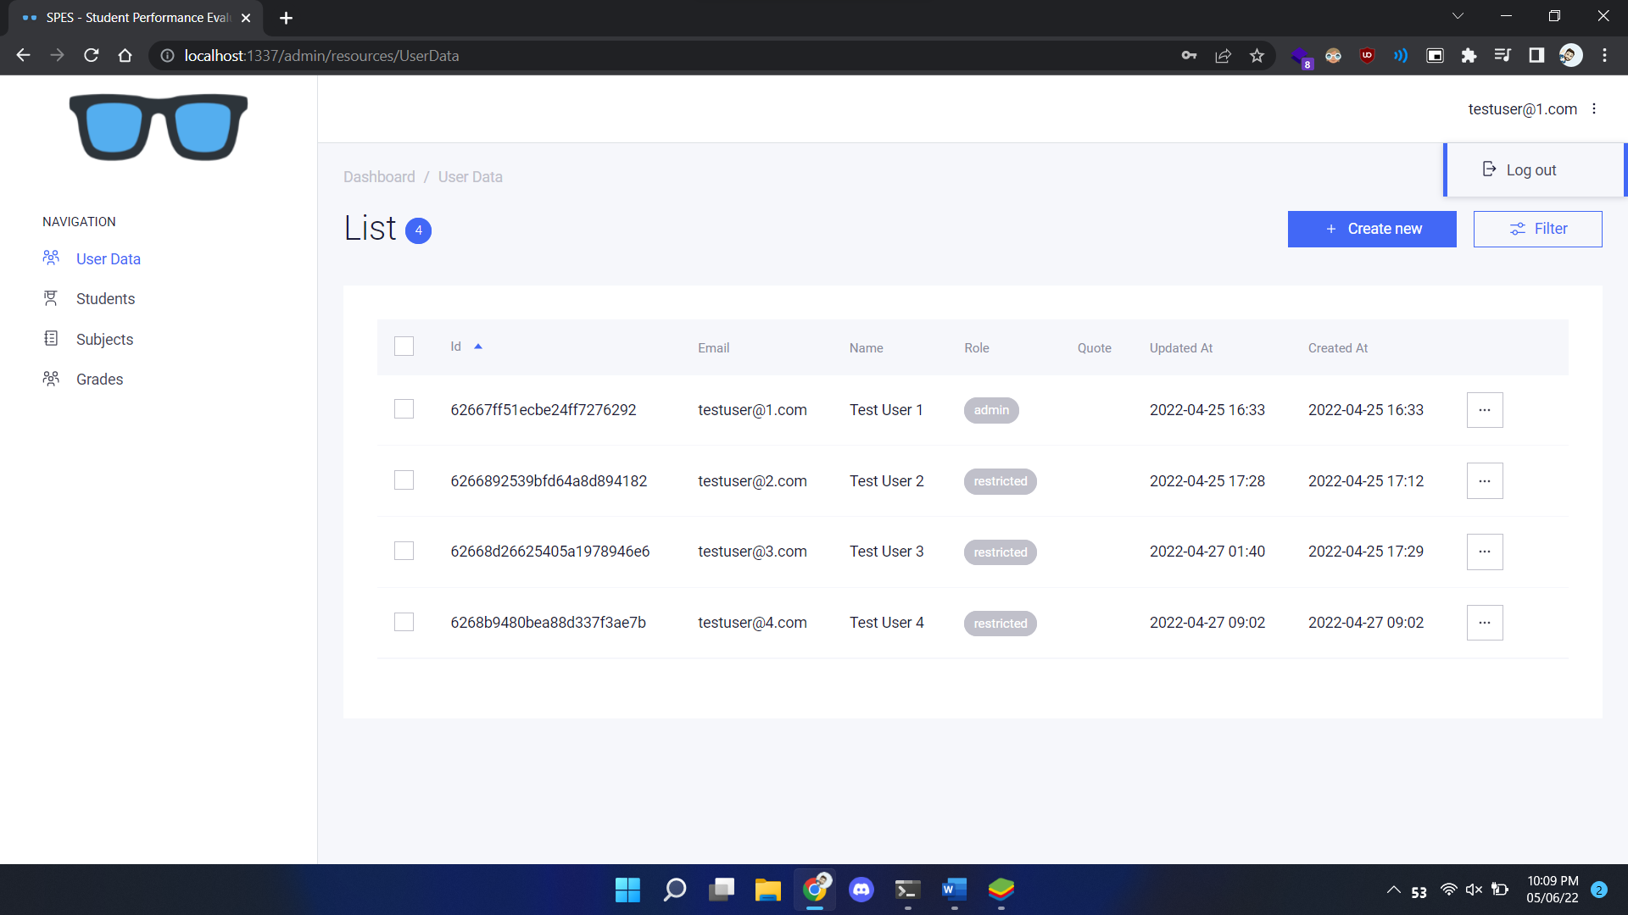**

1. **Agile Documentation**
   1. **Agile Project Charter**

|  |  |  |
| --- | --- | --- |
| **General Project Information** | | |
| Project Name | | Academic Performance Evaluation System |
| Project Champion | | Sufyan Mansuri, Roshan Chachre |
| Project Sponsor | | Prof. Anjum Mansuri |
| Project Manager | |  |
| Stakeholders | | Prof. Jinal |
| Expected Start Date | | 27th Nav 2022 |
| Expected Completion Date | | 10th May 2022 |
| **Project Details** | | |
| Mission | In the proposed system all this problem will be solved as there will be no paper involved in the new system and the data cannot be lost as it is stored in a secure remote database. | |
| Vision | The goal of the project is to analyze and visualize student details, attendance, faculty details and student performance in a useful and meaningful way. | |
| Scope | The proposed system provides the faculty an easy and accurate data about attendance reports and Academic percentages reports and Students details reports. | |
| Success metrics | We found that the application should be very easy to use enabling even for everyone to use it. We built this web-application in MERN STACK as well as POWER BI and we will try to make it easy. | |

* 1. **Agile Project Plan**

|  |  |  |  |
| --- | --- | --- | --- |
| Project Name | Academic Performance Evaluation System | Browser: | Chrome |
| Test Case ID | FIRST\_108 | Version: | 100.0.4896.127 |
| Written By: | Roshan Chachre | Description: | Test case written by Sufyan & Roshan |
| Tested By: | Sufyan Mansuri | Tested On: | 17/04/2022 |

|  |  |  |  |  |  |
| --- | --- | --- | --- | --- | --- |
| **Start Date** | | 17-Nov | | | |
| **End Date** | | 10-May | | | |
| **Overall Progress** | | 90% | | | |
| Task Name | Responsible | Start | End | Days | Status |
| Sprint 1 | Roshan, Sufyan | 01/24 | 04/08 | 34 | Complete |
| Introduction | Roshan | 01/24 | 01/26 | 2 | Complete |
| Project Profile | Sufyan | 02/01 | 02/10 | 10 | Complete |
| Development | Roshan | 02/11 | 02/12 | 2 | Complete |
| System Diagram | Sufyan | 02/14 | 02/20 | 6 | Complete |
| Coding Standards | Roshan | 02/21 | 02/22 | 2 | Complete |
| Agile | Roshan | 03/02 | 03/14 | 12 | Complete |
| Sprint 2 | Roshan | 02/22 | 03/10 | 18 | Complete |
| PowerBI Details | Roshan | 02/23 | 03/05 | 12 | Complete |
| Students Data | Roshan | 03/02 | 03/04 | 2 | Complete |
| Reports | Roshan | 03/06 | 03/10 | 4 | Complete |
| Sprint 3 | Sufyan | 02/02 | 04/22 | 28 | Complete |
| Front End | Roshan | 02/03 | 02/15 | 12 | Complete |
| Login | Sufyan | 02/22 | 02/28 | 6 | Complete |
| Reports (Embedded) | Sufyan | 03/02 | 03/07 | 5 | Complete |
| Edit Details | Sufyan | 03/15 | 03/16 | 1 | Complete |
| Validation | Sufyan | 03/18 | 03/22 | 4 | Complete |

* 1. **Agile User Story**

|  |  |  |  |  |
| --- | --- | --- | --- | --- |
| **User Story ID** | **As a** *<type of user>* | **I want to** *<perform some task>* | **so that I can** *<achieve some goal>* | **Pass?** |
| 1 | Admin | Sign In | Access Admin Dashboard | **True** |
| 2 | Admin | Manage Users | Manage User Details | **True** |
| 3 | Faculty | Sign in | Access Faculty Dashboard | **True** |
| 4 | Admin | Manage Students | Manage Student Details | **True** |
| 5 | Admin | Manage Subjects | Manage Student Details | **True** |
| 6 | Faculty | Manage Grades | Manage Student Grades | **True** |
| 7 | Student | View Grades | View Grades | **True** |

* 1. **Agile Release Plan**

|  |  |  |  |  |  |  |  |
| --- | --- | --- | --- | --- | --- | --- | --- |
| **Sprint** | **Task** | **Start** | **End** | **Duration** | **Status** | **Release Date** | **Goal** |
| 1 | Task 1 | 27/01/2022 | 29/01/2022 | 2 | Released | 28/01/2021 | Gather requirement refer previous interact system |
| 1 | Task 2 | 29/01/2022 | 04/02/2022 | 6 | Released | 03/02/2022 | Understand Whole Project |
| 1 | Task 3 | 04/02/2022 | 09/02/2022 | 5 | Released | 08/02/2022 | make one user can Create Reports |
| 1 | Task 4 | 09/02/2022 | 16/02/2022 | 2 | Released | 15/02/2022 | Make common login page |
| 2 | Task 1 | 26/02/2022 | 01/03/2022 | 2 | Released | 28/02/2022 | make dashboard in PowerBI (For Reports) |
| 2 | Task 2 | 01/03/2022 | 07/03/2022 | 1 | Released | 05/03/2022 | Authentication and Learn About the Embedded Project |
| 2 | Task 3 | 07/03/2022 | 11/03/2022 | 8 | Released | 10/03/2022 | decide operation which perform on this system |
| 2 | Task 4 | 12/03/2022 | 18/03/2022 | 2 | Released | 17/03/2022 | list operation |
| 2 | Task 5 | 18/03/2022 | 25/03/2022 | 2 | Released | 24/03/2022 | User can add details of Students |
| 3 | Task 1 | 05/04/2022 | 05/04/2022 | 2 | Released | 07/04/2022 | User can edit their Reports and Subjects details |
| 3 | Task 2 | 05/04/2022 | 08/04/2022 | 2 | Released | 12/04/2022 | manage Reports and Students as well as  Subject report |
| 3 | Task 3 | 09/04/2022 | 13/04/2022 | 1 | Released | 15/04/2022 | manage User profile by Admin |
| 3 | Task 4 | 13/04/2022 | 16/04/2022 | 5 | Released | 21/04/2022 | Admin can manage user |
| 3 | Task 5 | 17/04/2022 | 22/04/2022 | 2 | Released | 19/04/2022 | Admin can manage Reports as well as Students |
| 4 | Task 1 | 23/04/2022 | 30/04/2022 | 2 | Released | 27/04/202 | admin can view entire reports |

* 1. **Agile Test Plan**

|  |  |  |  |  |  |
| --- | --- | --- | --- | --- | --- |
| Project Name | Academic Performance Evaluation System | | Browser: | Chrome | |
| Test Case ID | Frist\_108 | | Version | 101.0.4951.41 | |
| Written By: | Roshan Chachre | | Description: | test case written by Roshan | |
| Tested By: | Sufyan Mansuri | | Tested On: | 17/04/2022 | |
|  |  |  |  |  |  |
| Test # | Date | Action | Expected Results | Actual Results | Pass? |
| 1 | 29-Jan | Logging in | Should get to home screen | User directed to different page | C:\Users\ACER\AppData\Local\Temp\msohtmlclip1\01\clip_image001.png |
| 2 | 03-Feb | Create Reports  (PoweBI) | Visualization Data And create BICharts | Adding Report Canvas | C:\Users\ACER\AppData\Local\Temp\msohtmlclip1\01\clip_image001.png |
| 3 | 07-Feb | functions in admin penal | create reports | created reports | C:\Users\ACER\AppData\Local\Temp\msohtmlclip1\01\clip_image001.png |
| 4 | 10-Feb | Manage user | Manage user Details | Manage Successfully | C:\Users\ACER\AppData\Local\Temp\msohtmlclip1\01\clip_image001.png |
| 5 | 20-Feb | manage Report(Marks) | manage Report by admin as well as User | Manage Marks Report Details Successfully | C:\Users\ACER\AppData\Local\Temp\msohtmlclip1\01\clip_image001.png |
| 6 | 22-Feb | manage Students By admin as well as Faculty | Manage Students Details | Manage Details | C:\Users\ACER\AppData\Local\Temp\msohtmlclip1\01\clip_image001.png |
| 7 | 10-Mar | user Login | Should get to home screen | User directed to different page | C:\Users\ACER\AppData\Local\Temp\msohtmlclip1\01\clip_image001.png |
| 8 | 20-Mar | manage Students Details | Manage Students details by User | manage successfully | C:\Users\ACER\AppData\Local\Temp\msohtmlclip1\01\clip_image001.png |
| 9 | 28-Mar | manager edit User details | manage User Details by admin | manage successfully | C:\Users\ACER\AppData\Local\Temp\msohtmlclip1\01\clip_image001.png |
| 10 | 10-Apr | generate report of Marks | generate report of Marks | getting error | C:\Users\ACER\AppData\Local\Temp\msohtmlclip1\01\clip_image003.png |
| 11 | 20-Apr | Dashboard Reports  ( PowerBI) | home page Dashboard Report Embedded from PowerBI | home page Embedded Report from PowerBI Dashboard Load Successfully | C:\Users\ACER\AppData\Local\Temp\msohtmlclip1\01\clip_image003.png |

* 1. **Burn Chart**

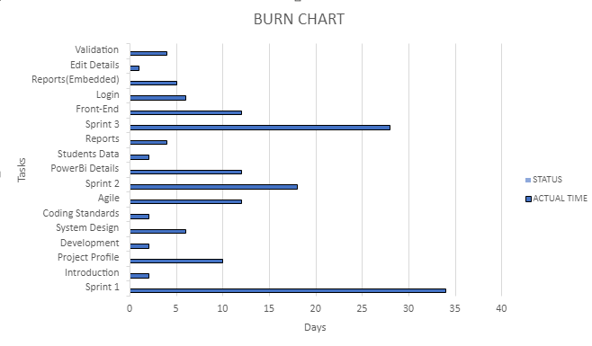

1. **Proposed Enhancements**

* Functionality to chat with admins
* Daily Attendance
* Automatically calculate Attendance and Assignments Grades
* Grades Reassessment Request
* Generate Better Reports

1. **Conclusion**

* We developed a web application that replaces old evaluation system that uses papers to store data & generate results with a modern easy to use web application system that not only generate reports but also utilises the data by visualizing it in different charts to make decisions.

1. **Bibliography**

During the development of project, we have used following resources:

* Software Engineering - A Practitioner’s Approach, 7th Edition

Roger S. Pressman

McGraw Hill Publications

* Beginning JavaScript

Jeremy McPeak, Paul Wilton

Wrox Publications

* <https://stackoverflow.com>
* <https://reactjs.org/docs/hello-world.html>
* <https://expressjs.com/en/starter/installing.html>
* <https://www.youtube.com/codedamn/>
* <https://online.visual-paradigm.com/>
* <https://creately.com>
* <https://app.powerbi.com/home>