Software Requirement Specifications
Cardio Care System



Submitted by
Sufiyan Sattar
S23BINFT1M01140
7th Semester, 3M

Submitted to
Dr Musarat Kareem

Department of Information Technology
Faculty of Computing
The Islamia University of Bahawalpur

Summary
This project, CardioCare, is a web-based system designed to resolve the issue of cardiovascular health monitoring for both medical professionals and patients. The website allows users to register online, input clinical parameters, check diagnostic results in real-time current time, and generate comprehensive medical reports. It improves the existing manual diagnostic methods by providing features like automated analysis, historical health tracking, ML-based risk assessment, and instant diagnosis summaries via email/PDF. Not only for users, it brings new features for admins, like a dedicated dashboard to monitor system performance, manage user datasets, oversee account activity, and view health trend reports. The goal of this project is to reduce diagnostic errors in healthcare, prevent delayed treatments found in traditional systems, and provide a convenient, digital-first experience that encourages proactive heart health management through modern technology.

Table of Contents
1. Introduction 5
1.1 Purpose 5
1.2 Scope 5
1.3 Product Perspective 6
1.4 User Characteristics 7
1.5 Similar apps and systems/Literature Review 7
1.6 Proposed Technologies 7
2. Requirements 8
2.1 Functional Requirements 8
2.1.1 User Registration & Authentication 8
2.1.2 Profile & Health Record Management 8
2.1.3 Clinical Data Input 8
2.1.4 ML Diagnostic Engine 8
2.1.5 Reporting & Analytics 8
2.1.6 Admin Panel (Django-based) 8
2.2 Non-Functional Requirements 9
3. Use Cases and Flow of Processes 10
3.1 USE Case Diagram 10
3.2 ER DIAGRAM 13
4. References 14

Table of Contents
- Introduction
1.1. Purpose
1.2. Scope
1.3. Product Perspective
1.4. User Characteristics
1.5. Similar apps and systems/Literature Review
1.6. Proposed Technologies
- Requirements
2.1. Functional Requirements
2.2. Non-Functional Requirements
- Use Cases and Flow of Processes
3.1 Use case diagram
3.2 Sequence Diagram
3.3 Data Flow Diagram
3.4 ER Diagram
- References

1. Introduction
Due to the rise in cardiovascular disorders and growing health awareness, automated heart disease detection services have become a popular, life-saving, and most needed mode of early clinical intervention in modern medicine. However, most available diagnostic systems do not keep records efficiently or rely on manual analysis, which leads to errors and poor patient experience. CardioCare is a web application developed to modernize the heart disease screening process. It provides users with an easy online platform to view diagnostic tools, check health parameters, assess risk levels, and receive results from anywhere. For healthcare providers, it offers a centralized dashboard to manage patient inventory, track screenings in real-time, handle medical data, and generate reports. This project aims to make heart health monitoring easier, transparent to users and admins, and hassle-free while promoting accessible and modern healthcare through technology.

1.1 Purpose
The purpose of the CardioCare system is to introduce heart disease detection operations with a fast, automated, web-based platform. It aims to help users assess heart risk anytime without visiting a clinic for initial screening, while enabling admins to manage medical datasets, prevent diagnostic delays, track patient history, and generate reports easily. The system promotes proactive health travel by making medical screening more accessible and efficient for both patients and healthcare businesses.

1.2 Scope
The scope of this project is to design and implement a web-based CardioCare System that modernizes clinical operations with an automated, user-friendly platform. The project focuses on the following core functionalities and boundaries:
- User Management Module: The system will provide user registration, login, and profile management. Users can view diagnosis history, update medical details, and reset passwords through a simple web interface.
- Health Assessment & Analysis: The admin panel will allow adding, updating, and removing medical parameters like age, cholesterol, and blood pressure levels. Users can input clinical data, check real-time status, select analysis types, and confirm assessments to prevent manual calculation errors.
- Reporting & Results: Integration with a secure reporting engine will enable digital report generation via PDF or browser view. The system will auto-generate health invoices and send screening confirmations through email after successful data processing.
- Admin Dashboard & Reporting: A centralized dashboard will let admins monitor active assessments, abnormal findings, total user volume, and system activity. Automated reports will categorize data by daily, weekly, and monthly trends to help with medical research decisions.
- Excluded operation:
  - Mobile Application: The system will be web-based only and will not include native Android/iOS apps.
  - EHR/IoT Integration: Initially, the web will not integrate live wearable heart tracking or smart hospital databases. Later, this feature will be added.

1.3 Product Perspective
The CardioCare System is an independent, web-based application designed to modernize heart health screening processes. It operates as a self-contained product but is built to integrate with existing medical datasets for extended functionality.
Relationship with Existing Systems
The system interfaces with external data repositories like the UCI Machine Learning Lab or GitHub Cleveland datasets to handle model training transactions. It does not process biological samples itself; it relies on user-provided clinical values. It uses third-party email/SMTP services to send diagnostic summaries, reminders, and health alerts to users. The system introduces a new screening way. Admins will manually update model weights during system maintenance.
System Environment
The system is accessible through any modern web browser on desktop, tablet, or mobile. No software installation is required for end users. It runs on a standard web server. End users need only an internet-connected device. The system is built using a web framework with a relational database for storage. It requires an operating system, web server, and database server to host. It communicates with external diagnostic and notification APIs over HTTPS. All data exchange is handled server-side to maintain security.
User Perspective (Target Audience)
Patients are non-technical users like senior citizens, health-conscious individuals, and students who need a simple way to find, assess, and track heart health online without visiting the clinic for minor screenings. Healthcare Admins are medical operators with limited technical skills who need a dashboard to manage data, track health trends, view diagnostics, and generate reports without manual paperwork.

1.4 User Characteristics
The users of this project are categorized into three primary groups based on their technical proficiency and security needs:
- User/Patient
  - Technical Skills: Not necessary (any low to high).
  - Knowledge: Minimum knowledge about modern website usage.
  - System Interaction: GUI attractive and easy page to input medical data and view results.
- Admin/Doctor
  - Technical Skills: Medium to High.
  - Knowledge: Understanding of using modern websites and experience in medical data management.
  - System Interaction: Django Default GUI based Admin Panel for management operations.

1.5 Similar apps and systems/Literature Review
The Healthcare AI sector is currently dominated by global enterprise platforms such as IBM Watson Health, Babylon, and Ada, particularly following a surge in capital investment post-2019. Despite this international growth, local diagnostic markets remain significantly underserved with minimal effort from major Tech Companies in specific regions. This lack of competition represents a market gap and a high-yield opportunity for investors to pioneer modern digital health services. Although we have local hospital portals, these are not shared and self-user analysis systems. Traditional screenings are costly (due to hospital overheads) and inefficient for users (patients may wait hours, finding available specialists, etc.). In this app, this problem is eliminated by providing a cost-effective digital screening solution.

1.6 Proposed Technologies
The project will be built on the following tech stack:
- Programming Language: Python offers extensible libraries (Scikit-learn, Pandas) to work easily.
- Web Backend Framework: Django is the industry standard for building modern, secure, fast website backends along with a built-in admin panel.
- UI: Frontend HTML, CSS, and JS (React) are used to build an interactive dashboard to interact with users.
- Database: MySQL is easy to use and perfect for a healthcare startup.

2. Requirements

2.1 Functional Requirements
This section provides a definite number of functional requirements in a standard format.

2.1.1 User Registration & Authentication
  - Users can register using email/phone.
  - Secure password encryption required.
  - Login/logout functionality.
  - Password reset.

2.1.2 Profile & Health Record Management
  - Users can update personal medical info.
  - Manage historical screening records.
  - View health progress trends.

2.1.3 Clinical Data Input
  - Input forms for age, sex, chest pain, BP, and cholesterol.
  - Validation for medical value ranges.

2.1.4 ML Diagnostic Engine
  - System processes data using Random Forest/Logistic Regression.
  - Generate real-time risk percentage.
  - Provide binary classification (Heart Disease: Yes/No).

2.1.5 Reporting & Analytics
  - Generate downloadable PDF reports.
  - Display graphical health charts.

2.1.6 Admin Panel (Django-based)
  - Manage user medical accounts.
  - Add/remove training dataset entries.
  - Monitor system diagnostic accuracy.

2.2 Non-Functional Requirements
1 Performance
The system shall return prediction results within 3 seconds for 95% of requests under normal load.
It shall support 10,000+ concurrent users by using load balancing and optimized ML model inference with caching for repeated queries.5.2 Security
All patient data transmission shall use HTTPS/TLS 1.3 and data at rest shall be encrypted using AES-256.
The system shall implement role-based authentication and authorization using JWT tokens, with audit logs for all access to medical records to comply with HIPAA/GDPR principles.5.3 Reliability
The system shall maintain 97.8% uptime per month, excluding scheduled maintenance windows communicated 48 hours in advance.
It shall include automatic error recovery for failed predictions and input validation to handle unexpected, incomplete, or out-of-range medical data without crashing.5.4 Usability
The UI shall follow clinical design standards with clear labels, units, and tooltips for all medical parameters to reduce data entry errors.
Data entry forms shall be completed by a trained user in under 2 minutes, with inline validation and pre-filled normal ranges for guidance.5.5 Scalability
The application shall be deployed on cloud infrastructure like AWS/Azure with auto-scaling groups to handle traffic spikes during peak hours.
The database shall support horizontal scaling and partitioning to accommodate growth from 10,000 to 1M+ patient records without performance degradation.5.6 Maintainability
The ML pipeline shall use a modular architecture to allow individual models to be retrained, versioned, and swapped without redeploying the entire system.
Code shall follow PEP8 and documentation standards, with CI/CD pipelines for automated testing and updates to reduce bug-fix time to <24 hours.5.7 Safety & Ethics
The system must ensure medical data privacy by not storing identifiable patient information unless explicitly consented, and must include a disclaimer on every report stating results are assistive only.
It shall follow regional health data regulations such as HIPAA in the US or PMDC guidelines in Pakistan, and avoid algorithmic bias by validating model performance across age, sex, and ethnicity subgroups.

3. Use Cases and Flow of Processes

3.1 USE Case Diagram

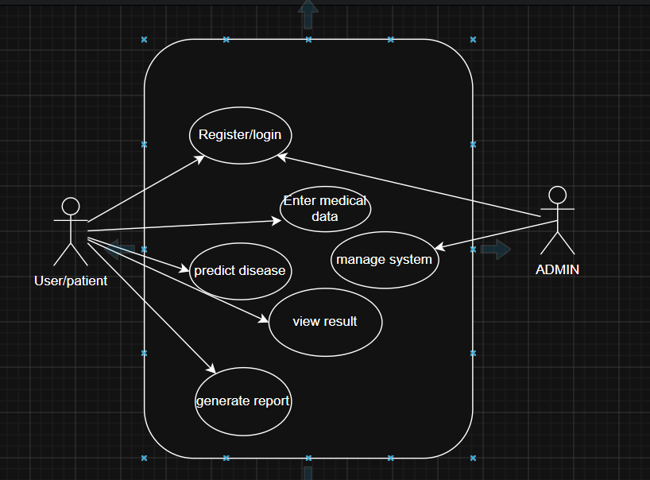
UC-1: User Registration
Actor: Admin/ New User
Precondition: User has valid email and is not already registered
Main Flow: User navigates to "Register" page
User enters name, email, hospital ID, password, and role
System validates email format and password strength

System sends verification email with OTP/link
User verifies email System creates account and redirects to login
Postcondition: New user account created with “Pending Approval” status for admin
Exception: Email already exists → Show error “Account exists.
Please login”
User Login
Actor: Registered User
Precondition: User has verified account
Main Flow: User enters email and password on login page System authenticates credentials using bcrypt hash System generates JWT token and starts session User is redirected to Dashboard Postcondition: User is logged in and can access authorized modules
Exception: 3 failed attempts → Account locked for 15 min + “Forgot Password” prompt shown
UC-2: Patient Input Data
Actor: Healthcare Staff
Precondition: User is logged in
Main Flow: User clicks on displays form with all 13 Cleveland dataset parameters Each field shows normal range, unit, and tooltip example User can view sample data via “Fill Example” button
Postcondition: User understands required inputs before entering patient data
UC-3: Check Data Validity/Predict diseases
Actor: System
Precondition: User has filled patient form and clicked “Predict”
Main Flow: System validates all fields for type, range, and completeness System checks for medically impossible combinations like Age=5 with Cholesterol=600 If valid, system passes data to ML model; else highlights errors Postcondition: Only validated data sent for prediction
Exception: Invalid/out-of-range input → Display field-level error + prevent submission
UC-4: Generate Heart Disease Prediction/View Result
Actor: Admin
Precondition: User submitted valid patient data
Main Flow: System preprocesses input data: scaling, encoding categorical values System runs data through trained ML model ensemble Model returns probability score and risk class: Low, Moderate, High System displays result with confidence % and feature importance chart
Postcondition: Prediction result shown within 3 seconds
Exception: Model timeout :-
Show “Service busy, retry”
UC-5: Generate report
Actor: Healthcare Staff
Precondition: User is logged in and has made past predictions
Main Flow: User clicks “History” on dashboard System fetches past predictions with timestamp, patient ID alias, and result
User can filter by date range, risk level, or patient ID
User clicks any record to view full input and output report
Postcondition: Historical predictions displayed in table format
Exception: No history → Show “No predictions yet. Start new assessment”
UC-8: Admin - Add/Update ML Model
Actor: System Admin
Precondition: Admin is logged in with model-management rights
Main Flow: Admin navigates to “Model Management”
Admin uploads new .pkl model file and version notes
System runs validation tests on holdout dataset
If accuracy > threshold, system activates new model and archives old version Postcondition: New model deployed without downtime
Exception:
Validation fails :- Reject upload and show accuracy metrics
UC-6: Admin - Manage Users
Actor: System Admin
Precondition: Admin is logged in
Main Flow: Admin views all users, roles, and last login
Admin can approve new registrations, deactivate users, or reset passwords
Admin can export audit logs of predictions for compliance review
System logs every admin action with timestamp
Postcondition: User access controlled and compliance logs maintained

3.2 ER DIAGRAM

It is a diagrarm which show each database table build
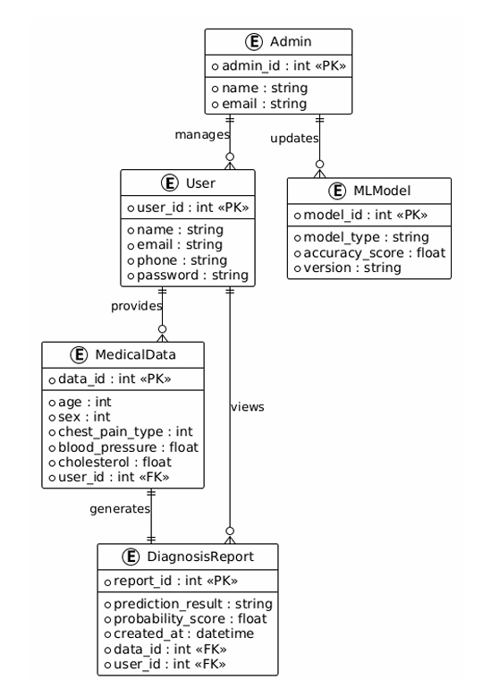

4. References

- UCI Machine Learning Repository: Cleveland Heart Disease Dataset.
- World Health Organization (WHO) Cardiovascular Diseases Fact Sheets.
- Journal of Medical Systems: AI in Clinical Diagnosis.
- National Health Vision (NHV) Digital Health Policy 2025–30.

