# Supplementary Figures

**Figure S1. Association between GRSs and cardiometabolic traits after group with and without obesity assignment**

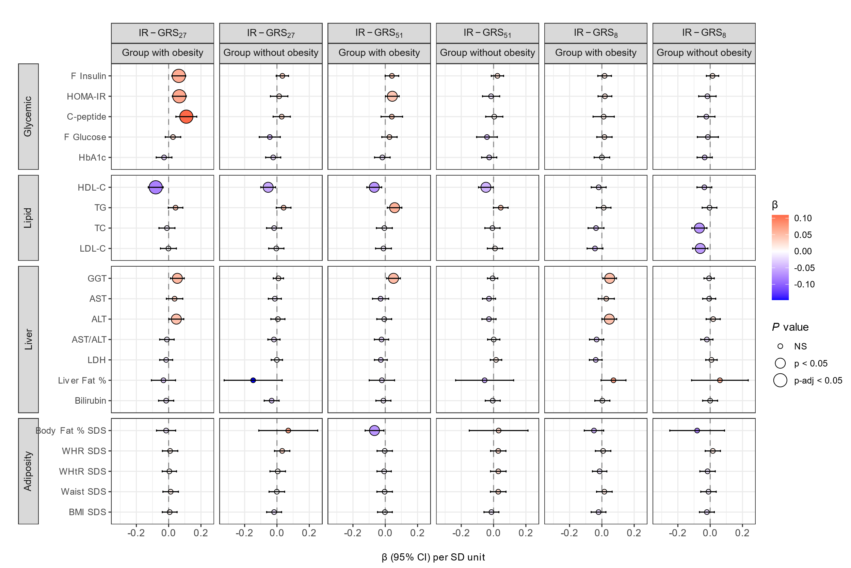

Association between the IR-GRS27, IR-GRS51, and IR-GRS8 and cardiometabolic traits after groups assignment of groups with and without obesity. Results shown side by side are for each GRS for obesity and population group. Beta coefficients (β) with 95% confidence intervals (CI) are presented, calculated using linear regression models. These models adjust for age, sex, BMI standard deviation scores (SDS) (not included in adiposity trait assessments), genotype batch, and four genetic principal components. NS represent non-significant for p-values above 0.05. Values of p < 0.05 are considered nominally significant, while adjusted p-values (p-adj) < 0.05 after false discovery rate correction are highlighted as significant, with stricter significance thresholds at less than 0.01.

**Figure S2. Association between GRSs and HOMA-IR, stratified by pubertal age**

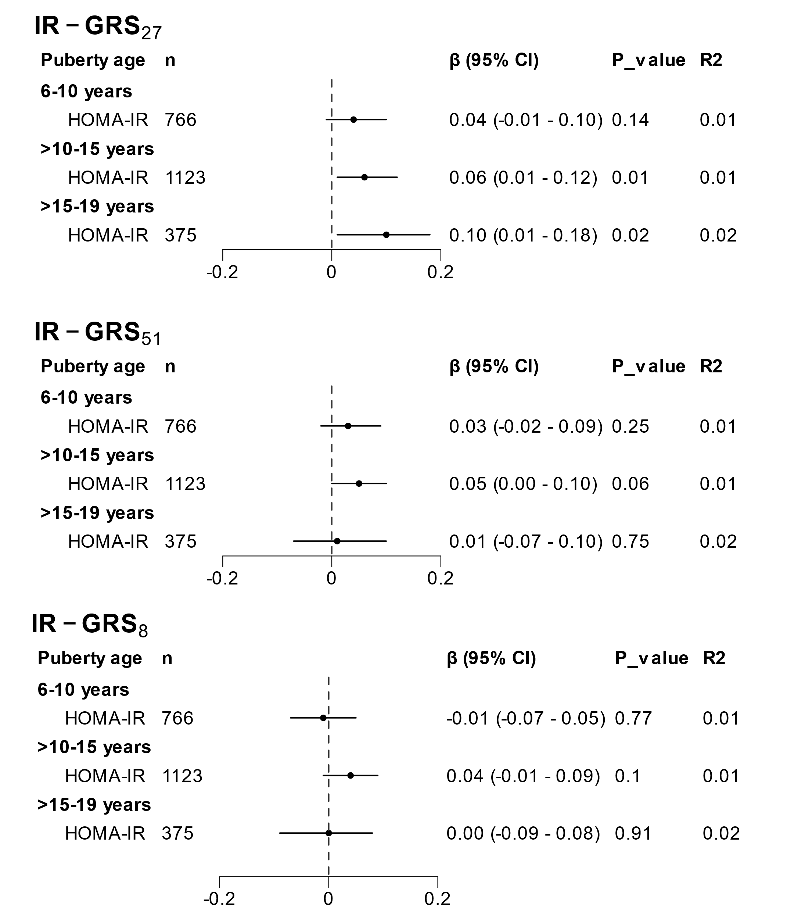

Association between IR-GRS27, IR-GRS51 and IR-GRS8 and HOMA-IR as a measure of IR with analysis stratified by pubertal age. Beta coefficients (β) with 95% confidence intervals (CI) are presented, calculated using linear regression models. These models adjust for age, sex, BMI standard deviation scores (SDS), genotype batch, and four genetic principal components. The R2 represents the variance explained by the GRS. It is calculated as the adjusted R2 for the model including GRS and covariates minus the adjusted R2 for the model including only the covariates.

**Figure S3. Interaction analysis of GRSs with cardiometabolic traits across groups with and without obesity**

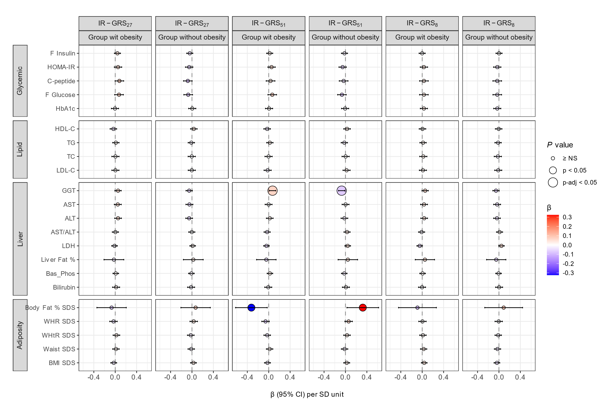

Interaction analysis between group with obesity and without obesity for association between IR-GRS27, IR-GRS51, and IR-GRS8 and cardiometabolic traits after groups assignment. Results shown side by side are for each GRS for obesity and population group for interaction effects. Beta coefficients (β) with 95% confidence intervals (CI) are presented, calculated using linear regression models. These models adjust for age, sex, BMI standard deviation scores (SDS) (not included in adiposity trait assessments), genotype batch, and four genetic principal components. NS represent non-significant for p-values above 0.05. Values of p < 0.05 are considered nominally significant, while adjusted p-values (p-adj) < 0.05 after false discovery rate correction are highlighted as significant, with stricter significance thresholds at less than 0.01.

**Figure S4. Association of single variants with cardiometabolic traits in separate groups**

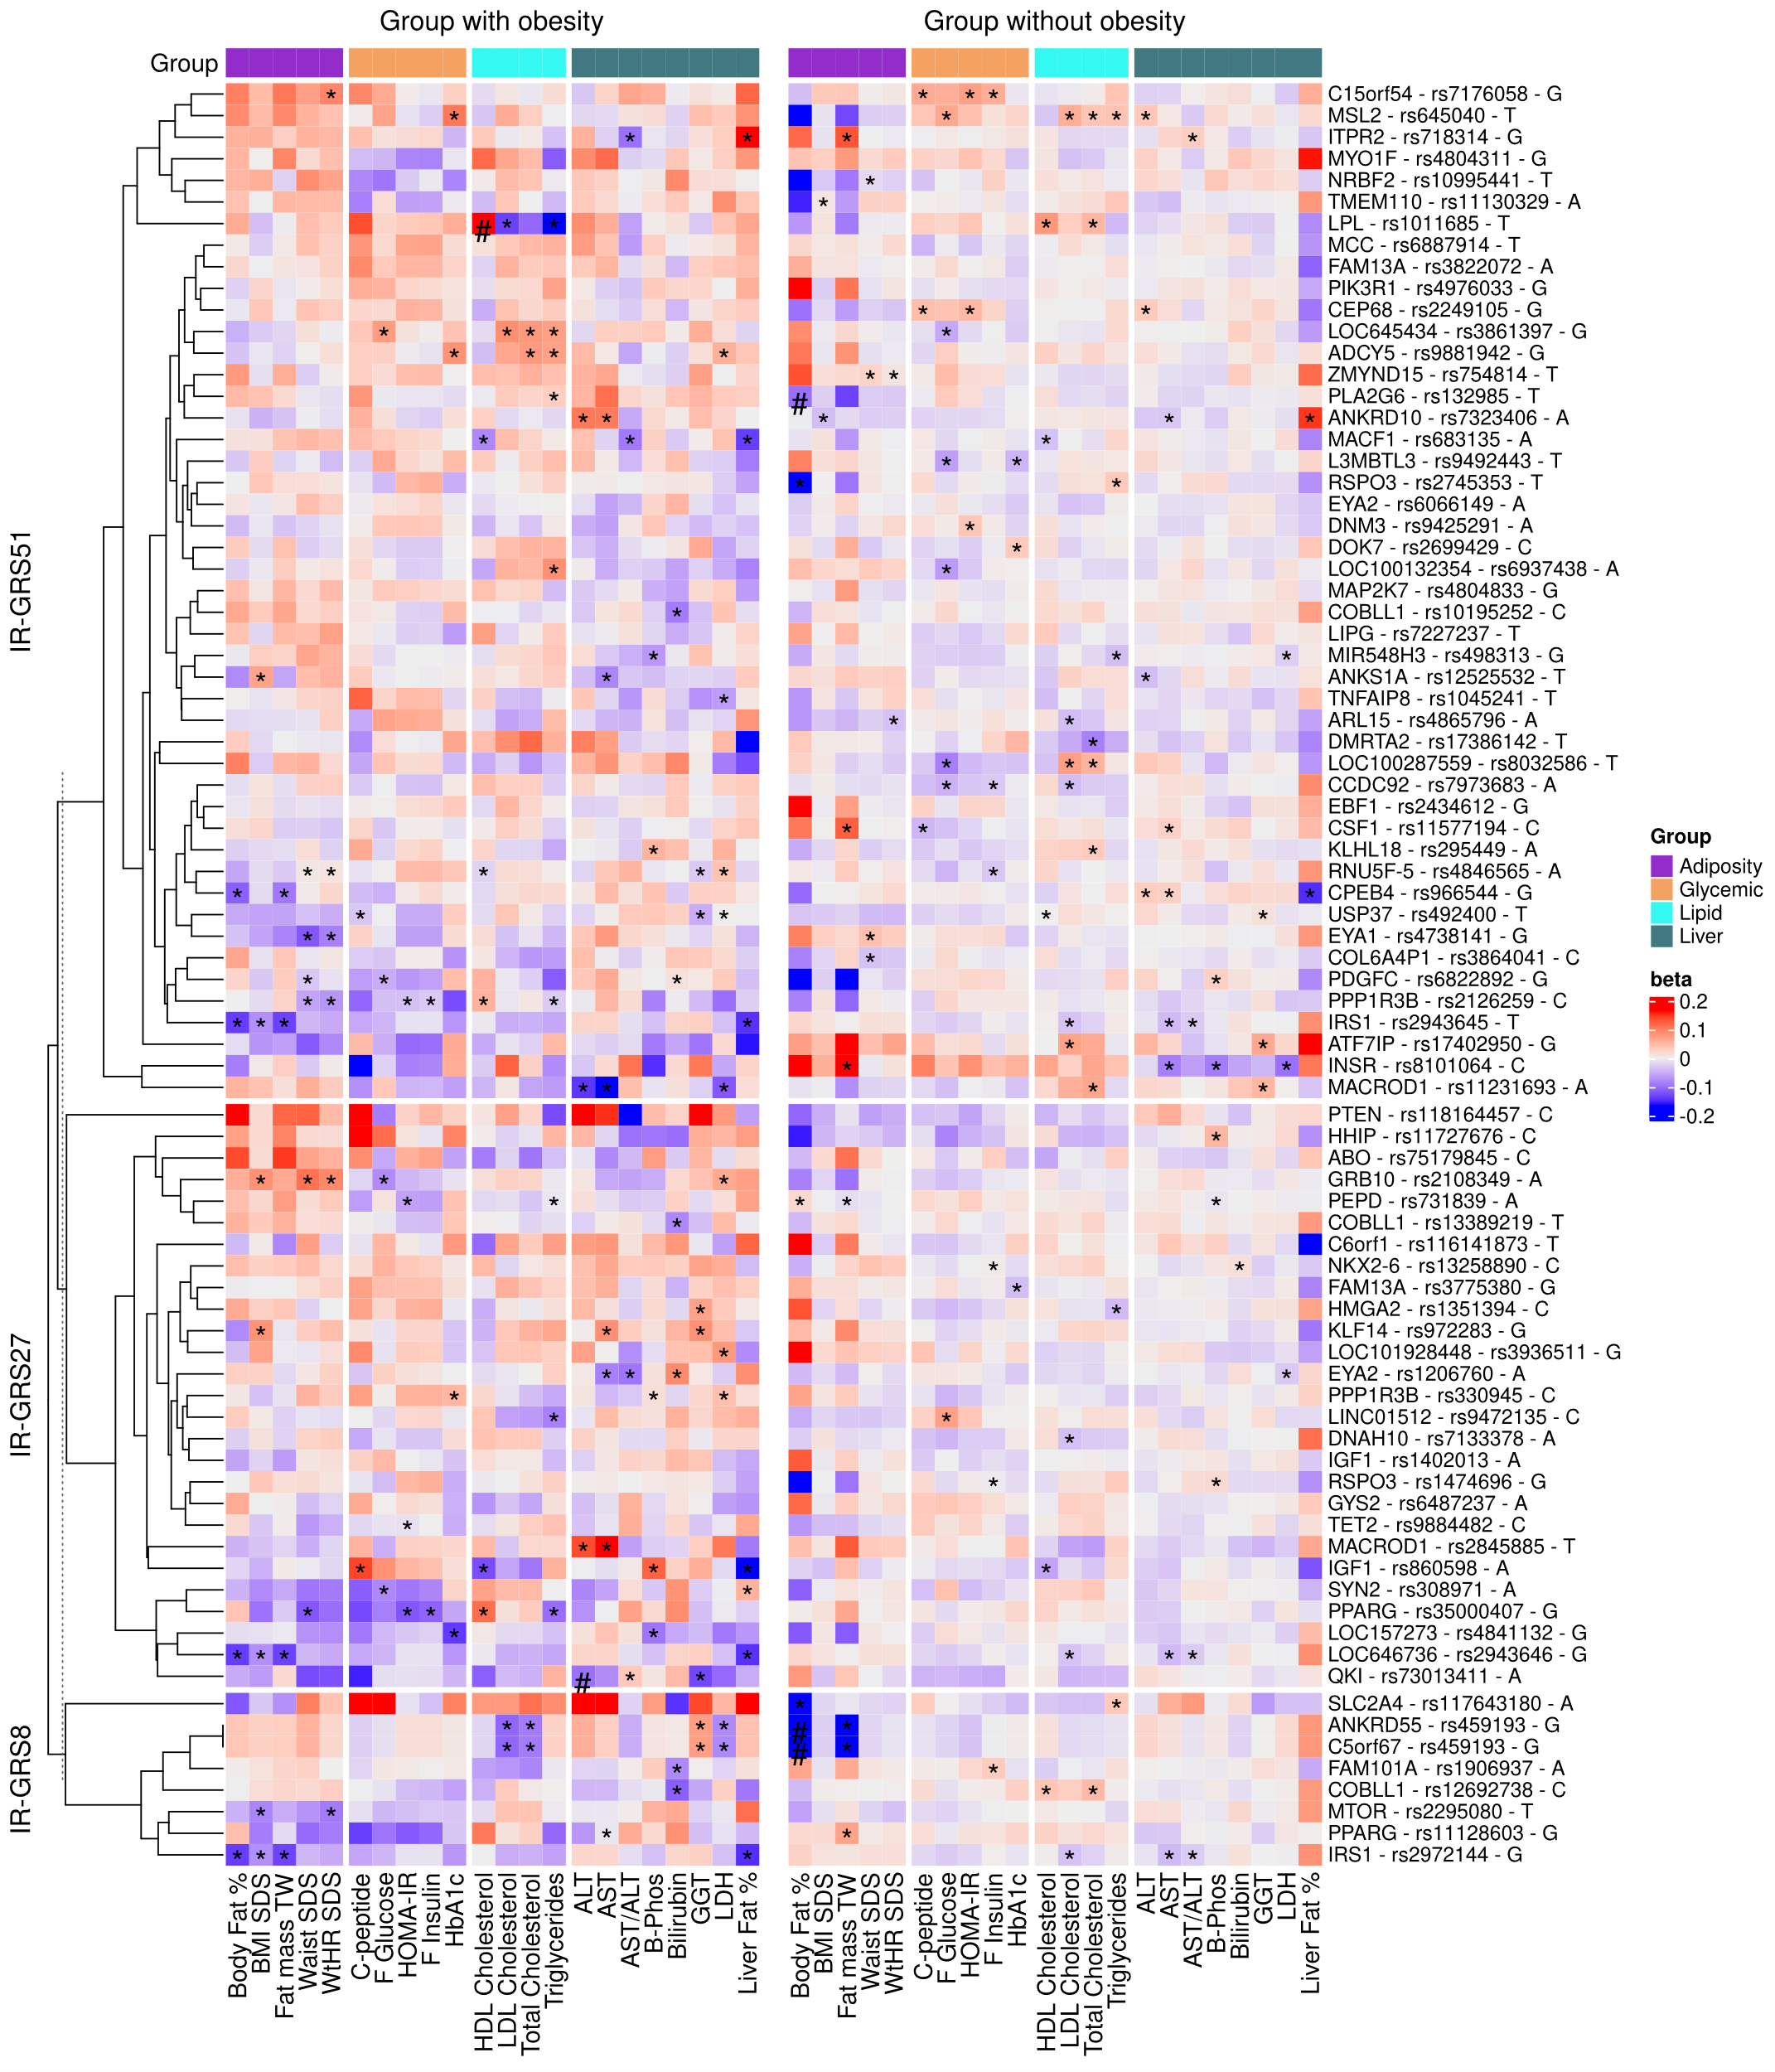

The association between single variants from each IR-GRS and cardiometabolic traits in groups with and without obesity separately. The analysis is adjusted for age, sex, genotype batch, four genetic principal components. The colour coding represents the direction and magnitude of the effect size (β) for associations of alleles. Specifically, red denotes positive associations, indicating an increase in trait, while blue signifies negative associations. Statistical significance is marked by an asterisk (*) for a p-value less than 0.05, and a hash (#) for a false discovery rate adjusted p-value padj less than 0.05.