Problem: Locating a Defined Area in the Star Map

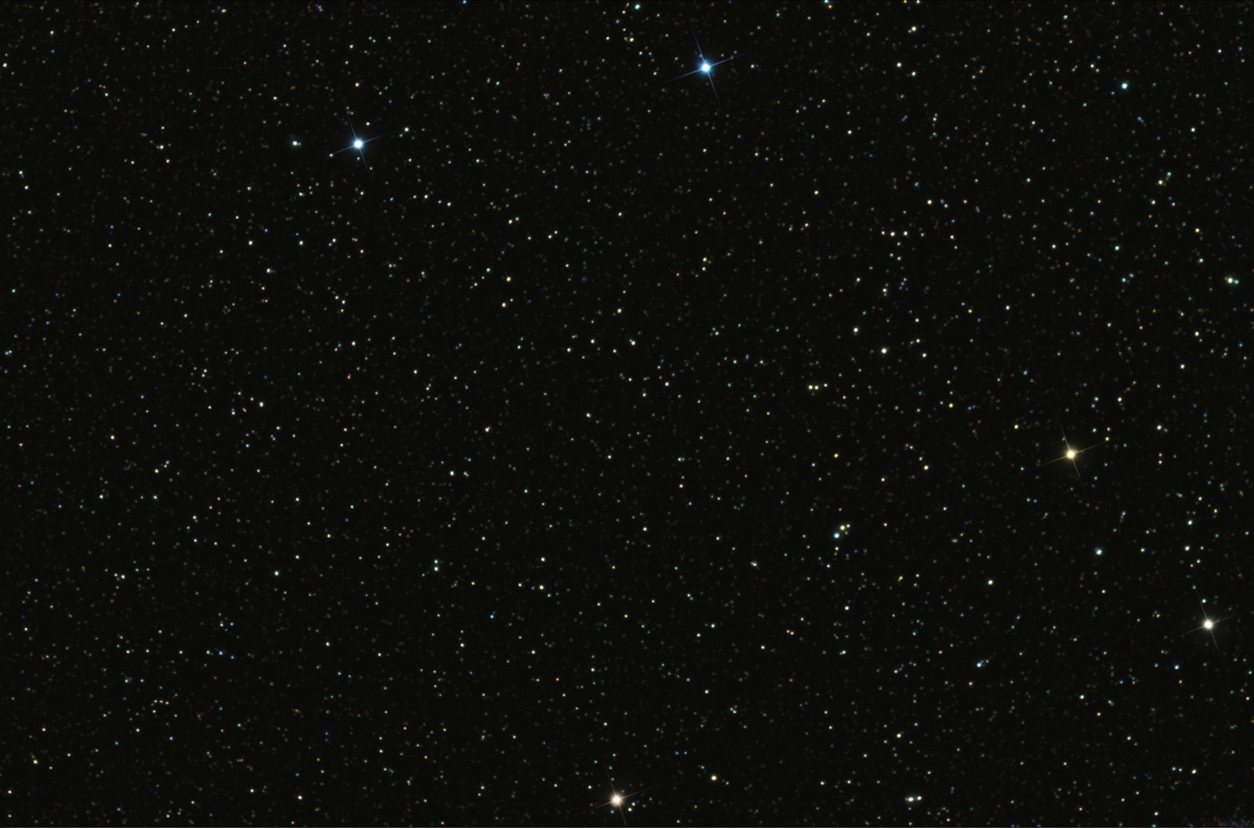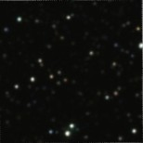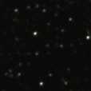

# Task

The available job position that you are applying involves scene understanding tasks which consists a lot of positional and color clustering problems. The task below we tried to simulate the similar problems in a star map scenario. Avg. development time is 2-4 hours.

There are 3 images provided to you. The big one is a Star Map, small ones are cropped images from the Star Map. One of the small one is horizontally and vertically matching with the Star Map, another one is rotated.

The task is developing a C++ program or a python script that takes 2 images as an input:

1. One of the small images
2. The Star Map

The program should output 4 point positions in the Star Map, each corresponding to small images’ corner points.

Please keep in mind that one of the images is horizontally matching with the Star Map, but another one is rotated, so your algorithm needs to be able to work even if the axis is not matching.

# Requirements

1. Programming language: C++ or Python
2. OS: Linux
3. Submit your project by sending your public github link to [**ciris@4dsight.com,**](mailto:ciris@4dsight.com) [**arda@4dsight.com,**](mailto:arda@4dsight.com) [**cem@4dsight.com,**](mailto:cem@4dsight.com) **ziya@4dsight.com, kivanc@4dsight.com, merve@4dsight.com**. Please include your compiled program and source codes in your repository. Please attach your CV and share your Linkedin URL in your e-mail
4. The project deadline is the January 31th 2021, Sunday 22:00 Turkey Time.

5. If you have any questions about the task, please e-mail to everyone above mentioned until January 30th, Saturday 22:00 Turkey Time.. 