ELECTRONIC ASSIGNMENT COVERSHEET | 

Student Number | 31550821
Surname | Bertram
Given name | Frederick
Email | Fred.bertram@gmail.com
Unit Code | ICT375
Unit name | Advanced Web Programming
Enrollment mode | external
Date | 23/05/2018
Assignment number | 2
Assignment name | Assignment 2
Tutor | Mark Abernathy

Student’s Declaration:

- Except where indicated, the work I am submitting in this assignment is my own work and has not been submitted for assessment in another unit.

- This submission complies with Murdoch University's academic integrity commitments. I am aware that information about plagiarism and associated penalties can be found at http://www.murdoch.edu.au/teach/plagiarism/. If I have any doubts or queries about this, I am further aware that I can contact my Unit Coordinator prior to submitting the assignment.

- I acknowledge that the assessor of this assignment may, for the purpose of assessing this assignment:
- Reproduce this assignment and provide a copy to another academic staff member; and/or
- Submit a copy of this assignment to a plagiarism-checking service. This web-based service may retain a copy of this work for the sole purpose of subsequent plagiarism checking, but has a legal agreement with the University that it will not share or reproduce it in any form.

- I have retained a copy of this assignment.

I am aware that in making this declaration, by submitting this document electronically and by using my Murdoch ID and password, it is deemed equivalent to executing this declaration with my written signature.

Optional Comments to Tutor:

Please insert this completed form into the body of the assignment you submit. Follow the instructions in the Unit Guide about how to submit your file(s) and how to name them, so that the Unit Coordinator knows whose work it is.

Assignment 2 ICT375

Introduction

For this assignment I am required to serve a html page with a form. The form takes input from the user regarding which weather data and which output style they wish to view in either table or graph format. The weather data provided is in the form of XML and JSON so I am expected to parse both of these formats using the tools I have learnt this semester. The XML and JSON must be downloaded from a Murdoch server. I have decided if a subsequent request of the same year is called it will just use the data it has already processed but if it is a different year from the last year called it will require a redownload of the data. One assumption I have is if the month isn’t complete in its data(there are days missing) it will continue to display the data either way. If a month doesn’t contain data it will not display that month in table or graph. There must be atleast two months select the start month and the last day of the end month those two dates must be in the same year and the start date must be prior to the end date.

Description of XML and JSON technologies.

After I fetch the xml or Json files I use xmldom for parsing the xml file for the three years that use xml. I am using xmldom because I learnt to use it in the labs with perl and the syntax of functions isn’t that much different in node js xmldom module so I went with this even though I am not manipulating the dom but reading it for processing. If the query sent to the server via form submission contains the year 2008 – 2009 it requests the xml file from the given server then the file is read as a string to the xmldom parser. The elements are converted to an array by getElementsByTagName(‘record’) which has each record as an element in an aarray. The program keeps track of the current month and iterates through the array while the month is the same it adds the data to total solar radiation and average wind speed by accessing those values using childNodes with an array index to get the correct values. The processed data is saved to a javascript object that is in years[year].month[currentmont] with ws and sr values. For the json files it is similar but is uses JSON.parse to convert it into an object then javascript object notation to access each part in the array. When the server is ready to send the data for the weather back to the client it filters out the selected months then uses JSON.stringify to send the data as a string to the client.

Detailed Description

For my design I used the same modules as assignment 1 the server.js router.js index.js and requestHanders.js. RequestHanders.js has the functions for each different request, for serving a image it serves the image, if it is serving a html file it serves that or Javascript file for the clientside js. The requestHanders file requires the weather.js file which contains processing logic for weather data. ReqSubmit in requestHanders passes the request query and response to the weather object using the initialize function which performs the logic processing for the server. Focusing on the weather.js file now. In weather.js there is a datastructure called year, for each index of year ‘2007’-‘2016’ it contains a link to the xml or json file on the server I am supposed to use for this project. The object weather inside weather.js contains a data structure that holds the processed data using each year as an index. The initialize function inside weather object takes a query and a response if it is 2008 – 2009 for the query year it will download the file in the year object and using either xml parsing or json parsing take each element in a large array and process it. If the month changes to a new month during the processing the total data or average is recorded for that month and stored in a data structure inside the weather object called years. If the processed data is at the end of the array. The processed data is sent via json object to the response in the function senddata which is a member of the weather object also. For this function it uses the client side query of months of a year to send just the data for those months back to the client for the given year. If the previous month requested by the server is the same as the current month requested it will not have to parse the xml or json data because it knows this was the last year called so it simply uses the senddata function.
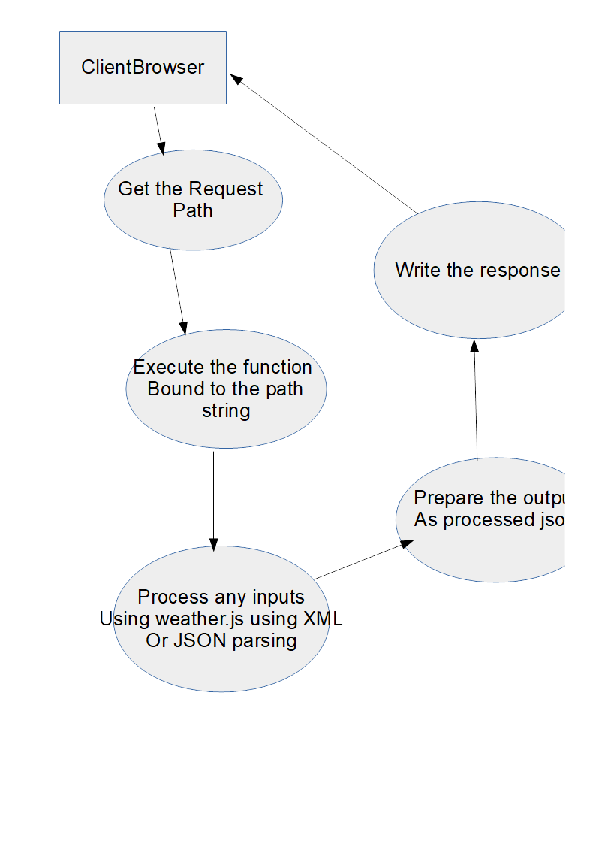

For the client code it simply presents the user the form in the form div. If the user submits the form it validates it then sends it using GET and ajax (vanilla js). When the data is sent to the server it is sent back as a JSON string which gets parsed via the client side to a javascript object. If graph is selected it uses google charts to draw a graph aslong as the months contain data, if there is no data for a month it will not display for that month. If table is selected the same data is used to draw a table, I found javascript function to modify tables useful for this. The CSS I use is designed to display on low width resolution screens by making the input div take up a whole row under a certain width as well as the other divs. If there is however enough room it will become a side bar to display contents neatly in columns.
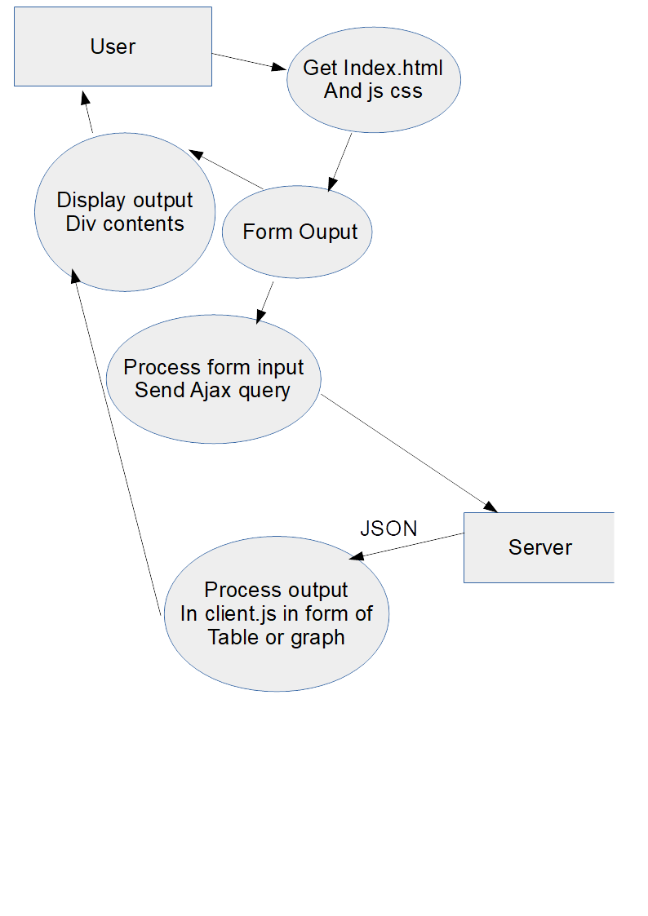

Some of this content is from first assignment but is same
Server.js

This module is the server that listens on the port it listens on my designated port of 41091 takes a route function and handle as a parameter figures out which url was called then it passes everything on to the route function.

Router.js

This is another simple module that calls the requesthandler module function depending on which URL path was called. So if it was index.html it would call the requesthandler reqStart() function and pass it the request and the response.

RequestHanders.js

This function contains several functions for each request.

The index.html page goes to reqStart function and this very simply serves the static index.html page which is our single page application.

The index.html file contains a link to client.js javascript file. Calling this file triggers the requestHander function clientJS which serves the text/javascript file.

The index.html also contains a link to style.css which makes the requestHander for style be called which serves a simple text/css file.

reqSubmit handles the form input and called the weather.js object when it is called.

weather.js
This file contains the logic to download xml and json files process them into the javascript object data for each month total SR or average WS and writes them to the given response object.

Data Structures

For data structures I used index.js holds an object of request addresses as keys and for each value there is an object, this is from labs and assignment 1 so no need to go into detail about this.

The weather.js file holds a complex object called weather which is an object containing functions it executes on its own data. It holds onto data for years each of these is a complex object. Each year in years holds the processed data for that year. When the client makes a request for data from a certain year it accesses a data structure outside of the weather object in weather.js called year which contains string addresses for the xml and json files. The key is the year the value is the url for the xml or json text file. When the calling function called initialize with the query strings from the client request the function checks what year it is after, if it is a xml year it downloads the xml file, if it’s a json year it downloads the json. It parses it using xmldom or JSON.parse to convert it to an object in node js. If it is xml it converts it into an array called targetNodes which contains many elements. Iterating through each element in this array gives each time frame of data recordings. Inside each section of the for loop it gets the data for total sr and total ws and stores it into the years object inside the parent object of the initialize function once the month changes. This keeps track of the year and month for the data values and can easily be accessed using keys to get the correct month and year. If it parses the JSON it also stores the elements into an array bv accessing jsondata.weather.record the process is quite similar but different enough to have its own if else statement to handle it. Once parsing the data is complete and processing the values for each month it executes a function that calls the querystring gets the start month and end month and makes a JSON object that contains only the months inbetween inclusive of those two months. The object is then sent as a string to the client using JSON.stringify then it becomes a javascript object on the client. On the client making the table or the graph requires an array an array to hold columns and rows so it is a 2 dimensional array. This makes constructing the content of the website easy the graph and the table both go very well using an array.

Testing
Below I will submit some screenshots and a brief explanation of my testing, later I will show curl output.

Conclusion

I feel I was successfully able to implement the program but some of my implemented features are quite basic. My validation of fields in the option1 form is quite basic it could be improved to be more robust checking but for now it does the job. For option 2 I think a drop down menu would be more appropriate but It didn’t sound like what was requested in the question so I simply made it a string input. For option 3 I am quite pleased with how it works resizing the image and everything and checking if its too big and not image mime type. I think the design with the three divs, no page loading while using and the reactive nature on this web-app make it quite nice. This would be my first single page web-app and I quite like making these type of websites. I think the node server is quite robust and doesn’t seem like it crashes from any incorrect input or anything which is a good thing. The modular layout of the server makes it quite easy to understand as well.

I forgot to do my testing with the xhtml and vcss logo so I added those to show that they have been validated also.

