ICT365 MAJOR ASSIGNMENT
CHECK LIST

Surname (Family Name): ___Bertram_______________________

Given Names: _____Frederick James______________________________

Student Number: ___31550821____________________________

Tutor’s Name: ___Afaq Shah_____________________________

Assignment Due Date: ____2/11/2020______ Date Submitted: ____2/11/2020__

Your assignment should meet the following requirements. Please confirm this (by ticking boxes) before submitting your assignment.

- All details above are complete.
- I acknowledge and agree that the assessor of this assignment may, for the purpose of assessing this assignment, reproduce this assignment and provide a copy to another academic staff member.
- I am aware of Murdoch University’s assessment policy 8.1.8 that states that “Unit Coordinators have the right to submit any assignment to the University’s plagiarism detection software if they suspect plagiarism.”
- I have read and understood the requirements for submission of assignments specified in the Unit Information and Learning Guide.
- I have read and understood the requirements for documenting and submitting this assignment that are specified in the assignment question sheet of this assignment.
- I understand that the archive file should be submitted to ICT365 Unit LMS.
- I have kept a copy of this assignment, including the archive file.

Documentation (System to push out Facebook messages for dementia sufferers)

Description of the problem I was Aiming to solve
My task in this assignment was to firstly re-write the assignment 1 using a different technology, I chose WPF because I knew it would be simple, and it was. I also had the option of XAMARIN and ASP.net

I was not sure that my Nuget package GMAP.NET would work correctly with those other systems so that was my reason for not selecting them. I enjoyed using XAML and WPF they were very smooth and I preferred them to WinForms. Very easy to customize and modify using XML syntax.

I was also required to be able to allow the system to life-log so if say the user wanted to push out a status update to people who had subscribed to the “dementia sufferer” the facebook message they add to the system will be posted on their page, I was only able to get it to work on my business page for some odd reason and not my personal page. I have created a long acting oauth token for being able to post to my page for testing, the page is located at https://www.facebook.com/sufyStudios If the supporer is greater than their maximum distance from the sufferer then a message will not be sent to their page using the oauth token. The distance is calculated using a route in my map provider.

The first basic task was allowing collaborators or aides to enter their name, address, level of KM(support) how far they are willing to travel to help the disabled person. As well as both Facebook OAUTH tokens and Twitter OAUTH tokens.

My twitter OAUTH token still hasn’t arrived at the date of submission I would just like to clarify that has not been tested and I blame twitter for their slow response to granting me access.

Facebook is tested and works great but only on a business page. More on that later.

There was a very basic task that I already had implemented in the first iteration of this assignment was ability to display text and images on the interface. Well seeing I could already do that I added the ability too again but using WPF which turned out to be a much different process. Adding text below the tweet and facebook images was also slightly different. I used GMapMarkers to make this a possibility and the image shape feature.

The system pushes messages out well to facebook and I made a unit test to test posting and then receiving a message to fulfill the 4th requirement
This is a unit test below
[TestMethod()]
public void GetAccountAsyncTest()
{
FacebookClient fb = new FacebookClient();
FacebookService service = new FacebookService(fb);
var post = service.PostOnWallAsync("EAAyOBEo3SgwBABfwsupr5IGtLgzLjOK5l3EWasARtrPGVDh0VFkzazL55t7ICfXtjTV71XUplvyYGDNXlMZC1DvOmiJkxFmTXCdJdESN1lVbvS12VoFuvCBL1GsSmNkltZABPA6Y2UIyL6o7riaDsGx1Kr2qfctfyKiVNOEYcZCXeuSerJoDOVjspZA0UeUZD","test");
Task.WaitAll(post);
var accountAsync = service.GetPostsAsync("EAAyOBEo3SgwBABfwsupr5IGtLgzLjOK5l3EWasARtrPGVDh0VFkzazL55t7ICfXtjTV71XUplvyYGDNXlMZC1DvOmiJkxFmTXCdJdESN1lVbvS12VoFuvCBL1GsSmNkltZABPA6Y2UIyL6o7riaDsGx1Kr2qfctfyKiVNOEYcZCXeuSerJoDOVjspZA0UeUZD");
Task.WaitAll(accountAsync);
Assert.AreEqual("test", accountAsync.Result);
}
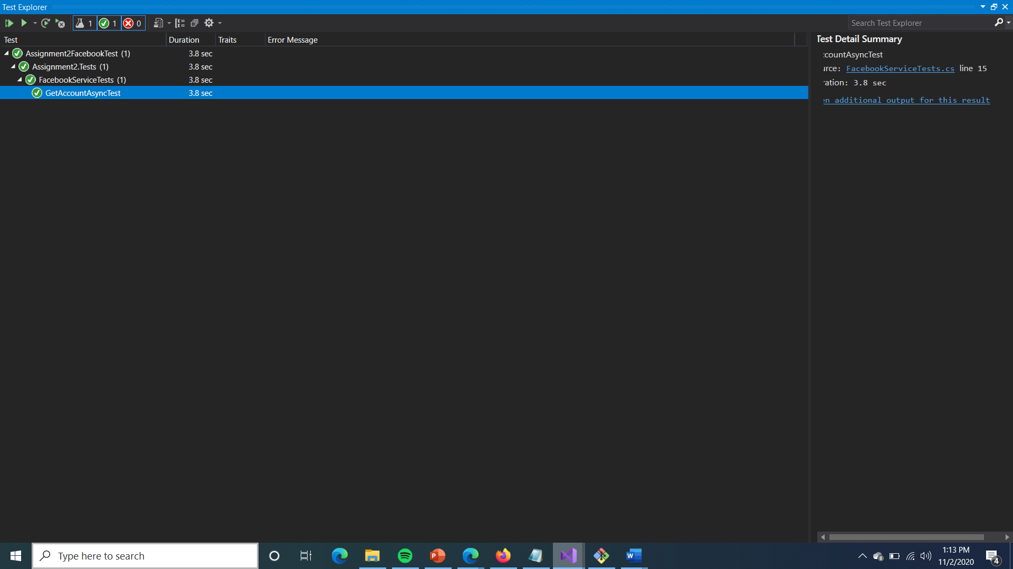

For design principles I followed a view Model Controller design pattern, I also followed the observer pattern for checking for UI changes.

I have refactored my code to pass a reference to the child windows so they can send data back to the root window and update the map appropriately.

iv.Self-diagnosis, evaluation and declaration. You must provide a full and detailed declaration of the following: the features that are fully implemented and fully working, the features that are not fully working, and the features that are not implemented. Where possible, you should also identify the possible causes of the problems for those features that are not fully working.You will not receive a pass mark unless the above declaration is made.

The one thing I was unable to complete was getting the twitter API key which I had ready to go and I have the code for sending messages to twitter in place, It just didn’t give me what I needed in the correct time frame unfortunately. I hope the marker can acknowledge that sometimes the big social media companies don’t cater for students on a deadline. So I only managed to have one stream and it is outgoing but the unit test does check the last post made to facebook and I can do other functionality as well if I desire.

Compared to assignment one I stripped out a lot of things I just didn’t feel were necessary to re-implement, such as allowing some of the categories of things to be added to the map such as videos of track logs, I wanted to mainly focus on the requirements of assignment two by still having a map and in this case a much more robust map because I have had a lot more experience since studying the content of this unit and feel I have learned a great deal more.

Posting to facebook and retrieving posts from facebook works perfectly but for some reason I had to make it set to my business page which I feel is fine, I couldn’t seme to be able to post to my own personal page even with the OAUTH for personal page postings. I don’t see this as an issue it is doing the requirements and they weren’t very specific.

The kilometer radius detection I feel works very well, and I have tested adding facebook posts near to the address of the person in this case my own address with my FB OAUTH token, and adding a facebook post in Sydney, the Sydney one was considered further than my required 50km maximum radius.

I am going to show an example of my app sending messages to my page with screenshots because It may not correctly work for the grader, You might have to add your own oauth token but you should be able to just use it how I submit it in debug and view my business page, don’t post anything naughty though 😉
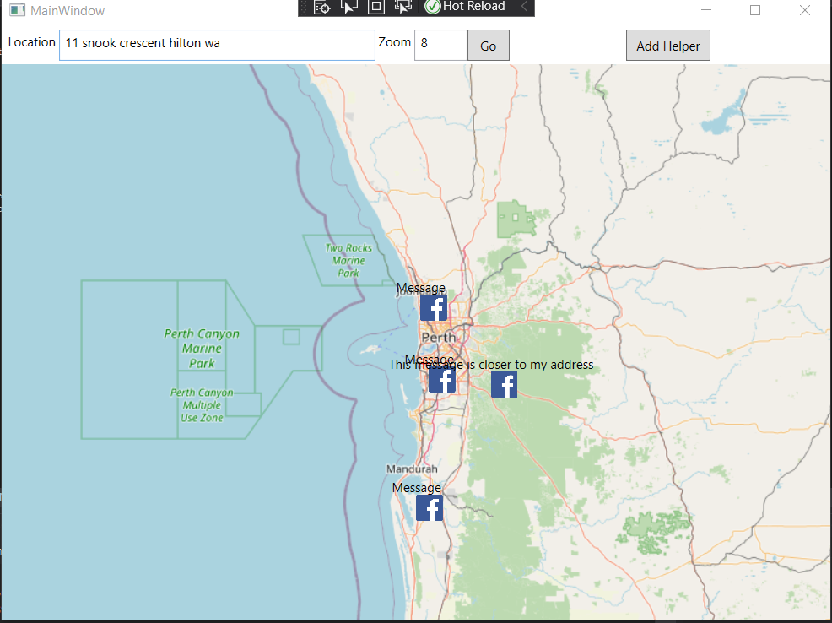
The one labeled this is closer to my address is near a road and managable within 50km to 11 snook crescent hilton in my helper.txt file
It posts to facebook
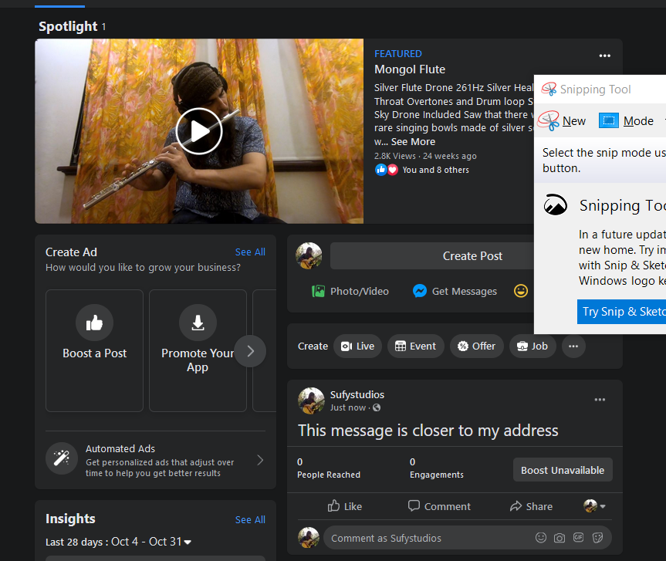
Message posted from app

The one below doesn’t post to facebook because it is in Sydney and greater than 50km
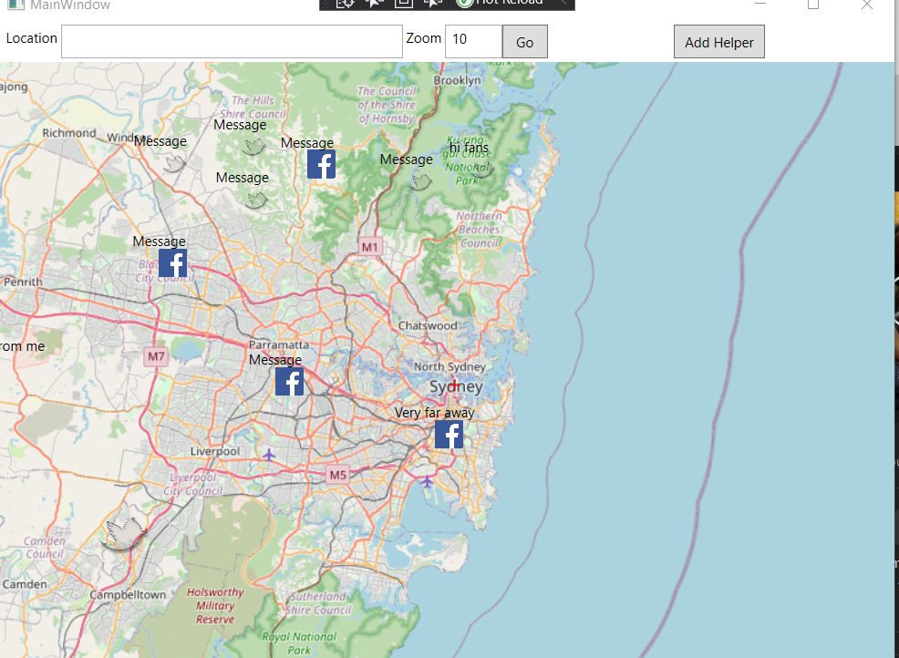
\

Here is another example with a clean slate
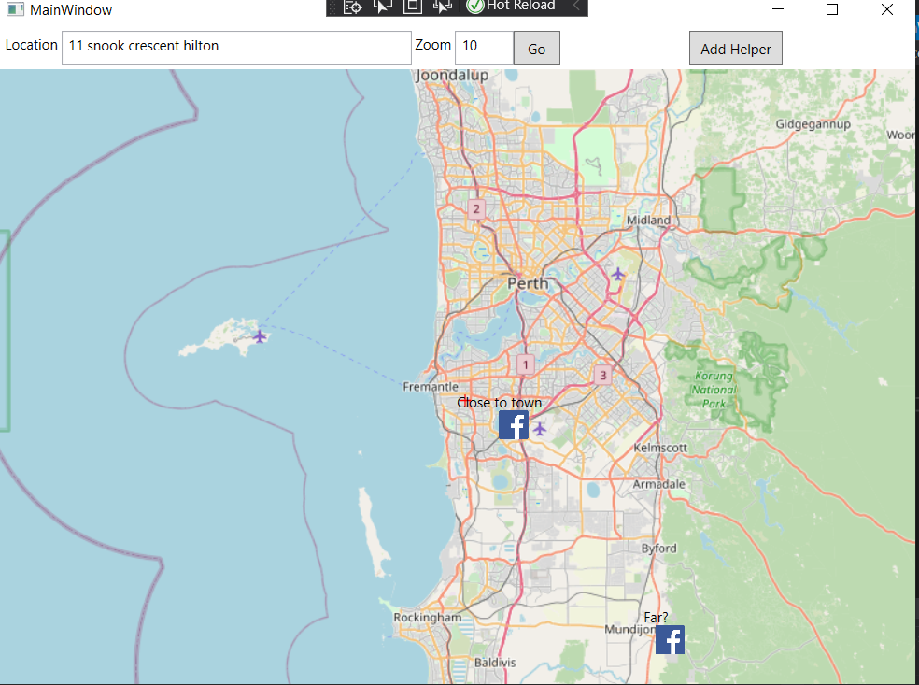

And the corresponding facebook page
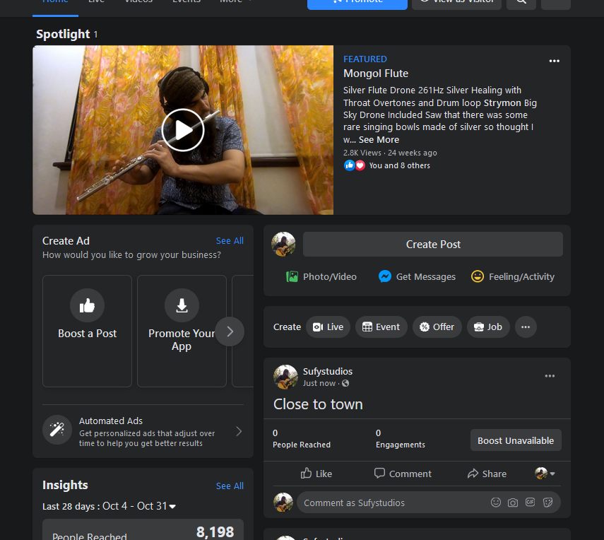

I didn’t bother to do the tracklog or add the pointless video icons and some of the other icons, that is what I consider bloat and a waste of time especially since I am so time consumed these days. One thing that is interesting is if I select a locaiton in the bush it won’t be able to navigate there and that makes sense, I’m not sure why a person with dementia would be asking for help in the middle of the bush, they would end up dead.

One refactor I had to do was also making so when the app opened up the messages didn’t get reposted, so I made an init variable to handle this.

Description of Solution

My solution is using WPF and XAML I have three views a MainWindow a window1 and a window2

The mainwindow houses the map and allows right clicks to be places on the map to bring up a form, the address and zoom level can be entered and the user can press go to navigate to that location.

Window1 is a window for entering details about events, I kept it simple and just facebook twitter and image(image doesn’t have a message) it can be opened up by right clicking

The Widnow2 can be opened up by clicking Add Helper and it asks for the helper details name, address(used for geolocation and distance to the person who can’t remember), Max KM radius , OATH for FB and twitter but twitter I didn’t get my credentials in time so I couldn’t complete that part. They are reviewing my app still.

The details in window2 are added to a file just line by line of values and are loaded into a data structure in the MainWindow containing all the helpers.

Messages are posted to their page walls using their oauth token if the user decides to do either a facebook or a tweet.

I have a class facebook client which makes http requests using Xamarins inbuilt http system and get/post methods for interacting with facebook graph.

The facebook service allows me to do specific functions, such as post to facebook, or peek the last message posted to facebook for my solitary unit test.

The functionality of Assignment 1 is all there still but I haven’t implemented all of it because it isn’t necessary you should be able to determine I am fully capable of it from what I have currently done in this assignment.

Evidence of meeting the requirements

I cannot provide 100% evidence I have met the requirements, Twitter was not functioning for me because they didn’t give my my app Key in time so they obviously want to make sure their platform is secure or might be understaffed due to covid.

I can provide 100% evidence every other functionality as written is the very very vague assignment description is working correctly.

I have provided screenshots above aswell as screenshots of my facebook wall being updated by this app.

The requirement of using XAML and WPF is obvious.

The requirement of having a form for collaborators/helpers to add data is obvious, it works okay for me.

The requirement of being able to add photos and text was there all along so that is obviously there.

Being able to post to facebook and get data off facebok is there. Again very sorry twitter refused to give me Oauth in time.

I have provided example of my refactoring, patterns, aswell as a solitary unit test that I think is very cool, that posts a message then gets the last message posted to check it is the same.

Source Listing Spam

using GMap.NET;

using GMap.NET.WindowsPresentation;
using System;
using System.Collections.Generic;
using System.IO;
using System.Linq;
using System.Text;
using System.Xml.Linq;

namespace Assignment1
{
class AddXML
{
public static void MakeNewXML()
{

XNamespace soapenv = "http://www.w3.org/2001/12/soap-envelope";
// SOAPENV:encodingStyle=\"http://www.w3.org/2001/12/soap-encoding";
XNamespace soapenvenc = "http://www.w3.org/2001/12/soap-encoding";// SOAP-ENV:encodingStyle=\"http://www.w3.org/2001/12/soap-encoding";
XNamespace lle = "http://www.xyz.org/lifelogevents";
XDocument xDoc = new XDocument(
new XDeclaration("1.0", "UTF-16", null),
new XElement(soapenv + "Envelope",
// new XAttribute(XNamespace.Xmlns + "SOAP-ENV", "http://www.w3.org/2001/12/soap-envelope\" SOAPENV:encodingStyle=\"http://www.w3.org/2001/12/soap-encoding"),
new XAttribute(XNamespace.Xmlns + "SOAP-ENV", "http://www.w3.org/2001/12/soap-envelope"),
new XAttribute(soapenv + "encodingStyle", "http://www.w3.org/2001/12/soap-encoding"),

new XElement(soapenv + "Body", new XAttribute(XNamespace.Xmlns + "lle", "http://www.xyz.org/lifelogevents")

)));

xDoc.Save("events.xml");
}
public static int AddToFile(string eventtype, string message, PointLatLng ll, string filepath)
{
try
{
if (!File.Exists("events.xml"))
{
MakeNewXML();
}
// new XAttribute(XNamespace.Xmlns + "SOAP-ENV", "http://www.w3.org/2001/12/soap-envelope\" SOAP-ENV:encodingStyle=\"http://www.w3.org/2001/12/soap-encoding"
XNamespace lle = "http://www.xyz.org/lifelogevents";
XNamespace soapenv = "http://www.w3.org/2001/12/soap-envelope";
XDocument file = XDocument.Load(@"events.xml");

// Console.WriteLine(file.ToString());

int id = 0;
// int id = (int?) Int32.Parse(file.Elements(soapenv + "Envelope").Elements(soapenv + "Body").Elements(lle + "Event").LastOrDefault().Element(lle + "eventid").Value) ?? 0;
//Console.WriteLine(file.Elements(soapenv + "Envelope").Elements(soapenv + "Body").Elements(lle + "Event").LastOrDefault().Element(lle+"eventid").Value);
if (file.Elements(soapenv + "Envelope").Elements(soapenv + "Body").Elements(lle + "Event").LastOrDefault() != null)
id = Int32.Parse(file.Elements(soapenv + "Envelope").Elements(soapenv + "Body").Elements(lle + "Event").LastOrDefault().Element(lle + "eventid").Value) + 1;
else
id = 0;
XElement ev;
if (eventtype == "tweet")
{
ev = new XElement(lle + "Event",

new XElement(lle + "eventid", id), new XElement(lle + eventtype.ToLower(), new XElement(lle + "text", message), new XElement(lle + "location", new XElement(lle + "lat", ll.Lat.ToString()), new XElement(lle + "lon", ll.Lng.ToString())), new XElement(lle + "datetimestamp", new DateTime().ToString())), new XElement(lle + "connections"));
file.Element(soapenv + "Envelope").Element(soapenv + "Body").Add(ev);
}
else if (eventtype == "facebook-status-update")
{
ev = new XElement(lle + "Event",

new XElement(lle + "eventid", id), new XElement(lle + eventtype, new XElement(lle + "text", message), new XElement(lle + "location", new XElement(lle + "lat", ll.Lat.ToString()), new XElement(lle + "lon", ll.Lng.ToString())), new XElement(lle + "datetimestamp", new DateTime().ToString())), new XElement(lle + "connections"));
file.Element(soapenv + "Envelope").Element(soapenv + "Body").Add(ev);
}
else if (eventtype == "photo")
{
ev = new XElement(lle + "Event",

new XElement(lle + "eventid", id), new XElement(lle + eventtype, new XElement(lle + "filepath", filepath), new XElement(lle + "location", new XElement(lle + "lat", ll.Lat.ToString()), new XElement(lle + "lon", ll.Lng.ToString()))), new XElement(lle + "connections"));
file.Element(soapenv + "Envelope").Element(soapenv + "Body").Add(ev);
}
else if (eventtype == "video")
{
ev = new XElement(lle + "Event",

new XElement(lle + "eventid", id), new XElement(lle + eventtype, new XElement(lle + "filepath", filepath), new XElement(lle + "location", new XElement(lle + "lat", ll.Lat.ToString()), new XElement(lle + "lon", ll.Lng.ToString())), new XElement(lle + "start-time", new XElement(lle + "datetimestamp", new DateTime().ToString())), new XElement(lle + "end-time", new XElement(lle + "datetimestamp", new DateTime().ToString()))), new XElement(lle + "connections"));
file.Element(soapenv + "Envelope").Element(soapenv + "Body").Add(ev);
}
else if (eventtype == "tracklog")
{
ev = new XElement(lle + "Event",
new XElement(lle + "eventid", id), new XElement(lle + eventtype, new XElement(lle + "filepath", filepath), new XElement(lle + "data", LoadGPXTracks(filepath) + LoadGPXWaypoints(filepath)), new XElement(lle + "start-time", new XElement(lle + "datetimestamp", new DateTime().ToString())), new XElement(lle + "end-time", new XElement(lle + "datetimestamp", new DateTime().ToString()))), new XElement(lle + "connections"));
file.Element(soapenv + "Envelope").Element(soapenv + "Body").Add(ev);
}

// Console.WriteLine("null");
//file.Element(soapenv +"Body").Add(ev);
file.Save("events.xml");
// Console.WriteLine(file);
//Console.WriteLine(sw);
return id;
}
catch (Exception e)
{
return -1;
}
}

private static XNamespace GetGpxNameSpace()
{
XNamespace gpx = XNamespace.Get("http://www.topografix.com/GPX/1/1");
return gpx;
}
public static List<double[]> getWaypoints(string data)
{
Console.WriteLine(data);
List<double[]> waypoints = new List<double[]>();
string[] split = data.Split('\n');

for (int i = 0; i < split.Length - 1; i++)
{
Console.WriteLine(split[i].Split(' ')[0].ToString());
double[] d = new double[2];
Console.WriteLine(split[i]);
d[0] = double.Parse(split[i].Split(' ')[1].Split(':')[1]);
d[1] = double.Parse(split[i].Split(' ')[2].Split(':')[1]);
waypoints.Add(d);
}
return waypoints;

}
public static IEnumerable<Tracklog> getTracklogs()
{

XNamespace soapenv = "http://www.w3.org/2001/12/soap-envelope";
// SOAPENV:encodingStyle=\"http://www.w3.org/2001/12/soap-encoding";
XNamespace soapenvenc = "http://www.w3.org/2001/12/soap-encoding";// SOAP-ENV:encodingStyle=\"http://www.w3.org/2001/12/soap-encoding";
XNamespace lle = "http://www.xyz.org/lifelogevents";

XDocument document = XDocument.Load("events.xml");
var events = from r in document.Descendants(lle + "Event")
from x in r.Elements().First().ElementsAfterSelf()
where x.Name.LocalName == "tracklog"
select new Tracklog(
Int32.Parse(r.Element(lle + "eventid").Value),
x.Element(lle + "data").Value,

x.Element(lle + "filepath").Value,
x.Name.LocalName.ToString()
);

return events;
;
}
public static string LoadGPXTracks(string sFile)
{
XDocument gpxDoc = GetGpxDoc(sFile);
XNamespace gpx = GetGpxNameSpace();
var tracks = from track in gpxDoc.Descendants(gpx + "trk")
select new
{
Name = track.Element(gpx + "name") != null ?
track.Element(gpx + "name").Value : null,
Segs = (
from trackpoint in track.Descendants(gpx + "trkpt")
select new
{
Latitude = trackpoint.Attribute("lat").Value,
Longitude = trackpoint.Attribute("lon").Value,
Elevation = trackpoint.Element(gpx + "ele") != null ?
trackpoint.Element(gpx + "ele").Value : null,
Time = trackpoint.Element(gpx + "time") != null ?
trackpoint.Element(gpx + "time").Value : null
}
)
};

StringBuilder sb = new StringBuilder();
foreach (var trk in tracks)
{
// Populate track data objects.
foreach (var trkSeg in trk.Segs)
{
// Populate detailed track segments
// in the object model here.
sb.Append(
string.Format("Date:{4} Latitude:{1} Longitude:{2} " +
"Elevation:{3} Date:{4}\n",
trk.Name, trkSeg.Latitude,
trkSeg.Longitude, trkSeg.Elevation,
trkSeg.Time));
}
}
return sb.ToString();
}

public static string LoadGPXWaypoints(string sFile)
{
try
{
XDocument gpxDoc = GetGpxDoc(sFile);
XNamespace gpx = GetGpxNameSpace();

var waypoints = from waypoint in gpxDoc.Descendants(gpx + "wpt")
select new
{
Latitude = waypoint.Attribute("lat").Value,
Longitude = waypoint.Attribute("lon").Value,
Elevation = waypoint.Element(gpx + "ele") != null ?
waypoint.Element(gpx + "ele").Value : null,
Name = waypoint.Element(gpx + "name") != null ?
waypoint.Element(gpx + "name").Value : null,
Dt = waypoint.Element(gpx + "cmt") != null ?
waypoint.Element(gpx + "cmt").Value : null
};

StringBuilder sb = new StringBuilder();
foreach (var wpt in waypoints)
{

sb.Append(
string.Format("Date:{4} Latitude:{1} Longitude:{2} Elevation:{3} Date:{4}\n",
wpt.Name, wpt.Latitude, wpt.Longitude,
wpt.Elevation, wpt.Dt));
}

//sb.Append(LoadGPXTracks(sFile));
Console.WriteLine(sb);
return sb.ToString();
}
catch (Exception e)
{
throw;
}
}
private static XDocument GetGpxDoc(string sFile)
{
try
{
XDocument gpxDoc;

gpxDoc = XDocument.Load(sFile);
return gpxDoc;
}
catch (Exception e)
{
throw;
}

}
public static IEnumerable<Event> getXMLEvents()
{

XNamespace soapenv = "http://www.w3.org/2001/12/soap-envelope";
// SOAPENV:encodingStyle=\"http://www.w3.org/2001/12/soap-encoding";
XNamespace soapenvenc = "http://www.w3.org/2001/12/soap-encoding";// SOAP-ENV:encodingStyle=\"http://www.w3.org/2001/12/soap-encoding";
XNamespace lle = "http://www.xyz.org/lifelogevents";

XDocument document = XDocument.Load("events.xml");
var events = from r in document.Descendants(lle + "Event")
from x in r.Elements().First().ElementsAfterSelf()
where x.Name.LocalName != "photo" && x.Name.LocalName != "video" && isTextEvent(x.Name.LocalName)

select new Event(
Int32.Parse(r.Element(lle + "eventid").Value),
double.Parse(x.Element(lle + "location").Element(lle + "lat").Value),
double.Parse(x.Element(lle + "location").Element(lle + "lon").Value),
x.Element(lle + "text").Value,
x.Name.LocalName.ToString()
);

return events;
;
}
public static IEnumerable<Video> getXMLVideos()
{

XNamespace soapenv = "http://www.w3.org/2001/12/soap-envelope";
// SOAPENV:encodingStyle=\"http://www.w3.org/2001/12/soap-encoding";
XNamespace soapenvenc = "http://www.w3.org/2001/12/soap-encoding";// SOAP-ENV:encodingStyle=\"http://www.w3.org/2001/12/soap-encoding";
XNamespace lle = "http://www.xyz.org/lifelogevents";

XDocument document = XDocument.Load("events.xml");
var events = from r in document.Descendants(lle + "Event")
from x in r.Elements().First().ElementsAfterSelf()
where x.Name.LocalName == "video"
select new Video(
Int32.Parse(r.Element(lle + "eventid").Value),
double.Parse(x.Element(lle + "location").Element(lle + "lat").Value),
double.Parse(x.Element(lle + "location").Element(lle + "lon").Value),
x.Element(lle + "filepath").Value,
x.Name.LocalName.ToString()
);

return events;
;
}
public static IEnumerable<Photo> getXMLPhotos()
{

XNamespace soapenv = "http://www.w3.org/2001/12/soap-envelope";
// SOAPENV:encodingStyle=\"http://www.w3.org/2001/12/soap-encoding";
XNamespace soapenvenc = "http://www.w3.org/2001/12/soap-encoding";// SOAP-ENV:encodingStyle=\"http://www.w3.org/2001/12/soap-encoding";
XNamespace lle = "http://www.xyz.org/lifelogevents";

XDocument document = XDocument.Load("events.xml");
var events = from r in document.Descendants(lle + "Event")
from x in r.Elements().First().ElementsAfterSelf()
where x.Name.LocalName == "photo"
select new Photo(
Int32.Parse(r.Element(lle + "eventid").Value),
double.Parse(x.Element(lle + "location").Element(lle + "lat").Value),
double.Parse(x.Element(lle + "location").Element(lle + "lon").Value),
x.Element(lle + "filepath").Value,
x.Name.LocalName.ToString()
);

return events;
;
}

public static IEnumerable<Connection> GetConnections(int id)
{

XNamespace soapenv = "http://www.w3.org/2001/12/soap-envelope";
// SOAPENV:encodingStyle=\"http://www.w3.org/2001/12/soap-encoding";
XNamespace soapenvenc = "http://www.w3.org/2001/12/soap-encoding";// SOAP-ENV:encodingStyle=\"http://www.w3.org/2001/12/soap-encoding";
XNamespace lle = "http://www.xyz.org/lifelogevents";

XDocument document = XDocument.Load("events.xml");
var connections = from r in document.Descendants(lle + "Event")
from x in r.Descendants(lle + "connection")
where x != null && r.Element(lle + "eventid").Value.Equals(id.ToString())
select new Connection(
Int32.Parse(x.Element(lle + "from").Value),
Int32.Parse(x.Element(lle + "to").Value)
);

return connections;
;
}
public static void removeEvent(int id)
{
XNamespace soapenv = "http://www.w3.org/2001/12/soap-envelope";
// SOAPENV:encodingStyle=\"http://www.w3.org/2001/12/soap-encoding";
XNamespace soapenvenc = "http://www.w3.org/2001/12/soap-encoding";// SOAP-ENV:encodingStyle=\"http://www.w3.org/2001/12/soap-encoding";
XNamespace lle = "http://www.xyz.org/lifelogevents";
XDocument file = XDocument.Load("events.xml");

//XDocument xmlDoc = XDocument.Load("d:/data.xml");
var elementsToDelete = from ele in file.Elements(soapenv + "Envelope").Elements(soapenv + "Body").Elements(lle + "Event")
where ele != null && ele.Element(lle + "eventid").Value.Equals(id.ToString())
select ele;
Console.WriteLine(id);
foreach (var e in elementsToDelete)
{
e.Remove();

}
file.Save("events.xml");
}
public static void removeEvent(double lat, double lon)
{
XNamespace soapenv = "http://www.w3.org/2001/12/soap-envelope";
// SOAPENV:encodingStyle=\"http://www.w3.org/2001/12/soap-encoding";
XNamespace soapenvenc = "http://www.w3.org/2001/12/soap-encoding";// SOAP-ENV:encodingStyle=\"http://www.w3.org/2001/12/soap-encoding";
XNamespace lle = "http://www.xyz.org/lifelogevents";
XDocument file = XDocument.Load("events.xml");

//XDocument xmlDoc = XDocument.Load("d:/data.xml");
var elementsToDelete = from ele in file.Elements(soapenv + "Envelope").Elements(soapenv + "Body").Elements(lle + "Event")
where ele != null && ele.Element(lle + "lat").Value.Equals(lat.ToString()) && ele.Element(lle + "lon").Value.Equals(lon.ToString())
select ele;

foreach (var e in elementsToDelete)
{
e.Remove();

}
file.Save("events.xml");

}
public static void addConnection(int start, int to)
{
XNamespace soapenv = "http://www.w3.org/2001/12/soap-envelope";
// SOAPENV:encodingStyle=\"http://www.w3.org/2001/12/soap-encoding";
XNamespace soapenvenc = "http://www.w3.org/2001/12/soap-encoding";// SOAP-ENV:encodingStyle=\"http://www.w3.org/2001/12/soap-encoding";
XNamespace lle = "http://www.xyz.org/lifelogevents";
XDocument file = XDocument.Load("events.xml");
XElement conn = new XElement(lle + "connection",

new XElement(lle + "from", start), new XElement(lle + "to", to));

var elementsToUpdate = from ele in file.Elements(soapenv + "Envelope").Elements(soapenv + "Body").Elements(lle + "Event")
where ele != null && ele.Element(lle + "eventid").Value.Equals(start.ToString())
select ele;
int id = 0;

foreach (var e in elementsToUpdate)
{
e.Element(lle + "connections").Add(conn);
//id = Int32.Parse(e.Element(lle + "eventid").Value);
}
// file.Element(soapenv + "Envelope").Element(soapenv + "Body").Add(ev);
file.Save("events.xml");
}
public static void updateEvent(GMapMarker mark, string text)
{

XNamespace soapenv = "http://www.w3.org/2001/12/soap-envelope";
// SOAPENV:encodingStyle=\"http://www.w3.org/2001/12/soap-encoding";
XNamespace soapenvenc = "http://www.w3.org/2001/12/soap-encoding";// SOAP-ENV:encodingStyle=\"http://www.w3.org/2001/12/soap-encoding";
XNamespace lle = "http://www.xyz.org/lifelogevents";
XDocument file = XDocument.Load("events.xml");

//XDocument xmlDoc = XDocument.Load("d:/data.xml");
try
{
var elementsToUpdate = from ele in file.Elements(soapenv + "Envelope").Elements(soapenv + "Body").Elements(lle + "Event")
from x in ele.Elements().First().ElementsAfterSelf()
where ele != null && ele.Element(lle + "eventid").Value.Equals(Event.getIndex(mark).ToString()) && isTextEvent(x.Name.LocalName)
select ele;
int id = 0;

foreach (var e in elementsToUpdate)
{

e.Elements().First().ElementsAfterSelf().Elements(lle + "text").First().Value = text;
id = Int32.Parse(e.Element(lle + "eventid").Value);
}
if (isTextEvent(elementsToUpdate.Elements().First().ElementsAfterSelf().First().Name.LocalName))
{
file.Save("events.xml");

mark.Tag = id + ":" + elementsToUpdate.Elements().First().ElementsAfterSelf().First().Name.LocalName + ": " + text;

}
}
catch (Exception e)
{

}
}
public static void addToTracklog(double lat, double lon, int id)
{

}
public static bool isTextEvent(string name)
{
if (name == "facebook-status-update")
return true;
if (name == "tweet")
return true;
return false;
}
}
}

using GMap.NET.WindowsPresentation;
using System;
using System.Collections.Generic;

namespace Assignment1
{
class Event
{
public double lat { get; set; }
public double lon { get; set; }
public string message { get; set; }
public int id { get; set; }
public int[] destinations { get; set; }
public string type { get; set; }
public IEnumerable<Connection> conns;
public Event(int id, double lat, double lon, string message, string type)
{
this.id = id;
this.lat = lat;
this.lon = lon;
this.message = message;
this.type = type;
}
public static int getIndex(GMapMarker e)
{
int index = e.Tag.ToString().IndexOf(":");
string sub = e.Tag.ToString().Substring(0, index);
return Int32.Parse(sub);

}
}
class Tracklog : Event
{
public string data;
public string filename;
public Tracklog(int id, string data, string filename, string type) : base(id, 0, 0, "", "tracklog")
{
this.data = data;
this.filename = filename;
}
}
class Video : Photo
{
public Video(int id, double lat, double lon, string filename, string type) : base(id, lat, lon, filename, type)
{

}
}
class Photo : Event
{
public string filename;
public Photo(int id, double lat, double lon, string filename, string type) : base(id, lat, lon, "", type)
{
this.filename = filename;
}
}
class Connection
{
public int from { get; set; }
public int to { get; set; }
public Connection(int from, int to)
{
this.from = from;
this.to = to;
}
}
}
using System;
using System.Net.Http;
using System.Net.Http.Headers;
using System.Text;
using System.Threading.Tasks;
using Newtonsoft.Json;

namespace Assignment2
{
public interface IFacebookClient
{
Task<T> GetAsync<T>(string accessToken, string endpoint, string args = null);
Task PostAsync(string accessToken, string endpoint, object data, string args = null);
}

public class FacebookClient : IFacebookClient
{
private readonly HttpClient _httpClient;

public FacebookClient()
{
_httpClient = new HttpClient
{
BaseAddress = new Uri("https://graph.facebook.com/v8.0/")
};
_httpClient.DefaultRequestHeaders
.Accept
.Add(new MediaTypeWithQualityHeaderValue("application/json"));
}

public async Task<T> GetAsync<T>(string accessToken, string endpoint, string args = null)
{
var response = await _httpClient.GetAsync($"{endpoint}?access_token={accessToken}&{args}");
if (!response.IsSuccessStatusCode)
return default(T);

var result = await response.Content.ReadAsStringAsync();

return JsonConvert.DeserializeObject<T>(result);
}

public async Task PostAsync(string accessToken, string endpoint, object data, string args = null)
{
var payload = GetPayload(data);
Console.WriteLine($"{endpoint}?access_token={accessToken}&{args} {data}");
await _httpClient.PostAsync($"{endpoint}?access_token={accessToken}&{args}", payload);
}

private static StringContent GetPayload(object data)
{
var json = JsonConvert.SerializeObject(data);
return new StringContent(json, Encoding.UTF8, "application/json");
}
}
}using System;
using System.Collections;
using System.Threading.Tasks;

namespace Assignment2
{
public interface IFacebookService
{
Task<Account> GetAccountAsync(string accessToken);
Task PostOnWallAsync(string accessToken, string message);
}

public class FacebookService : IFacebookService
{
private readonly IFacebookClient _facebookClient;

public FacebookService(IFacebookClient facebookClient)
{
_facebookClient = facebookClient;
}

public async Task<Account> GetAccountAsync(string accessToken)
{
var result = await _facebookClient.GetAsync<dynamic>(
accessToken, "me", "fields=id,name,email,first_name,last_name,age_range,birthday,gender,locale");

if (result == null)
{
return new Account();
}

var account = new Account
{
Id = result.id,
Email = result.email,
Name = result.name,
UserName = result.username,
FirstName = result.first_name,
LastName = result.last_name,
Locale = result.locale
};

return account;
}

public async Task<string> GetPostsAsync(string accessToken)
{
var result = await _facebookClient.GetAsync<dynamic>(
accessToken, "me/feed", "limit(1){message}");

if (result == null)
{
return "";
}

string combo = "";

return result.data[0].message;
}

public async Task PostOnWallAsync(string accessToken, string message)
=> await _facebookClient.PostAsync(accessToken, "me/feed", new { message });
}
}
<Window x:Class="Assignment2.MainWindow"
xmlns="http://schemas.microsoft.com/winfx/2006/xaml/presentation"
xmlns:x="http://schemas.microsoft.com/winfx/2006/xaml"
xmlns:d="http://schemas.microsoft.com/expression/blend/2008"
xmlns:gmaps="clr-namespace:GMap.NET.WindowsPresentation;assembly=GMap.NET.WindowsPresentation"
xmlns:mc="http://schemas.openxmlformats.org/markup-compatibility/2006"
xmlns:local="clr-namespace:Assignment2"
mc:Ignorable="d"
Title="MainWindow" Height="600" Width="800">
<StackPanel>
<DockPanel Height="30" Margin="3">
<TextBlock Text="Location" Padding="3" />
<TextBox Name="Address" Width="300" Padding="3"/>
<TextBlock Text="Zoom" Padding="3" />
<TextBox Width="50" Padding="3" Text="10" Name="Zoom"/>
<Button Name="Go" Content="Go" Padding="3" Width="40" Click="Go_Click"/>
<Button Name="AddHelper" Content="Add Helper" Padding="3" Width="80" Height="30" VerticalAlignment="Top" Click="AddHelper_Click"/>

</DockPanel>
<gmaps:GMapControl x:Name="mapView" Loaded="mapView_Loaded" Height="567" Width="800" MouseRightButtonDown="rightMouse" />
</StackPanel>
</Window>

using Assignment1;
using GMap.NET;

using GMap.NET.WindowsForms.Markers;
using GMap.NET.WindowsPresentation;
using System;
using System.Collections.Generic;
using System.ComponentModel;
using System.Data.Entity.Infrastructure.MappingViews;
using System.IO;
using System.Linq;
using System.Text;
using System.Threading.Tasks;
using System.Windows;
using System.Windows.Controls;
using System.Windows.Documents;
using System.Windows.Input;
using System.Windows.Media;
using System.Windows.Shapes;
using Tweetinvi;

namespace Assignment2
{
/// <summary>
/// Interaction logic for MainWindow.xaml
/// </summary>
public partial class MainWindow : Window
{
private Dictionary<int, GMapMarker> markers;
private FacebookService facebookService;
bool init = true;
private List<Account> facebookHelpers;
TwitterClient userClient;
public class helper
{
public string name;
public string address;
public string km;
public string fbauth;
public string twitterauth;
}

public List<helper> helperlist;

public MainWindow()
{
InitializeComponent();
facebookHelpers = new List<Account>();
facebookService = new FacebookService(new FacebookClient());
markers = new Dictionary<int, GMapMarker>();
userClient = new TwitterClient("CONSUMER_KEY", "CONSUMER_SECRET", "ACCESS_TOKEN", "ACCESS_TOKEN_SECRET");
updateHelpers();

}

public void postFacebookMessage(PointLatLng latlng,string message)
{
if (!init)
{
foreach (helper i in helperlist)
{
Console.WriteLine(i.address == null);
Console.WriteLine("name " + i.name);
Console.WriteLine("address " + i.address);
Console.WriteLine("km " + i.km);
Console.WriteLine("fbauth " + i.fbauth);
Console.WriteLine(helperlist.Count());
Console.WriteLine(mapView.GetPositionByKeywords(i.address));
try
{
var route = GMap.NET.MapProviders.OpenStreetMapProvider.Instance
.GetRoute(mapView.GetPositionByKeywords(i.address), latlng, false, false, 14);

var distance = route.Distance;
Console.WriteLine("Distance" + distance);

if (distance <= Convert.ToDouble(i.km) && distance != 0)
{
Console.WriteLine("Near the point");

Task.Run(() =>
{

var post = facebookService.PostOnWallAsync(i.fbauth, message);
Task.WaitAll(post);
Console.WriteLine("Post Complete");
}
);
}
else
{
Console.WriteLine("not near the point");
}
}
catch (Exception e)
{

}
}
}

}

private void mapView_Loaded(object sender, RoutedEventArgs e)
{
GMap.NET.GMaps.Instance.Mode = GMap.NET.AccessMode.ServerAndCache;
// choose your provider here
mapView.MapProvider = GMap.NET.MapProviders.OpenStreetMapProvider.Instance;
mapView.MinZoom = 2;
mapView.MaxZoom = 17;
mapView.BringIntoView();

// whole world zoom
mapView.Zoom = 2;
// lets the map use the mousewheel to zoom
mapView.MouseWheelZoomType = GMap.NET.MouseWheelZoomType.MousePositionAndCenter;
// lets the user drag the map
mapView.CanDragMap = true;
// lets the user drag the map with the left mouse button
mapView.DragButton = MouseButton.Left;
mapView.SetPositionByKeywords("Sydney, Australia");
mapView.Zoom = 10;

updateHelpers();
showMap();
init = false;

}

private void rightMouse(object sender, MouseEventArgs e)
{
var p = e.GetPosition(mapView);

PointLatLng pp = mapView.FromLocalToLatLng((int)p.X,(int)p.Y);

Console.WriteLine(pp.ToString());

Window1 window = new Window1(this,sender);
window.addCoords(pp);
window.Show();

}

internal void updateHelpers()
{
string helpers = "";
helperlist = new List<helper>();
try
{
helpers = System.IO.File.ReadAllText(@"helpers.txt");
} catch( Exception e)
{

}
// Console.WriteLine(helpers);
string aLine;
StringReader strReader = new StringReader(helpers);
bool eof = false;
while (!eof)
{

helper helpertmp = new helper();
for (int i = 0; i < 5; i++)
{
aLine = strReader.ReadLine();
Console.WriteLine(aLine);
if (aLine == null )
{
eof = true;
break;
}
if(aLine.Equals("")) {
eof = true;
break;
}

switch (i)
{
case 0:
helpertmp.name = aLine;
Console.WriteLine(aLine);
break;
case 1:
helpertmp.address = aLine;
Console.WriteLine(aLine);
break;
case 2:
helpertmp.km = aLine;
Console.WriteLine(aLine);
break;
case 3:
helpertmp.fbauth = aLine;
Console.WriteLine(aLine);
break;
case 4:
helpertmp.twitterauth = aLine;
Console.WriteLine(aLine);
break;

}

}
helperlist.Add(helpertmp);

}
helperlist.RemoveAt(helperlist.Count() - 1);
foreach (helper h in helperlist)
{
Console.WriteLine(h.name);

}

}

public GMapControl GetGMapControl()
{
return mapView;
}

public async void showMap()
{
try
{

var events = AddXML.getXMLEvents();

//markers = new List<GMapMarker>();
//labels = new List<Label>();

foreach (var item in events)
{
// Point p = getPositionOnScreen(item.lon, item.lat);
addMarker(item.id, item.lat, item.lon, item.message, item.type);
/* PointLatLng point = new PointLatLng(item.lat,item.lon);
GMapMarker marker = new GMarkerGoogle(point,GMarkerGoogleType.pink);
overlay.Markers.Add(marker);
marker.ToolTipText =item.id+ item.message;
marker.ToolTipMode = MarkerTooltipMode.Always;
*/

}
var tracklogs = AddXML.getTracklogs();

var photos = AddXML.getXMLPhotos();
foreach (var item in photos)
{
Console.WriteLine("test");
// Point p = getPositionOnScreen(item.lon, item.lat);
addMarkerImage(item.id, item.lat, item.lon, item.filename, item.type);
/* PointLatLng point = new PointLatLng(item.lat,item.lon);
GMapMarker marker = new GMarkerGoogle(point,GMarkerGoogleType.pink);
overlay.Markers.Add(marker);
marker.ToolTipText =item.id+ item.message;
marker.ToolTipMode = MarkerTooltipMode.Always;
*/

}
var videos = AddXML.getXMLVideos();
foreach (var item in videos)
{
Console.WriteLine(item.type);

// Point p = getPositionOnScreen(item.lon, item.lat);

/* PointLatLng point = new PointLatLng(item.lat,item.lon);
GMapMarker marker = new GMarkerGoogle(point,GMarkerGoogleType.pink);
overlay.Markers.Add(marker);
marker.ToolTipText =item.id+ item.message;
marker.ToolTipMode = MarkerTooltipMode.Always;
*/

}

}
catch (Exception e)
{
Console.WriteLine("couldn't download" + e);
}
}

public void addMarker(int id, double lat, double lon, string message, string type)
{
PointLatLng point = new PointLatLng(lat, lon);
var marker = new GMapMarker(point);
if (type == "tweet")
{
System.Windows.Media.Imaging.BitmapImage bitmapImage = new System.Windows.Media.Imaging.BitmapImage();
bitmapImage.BeginInit();
var uri = new Uri("pack://application:,,,/bird.png");
bitmapImage.UriSource = uri;

bitmapImage.EndInit();

System.Windows.Controls.Image image = new System.Windows.Controls.Image();
image.Source = bitmapImage;
image.Width = 25;
image.Height = 25;

marker = new GMapMarker(point);
marker.Shape = image;
Task.Run(async () =>
{
var tweet = await userClient.Tweets.PublishTweetAsync(message);
Console.WriteLine("You published the tweet : " + tweet);
});
}
else if (type == "facebook-status-update")
{

System.Windows.Media.Imaging.BitmapImage bitmapImage = new System.Windows.Media.Imaging.BitmapImage();
bitmapImage.BeginInit();
bitmapImage.UriSource = new Uri("pack://application:,,,/fb.png");
bitmapImage.EndInit();
GMap.NET.WindowsPresentation.GMapMarker marker2 = new GMap.NET.WindowsPresentation.GMapMarker(new GMap.NET.PointLatLng(35.6960617168288, 51.4005661010742));
System.Windows.Controls.Image image = new System.Windows.Controls.Image();
image.Source = bitmapImage;
image.Width = 25;
image.Height =25;

marker = new GMapMarker(point);
marker.Shape = image;
postFacebookMessage(point, message);
}
else
{
marker = new GMapMarker(point);
marker.ZIndex = 1;
marker.Shape = new Ellipse
{
Width = 10,
Height = 10,
Stroke = Brushes.Black,
StrokeThickness = 1.5
};
}
mapView.Markers.Add(marker);
markers[id] = marker;

marker.Tag = id.ToString() + ":" + type + " :" + message;
var textBlock = new TextBlock(new Run(message));
textBlock.Measure(new Size(double.PositiveInfinity, double.PositiveInfinity));
textBlock.Arrange(new Rect(textBlock.DesiredSize));
mapView.Markers.Add(new GMapMarker(new PointLatLng(lat, lon))
{
Offset = new Point(-textBlock.ActualWidth / 2 ,-15),
Shape = textBlock
}) ;

}
public void addMarkerImage(int id, double lat, double lon, string filename, string type)
{
PointLatLng point = new PointLatLng(lat, lon);
try
{

System.Windows.Media.Imaging.BitmapImage bitmapImage = new System.Windows.Media.Imaging.BitmapImage();
bitmapImage.BeginInit();
bitmapImage.UriSource = new Uri(filename);
bitmapImage.EndInit();
System.Windows.Controls.Image image = new System.Windows.Controls.Image();
image.Source = bitmapImage;
GMapMarker marker = new GMapMarker(point);
image.Width = 50;
image.Height = 50;
markers[id] = marker;

marker.Tag = id.ToString() + ":" + type + " :";
marker.Shape = image;
mapView.Markers.Add(marker);
}
catch (Exception e)
{

}

}

private void AddHelper_Click(object sender, RoutedEventArgs e)
{

Window2 helperWindow = new Window2(this);

helperWindow.Show();

}

private void Go_Click(object sender, RoutedEventArgs e)
{
mapView.SetPositionByKeywords(Address.Text);
mapView.Zoom=Convert.ToDouble(Zoom.Text);

}
}

}
<Window x:Class="Assignment2.Window1"
xmlns="http://schemas.microsoft.com/winfx/2006/xaml/presentation"
xmlns:x="http://schemas.microsoft.com/winfx/2006/xaml"
xmlns:d="http://schemas.microsoft.com/expression/blend/2008"
xmlns:mc="http://schemas.openxmlformats.org/markup-compatibility/2006"
xmlns:local="clr-namespace:Assignment2"
mc:Ignorable="d"
Title="Window1" Height="309.267" Width="373.842">
<Grid >
<TextBlock HorizontalAlignment="Left" Margin="44,44,0,0" TextWrapping="Wrap" VerticalAlignment="Top" Text="Enter Message"></TextBlock>
<Button Content="Add Event" HorizontalAlignment="Left" Margin="111,203,0,0" VerticalAlignment="Top" Width="103" Height="40" Click="Button_Click"/>
<RadioButton GroupName="type" Name="twitter" Content="twitter" HorizontalAlignment="Left" Margin="146,112,0,0" VerticalAlignment="Top"/>
<RadioButton GroupName="type" Name="facebook" Content="facebook" HorizontalAlignment="Left" Margin="146,132,0,0" VerticalAlignment="Top" RenderTransformOrigin="0.5,0.5">
</RadioButton>
<RadioButton GroupName="type" Name="image" Content="image" HorizontalAlignment="Left" Margin="146,155,0,0" VerticalAlignment="Top"/>
<Button Content="File Picker" HorizontalAlignment="Left" Margin="239,203,0,0" VerticalAlignment="Top" Width="93" Click="pickFile" Height="40"/>
<TextBox Name="message" HorizontalAlignment="Left" Height="23" Margin="146,44,0,0" TextWrapping="Wrap" Text="Message" VerticalAlignment="Top" Width="120" TextChanged="TextBox_TextChanged"/>

</Grid>
</Window>

using Assignment1;
using GMap.NET;
using GMap.NET.WindowsForms;
using GMap.NET.WindowsPresentation;
using Microsoft.Win32;
using System;
using System.Collections.Generic;
using System.IO;
using System.Linq;
using System.Text;
using System.Threading.Tasks;
using System.Windows;
using System.Windows.Controls;
using System.Windows.Data;
using System.Windows.Documents;
using System.Windows.Input;
using System.Windows.Media;
using System.Windows.Media.Imaging;
using System.Windows.Shapes;

namespace Assignment2
{
/// <summary>
/// Interaction logic for Window1.xaml
/// </summary>
///

public partial class Window1 : Window
{
private Window root;
string filename;
private PointLatLng pp;

public Window1( Window root, object sender)
{
InitializeComponent();
if(sender.GetType()== typeof(GMap.NET.WindowsPresentation.GMapMarker))
{
Console.WriteLine("clicked marker");
}
this.root=root;
}

public void addCoords(GMap.NET.PointLatLng latlng)
{
pp = latlng;

}

private void addEvent_Click()
{
MainWindow f = (MainWindow)root;
f.Show();

if ((bool)image.IsChecked)
{
int id = AddXML.AddToFile("photo", message.Text, pp, filename);
(f).addMarkerImage(id, pp.Lat, pp.Lng, filename, message.Text);
}
else if((bool)twitter.IsChecked)
{
Console.WriteLine("test");
int id = AddXML.AddToFile("tweet", message.Text, pp, filename);
(f).addMarker(id, pp.Lat, pp.Lng, message.Text,"tweet");
}

else if((bool)facebook.IsChecked)
{
Console.WriteLine("test");
int id = AddXML.AddToFile("facebook-status-update", message.Text, pp, filename);
(f).addMarker(id, pp.Lat, pp.Lng, message.Text, "facebook-status-update");
}
this.Close();
//f.getPanel().Controls.Add(l);
// int zIndex = f.getPanel().Controls.GetChildIndex(l);
// l.BringToFront();
// Do something...
// Then send it back again
//f.showMap();
//f.getPanel().Controls.SetChildIndex(l, zIndex +1 );
// Console.WriteLine("testing");
// Label l= new Label();
// l.Text = "HI";
// l.Location = new Point(PositionSystem.Instance().X, PositionSystem.Instance().Y);
//l.MouseClick+=new System.Windows.Forms.MouseEventHandler(f.panel1_MouseClick);
// Random rnd = new Random();
// Color randomColor = Color.FromArgb(rnd.Next(256), rnd.Next(256), rnd.Next(256));
// l.BackColor = randomColor;

//f.getPanel().Controls.Add(l);
// int zIndex = f.getPanel().Controls.GetChildIndex(l);
// l.BringToFront();
// Do something...
// Then send it back again
//f.showMap();
//f.getPanel().Controls.SetChildIndex(l, zIndex +1 );

}

private void Button_Click(object sender, RoutedEventArgs e)
{
Console.WriteLine(filename);
addEvent_Click();
this.Close();
}

private void TextBox_TextChanged(object sender, TextChangedEventArgs e)
{

}

private void pickFile(object sender, RoutedEventArgs e)
{
OpenFileDialog openFileDialog = new OpenFileDialog();
if (openFileDialog.ShowDialog() == true)
filename = openFileDialog.FileName;
Console.WriteLine(filename);
}
}
}

<Window x:Class="Assignment2.Window2"
xmlns="http://schemas.microsoft.com/winfx/2006/xaml/presentation"
xmlns:x="http://schemas.microsoft.com/winfx/2006/xaml"
xmlns:d="http://schemas.microsoft.com/expression/blend/2008"
xmlns:mc="http://schemas.openxmlformats.org/markup-compatibility/2006"
xmlns:local="clr-namespace:Assignment2"
mc:Ignorable="d"
Title="Window2" Height="450" Width="400">
<Grid>
<TextBlock HorizontalAlignment="Left" Margin="87,46,0,0" TextWrapping="Wrap" Text="Name" VerticalAlignment="Top"/>
<TextBox Name="name" HorizontalAlignment="Left" Height="23" Margin="87,67,0,0" TextWrapping="Wrap" Text="Enter here" VerticalAlignment="Top" Width="120"/>
<TextBlock HorizontalAlignment="Left" Margin="87,113,0,0" TextWrapping="Wrap" Text="Address" VerticalAlignment="Top"/>
<TextBox Name="address" HorizontalAlignment="Left" Height="23" Margin="87,134,0,0" TextWrapping="Wrap" Text="Enter Address" VerticalAlignment="Top" Width="120"/>
<TextBox Name="km" HorizontalAlignment="Left" Height="23" Margin="87,210,0,0" TextWrapping="Wrap" Text="Enter Number KM" VerticalAlignment="Top" Width="120"/>
<TextBlock HorizontalAlignment="Left" Margin="87,183,0,0" TextWrapping="Wrap" Text="Support Radius" VerticalAlignment="Top"/>
<TextBox Name="fb_oauth" HorizontalAlignment="Left" Height="23" Margin="87,279,0,0" TextWrapping="Wrap" Text="Enter OAuth key" VerticalAlignment="Top" Width="120"/>
<TextBlock HorizontalAlignment="Left" Margin="87,258,0,0" TextWrapping="Wrap" Text="Facebook OAUTH | NULL" VerticalAlignment="Top"/>
<TextBlock HorizontalAlignment="Left" Margin="87,307,0,0" TextWrapping="Wrap" Text="Twitter OAUT | NULL
" VerticalAlignment="Top"/>
<TextBox Name="twitter_oauth" HorizontalAlignment="Left" Height="23" Margin="87,328,0,0" TextWrapping="Wrap" Text="Enter OAUTH Key" VerticalAlignment="Top" Width="120"/>
<Button Content="Submit" HorizontalAlignment="Left" VerticalAlignment="Top" Width="75" Margin="93,374,0,0" Click="Button_Click"/>

</Grid>
</Window>

using GMap.NET;
using System;
using System.Collections.Generic;
using System.Linq;
using System.Text;
using System.Text.RegularExpressions;
using System.Threading.Tasks;
using System.Windows;
using System.Windows.Controls;
using System.Windows.Data;
using System.Windows.Documents;
using System.Windows.Input;
using System.Windows.Media;
using System.Windows.Media.Imaging;
using System.Windows.Shapes;

namespace Assignment2
{
/// <summary>
/// Interaction logic for Window2.xaml
/// </summary>
public partial class Window2 : Window
{
private MainWindow root;
public Window2(MainWindow root)
{
this.root = root;
InitializeComponent();
}

private void Button_Click(object sender, RoutedEventArgs e)
{
string nameString = name.Text;
string addressText = address.Text;
string fbauthtext = fb_oauth.Text;
string twitterAuthTxt = twitter_oauth.Text;
string distance = km.Text;

Console.WriteLine(nameString + addressText + distance + fbauthtext);

LogHelper(nameString,addressText,distance,fbauthtext,twitterAuthTxt);

this.Close();

}

private void LogHelper(string nameString, string addressText, string distance, string fbauthtext, string twitterAuthTxt)
{
string helperstxt="";
try
{
helperstxt = System.IO.File.ReadAllText(@"helpers.txt");
} catch(System.IO.FileNotFoundException e) {

}

helperstxt = Regex.Replace(helperstxt, @"^\s+$[\r\n]*", string.Empty, RegexOptions.Multiline);
string[] lines = {helperstxt+nameString, addressText, distance, fbauthtext, twitterAuthTxt };
// WriteAllLines creates a file, writes a collection of strings to the file,
// and then closes the file. You do NOT need to call Flush() or Close().

System.IO.File.WriteAllLines(@"helpers.txt", lines);
root.updateHelpers();

}

public static double calculateDistance(PointLatLng p1, PointLatLng p2)
{
return 0;
}
}
}

[TestMethod()]
public void GetAccountAsyncTest()
{
FacebookClient fb = new FacebookClient();
FacebookService service = new FacebookService(fb);
var post = service.PostOnWallAsync("EAAyOBEo3SgwBABfwsupr5IGtLgzLjOK5l3EWasARtrPGVDh0VFkzazL55t7ICfXtjTV71XUplvyYGDNXlMZC1DvOmiJkxFmTXCdJdESN1lVbvS12VoFuvCBL1GsSmNkltZABPA6Y2UIyL6o7riaDsGx1Kr2qfctfyKiVNOEYcZCXeuSerJoDOVjspZA0UeUZD","test");
Task.WaitAll(post);
var accountAsync = service.GetPostsAsync("EAAyOBEo3SgwBABfwsupr5IGtLgzLjOK5l3EWasARtrPGVDh0VFkzazL55t7ICfXtjTV71XUplvyYGDNXlMZC1DvOmiJkxFmTXCdJdESN1lVbvS12VoFuvCBL1GsSmNkltZABPA6Y2UIyL6o7riaDsGx1Kr2qfctfyKiVNOEYcZCXeuSerJoDOVjspZA0UeUZD");
Task.WaitAll(accountAsync);
Assert.AreEqual("test", accountAsync.Result);
}

