MATLAB
- Introduction of Matlab
- Simple operation in Matlab
- Commands in Matrix functions
- Commands in Vectors
Exercises
By using Matlab:
12. Create a 2x3 matrix of zeros.
Solution:
zeros(2,3)
ans =
0 0 0
0 0 0
13. Create a 3x3 matrix of ones.
Solution:
>> ones(3,3)
ans =
1 1 1
1 1 1
1 1 1
14. Create a diagonal matrix of order 3.
Solution:
>> D=[1;2;3]
D =
1
2
3

>> diag(D)
ans =
1 0 0
0 2 0
0 0 3

15. Let A= $\left[\begin{matrix}3 & -1 & 4 \\ 1 & 0 & 8 \\ 7 & -2 & 9\end{matrix}\right]$ and B= $\left[\begin{matrix}3 & 4 & -2 \\ 0 & 7 & 1 \\ -4 & 6 & 5\end{matrix}\right]$, then find:
- Size of matrices A and B.
Solution:
>> A=[3,-1,4;1,0,8;7,-2,9]
A =
3 -1 4
1 0 8
7 -2 9

>> B=[3,4,-2;0,7,1;-4,6,5]
B =
3 4 -2
0 7 1
-4 6 5

>> size(A)
ans =
3 3

>> size(B)
ans =
3 3

- A + B.
Solution:
>> A + B
ans =
6 3 2
1 7 9
3 4 14

- AB and BA.
Solution:
>> A*B
ans =
-7 29 13
-29 52 38
-15 68 29

>> B*A
ans =
-1 1 26
14 -2 65
29 -6 77

- Transpose of B.
Solution:
>> B'
ans =
3 0 -4
4 7 6
-2 1 5

- Inverse of A.
Solution:
>> inv(A)
ans =
-2.2857 -0.1429 1.1429
-6.7143 0.1429 2.8571
0.2857 0.1429 -0.1429

- Determinant of matrix B.
Solution:
>> det(A)
ans =
-7.0000
- Rank of matrix A.
Solution:
>> rank(A)
ans =
3

- Inverse of matrix B.
Solution:
>> inv(B)
ans =
1.9333 -2.1333 1.2000
-0.2667 0.4667 -0.2000
1.8667 -2.2667 1.4000
16. Let $\vec{a}$ =2$\vec{i }$- 3$\vec{j }$+ 5$\vec{k }$and $\vec{b}$= $\vec{i }$+ 2$\vec{j}$ - 7$\vec{k}$, then find:
a) $\vec{a}$ – $\vec{b}$
Solution:
>> a=[2,-3,5]
a =
2 -3 5
>> b=[1,2,-7]
b =
1 2 -7
>> a-b
ans =
1 -5 12
b) Magnitude of $\vec{a}$.
Solution:
>> norm(a)
ans =
6.1644
c) Dot product of $\vec{a}$ and $\vec{b}$.
Solution:
>> dot(a,b)
ans =
-39

d) Cross product of $\vec{a}$ and $\vec{b}$.
Solution:
>> cross(a,b)
ans =
11 19 7
- Unit vector along $\vec{a}$.
Solution:
>> a/norm(a)
ans =
0.3244 -0.4867 0.8111
17. Plot:
a) y=$x^{2}$
>> x=-10:1:10
x =
Columns 1 through 20
-10 -9 -8 -7 -6 -5 -4 -3 -2 -1 0 1 2 3 4 5 6 7 8 9
Column 21
10
>> y=x.^2
y =
Columns 1 through 20
100 81 64 49 36 25 16 9 4 1 0 1 4 9 16 25 36 49 64 81
Column 21
100
>> plot(x,y,'r')
>> grid on

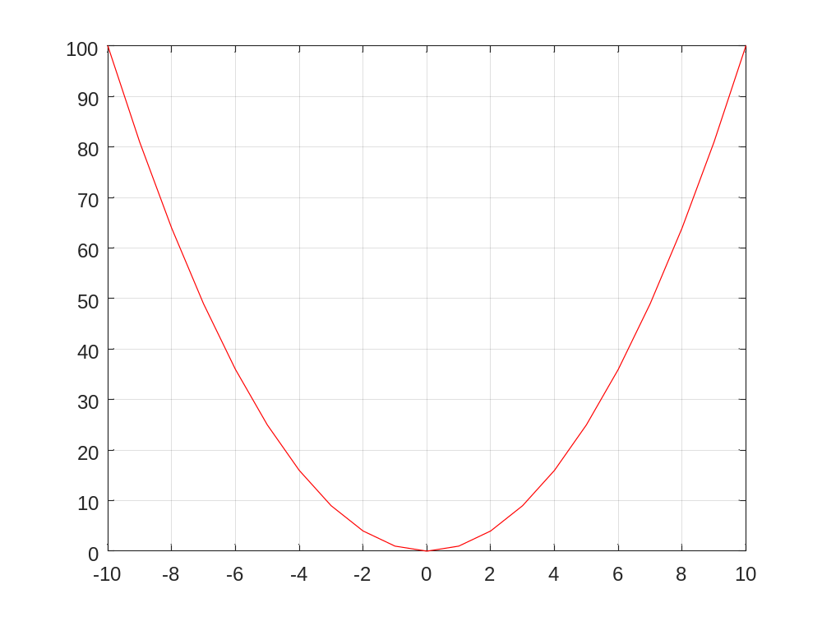
b) y=sinx
>> x=-2*pi:2*pi;
>> y=sin(x)
y =
Columns 1 through 11
0.0000 0.8415 0.9093 0.1411 -0.7568 -0.9589 -0.2794 0.6570 0.9894 0.4121 -0.5440
Columns 12 through 13
-1.0000 -0.5366
>> plot(x,y)
>> xlabel('x-axis')
>> ylabel('y-axis')
>> title('The graph of Sin function')
>> grid on
