- Following are the 20 subjects related with socio-demographic and some health-related variables.
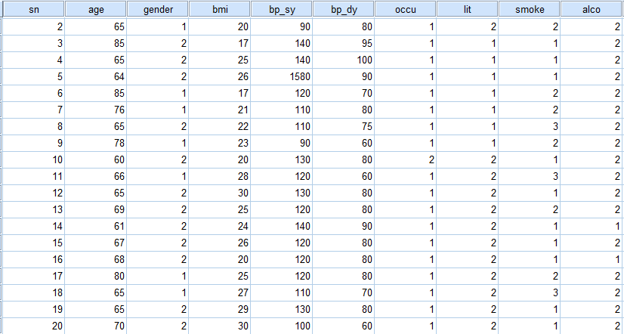
The details of the variables are as follows.
sn | Serial Number
Age | Age of Persons
Gender | 1 for male; 2 for female
Bp_sy | Systolic blood pressure
Bp_dy | Diastolic blood pressure
Occu | Occupation: 1 Agriculture; 2 Others
Lit | Literacy Status: 1 Literate; 2 Illiterate
Smoke | Smoking habit: 1 Non smoke; 2 Previous Smoker; 3 Current Smoker
Bmi | Body mass index
alco | Habit of using alcohol: 1 never; 2 past; 3 current

Output:
- Enter the following data into the IBM SPSS Statistics.

Variable View
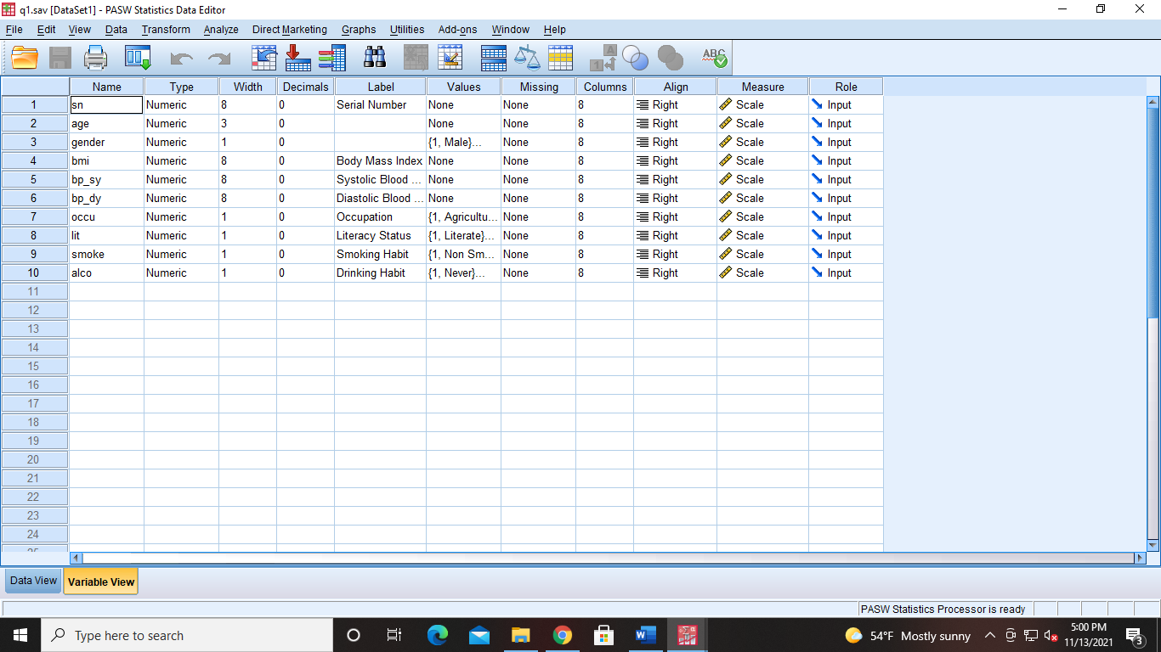
Data View
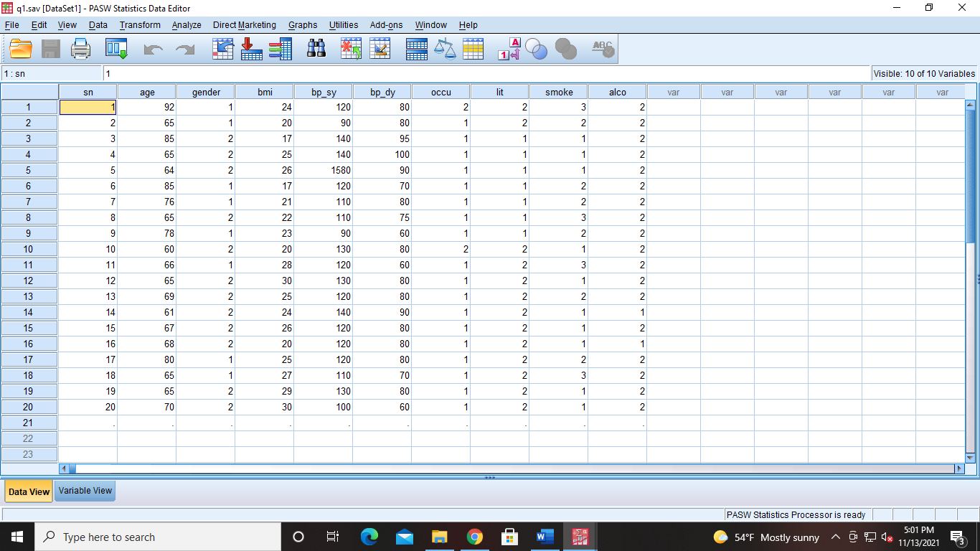

- Compute mean, median, mode, standard deviation, variance, minimum value, maximum value, skewness and kurtosis of age, bmi, bp_sy, bp_dy,.
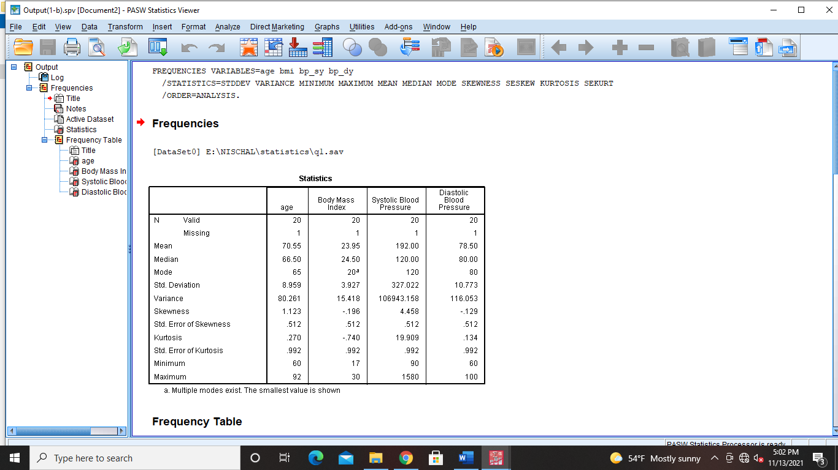
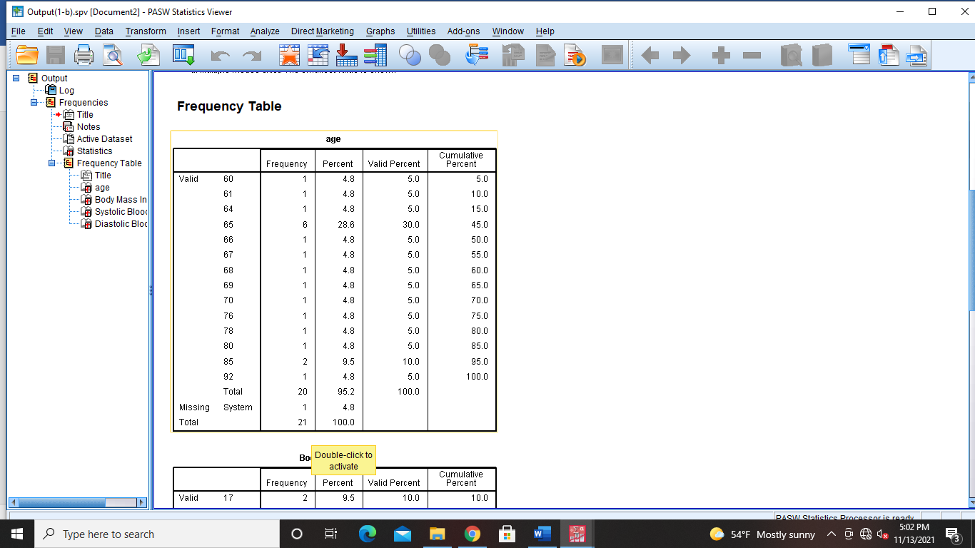
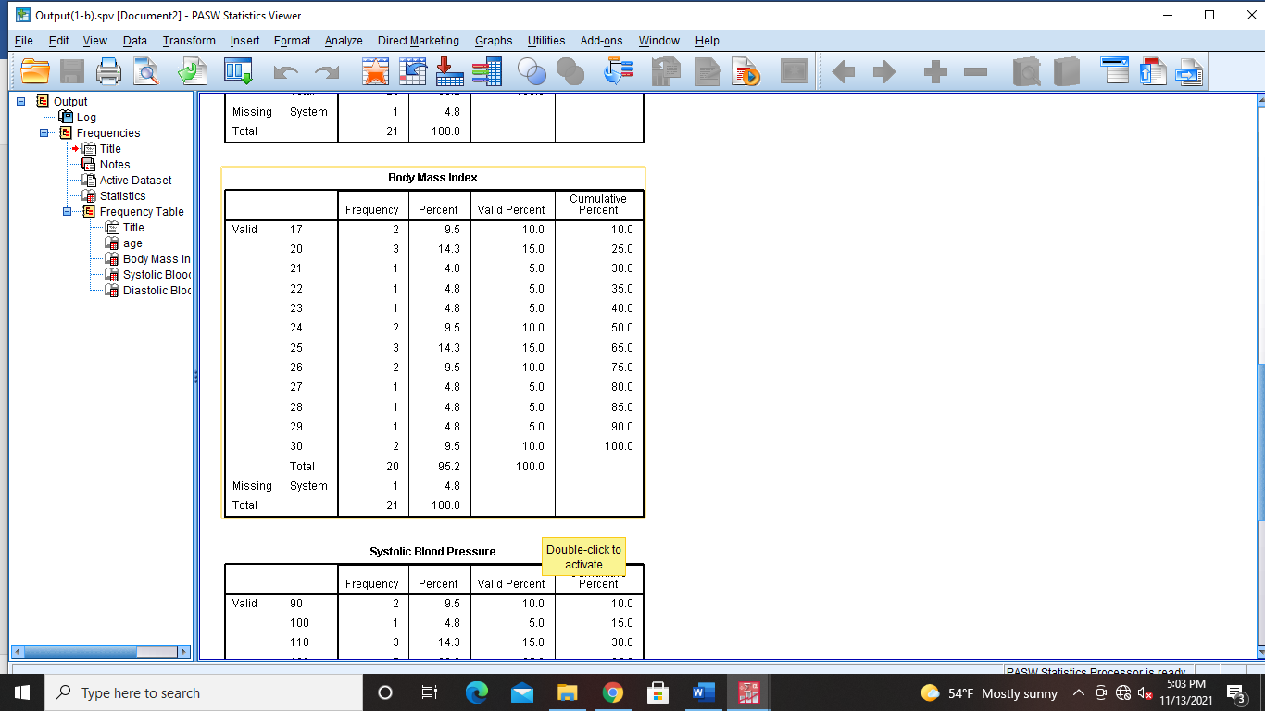
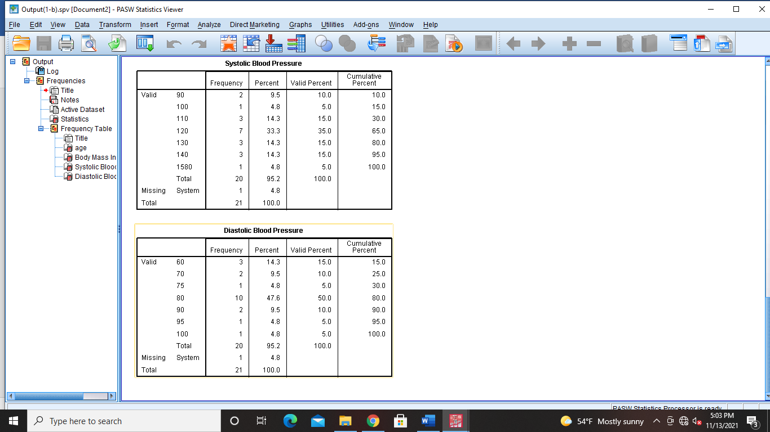
- Generate frequency distribution for each categorical variable gender, occu, lit, smoke and alco.

- Gender:
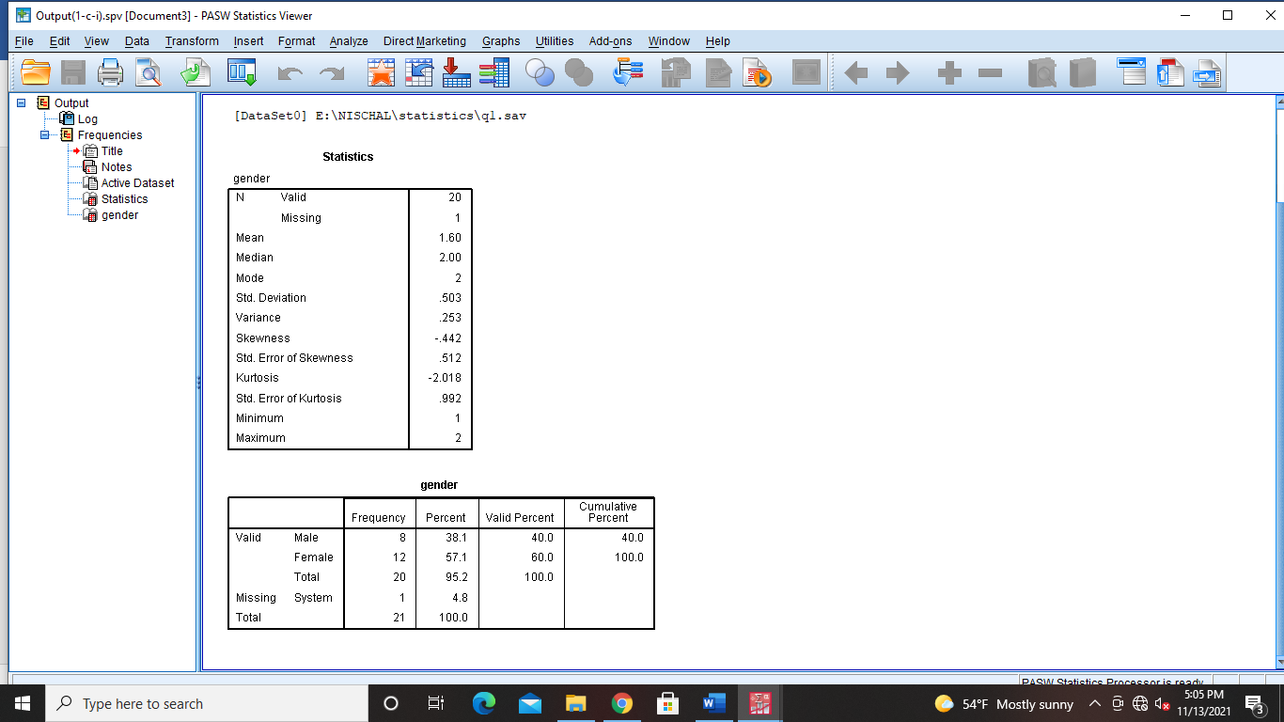
- Occupation:
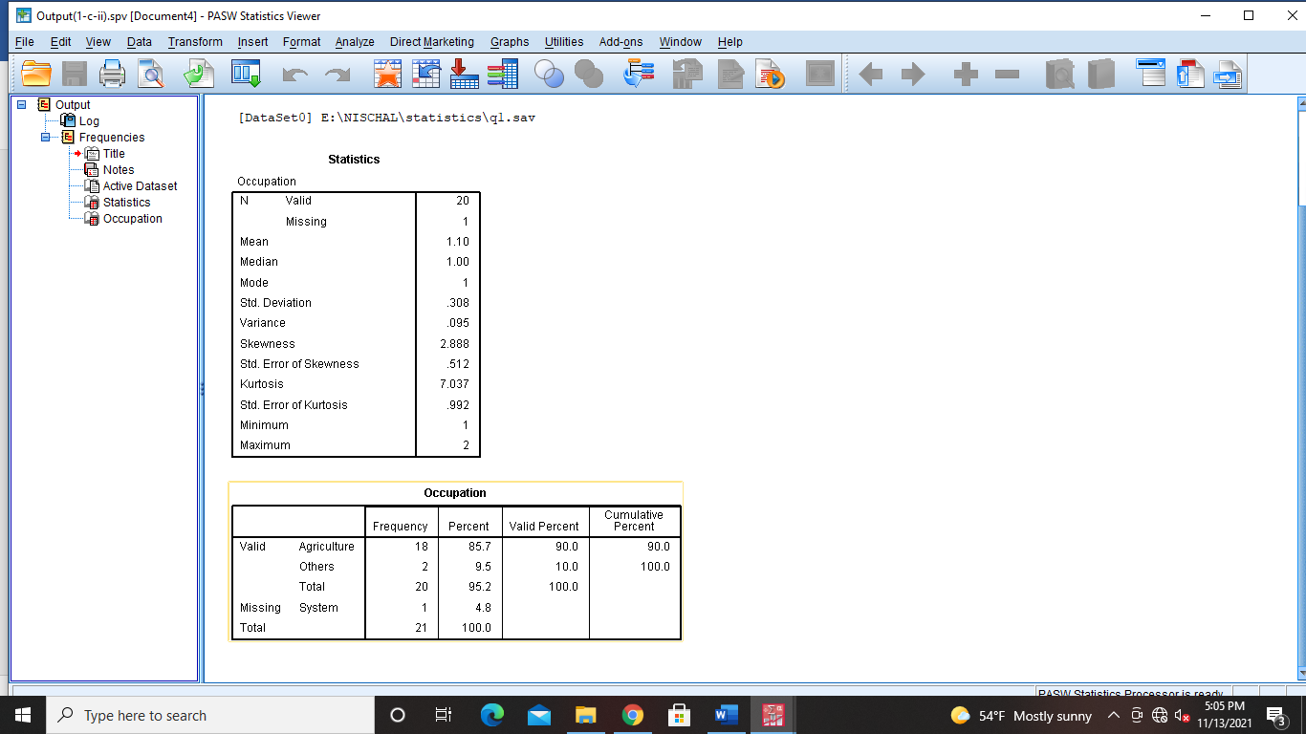
- Literacy Status:
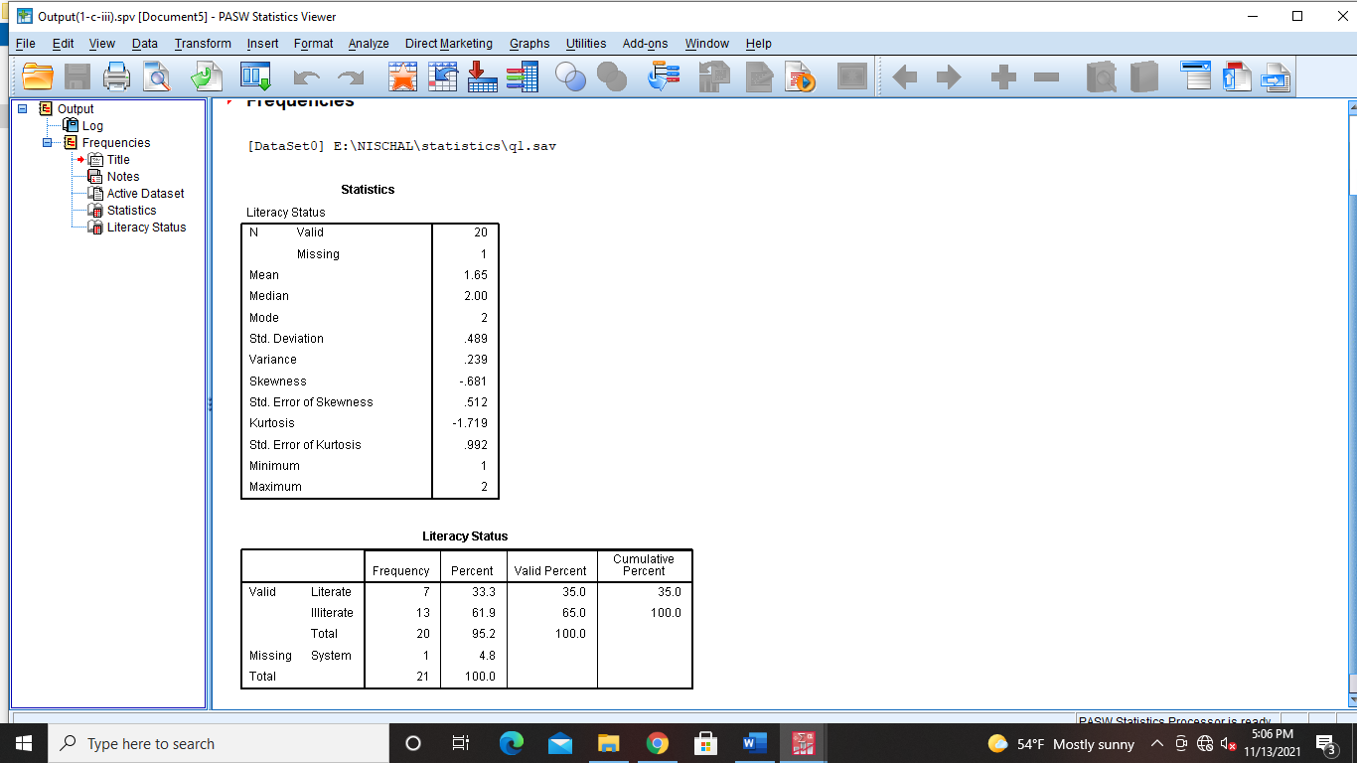
- Smoking Habit:
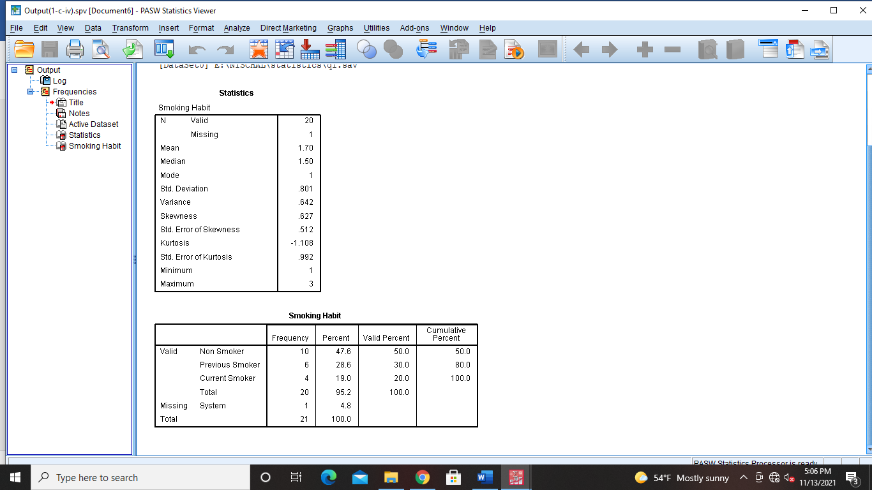
- Alcohol
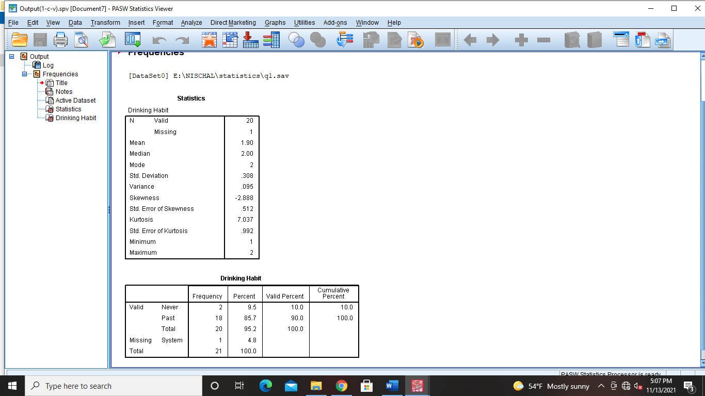
- Prepare boxplots of bmi and age separately.
- Bmi:
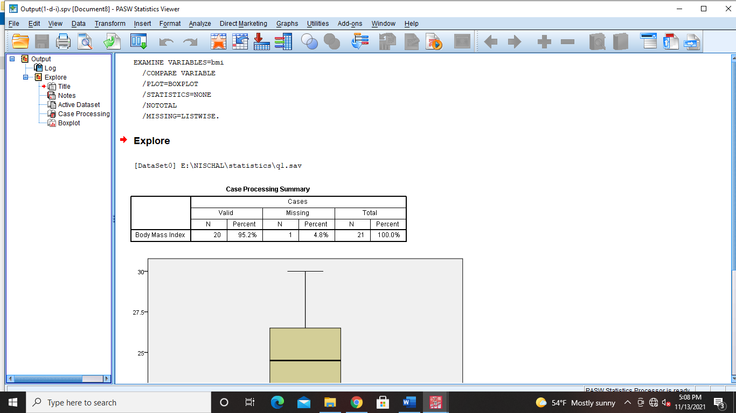

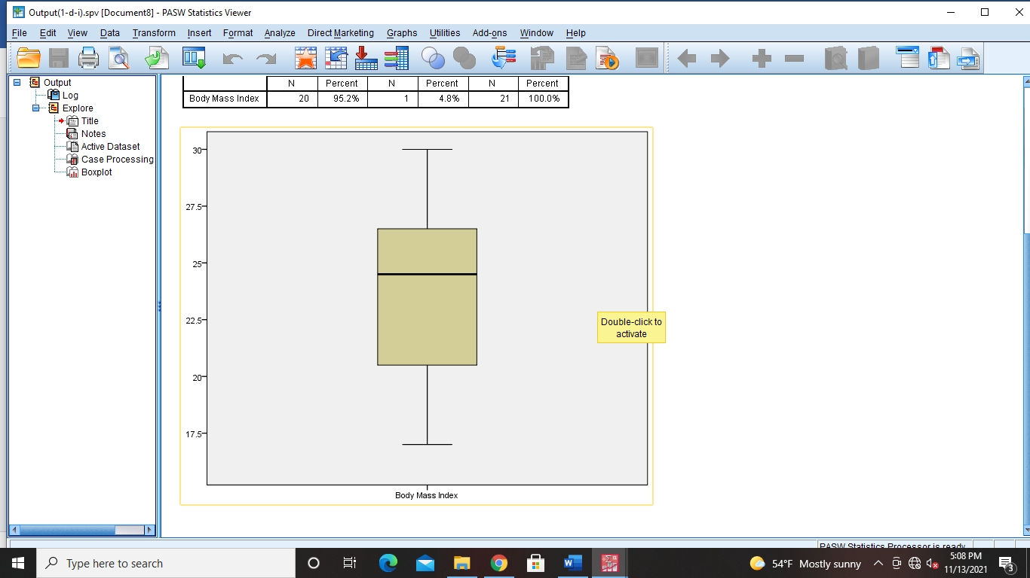

- age
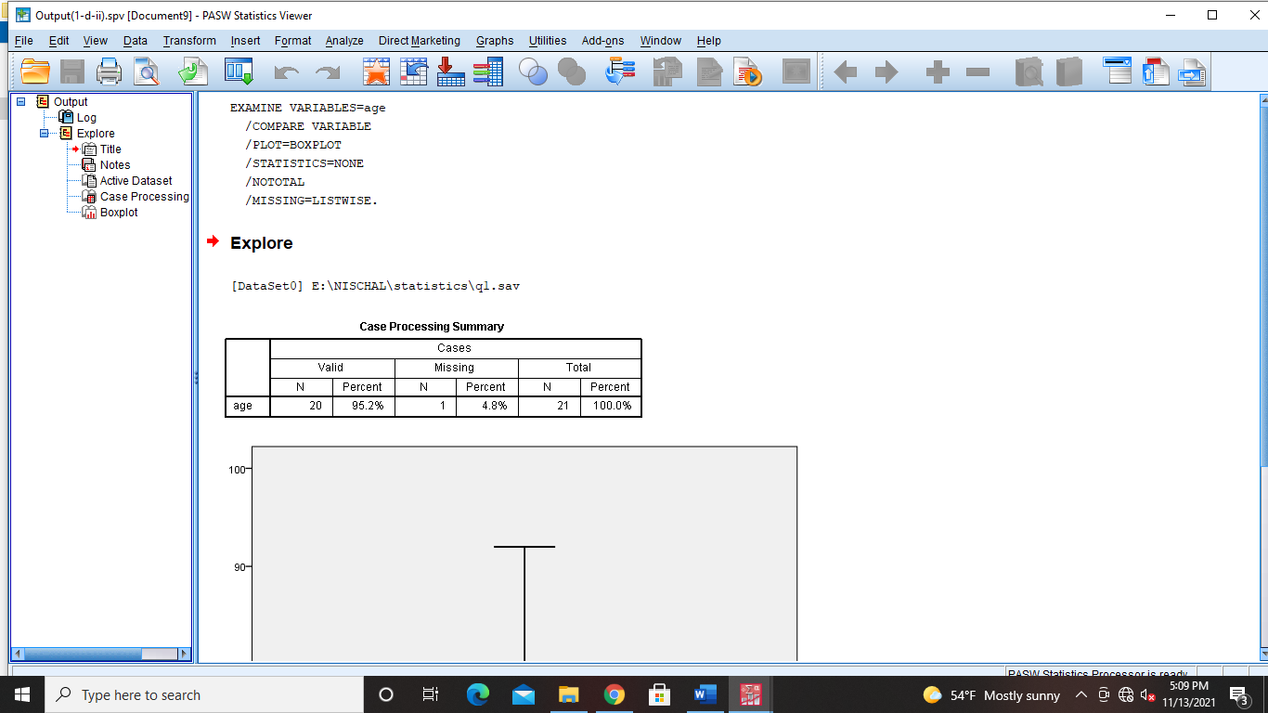
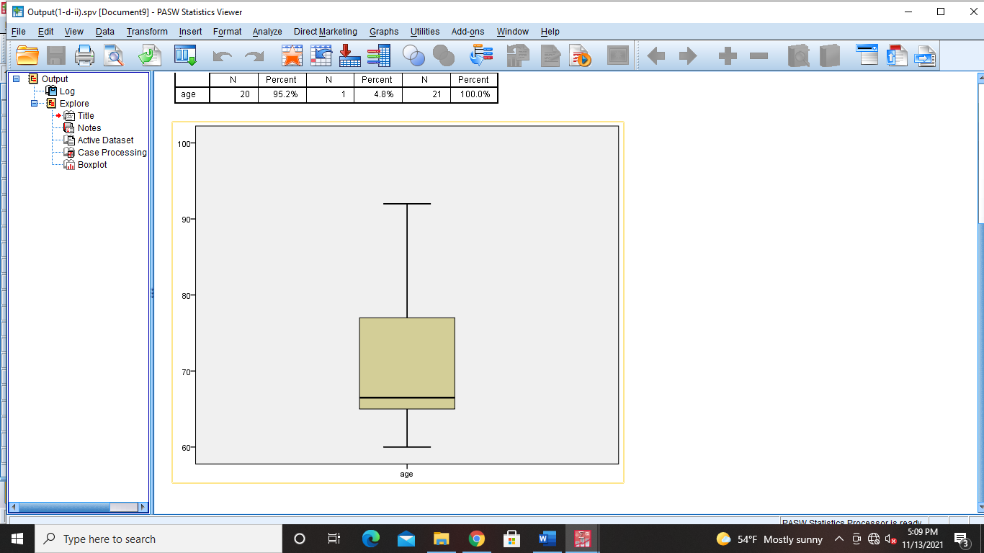
- Prepare boxplots of bp_dy and bp_sy in a single graph.
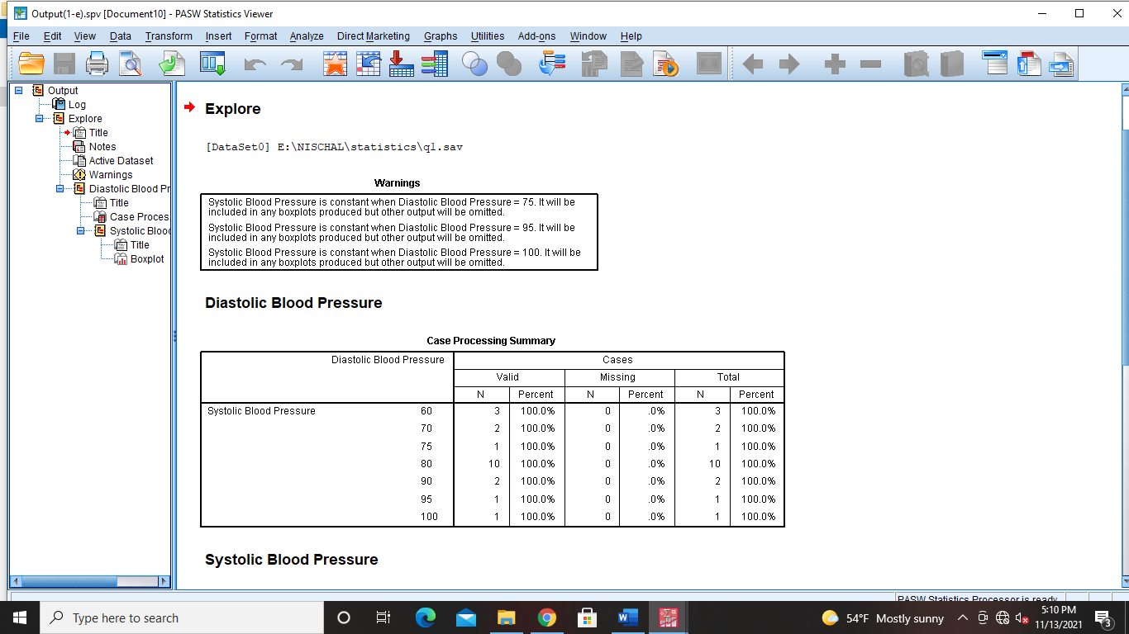
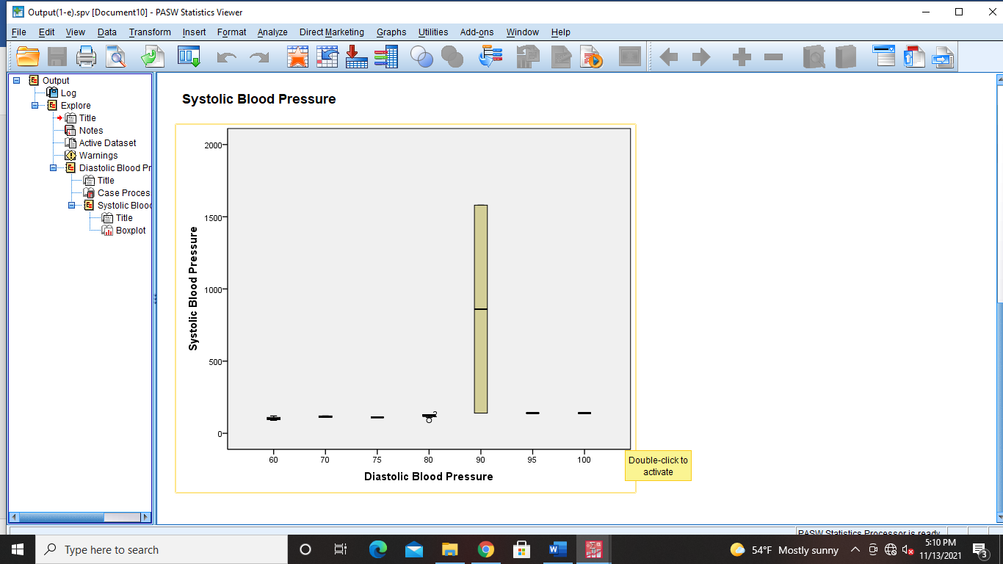
- Prepare boxplot of bmi over gender.
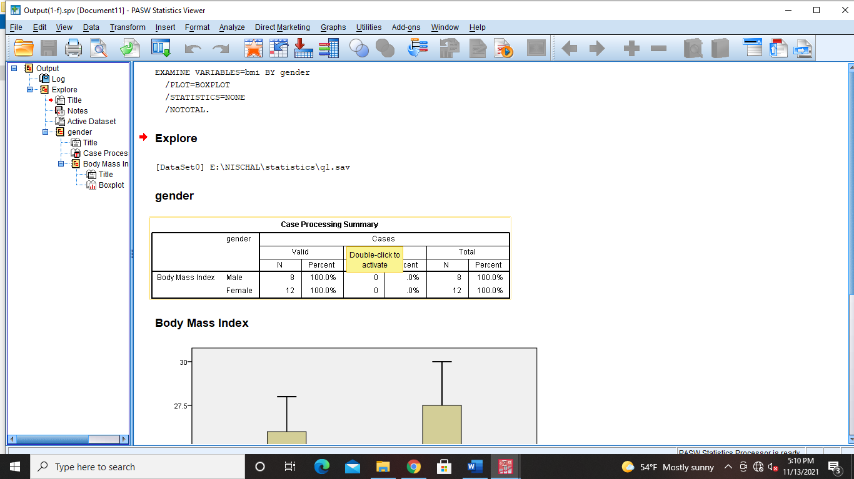
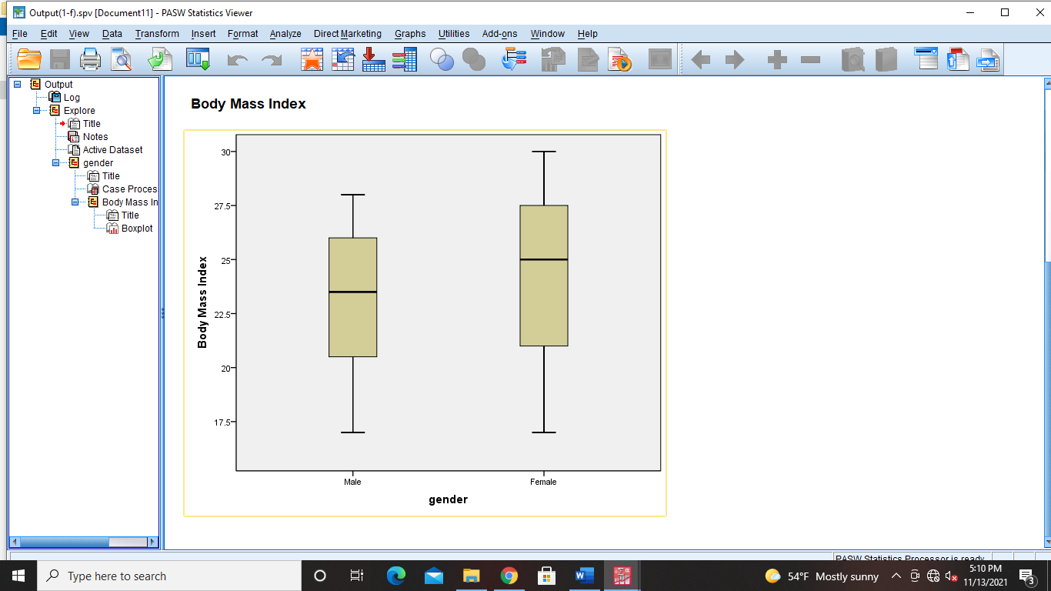

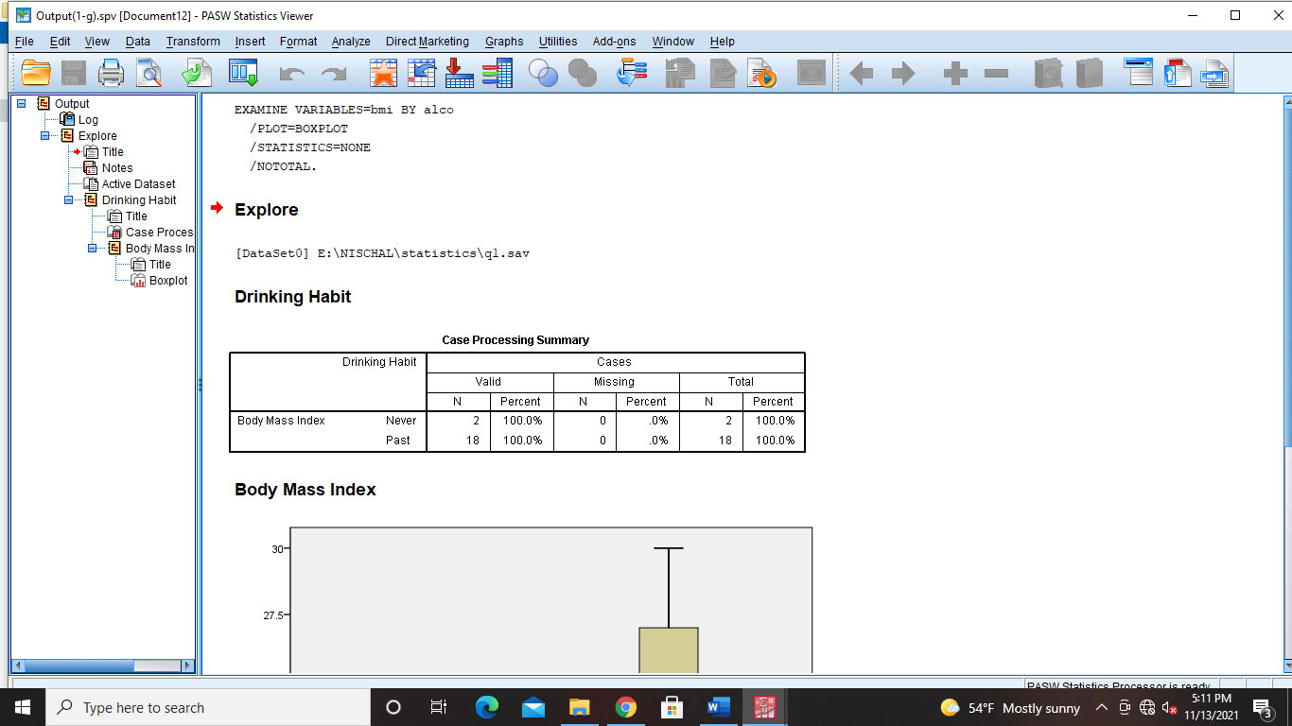
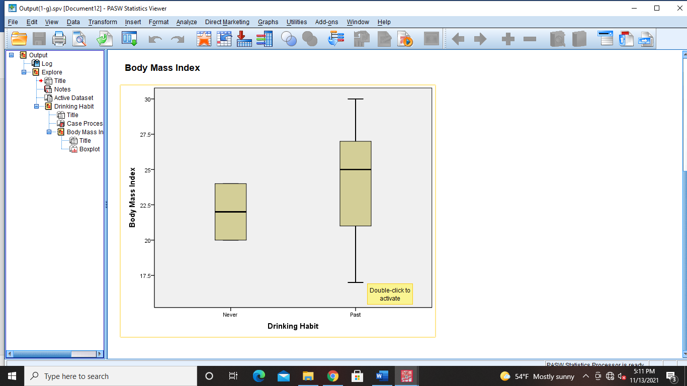

- Prepare pie-chart of smoke.
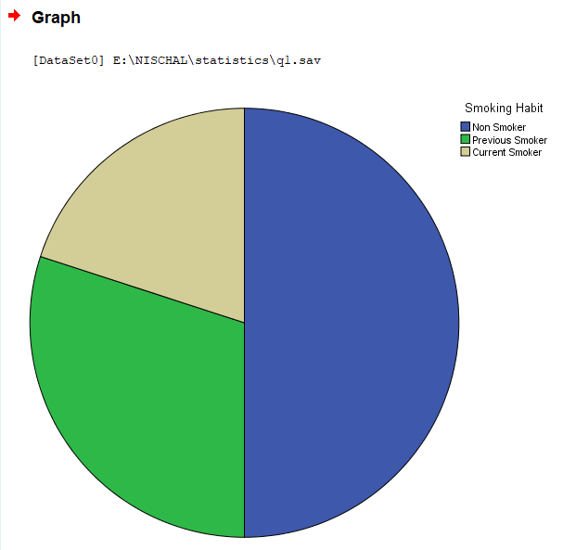
- Compute the Karl Pearson’s correlation coefficient using Spss for the following age of husband and wives (in years) at the time of marriage.
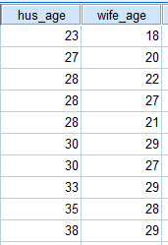
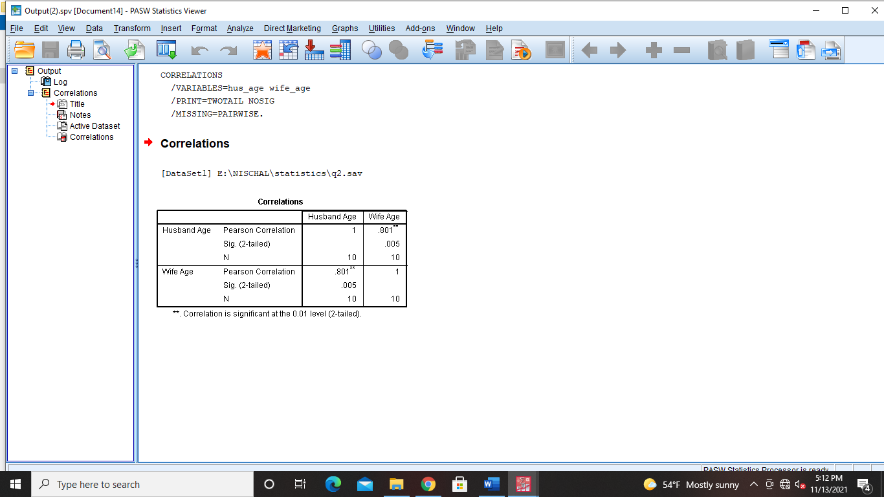

- Fit a regression line of blood pressure on age of 20 patients using SPSS. The data is as follows.
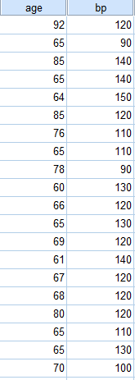

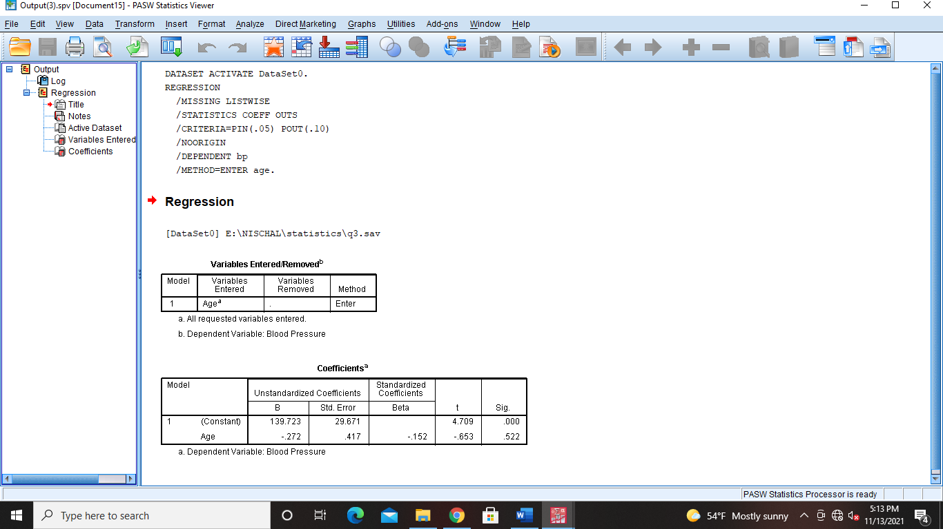
- Compute correlation between experience and performance. Also fit a regression line of performance on experience. The data is as follows.
