Sin function

Enter the value of x 5

N Sin(x) Sine Series Error Abs Error Rel Error Perc Error

1. 0.0871557 0.0872665 - 0.0001107 0.0001107 0.0012704 0.1270368

2. 0.0871557 - 0.1308997 0.2180554 0.2180554 2.5019056 250.19056

3. 0.0871557 0.1345358 - 0.0473801 0.0473801 0.5436252 54.362515

4. 0.0871557 - 0.134657 0.2218127 0.2218127 2.5450158 254.50158

5. 0.0871557 0.1346592 - 0.0475034 0.0475034 0.5450406 54.504064

6. 0.0871557 - 0.1346592 0.2218149 0.2218149 2.5450409 254.50409

Cos function

Enter the value of x 6

N Cos (x) Cosine Series Error Abs Error Rel Error Perc Error

1. 0.9945219 0.1047198 0.8898021 0.8898021 0.8947034 89.470342

2. 0.9945219 0.0872665 0.9072554 0.9072554 0.9122528 91.225285

3. 0.9945219 0.0881391 0.9063828 0.9063828 0.9113754 91.137538

4. 0.9945219 0.0881183 0.9064035 0.9064035 0.9113963 91.139627

5. 0.9945219 0.0881186 0.9064033 0.9064033 0.9113960 91.139598

Bisection Method

First value 0

Second value 2

iter a b c f(c) err

0 0.000000 2.000000 1.000000 -1.000000 1.000000

1 0.000000 1.000000 0.500000 -0.085786 0.500000

2 0.000000 0.500000 0.250000 0.439207 0.250000

3 0.250000 0.500000 0.375000 0.171840 0.125000

4 0.375000 0.500000 0.437500 0.041756 0.062500

5 0.437500 0.500000 0.468750 -0.022340 0.031250

6 0.437500 0.468750 0.453125 0.009627 0.015625

7 0.453125 0.468750 0.460938 -0.006377 0.007812

8 0.453125 0.460938 0.457031 0.001620 0.003906

9 0.457031 0.460938 0.458984 -0.002379 0.001953

10 0.457031 0.458984 0.458008 -0.000380 0.000977

11 0.457031 0.458008 0.457520 0.000620 0.000488

12 0.457520 0.458008 0.457764 0.000120 0.000244

13 0.457764 0.458008 0.457886 -0.000130 0.000122

14 0.457764 0.457886 0.457825 -0.000005 0.000061

The solution is 0.457825 after 14 iterations

Secant Method

First value 0

Second value 2

iter x0 f(x0) x1 f(x1) x2 error

1 0.000000 1.000000 2.000000 0.479759 3.844370 3.844370

2 2.000000 0.479759 3.844370 35.842452 1.974978 0.025022

3 3.844370 35.842452 1.974978 0.362102 1.955899 1.888470

4 1.974978 0.362102 1.955899 0.275817 1.894913 0.080065

5 1.955899 0.275817 1.894913 0.019299 1.890325 0.065574

6 1.894913 0.019299 1.890325 0.001161 1.890031 0.004882

7 1.890325 0.001161 1.890031 0.000005 1.890030 0.000295

8 1.890031 0.000005 1.890030 0.000000 1.890030 0.00000

The root is 1.890030

Gauss Jordan

Enter the square matrix [1 1 1; 2 3 5; 4 0 5]

Enter the matrix [5;8;2]

The solution is:

x= 0.50000

y=0.66667

z=-52.97041

Euler Method

Interval 1 0

Interval 2 20

No. of subintervals 20

x= 1.000000 y= 1.000000

x= 2.000000 y= 1.841471

x= 3.000000 y= 3.660066

x= 4.000000 y= 4.083426

x= 5.000000 y= 1.056216

x= 6.000000 y= -3.738405

x= 7.000000 y= -5.414898

x= 8.000000 y= -0.815992

x= 9.000000 y= 7.098874

x= 10.000000 y= 10.807940

x= 11.000000 y= 5.367729

x= 12.000000 y= -5.632163

x= 13.000000 y= -12.071038

x= 14.000000 y= -6.608867

x= 15.000000 y= 7.259636

x= 16.000000 y= 17.013954

x= 17.000000 y= 12.407501

x= 18.000000 y= -3.936257

x= 19.000000 y= -17.454027

x= 20.000000 y= -14.606360

The result is -14.606360

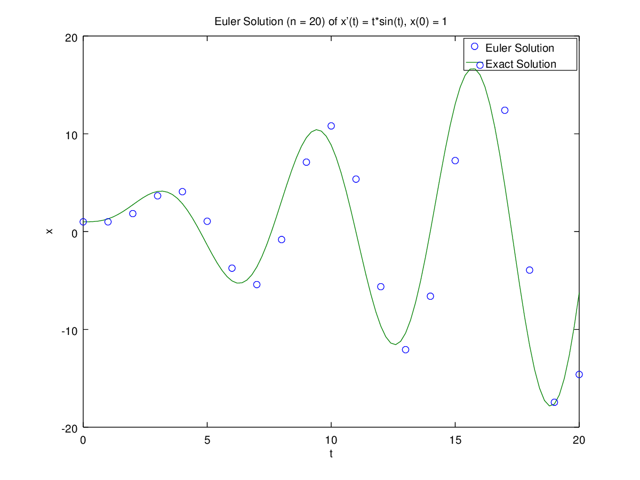

Romberg

I (0.5) = 0.5

I (0.25) = 0.5

I (0.125) = 0.5

0.50000 0.00000 0.00000

0.00000 0.50000 0.00000

0.50000 0.00000 0.50000

0.00000 0.50000 0.00000

0.50000 0.00000 0.00000