Ramar's Academy — MCQ Import Template (Word)
Fill in your questions using this layout and upload the .docx file in Admin → MCQ Tests → Add Test → Import file.

Guidelines
- File must be a Word document (.docx), up to 5 MB and 100 questions.
- Start every question with its number: Q1. Q2. … (or 1. 2. …).
- Put each option on its own line, labelled A) B) C) D).
- Write the correct option on its own line: Answer: B
- Explanation: is optional. It can run over several lines.
- Type formulas with Word's equation tool (Insert → Equation, or Alt + =). MathType equations are imported as pictures and may not display.
- Insert diagrams as pictures (Insert → Pictures) inside the question, option or explanation they belong to.
- Delete these guidelines and the sample questions before uploading your own paper. Anything before Q1 is ignored.

Sample questions
Q1. Which language is used to build Flutter apps?
A) Java
B) Dart
C) Python
D) Kotlin
Answer: B
Explanation: Flutter apps are written in Dart, a language developed by Google.

Q2. The roots of the equation $x^{2}−5x+6=0$ are:
A) $2, 3$
B) $−2, −3$
C) $1, 6$
D) $−1, −6$
Answer: A
Explanation: Factorising, $x^{2}−5x+6=(x−2)(x−3)$, so $x=2$ or $x=3$.

Q3. Evaluate $\int_{0}^{1}{2x dx}$.
A) $0$
B) $\frac{1}{2}$
C) $1$
D) $2$
Answer: C
Explanation: $\int_{0}^{1}{2x dx}=1^{2}−0^{2}=1$.

Q4. In the right-angled triangle shown below, find the length of the side x.
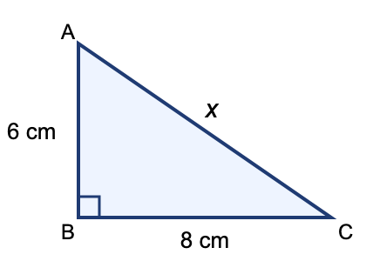
A) 8 cm
B) 9 cm
C) 10 cm
D) 12 cm
Answer: C
Explanation: By Pythagoras' theorem, $x=\sqrt{6^{2}+8^{2}}=\sqrt{100}=10$ cm.

Q5. The chemical formula of sulphuric acid is:
A) $H_{2}SO_{3}$
B) $H_{2}SO_{4}$
C) $HNO_{3}$
D) $H_{2}S$
Answer: B
Explanation: Sulphuric acid has two hydrogen, one sulphur and four oxygen atoms: $H_{2}SO_{4}$.

Q6. In the circuit shown, the two resistors are connected in series to a 12 V battery. What current flows through the circuit?
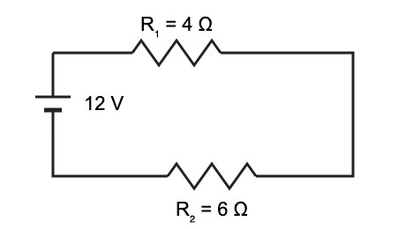
A) 0.5 A
B) 1.2 A
C) 2 A
D) 3 A
Answer: B
Explanation: Total resistance $R=R_{1}+R_{2}=4+6=10 Ω$. By Ohm's law, $I=\frac{V}{R}=\frac{12}{10}=1.2 A$.

Q7. If $\sin{θ}=\frac{3}{5}$ and θ is acute, then $\tan{θ}$ equals:
A) $\frac{3}{4}$
B) $\frac{4}{3}$
C) $\frac{4}{5}$
D) $\frac{5}{3}$
Answer: A
Explanation: $\cos{θ}=\sqrt{1−\frac{9}{25}}=\frac{4}{5}$, so $\tan{θ}=\frac{3}{4}$.

Q8. Which figure shows a right-angled triangle?
A)
B)
C) Neither figure
D) Both figures
Answer: A
Explanation: Figure A has a 90° angle at B; figure B is an electric circuit, not a triangle.

