List of Certification for AI Assisted Coding

Name: Suganth C J
Enrollment Number: 2503b09901

Certification#1
Title: Introduction to Git and GitHub
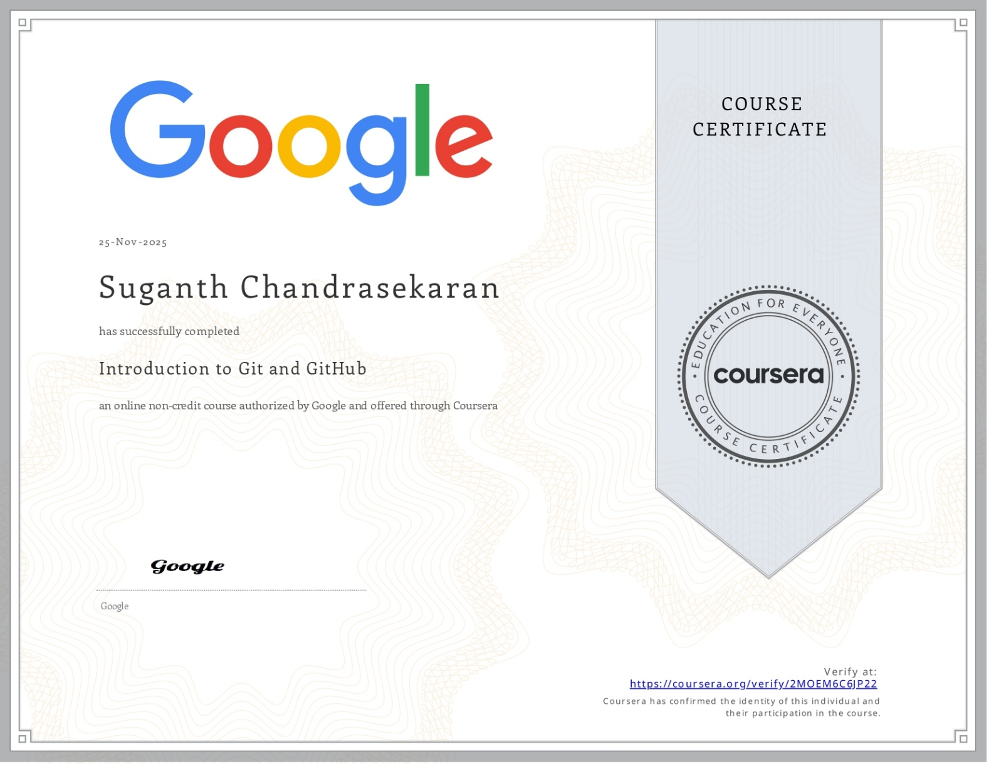

Certification#2
Title: Prompt Engineering
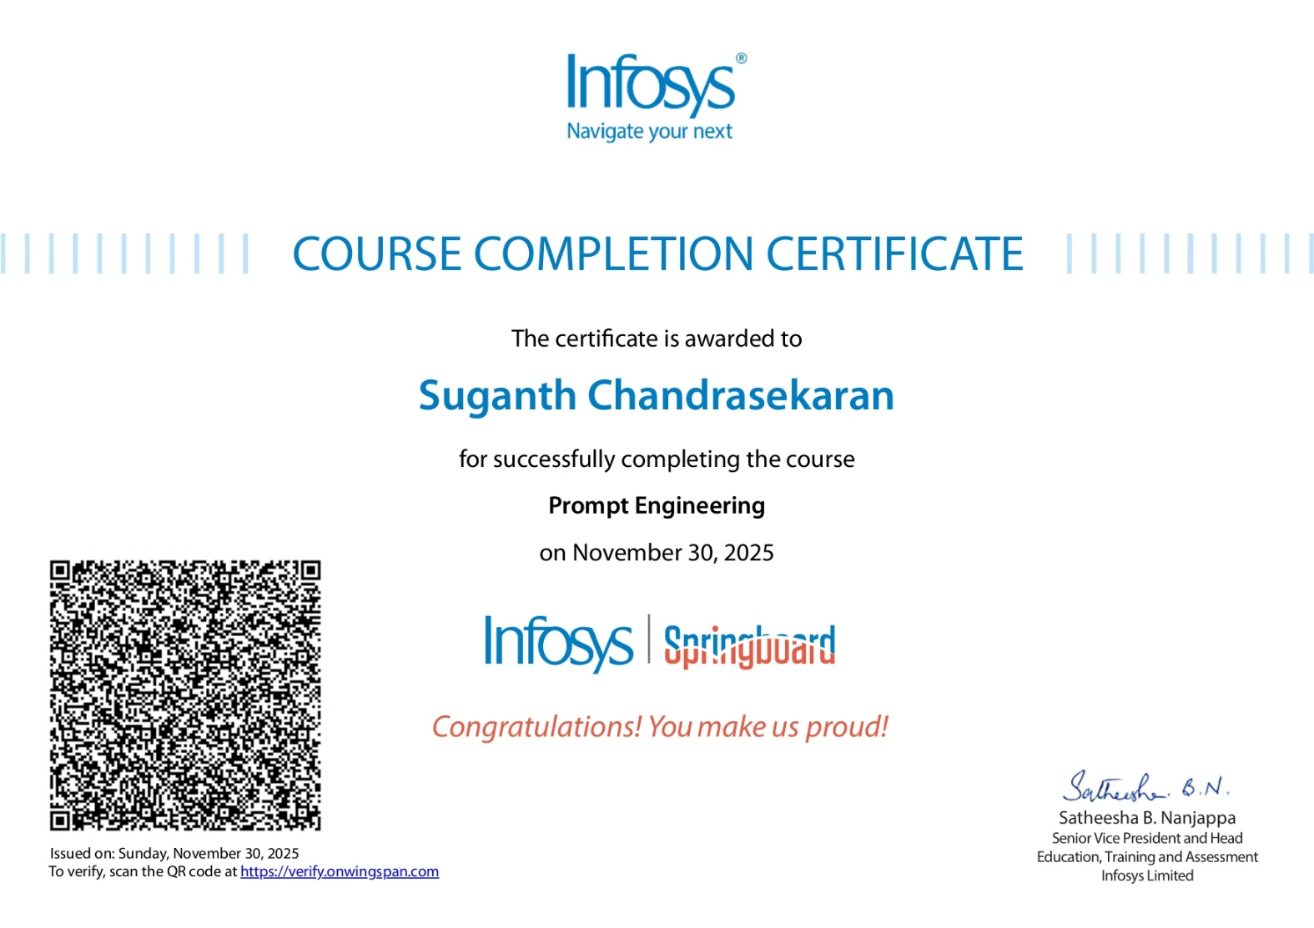

Certification#3
Title: GitHub Copilot for developers
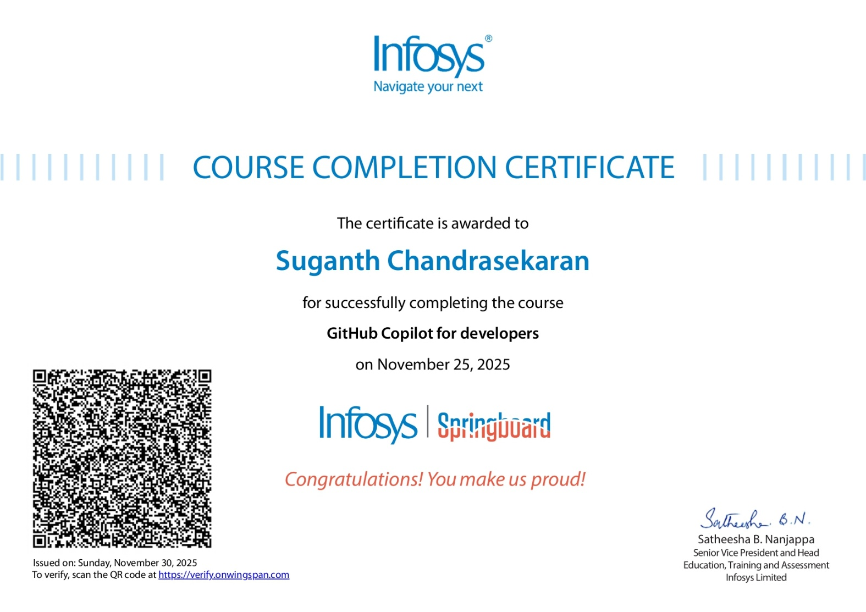

Certification#4
Title: Build Generative AI Apps and Solutions with No-Code Tools
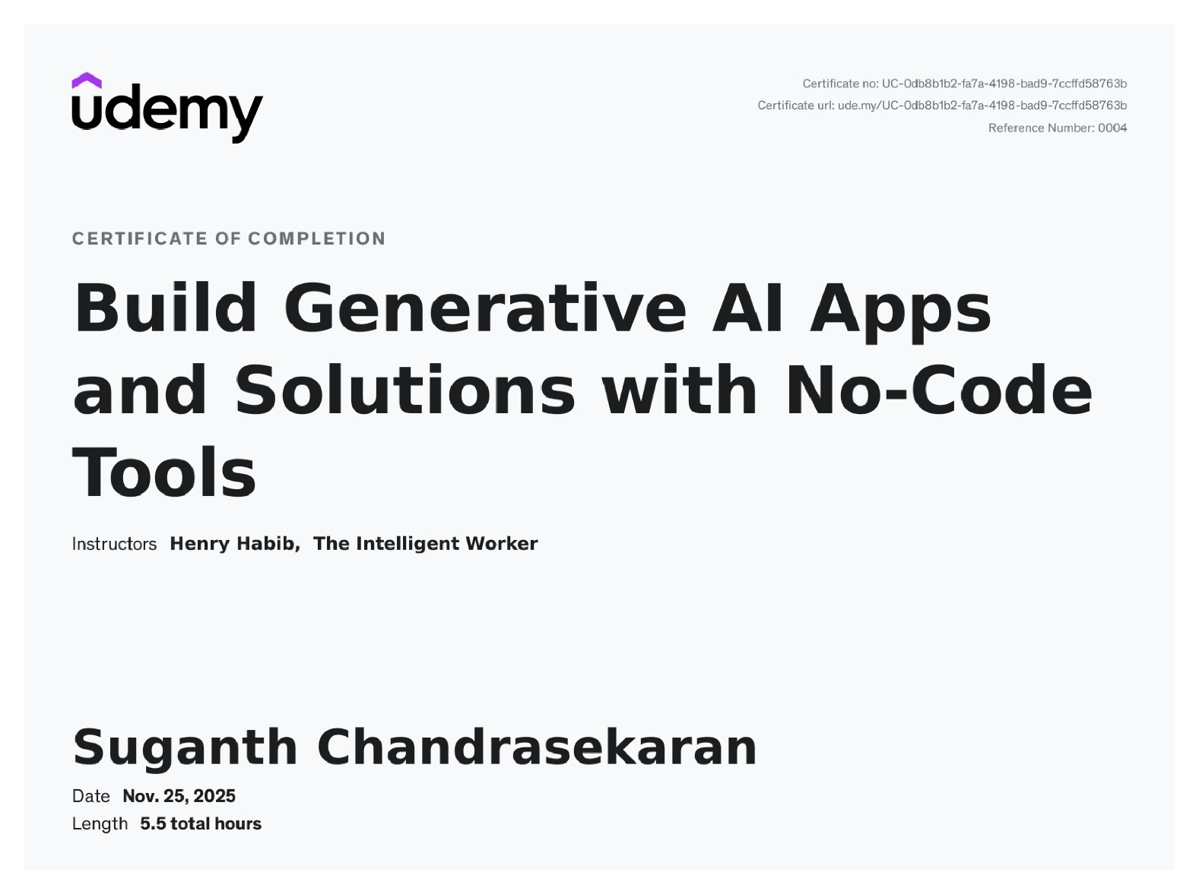
Certification#5
Title: GenAI for IT: Transforming IT with Generative AI
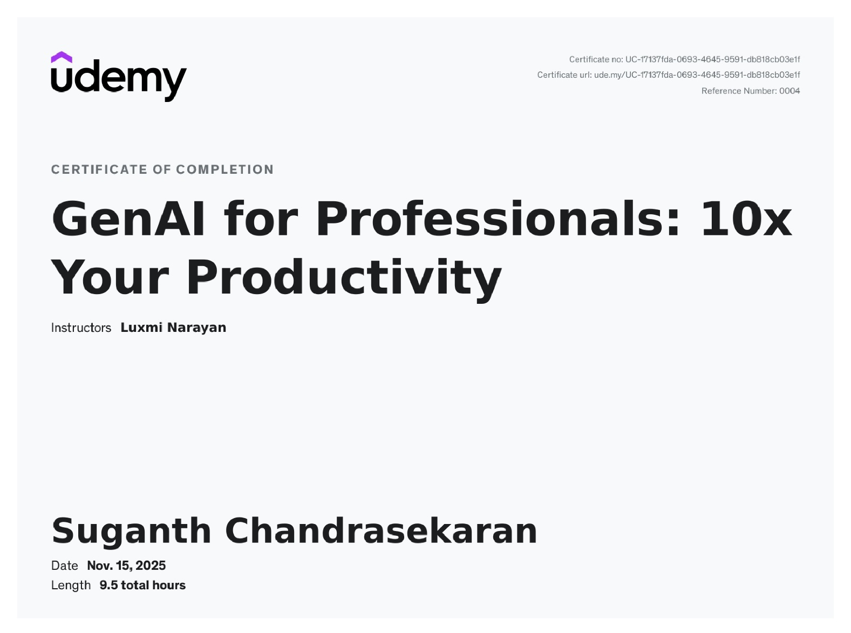

Certification#6
Title: Github Copilot with Python: Creating Text Games
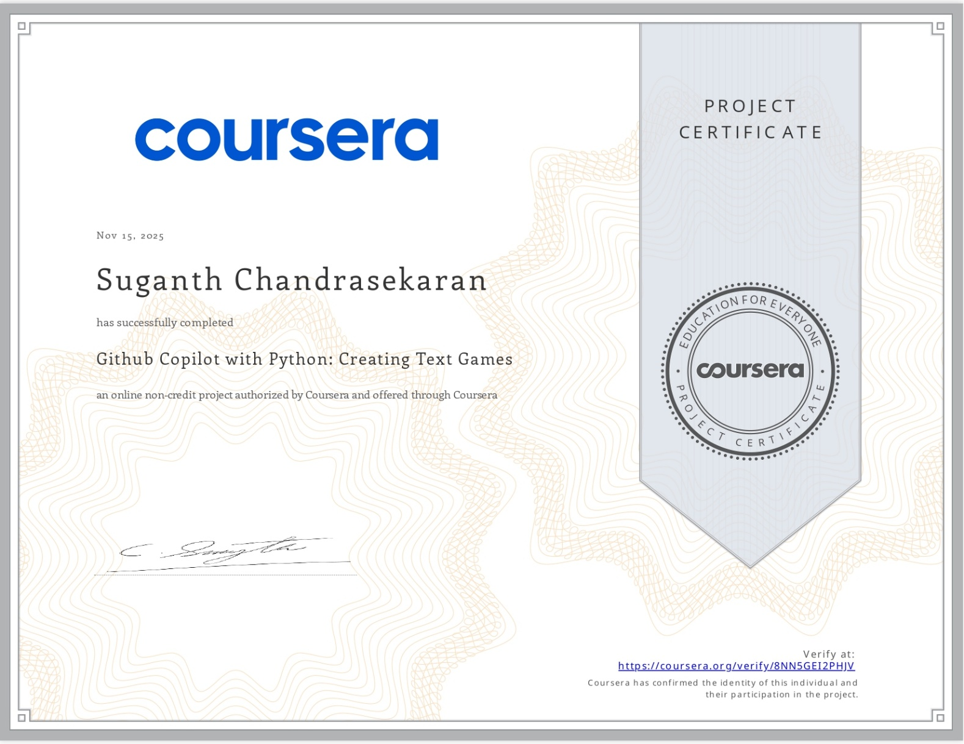

Certification#7
Title: Software Development with ChatGPT: Generating Code with AI
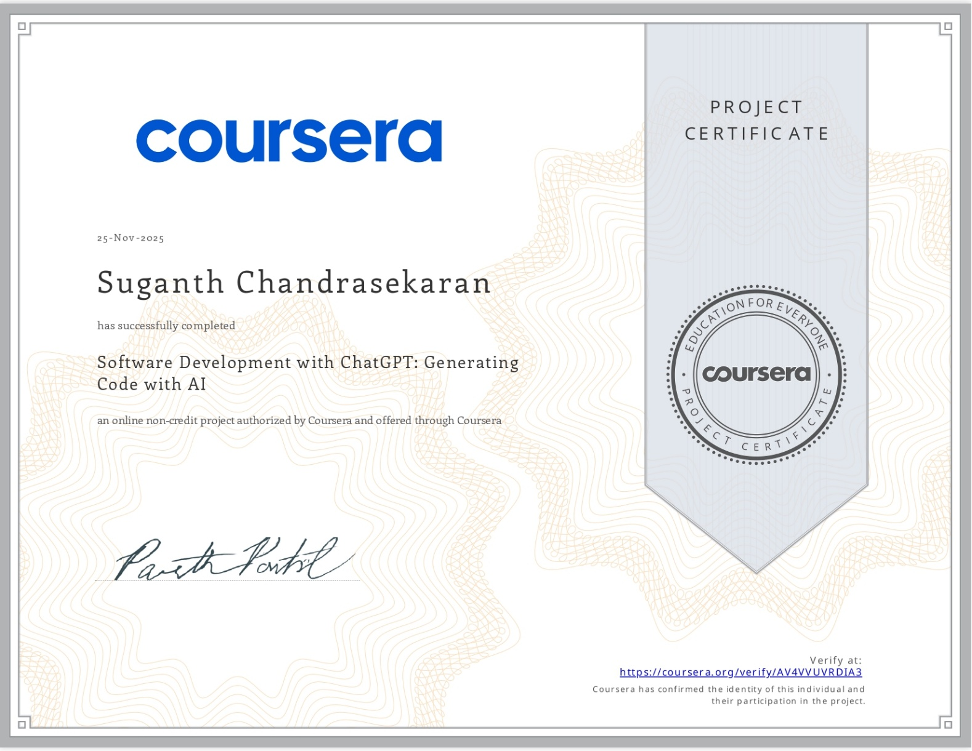
Certification#8
Title: Gen AI for developers: Web development with Python & Copilot

Certification#10
Title: Gen AI for Software Development: Code Generation for Python
Certification#11
Title: Master Generative AI & Generative AI tools (ChatGPT & more)
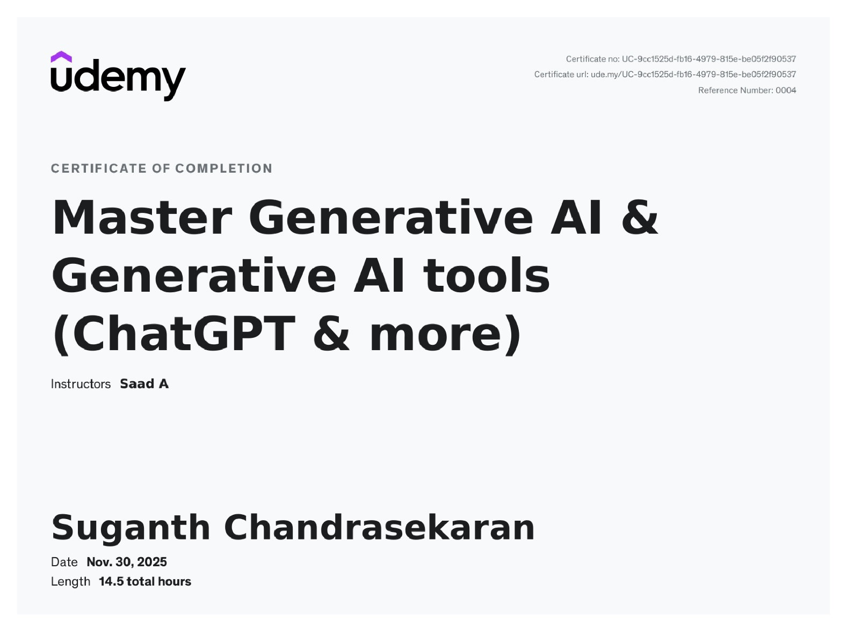
Certification#12
Title: Python Development with ChatGPT: Fullstack App Development
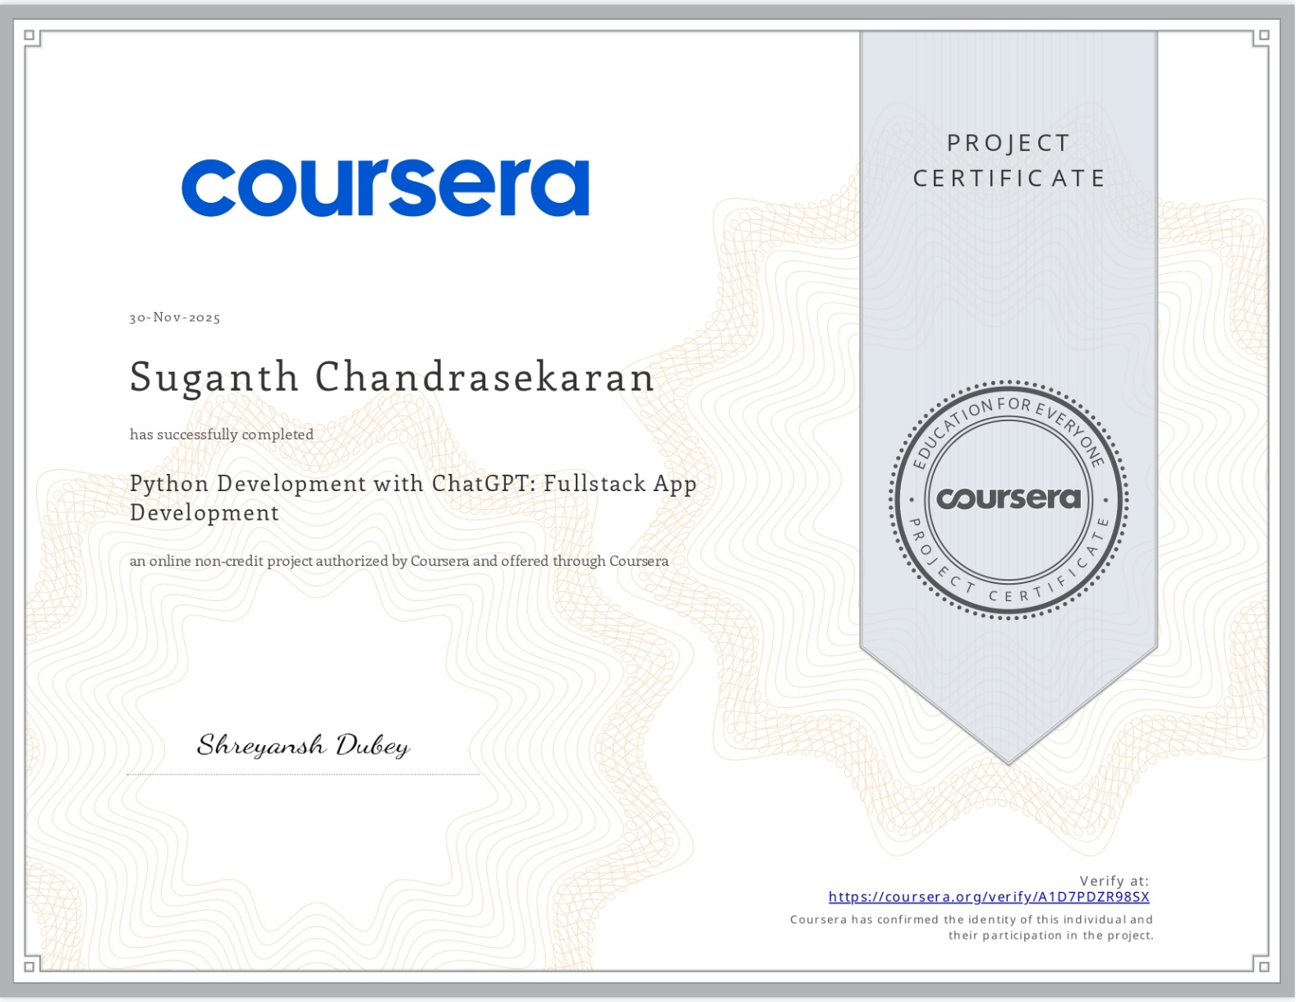
Certification#13
Title: PHP Development with ChatGPT: Practical Web Development
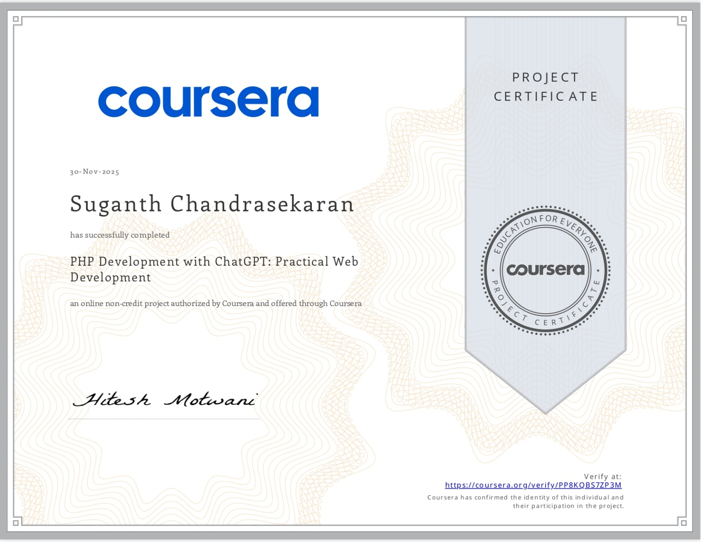
Certification#14
Title: AI-Powered Development with Codepal: Write & Test To-Do App
