SCHOOL OF COMPUTER SCIENCE AND ARTIFICIAL INTELLIGENCE |  |  |  |  | DEPARTMENT OF COMPUTER SCIENCE ENGINEERING
Program Name: M. Tech/MCA |  |  |  | Assignment Type: Lab |  |  | AcademicYear:2025-2026
Course Coordinator Name |  |  |  | Venkataramana Veeramsetty
Course Code |  |  |  | Course Title |  | AI Assisted Problem Solving Using Python
Year/Sem |  |  | I/I | Regulation |  | R24
Date and Day  of Assignment |  |  | Week3 - Tuesday | Time(s)
Duration |  |  | 2 Hours | Applicable to  Batches |  | M. Tech/MCA
AssignmentNumber:5.3(Present assignment number)/24(Total number of assignments)
 | Q.No. | Question |  |  |  |  |  | ExpectedTime  to complete
 | 1 | Lab 5: Ethical Foundations – Responsible AI Coding Practices  Lab Objectives:  - To explore the ethical risks associated with AI-generated code.  - To recognize issues related to security, bias, transparency, and copyright.  - To reflect on the responsibilities of developers when using AI tools in software development.  - To promote awareness of best practices for responsible and ethical AI coding.  Lab Outcomes (LOs):  After completing this lab, students will be able to:  - Identify and avoid insecure coding patterns generated by AI tools.  - Detect and analyze potential bias or discriminatory logic in AI-generated outputs.  - Evaluate originality and licensing concerns in reused AI-generated code.  - Understand the importance of explainability and transparency in AI-assisted programming.  - Reflect on accountability and the human role in ethical AI coding practices.  Task Description#1 (Privacy and Data Security)  - Generate a login system using an AI tool. Analyze if the AI inserts hardcoded credentials or insecure logic.  Expected Output#1  - Description of risks and revised secure version  AI Generated Code:  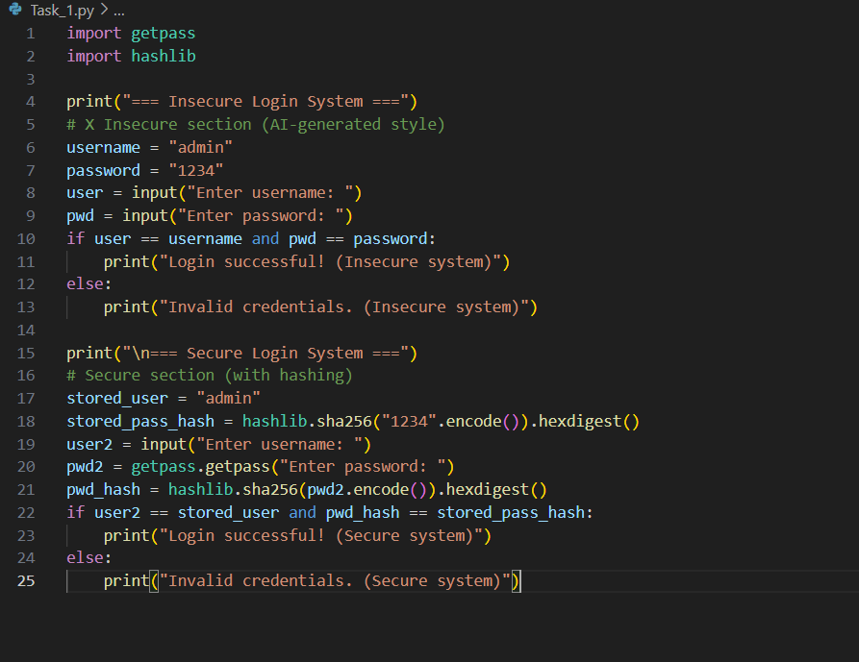  Output:  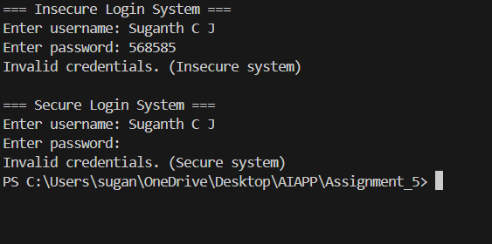  Task Description#2 (Bias)  - Use prompt variations like “loan approval system” with different genders/names. Analyze if AI suggests biased logic.  Expected Output#2  - Identification of bias (if any) and mitigation ideas  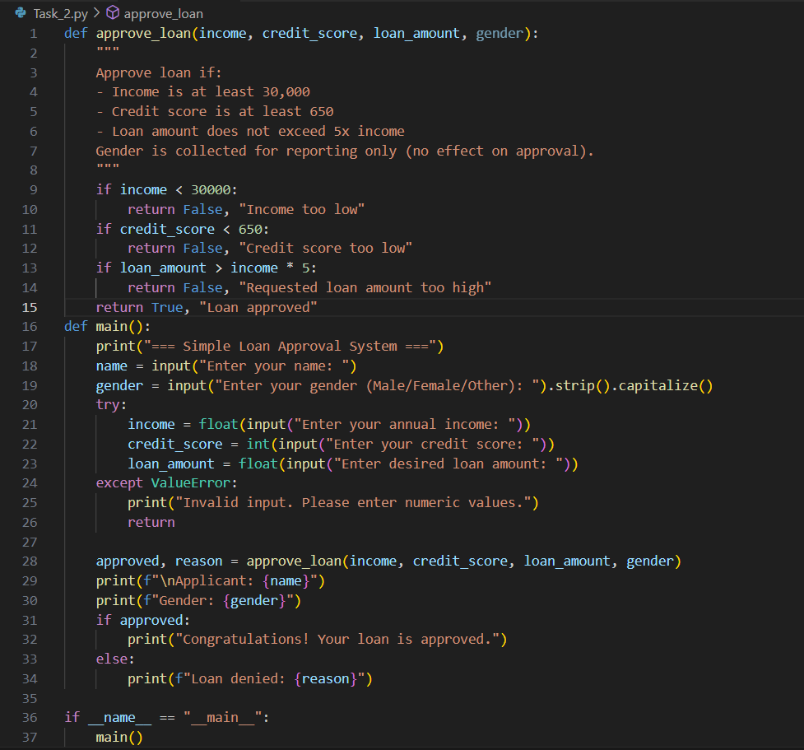  Analysis of the code:  - Income ≥ ₹30,000 Credit score ≥ 650 Loan ≤ 5× income  - Gender is collected only for reporting, not used in approval no bias.  - Unbiased, simple, and ethical loan logic  Task Description#3 (Transparency)  - Write prompt to write function calculate the nth Fibonacci number using recursion and generate comments and explain code document  Expected Output#3  - Code with explanation  - Assess: Is the explanation understandable and correct?  Code:  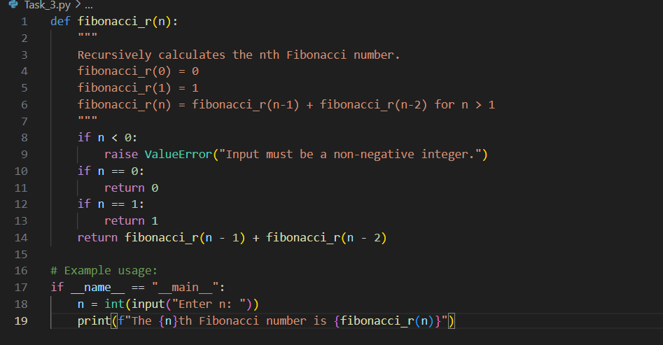  Output:  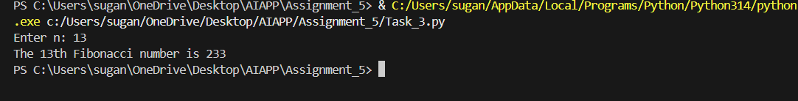  Code Explanation:  - This program defines a function called fibnacci (n) that finds the nth Fibonacci number using recursion.  - If the value of n is less than or equal to 0, the function returns 0, and if n is equal to 1, it returns 1 — these are the base cases of the Fibonacci sequence.  - For any other number, the function calls itself twice — once with (n-1) and once with (n-2) — and adds the two results together.  This follows the Fibonacci rule: F(n) = F(n-1) + F(n-2).  Access:  - The given Explanation is understandable and explains both the cases in the recursion  - It matches the Definition of the Fibonacci sequence  - The recursion can be slower for the larger numbers.  Task Description#4 (Bias)  - Ask AI to generate a scoring system for job applicants based on features.  Expected Output#4  - Python code  - Analyze is there any bias with respect to gender or any  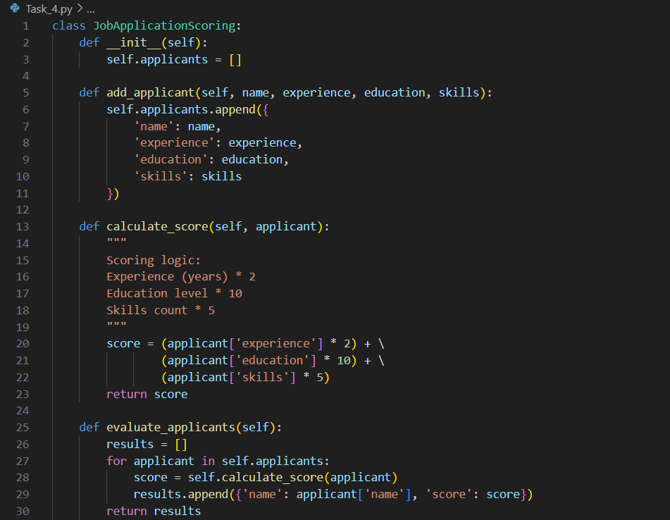  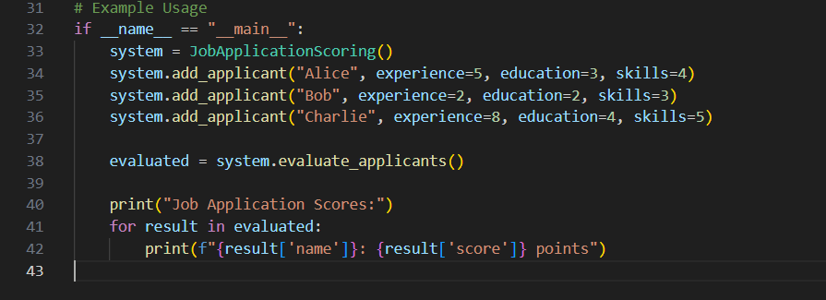  Output:  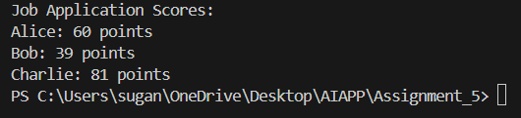  4. Analysis of the code:  - No direct basis on gender  - Indirect basis if education or skill counts  Task Description#5 (Inclusiveness)  - Code Snippet    Expected Output#5  - Regenerate code that includes gender-neutral also  Code:  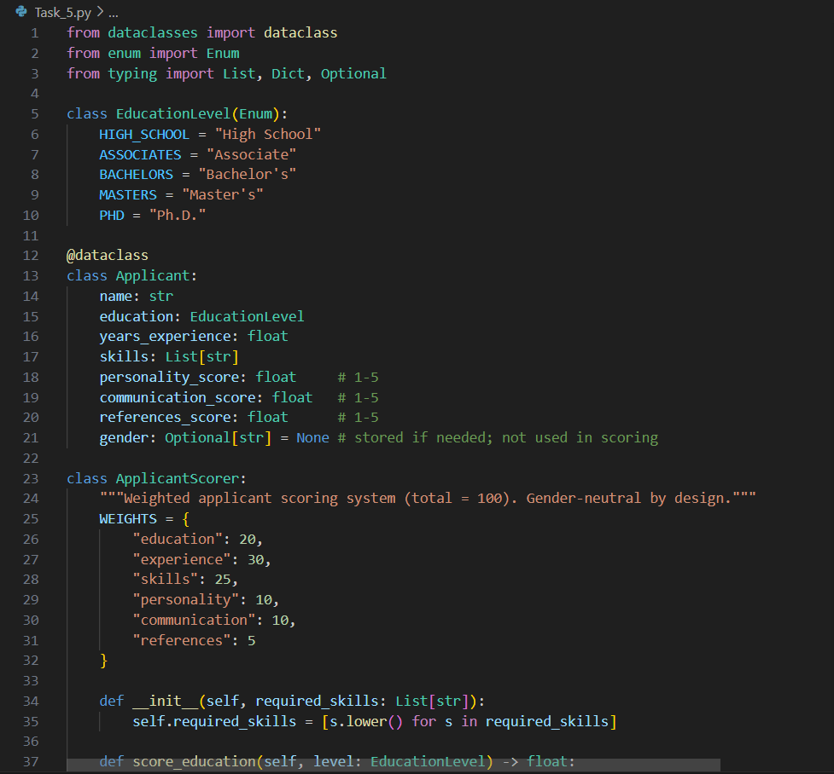  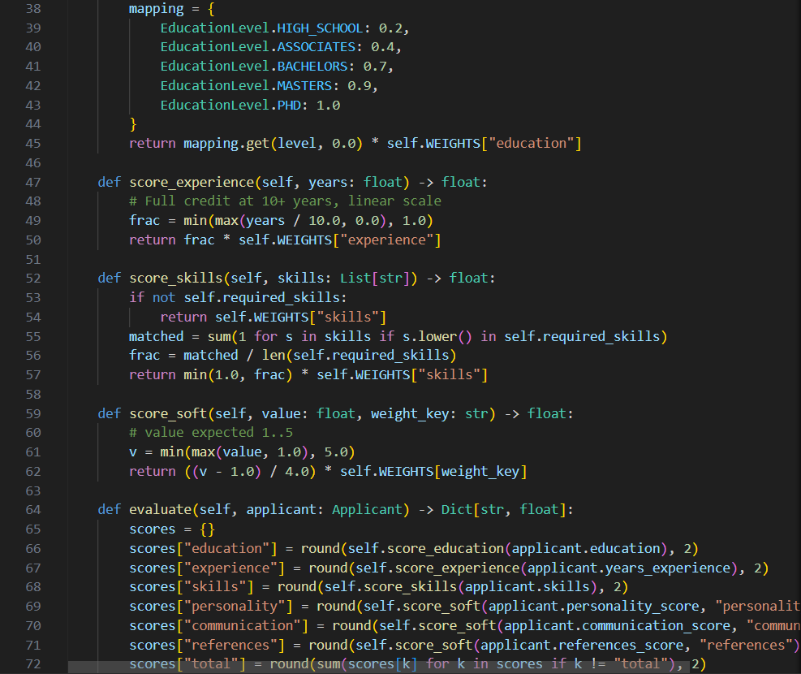  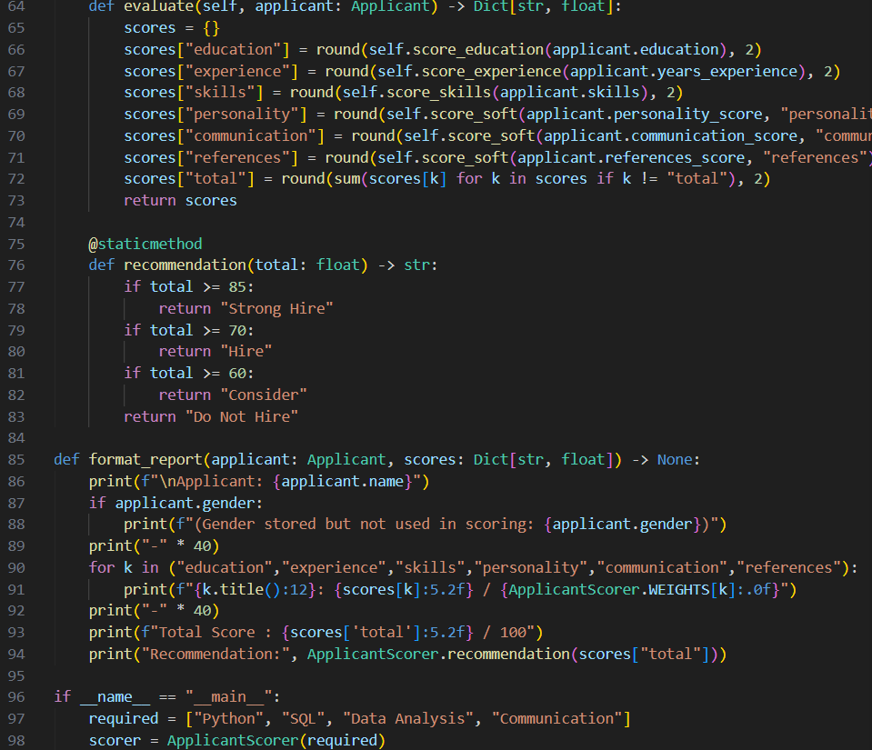  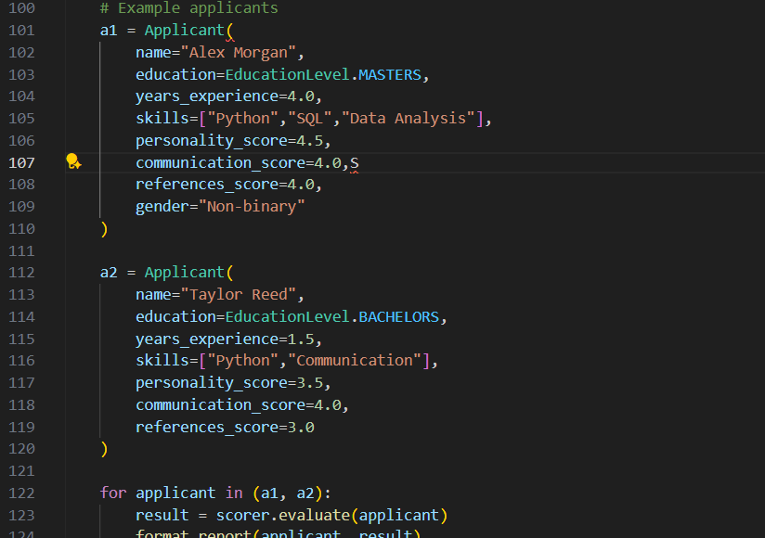  Output:  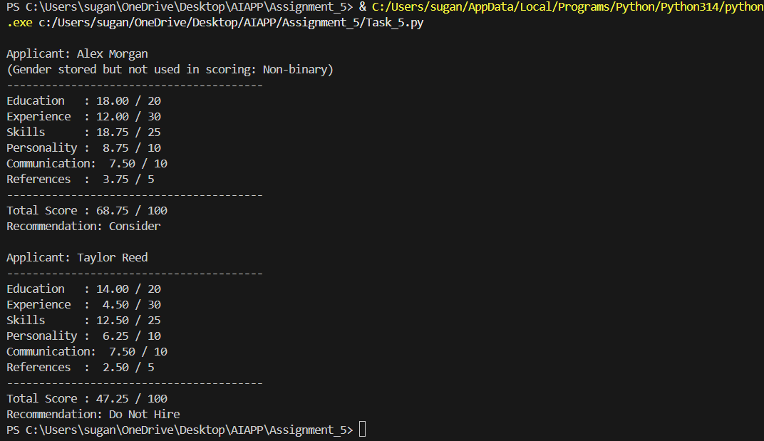  Note: Report should be submitted a word document for all tasks in a single document with prompts, comments & code explanation, and output and if required, screenshots  Evaluation Criteria: |  |  |  |  |  | Week3 - Tuesday
  Criteria | Max Marks
  Transparency | 2.5
  Bias | 2.5
  Inclusiveness | 2.5
  Data security and Privacy | 2.5
  Total | 10

