Assignment On
"Modern Operating System and Computer Networks"
(Assignment-4)
Submitted by: Suganth C J
2503B09901
(MCA)
Submitted to: Dr. Mathivanan D
Date :11/11/2025.

Question:
Write a C++ program to implement Hamming Code for error detection and correction.

Code :
#include <iostream> #include <string> using namespace std;

// Function to perform XOR between two bit strings string xorBits(const string &a, const string &b) { string result = ""; for (size_t i = 0; i < b.length(); i++) { result += (a[i] == b[i]) ? '0' : '1';
}
return result;
}

// Function to compute CRC string computeCRC(string data, const string &generator) { int genLen = generator.length(); string appendedData = data;

// Append zeros to the data equal to degree of generator appendedData.append(genLen - 1, '0');

string temp = appendedData.substr(0, genLen);

for (size_t i = genLen; i <= appendedData.length(); i++) { if (temp[0] == '1') { temp = xorBits(temp, generator);
} else {
temp = xorBits(temp, string(genLen, '0'));
}

if (i < appendedData.length()) temp = temp.substr(1) + appendedData[i]; else
temp = temp.substr(1); // last step, no more bits to bring down
}

return temp; // This is the remainder
}

int main() { string data = "1101011011"; string generator = "10011";

string crc = computeCRC(data, generator); string transmitted = data + crc;

cout << "Original data: " << data << endl; cout << "Generator: " << generator << endl; cout << "CRC Remainder: " << crc << endl; cout << "Transmitted Frame: " << transmitted << endl;

return 0;
}

Output :
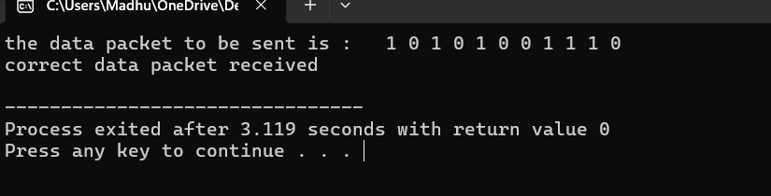

Question 2
#include <iostream>
#include <vector>
#include <cmath>
using namespace std;

// Function to calculate number of redundant bits
int calcRedundantBits(int m) {
int r = 0;
while (pow(2, r) < (m + r + 1))
r++;
return r;
}

int main() {
string data;
cout << "Enter binary data: ";
cin >> data;

int m = data.length();
int r = calcRedundantBits(m);
int n = m + r;

vector<int> hamming(n + 1);

// Step 1: Insert data bits and reserve parity positions
int j = 0; // index for data input
for (int i = 1; i <= n; i++) {
if ((i & (i - 1)) == 0) {
hamming[i] = 0; // parity bit placeholder
} else {
hamming[i] = data[m - j - 1] - '0';
j++;
}
}

// Step 2: Calculate parity bits using even parity
for (int i = 0; i < r; i++) {
int pos = pow(2, i);
int parity = 0;

for (int k = 1; k <= n; k++) {
if (k & pos)
parity ^= hamming[k];
}

hamming[pos] = parity;
}

cout << "\nTransmitted Hamming Code: ";
for (int i = n; i >= 1; i--)
cout << hamming[i];
cout << endl;

// Step 3: Simulate error (receiver)
int errPos;
cout << "\nEnter error position to simulate (0 = no error): ";
cin >> errPos;

if (errPos > 0 && errPos <= n) {
hamming[errPos] ^= 1; // flip bit
cout << "Received code with error: ";
for (int i = n; i >= 1; i--)
cout << hamming[i];
cout << endl;
}

// Step 4: Recalculate parity at receiver
int error = 0;
for (int i = 0; i < r; i++) {
int pos = pow(2, i);
int parity = 0;

for (int k = 1; k <= n; k++) {
if (k & pos)
parity ^= hamming[k];
}

if (parity != 0)
error += pos;
}

// Step 5: Show results
if (error == 0) {
cout << "\nNo error detected in received data.\n";
} else {
cout << "\nError detected at bit position: " << error << endl;

// Correct the error
hamming[error] ^= 1;

cout << "Corrected Hamming Code: ";
for (int i = n; i >= 1; i--)
cout << hamming[i];
cout << endl;
}

return 0;
}
Output:
