NAME : Suganthan Kumaresan

REG NO: 192424105

8. Write a C program for implementing a Lexical Analyzer to Count the number of characters, words, and lines .

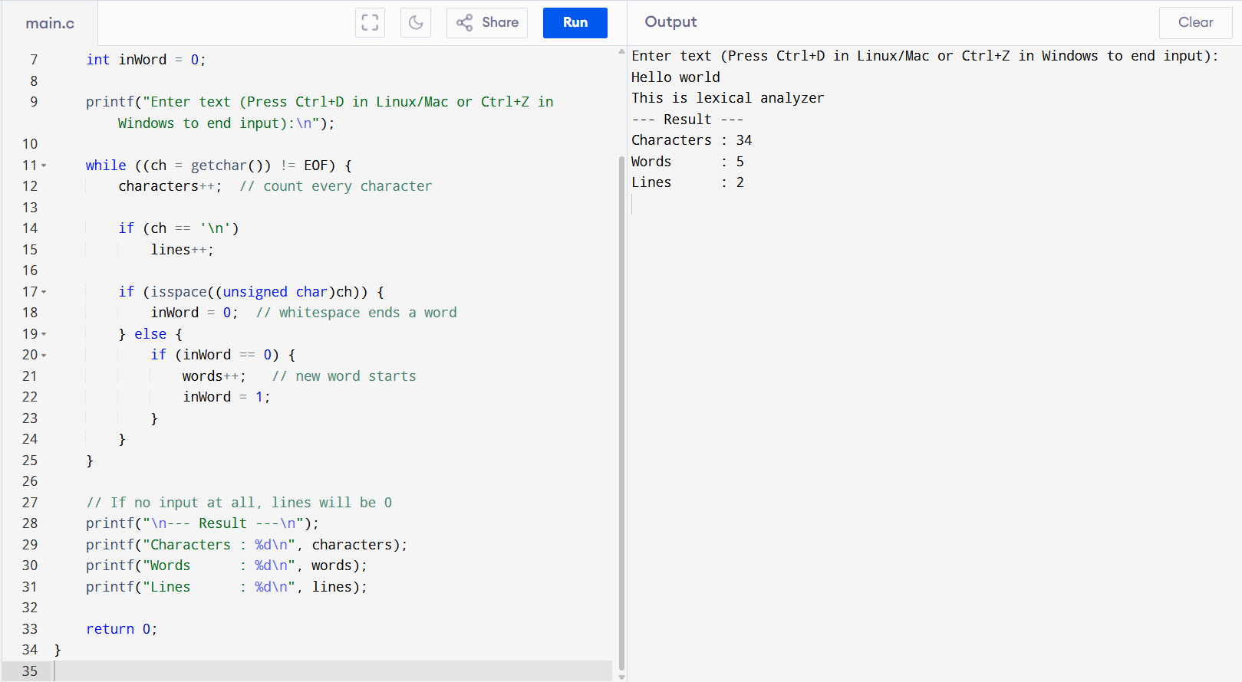

9. Implement a C program to perform symbol table operations.

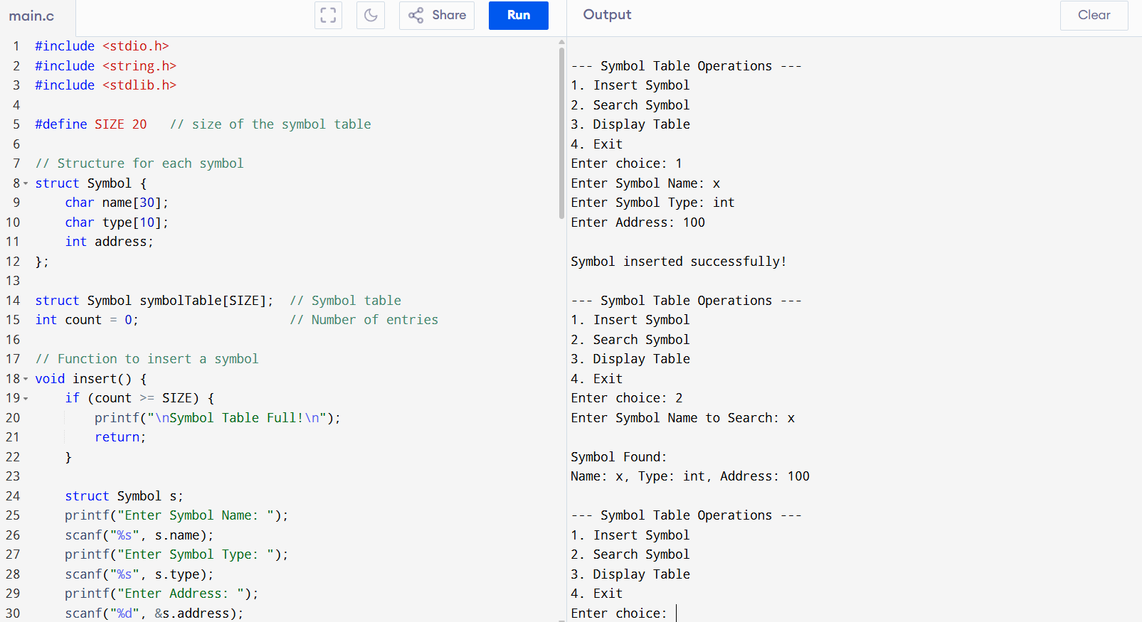

10. All languages have Grammar. When people frame a sentence we usually say whether the sentence is framed as per the rules of the Grammar or Not. Similarly use the same ideology , implement to check whether the given input string is satisfying the grammar or not .

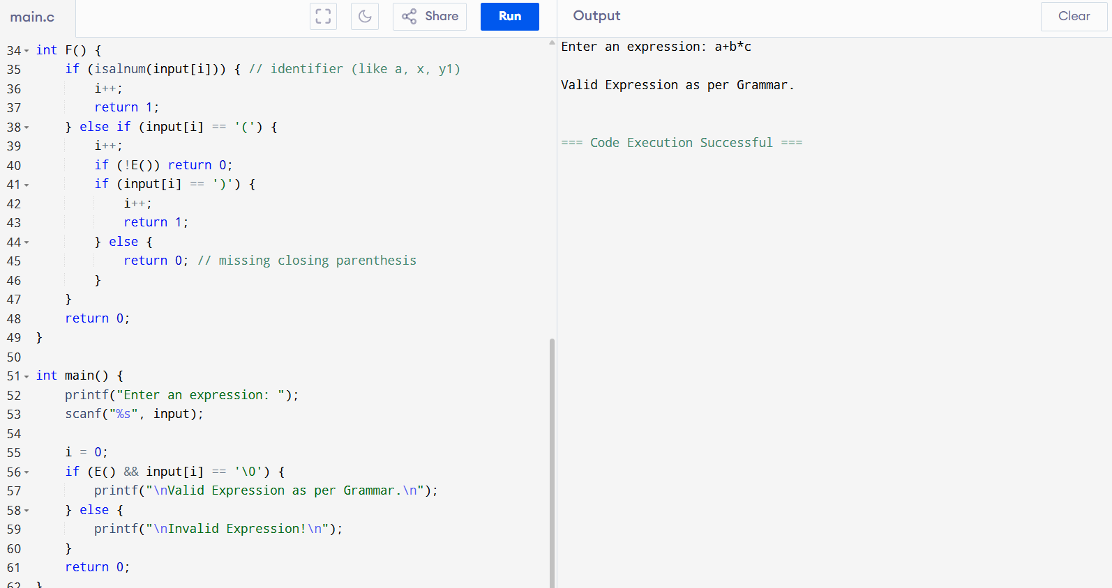

11. Write a C program to construct recursive descent parsing.

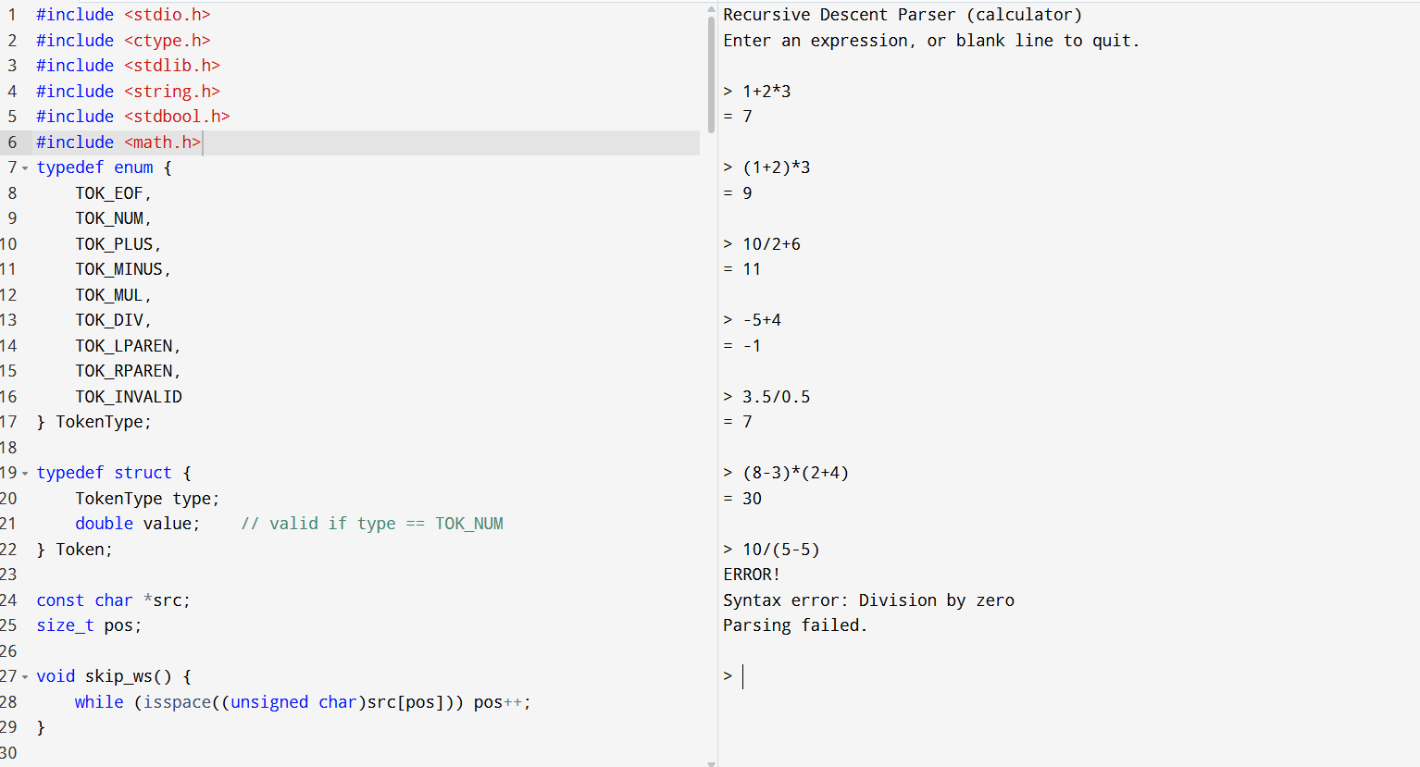

12. In a class of Grade 3, MathematicsTeacher asked for the Acronym PEMDAS?. All of them are thinking for a while. A smart kid of the class Kishore of the class says it is Parentheses, Exponentiation, Multiplication, Division, Addition, Subtraction. Can you writea C Program to help the students to understand about the operator precedence parsing for an expression containing more than one operator, the order of evaluation depends on the order of operations.

