SIMATS ENGINEERING
ASSESSMENT TOOL 3
MCQ Test
COURSE NAME: Computer Networks COURSE CODE: CSA07
COURSE OUTCOME COVERED
CO3: Analyze the performance of core network protocols such as TCP, UDP, HTTP, and DNS under varying conditions
Assessment Tool Weightage: 20%
QUESTIONS: 50 Total Marks:50
Code of Conduct:
I Suganthan Kumaresan – (192424105) (Name / Reg No) certify that this submission is my original work and that I have adhered to the guidelines specified for this assessment. I understand that any violation of academic integrity rules will result in disciplinary action.
Signature of the student: K Suganthan

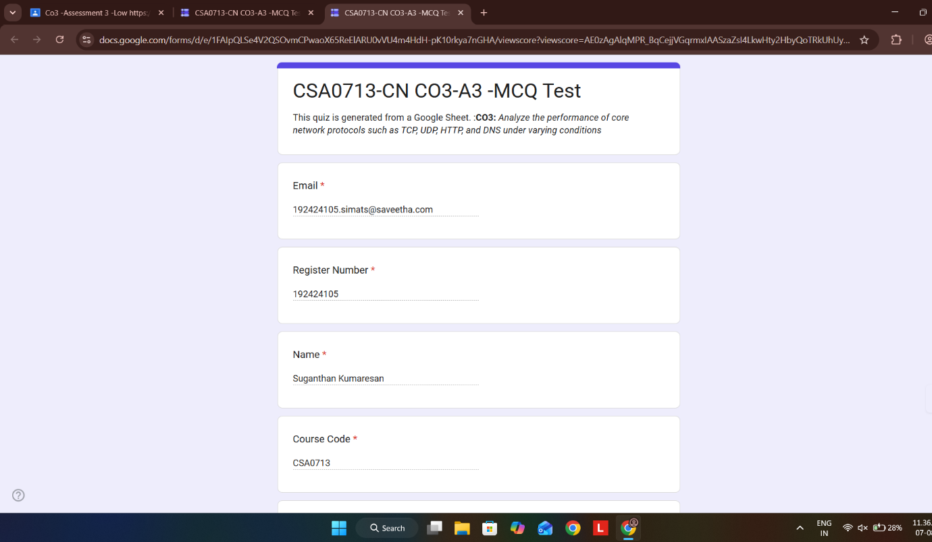
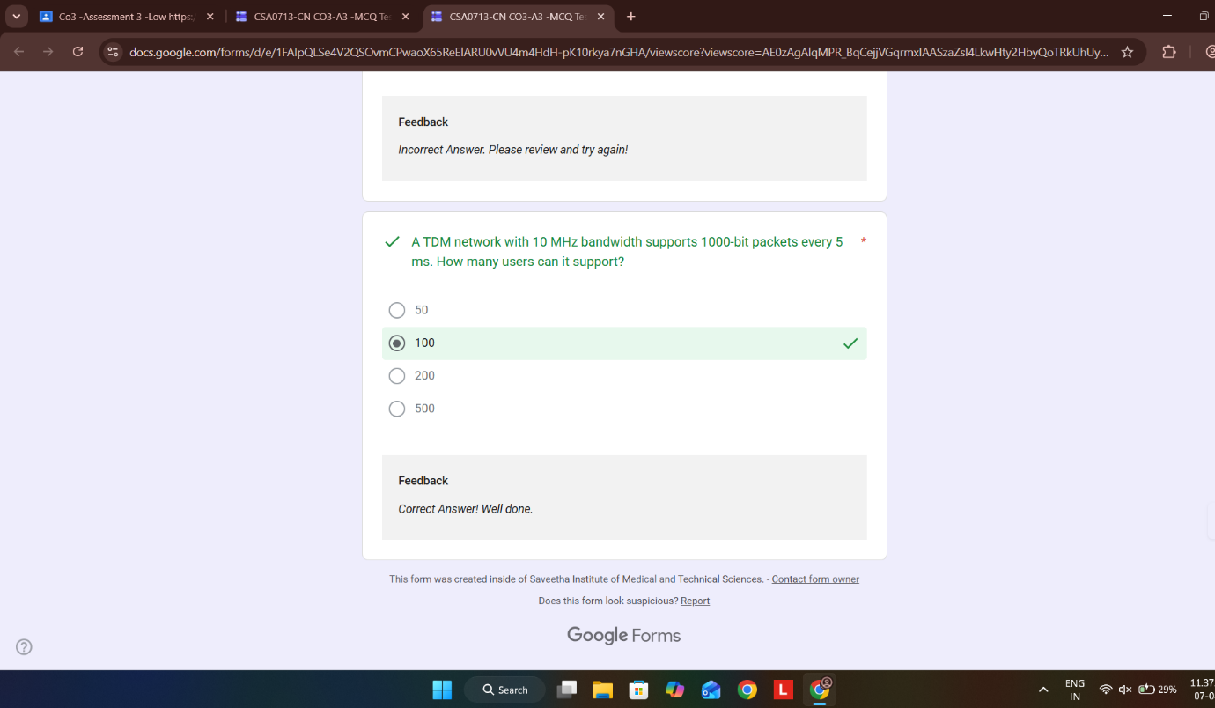

Google Form Online Test :
RUBRICS FOR CALCULATION:
Criteria | Weightag e (%) | Level 4  (Exemplary) | Level 3  (Proficient) | Level 2  (Developing) | Level 1  (Beginning)
Conceptual Understandin g | 30% | Demonstrates thorough understandin g; answers all questions accurately | Shows good understandin g with few errors | Partial  understandin g; several incorrect responses | Lacks understandin g; majority of answers incorrect
Accuracy of  Answers | 25% | All answers are correct | Most answers are correct with minor mistakes | Some correct answers; frequent errors | Mostly incorrect answers
Application of Knowledge | 20% | Correctly applies concepts to problembased questions | Applies concepts with minor errors | Limited ability  to apply concepts | Unable to apply concepts
Time  Management | 15% | Completes quiz well within time efficiently | Completes on time with minor delays | Requires extra time or rushes through questions | Unable to complete within given time
Question  Interpretation | 10% | Interprets all questions correctly and responds appropriately | Misinterprets a few questions | Often misinterprets questions | Unable to understand questions

