This assignment is created using the below technologies

* Dot Net Core 2.1
* MVC
* Onion Architecture
* Entity Framework

I have used below layers to implement the Onion Architecture with repository pattern to interact with data base.

* Data Access Layer
* Application Layer
* Repository Layer
* Server Layer

**Drill down page**

Users

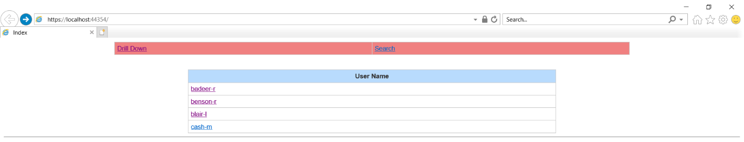

Mail Items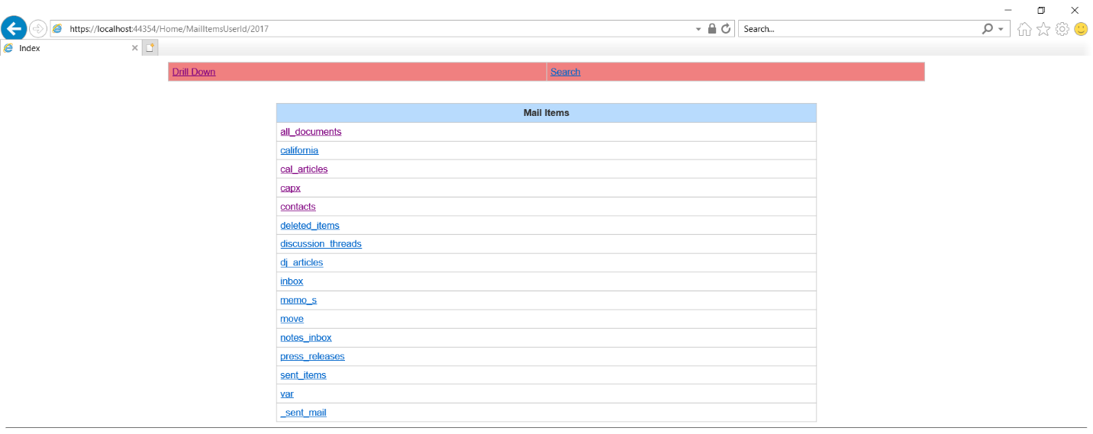

Mails Details

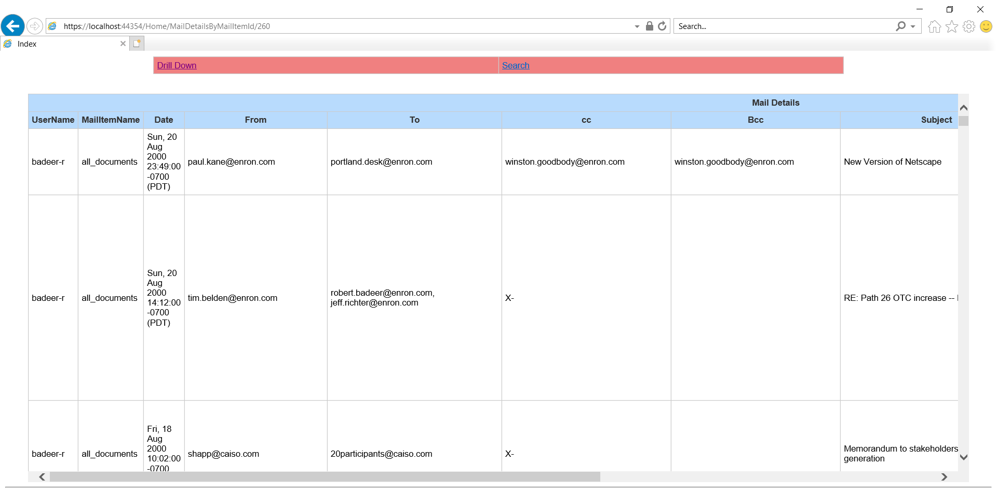

Search page

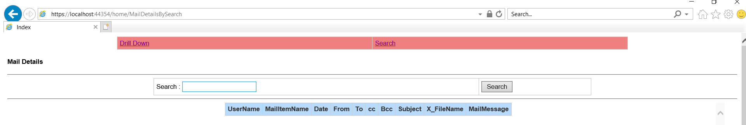

Search page with result

