**Exercise 1: Configuring a Basic Spring Application**

**BookRepository.java :**

package com.library.repository;

import org.springframework.context.annotation.ComponentScan;

import org.springframework.stereotype.Repository;

@Repository

public class BookRepository {

public String getBook() {

return "Spring in Action";

}

}

**BookService.java :**

package com.library.service;

import org.springframework.beans.factory.annotation.Autowired;

import org.springframework.context.annotation.ComponentScan;

import org.springframework.stereotype.Service;

import com.library.repository.BookRepository;

@Service

public class BookService {

private final BookRepository bookRepository;

@Autowired

public BookService(BookRepository bookRepository) {

this.bookRepository = bookRepository;

}

public String fetchBook() {

return bookRepository.getBook();

}

}

**applicationContext.xml :**

<?xml version="1.0" encoding="UTF-8"?>

<beans xmlns="http://www.springframework.org/schema/beans"

xmlns:xsi="http://www.w3.org/2001/XMLSchema-instance"

xsi:schemaLocation="

http://www.springframework.org/schema/beans

http://www.springframework.org/schema/beans/spring-beans.xsd">

<bean id="bookService" class="com.library.service.BookService">

<property name="bookRepository" ref="bookRepository" />

</bean>

</beans>

**Pom.xml :**

<?xml version="1.0" encoding="UTF-8"?>

<project xmlns="http://maven.apache.org/POM/4.0.0" xmlns:xsi="http://www.w3.org/2001/XMLSchema-instance"

xsi:schemaLocation="http://maven.apache.org/POM/4.0.0 https://maven.apache.org/xsd/maven-4.0.0.xsd">

<modelVersion>4.0.0</modelVersion>

<parent>

<groupId>org.springframework.boot</groupId>

<artifactId>spring-boot-starter-parent</artifactId>

<version>3.5.3</version>

<relativePath/> <!-- lookup parent from repository -->

</parent>

<groupId>com.exercise</groupId>

<artifactId>LibraryManagement</artifactId>

<version>0.0.1-SNAPSHOT</version>

<name>Spring1</name>

<description>Demo project for Spring Boot</description>

<url/>

<licenses>

<license/>

</licenses>

<developers>

<developer/>

</developers>

<scm>

<connection/>

<developerConnection/>

<tag/>

<url/>

</scm>

<properties>

<java.version>17</java.version>

</properties>

<dependencies>

<dependency>

<groupId>org.springframework.boot</groupId>

<artifactId>spring-boot-starter-web</artifactId>

</dependency>

<dependency>

<groupId>org.springframework.boot</groupId>

<artifactId>spring-boot-devtools</artifactId>

<scope>runtime</scope>

<optional>true</optional>

</dependency>

<dependency>

<groupId>org.springframework.boot</groupId>

<artifactId>spring-boot-starter-test</artifactId>

<scope>test</scope>

</dependency>

</dependencies>

<build>

<plugins>

<plugin>

<groupId>org.springframework.boot</groupId>

<artifactId>spring-boot-maven-plugin</artifactId>

</plugin>

</plugins></build></project>

**LibraryManagementApplication.java :**

package com.library;

import com.library.service.BookService;

import org.springframework.boot.SpringApplication;

import org.springframework.boot.autoconfigure.SpringBootApplication;

import org.springframework.context.ApplicationContext;

@SpringBootApplication

public class LibraryManagementApplication {

public static void main(String[] args) {

ApplicationContext context = SpringApplication.run(LibraryManagementApplication.class, args);

BookService bookService = context.getBean(BookService.class);

System.out.println("Book fetched: " + bookService.fetchBook());

}

}

**Output :**

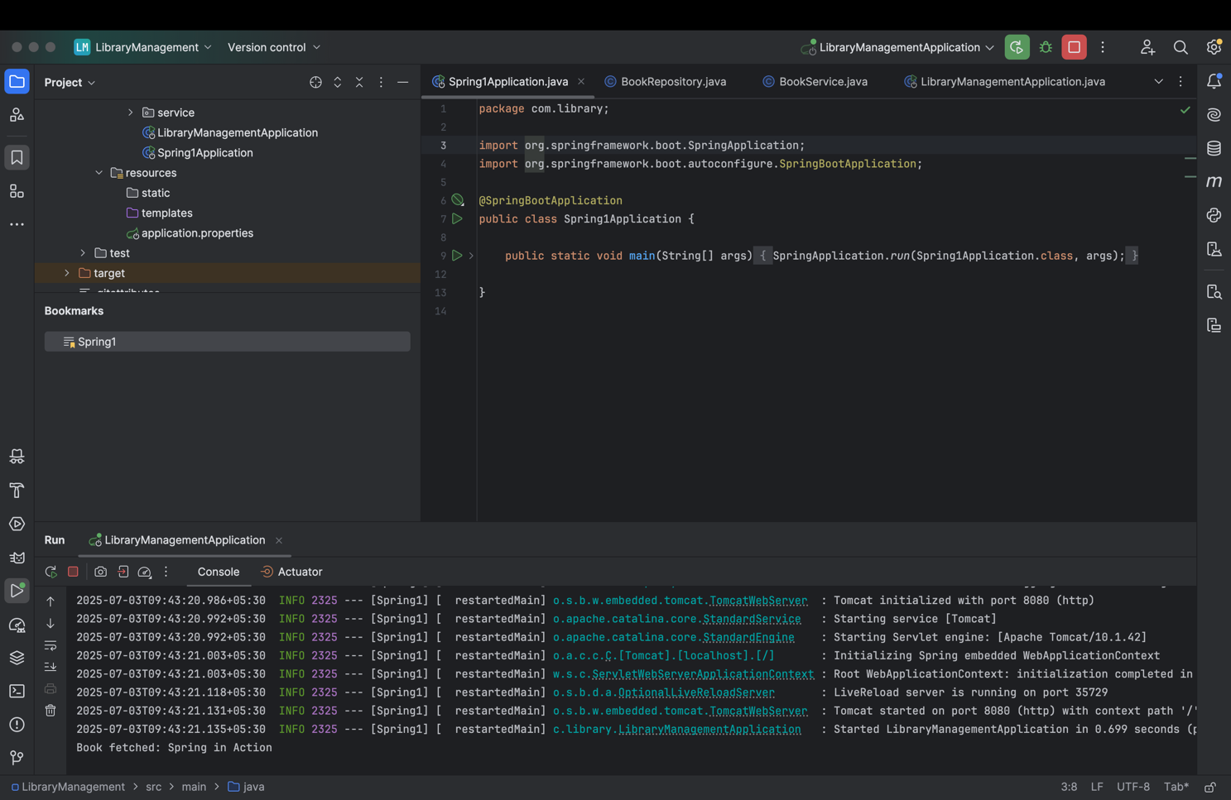

**Exercise 2: Implementing Dependency Injection**

**ApplicationContext.xml :**

<?xml version="1.0" encoding="UTF-8"?>

<beans xmlns="http://www.springframework.org/schema/beans"

xmlns:xsi="http://www.w3.org/2001/XMLSchema-instance"

xsi:schemaLocation="

http://www.springframework.org/schema/beans

http://www.springframework.org/schema/beans/spring-beans.xsd">

<bean id="bookRepository" class="com.library.repository.BookRepository" />

<bean id="bookService" class="com.library.service.BookService">

<property name="bookRepository" ref="bookRepository" />

</bean>

</beans>

### BookRepository.java :

### package com.library.repository;

### public class BookRepository {

### public String getBook() {

### return "Spring in Action";

### }

### }

**BookService.java :**

package com.library.service;

import com.library.repository.BookRepository;

public class BookService {

private BookRepository bookRepository;

// Setter for Dependency Injection

public void setBookRepository(BookRepository bookRepository) {

this.bookRepository = bookRepository;

}

public String fetchBook() {

return bookRepository.getBook();

}

}

**LibraryManagementApplication :**

package com.library;

import com.library.service.BookService;

import org.springframework.context.ApplicationContext;

import org.springframework.context.support.ClassPathXmlApplicationContext;

public class LibraryManagementApplication {

public static void main(String[] args) {

// Load XML-based application context

ApplicationContext context = new ClassPathXmlApplicationContext("applicationContext.xml");

// Get BookService bean

BookService bookService = context.getBean("bookService", BookService.class);

// Test dependency injection

String book = bookService.fetchBook();

System.out.println("Fetched Book: " + book);

}

}

**Output :**

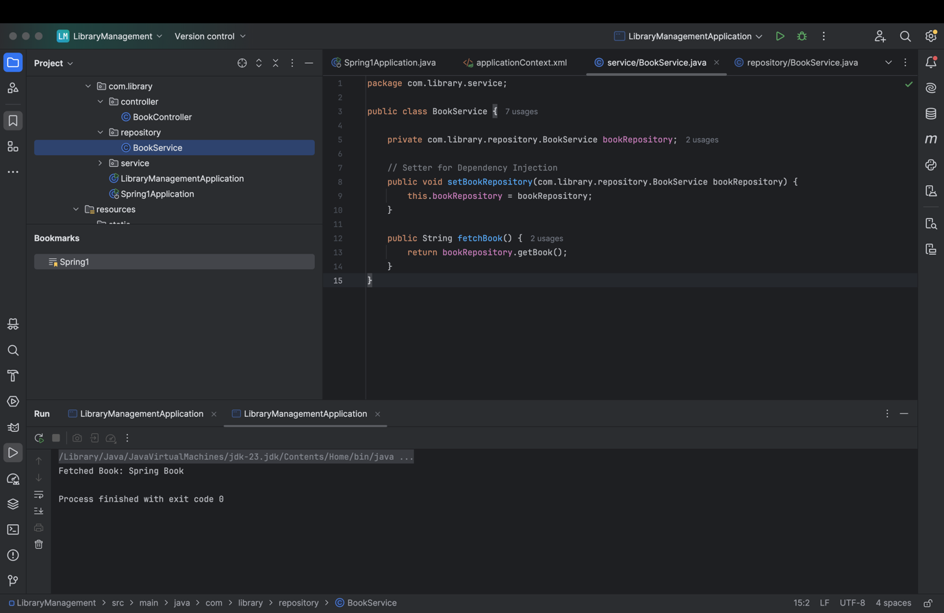

**Exercise 4: Creating and Configuring a Maven Project**

### pom.xml :

### <project xmlns="http://maven.apache.org/POM/4.0.0"

### xmlns:xsi="http://www.w3.org/2001/XMLSchema-instance"

### xsi:schemaLocation="http://maven.apache.org/POM/4.0.0

### http://maven.apache.org/xsd/maven-4.0.0.xsd">

### <modelVersion>4.0.0</modelVersion>

### <groupId>com.library</groupId>

### <artifactId>LibraryManagement</artifactId>

### <version>1.0-SNAPSHOT</version>

### <dependencies>

### <dependency>

### <groupId>org.springframework</groupId>

### <artifactId>spring-context</artifactId>

### <version>5.3.36</version>

### </dependency>

### <dependency>

### <groupId>org.springframework</groupId>

### <artifactId>spring-aop</artifactId>

### <version>5.3.36</version>

### </dependency>

### <dependency>

### <groupId>org.springframework</groupId>

### <artifactId>spring-webmvc</artifactId>

### <version>5.3.36</version>

### </dependency>

### <dependency>

### <groupId>javax.servlet</groupId>

### <artifactId>javax.servlet-api</artifactId>

### <version>4.0.1</version>

### <scope>provided</scope>

### </dependency>

### </dependencies>

### <build>

### <plugins>

### <!-- Maven Compiler Plugin -->

### <plugin>

### <groupId>org.apache.maven.plugins</groupId>

### <artifactId>maven-compiler-plugin</artifactId>

### <version>3.8.1</version>

### <configuration>

### <source>1.8</source>

### <target>1.8</target>

### </configuration>

### </plugin>

### </plugins>

### </build>

### </project>

### Output :

### 