EBS- Elastic beanstalk -> webapplication environement - u can deploy ur web application and run it. provieds PAAS

ECS->elastic container service

Elastic Container Service (Amazon ECS) is a fully managed container orchestration service that helps you easily deploy, manage, and scale containerized applications.

taskdefinition => it defines , what container to run

services => how many task to run , do you want to use loadbalancer and all that kind of stuff, if u want 5 instances of the application , u define it here.

cluster=> where do u want to run the task, run them in a cluster

policy to attach for ur ecs role is => AmazonECSTaskExecutionRolePolicy

docker tag local-image:tagname new-repo:tagname

docker push new-repo:tagname

docker tag ecsdemo shanmugapriyav/myecs-repo:ecsdemo

docker push shanmugapriyav/myecs-repo:ecsdemo

Create one spring application with docker file

Create jar file

Login into docker hub

Create repository

Name: ecsdemo

docker tag local-image:tagname new-repo:tagname  
docker push new-repo:tagname

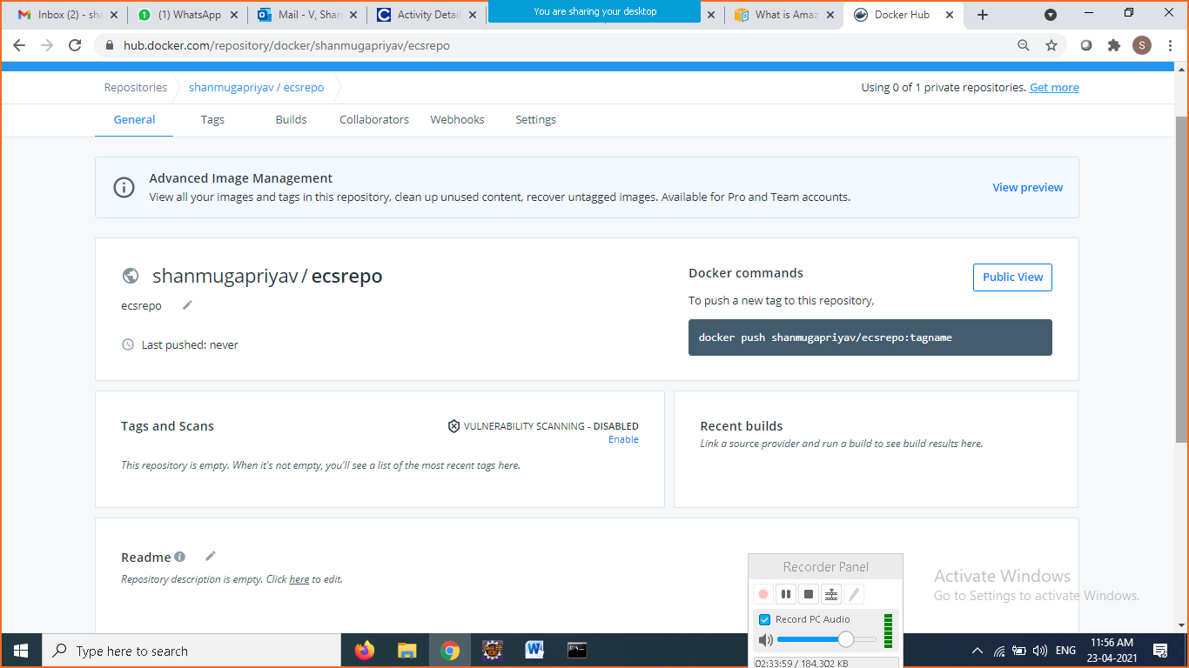

Goto cmd create the docker image

Build the docker image

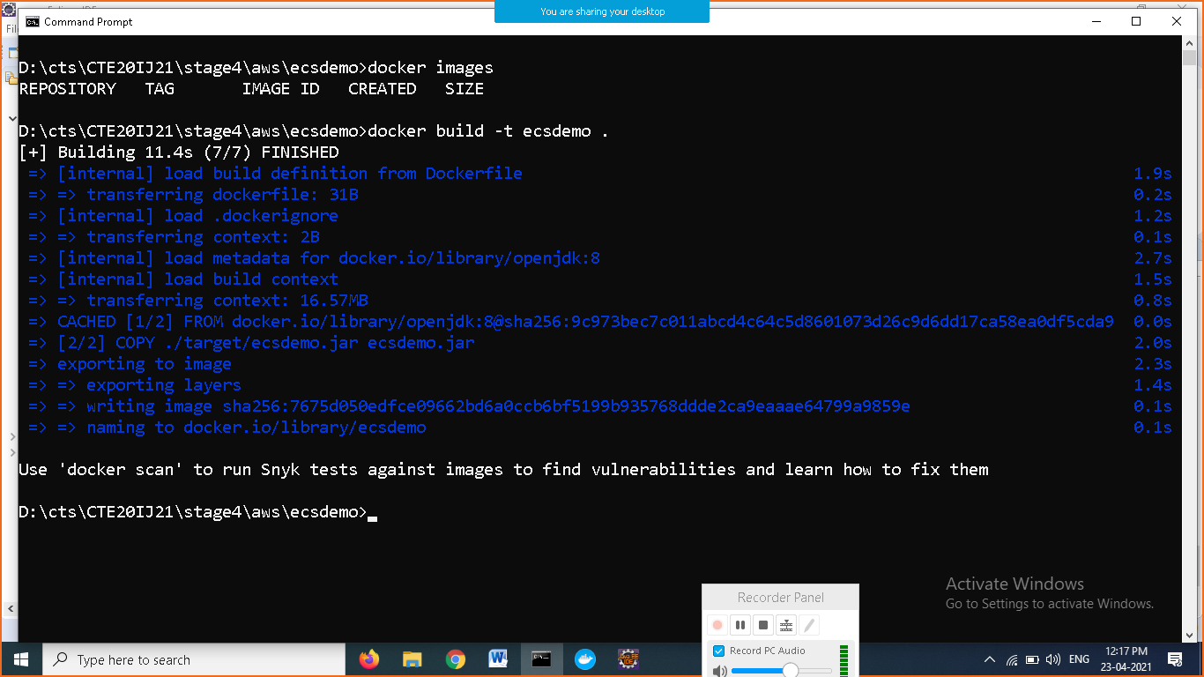

Push docker image to dockerhub

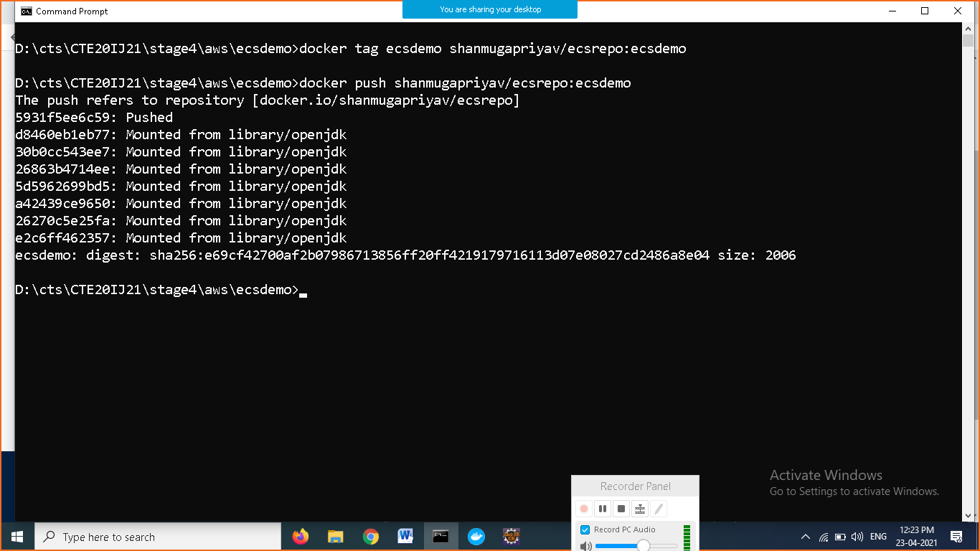

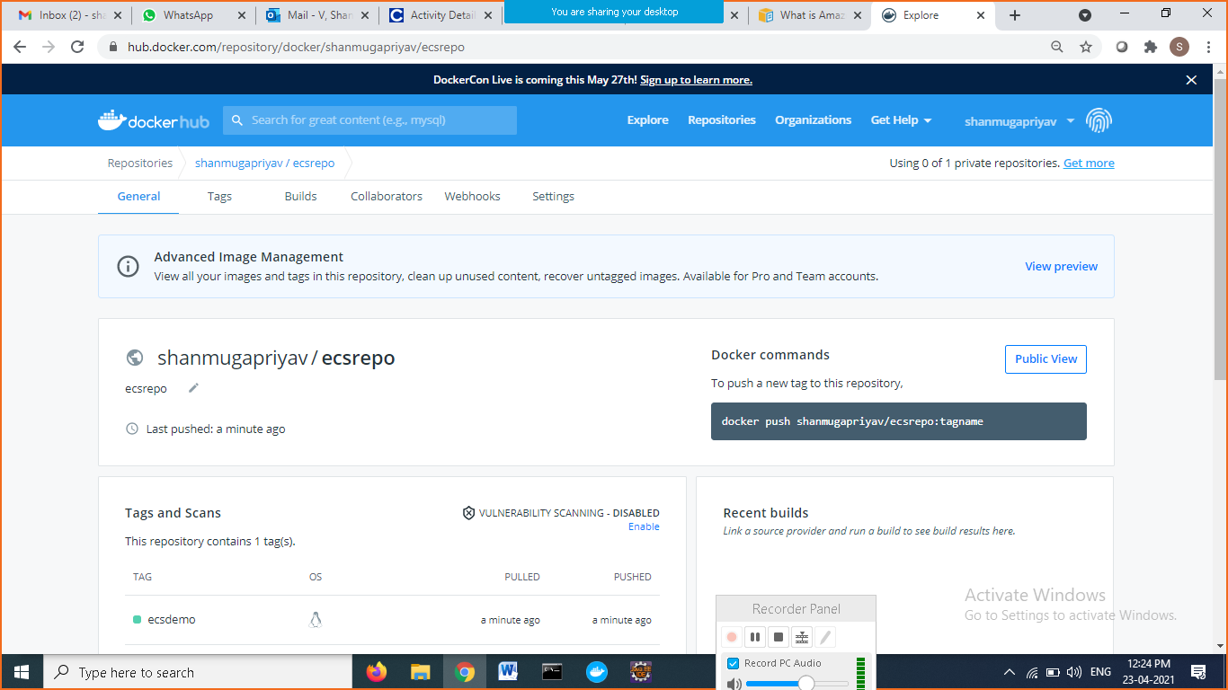

\*\*\*\*\*\*\*\*\*\*\*\*\*\*\*\*\*\*\*\*\*\*\*\*\*\*\*\*\*\*\*\*\*\*\*\*\*\*\*\*\*\*\*\*

Creating ECS in aws run the docker image

Aws => go to ECS

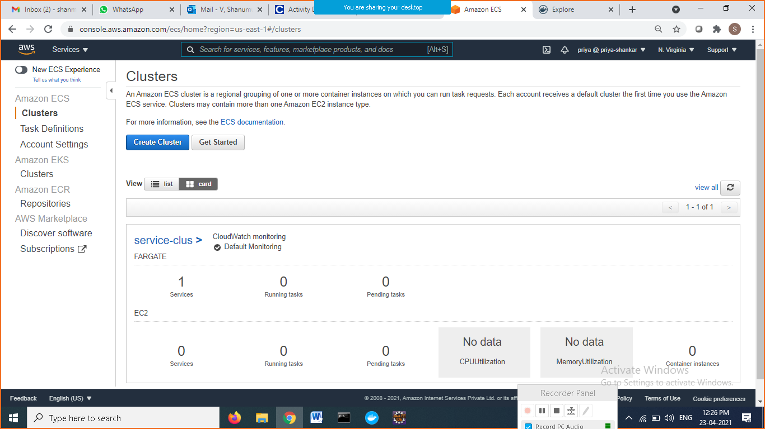

Click getstarted

1. In container definition => Click configure
2. Configure ur repository and image

Select custom

Docker hub image url

Port number :9191

Other configuration default

Click on update

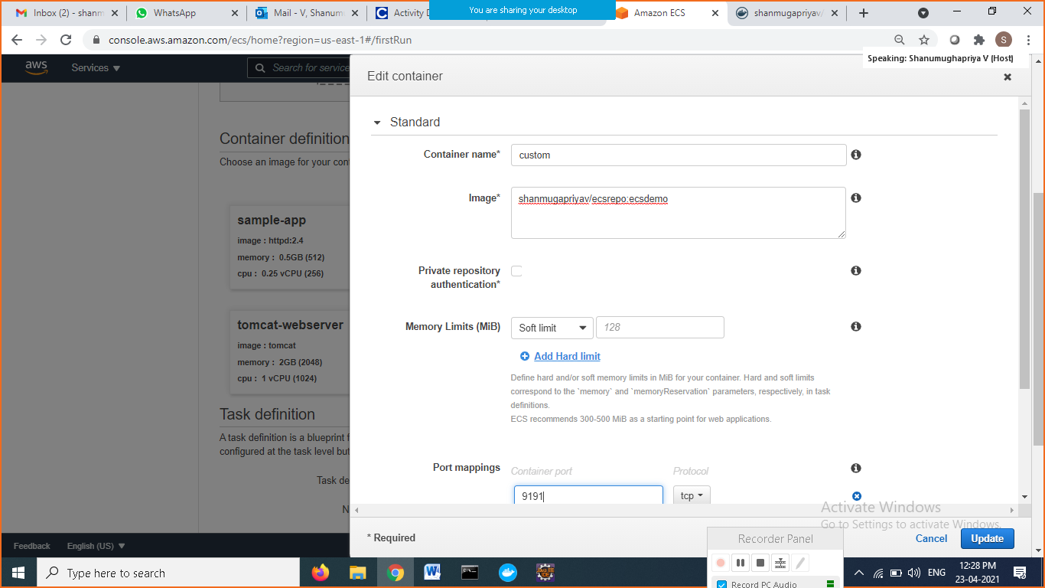

Click on next

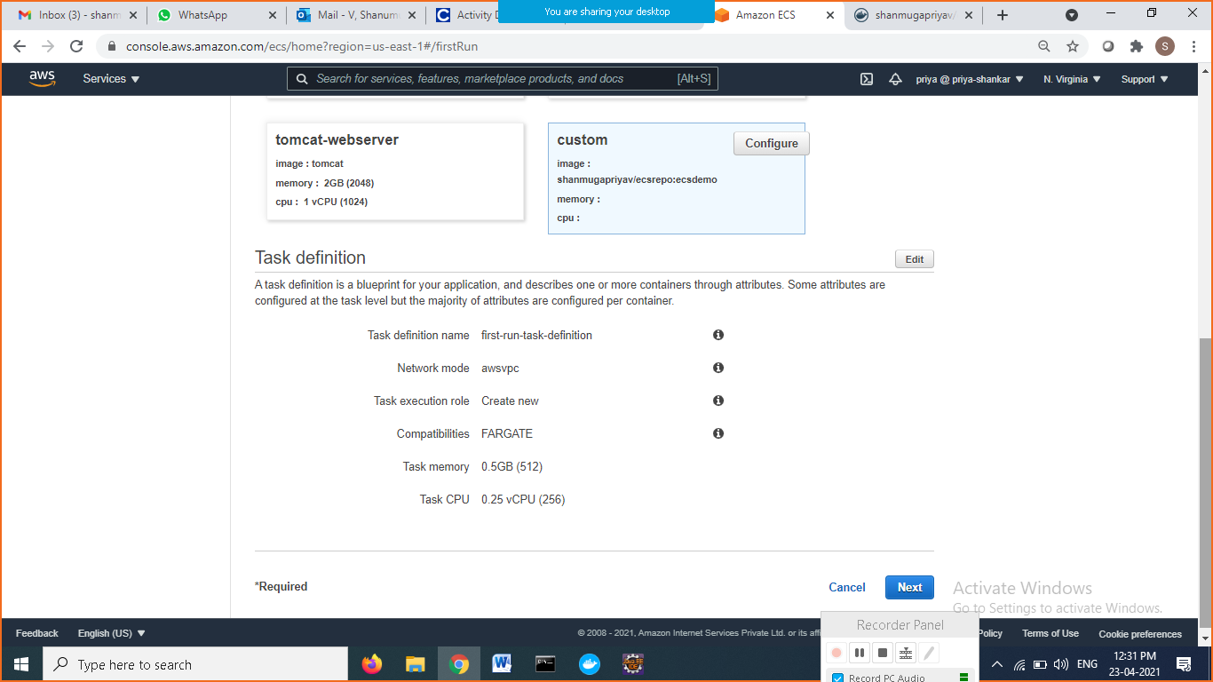

Choose application load balancer

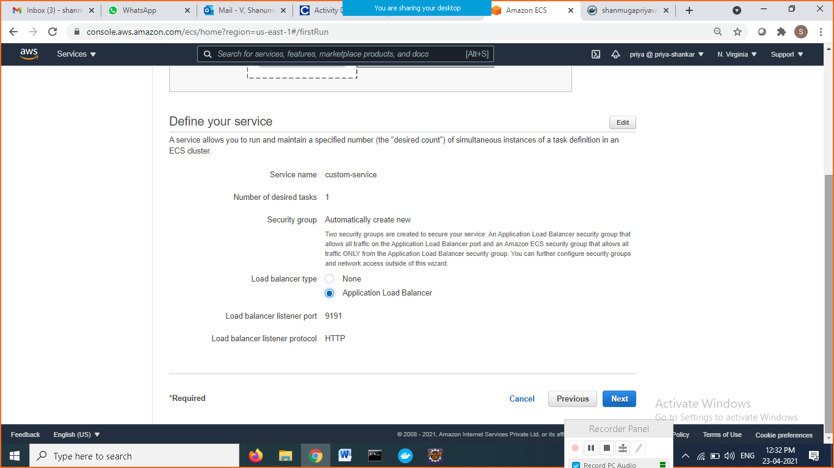

Click on Next => next => Review and click on create button

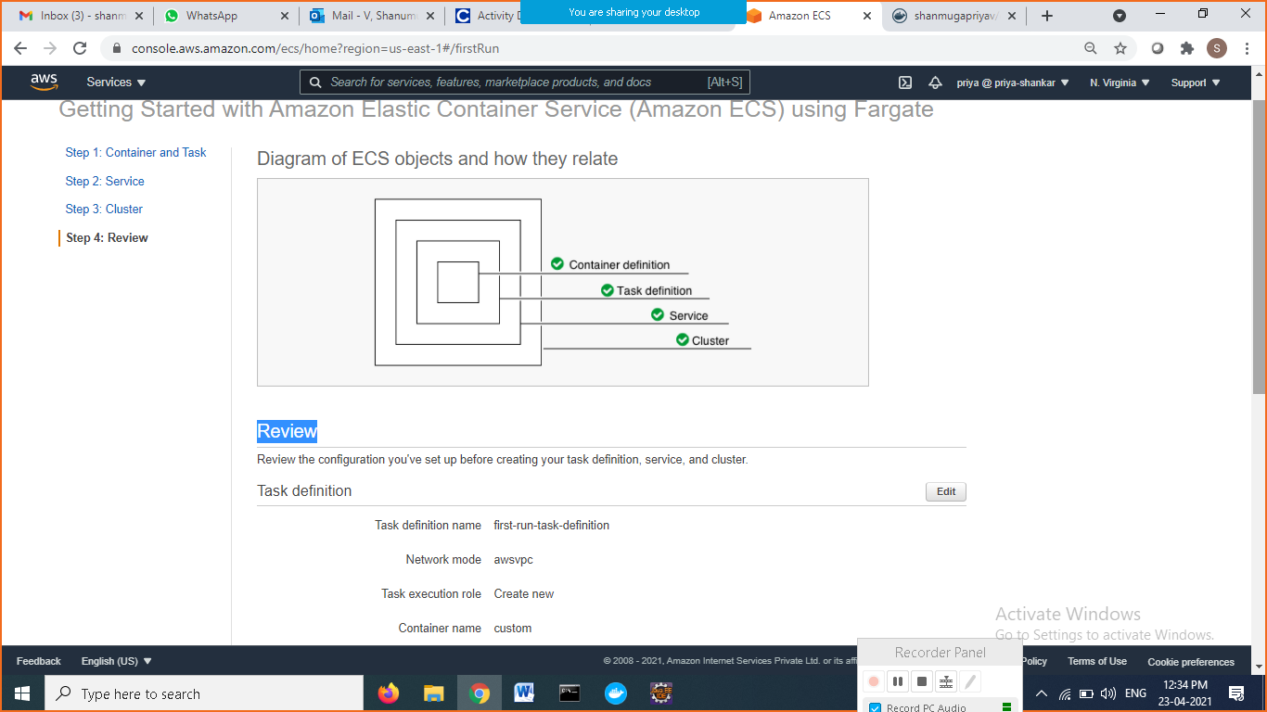

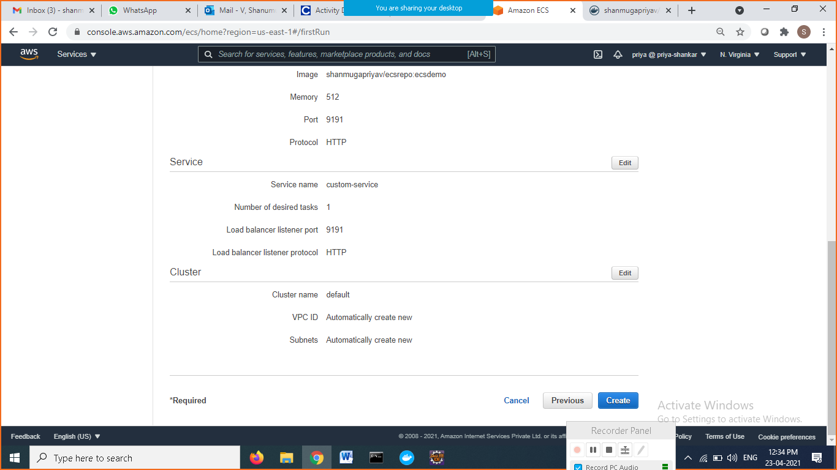

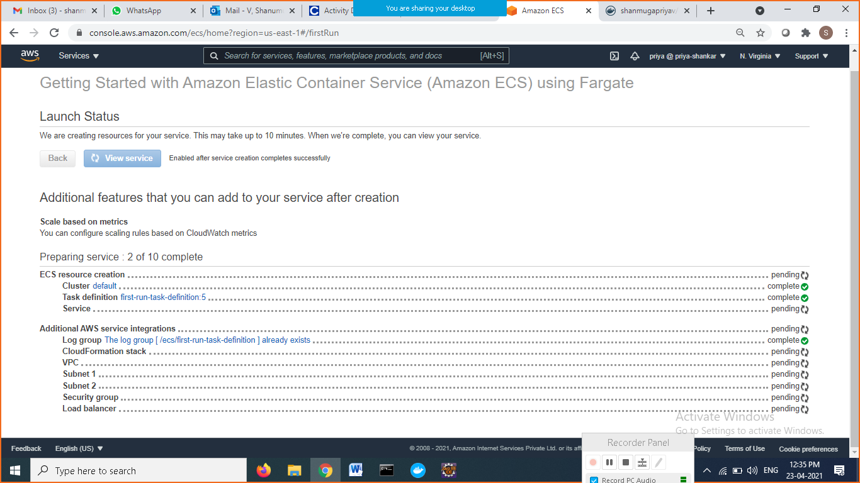

After completion click on view service button

Details tab

Load balancing

Under Target Group Name

Link available click on

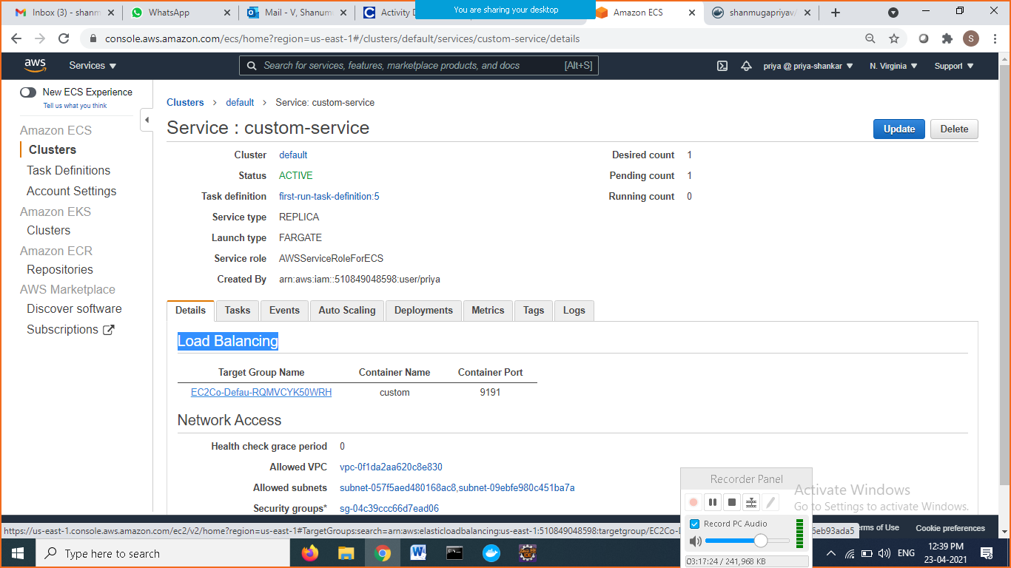

Click on Name link

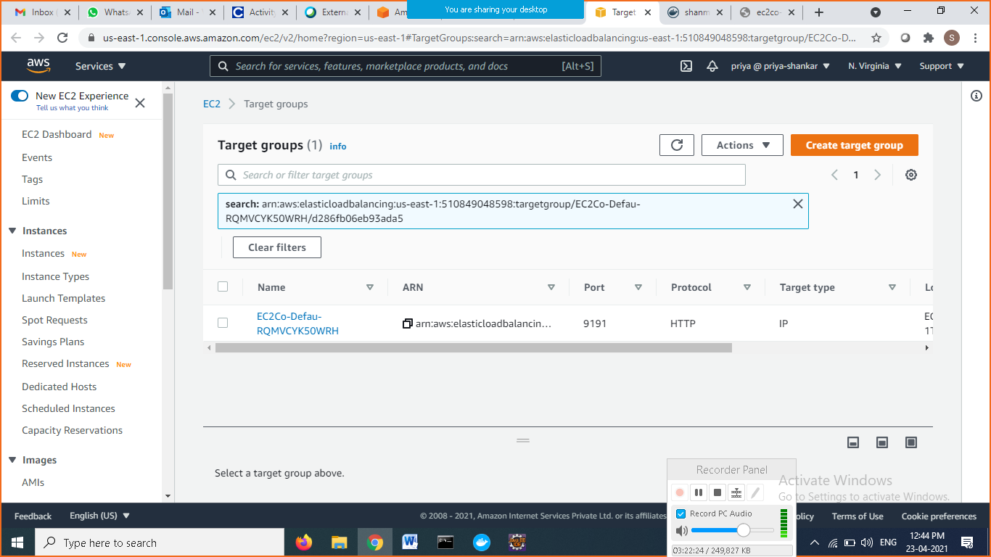

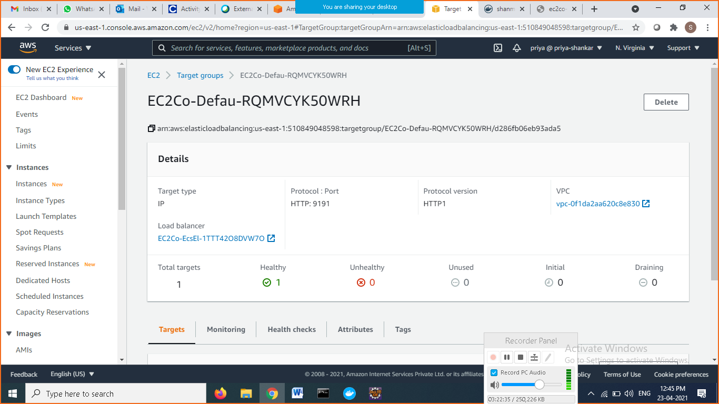

Click on link under load balancer

Copy the DNS name and go to browser run it

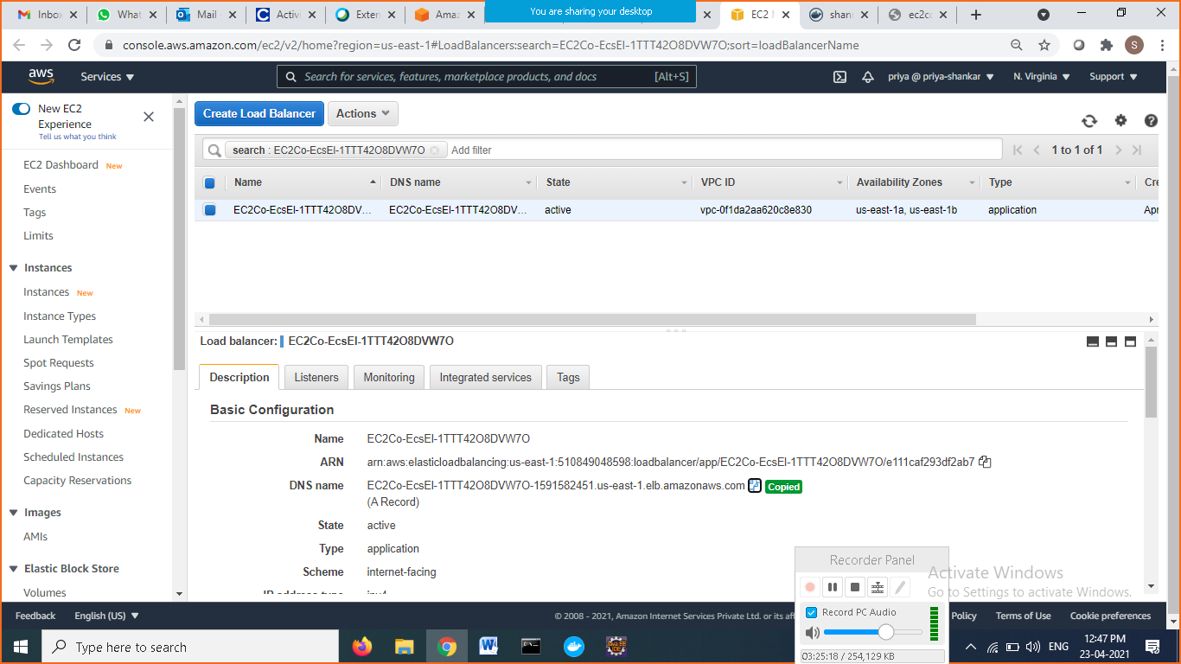

<http://ec2co-ecsel-1ttt42o8dvw7o-1591582451.us-east-1.elb.amazonaws.com:9191/>

