Code-commit => it’s a repository => it used to store your source code (git)

Go to aws console

1. Go to IAM users => navigate to ur id

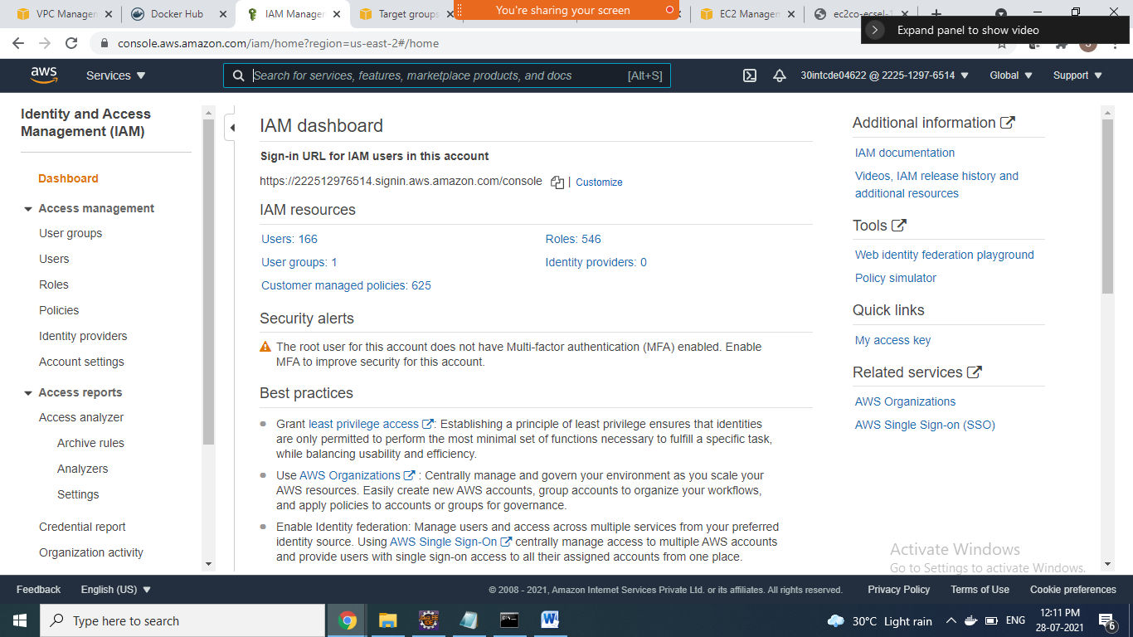

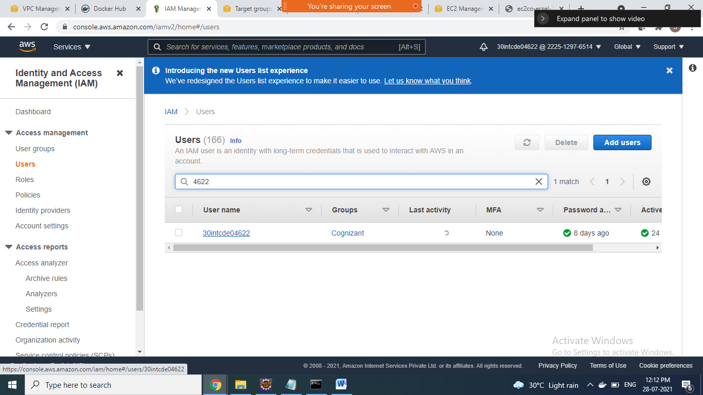

1. Click on userid link => go to security credentials tab

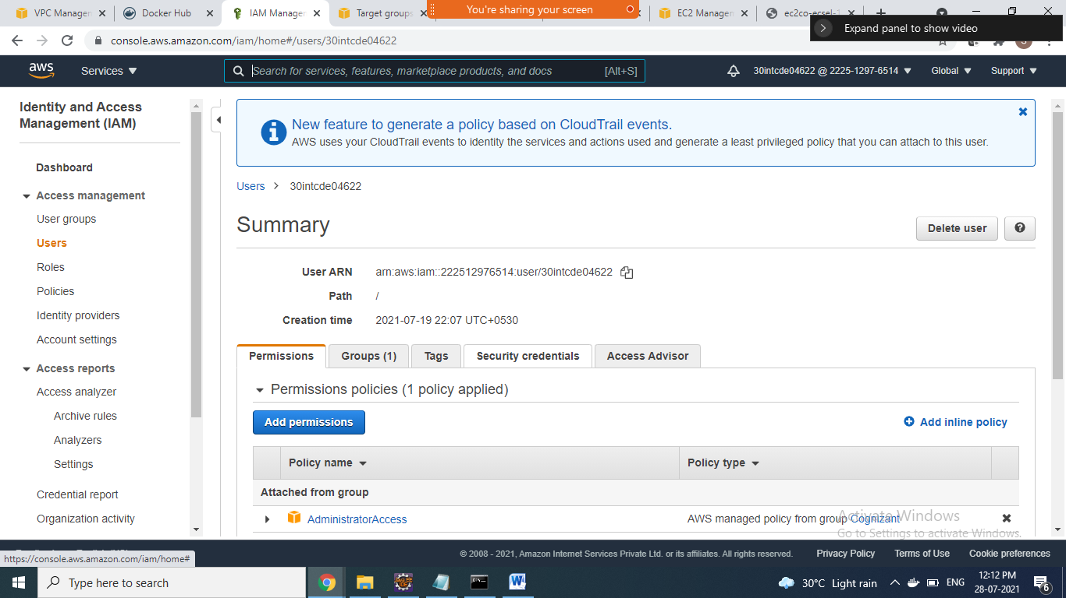

1. Go to => HTTPS Git credentials for AWS CodeCommit section => and click generate credentials button

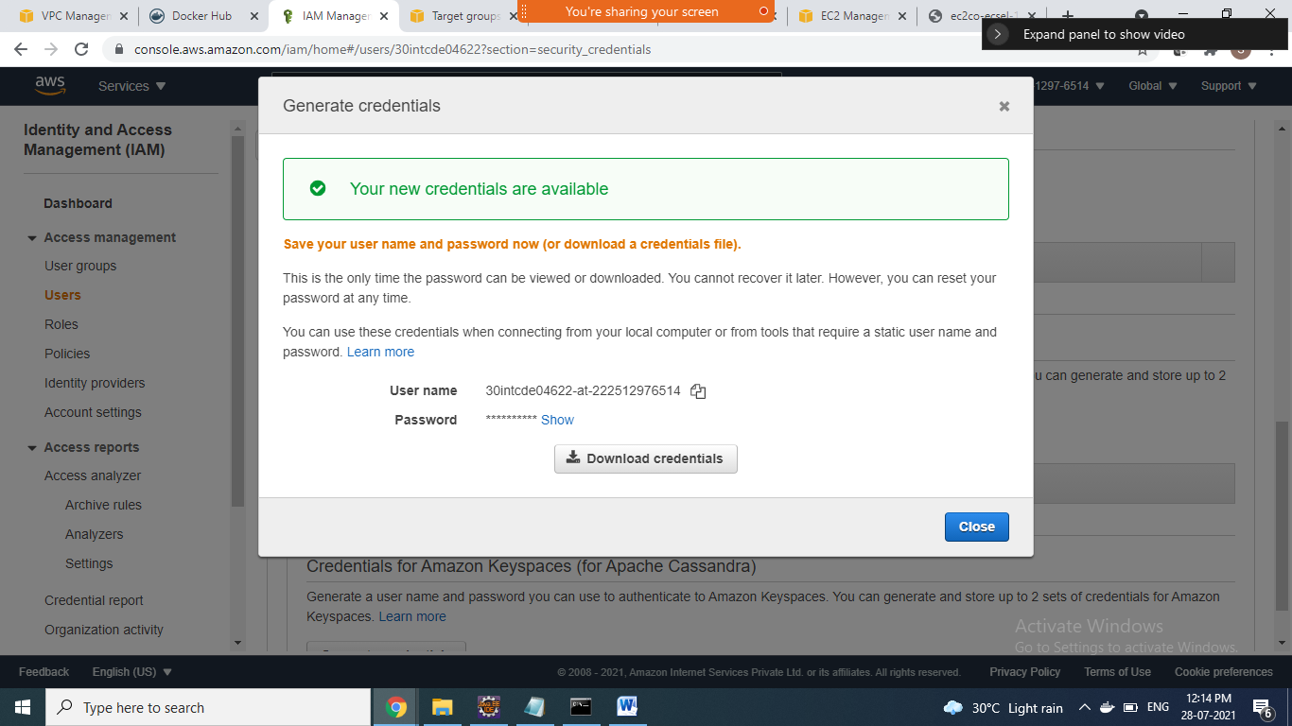

1. Download the csv file by clicking download credentials

File name => 30intcde04622_codecommit_credentials.csv

Navigate to codecommit service

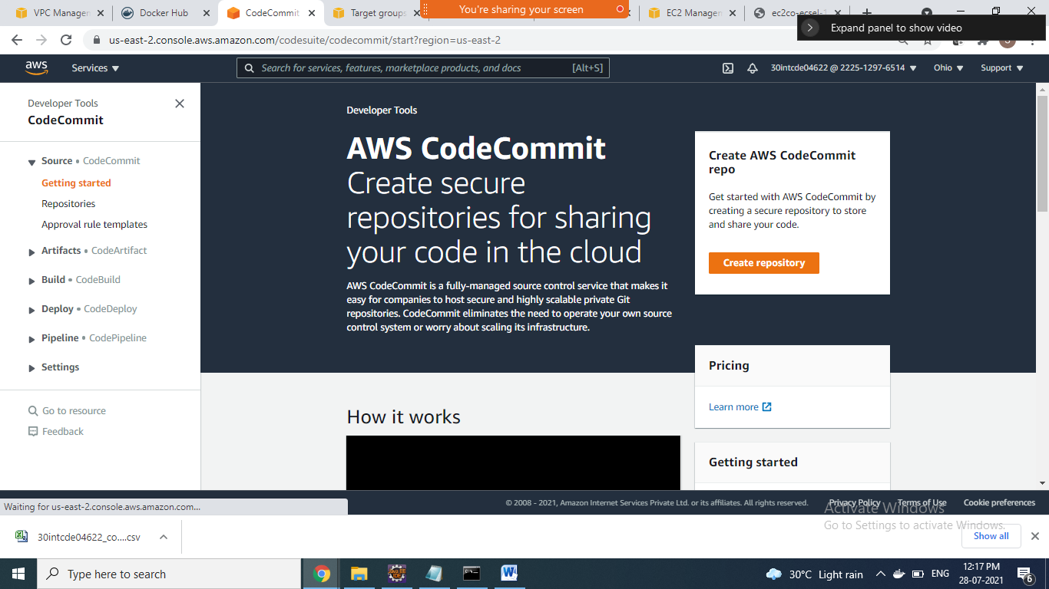

1. Click on create repository button to create new repository

Give name for ur repository and click on create button

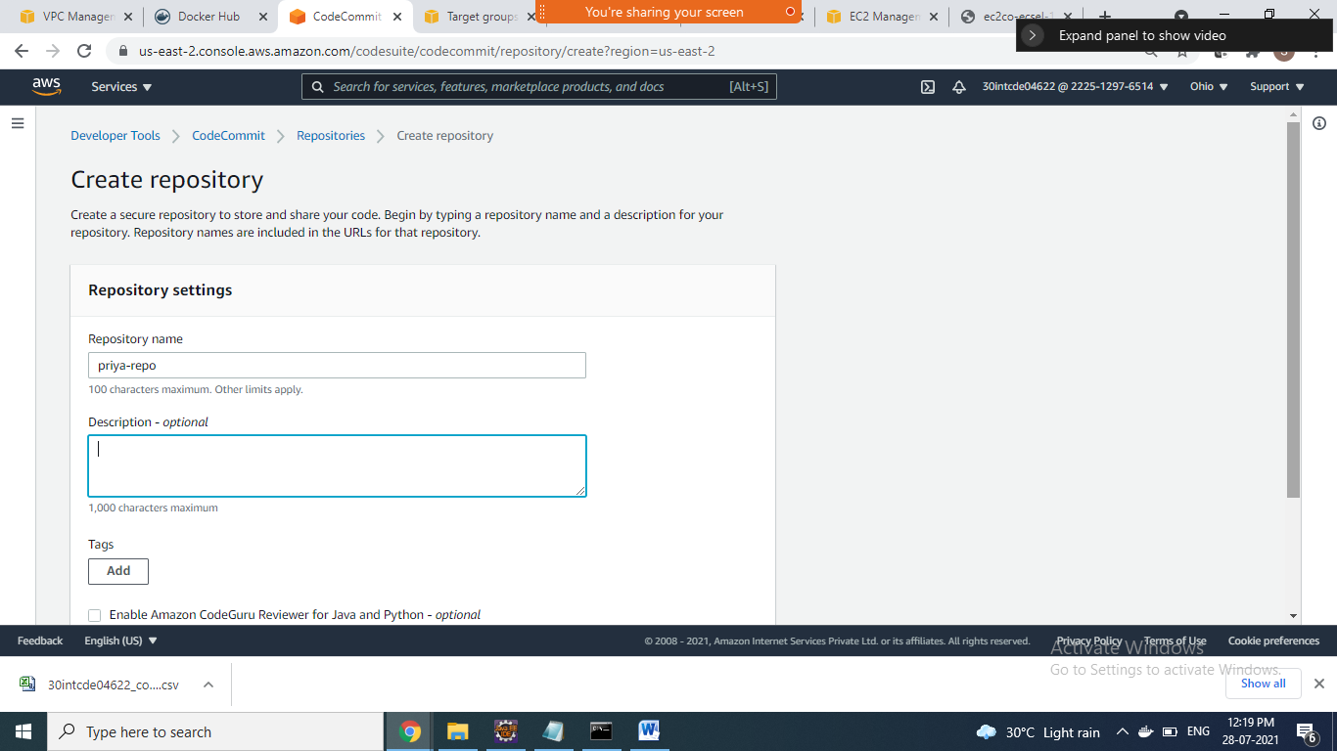

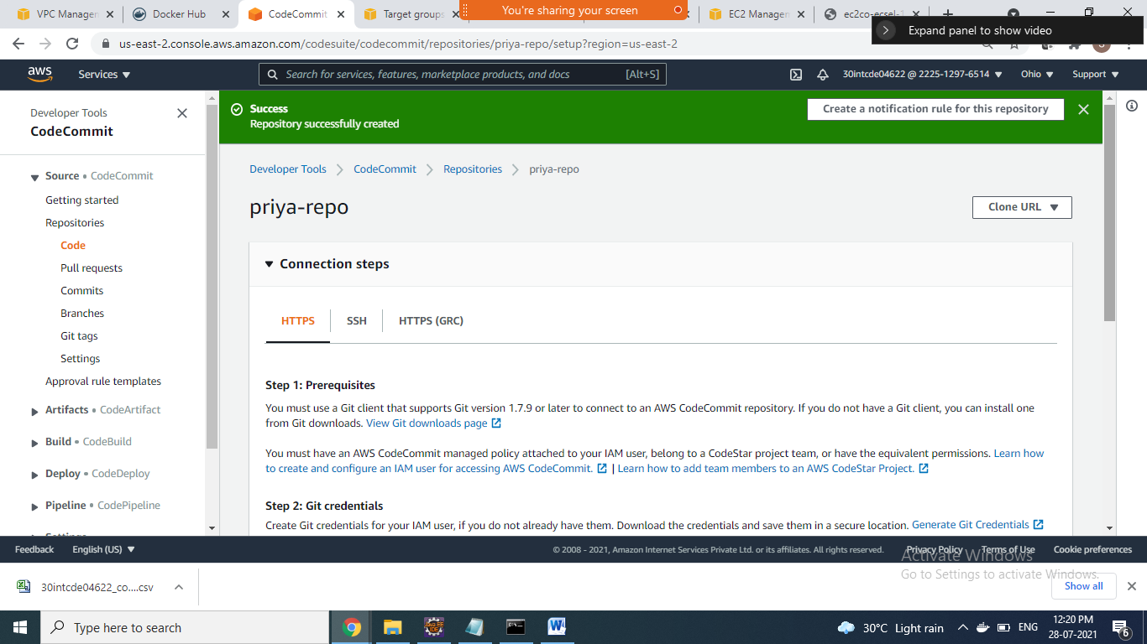

1. Copy the url to clone to local repository

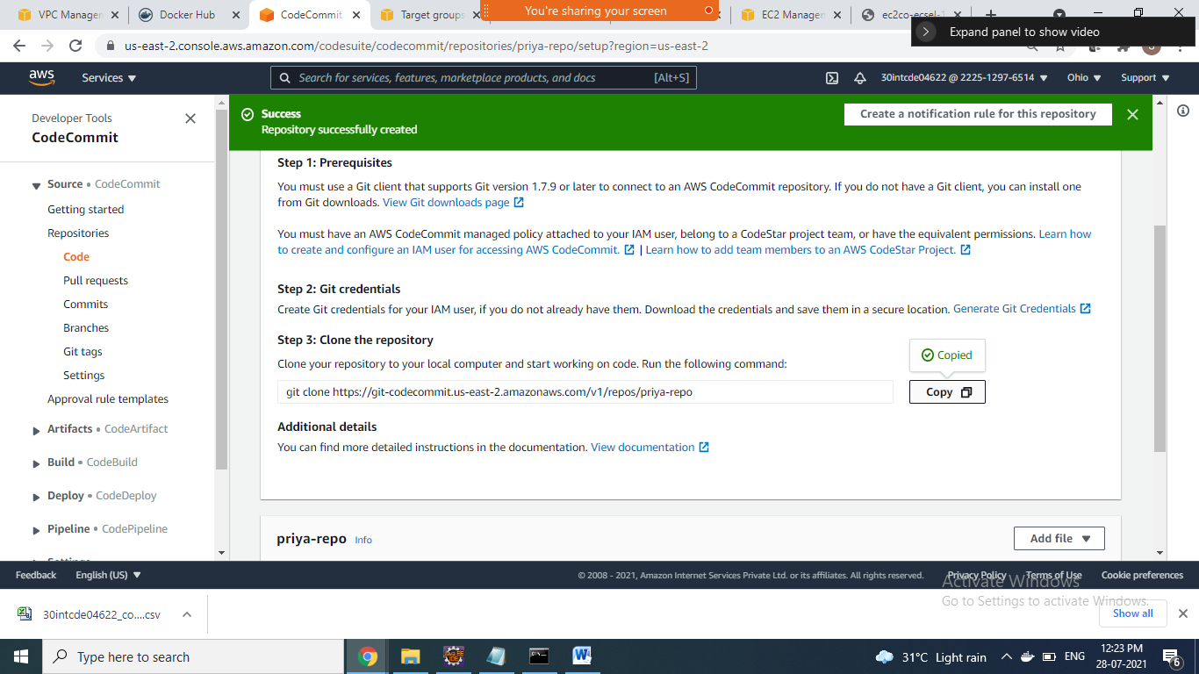

1. Eclipse goto window=>showview =>others=>type git => open git repository and git staging window

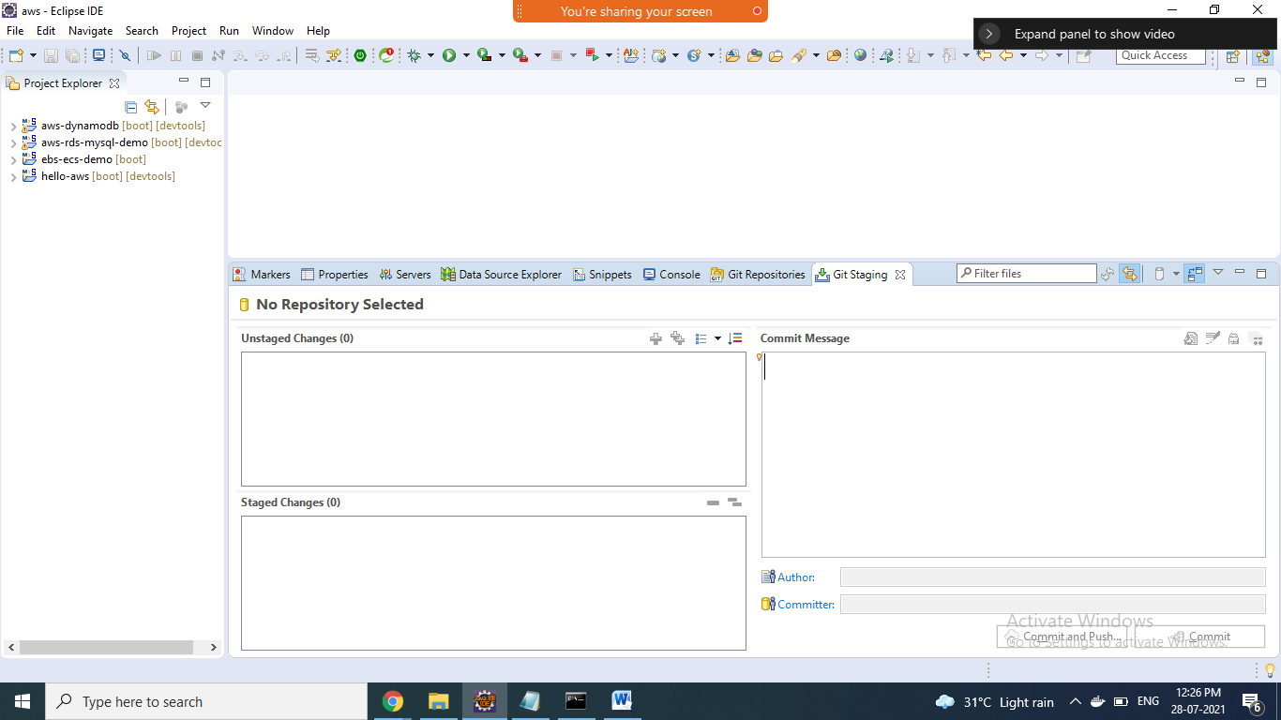

1. Click on clone git repository from git repository window

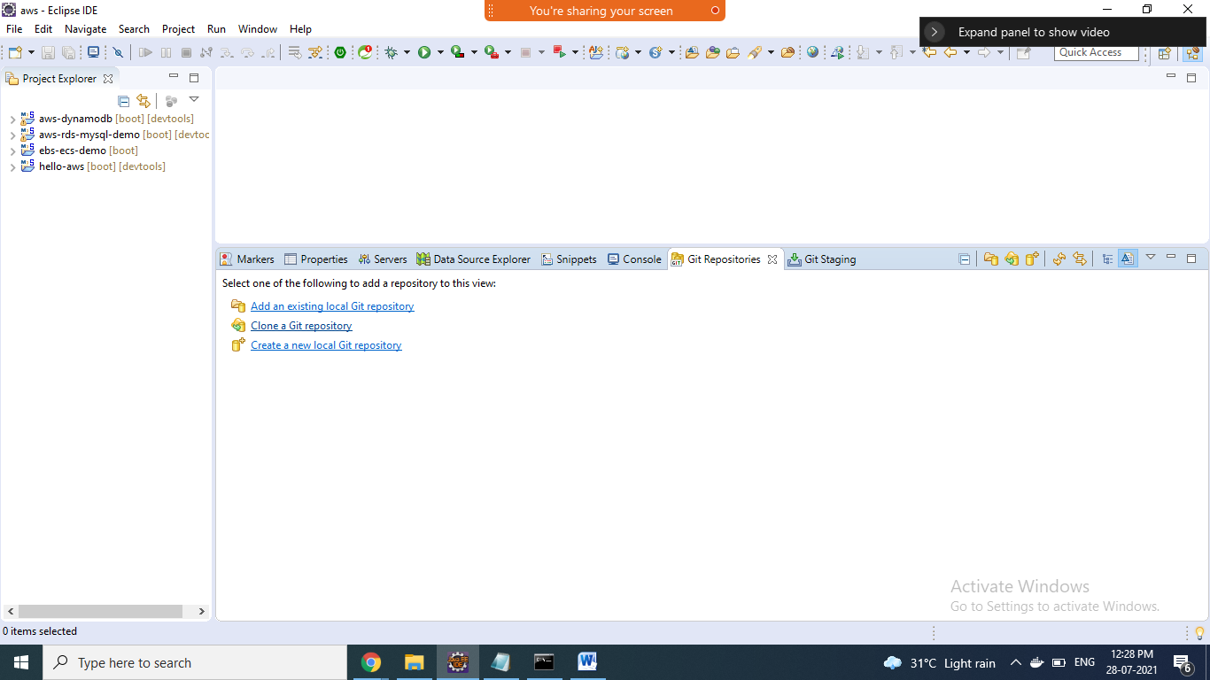

1. Paste ur copied URI here and type username and password and click next button

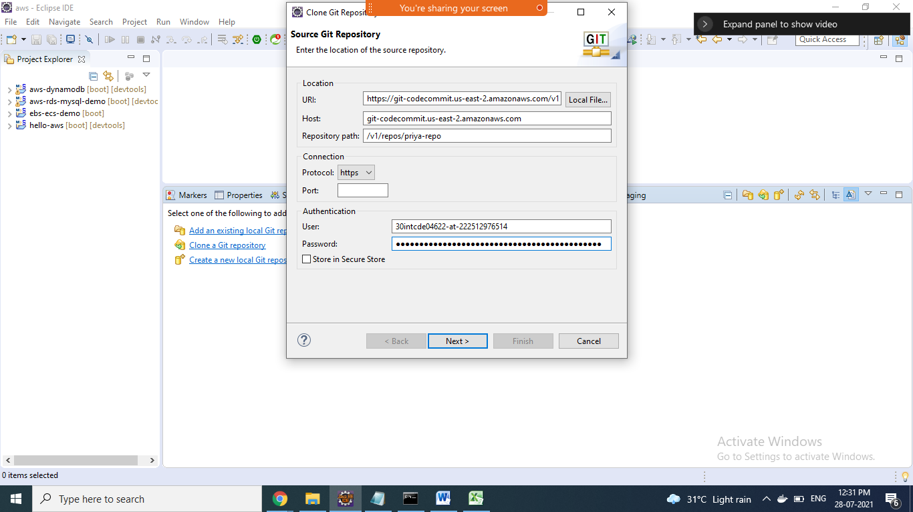

1. Click on => next=>finish button

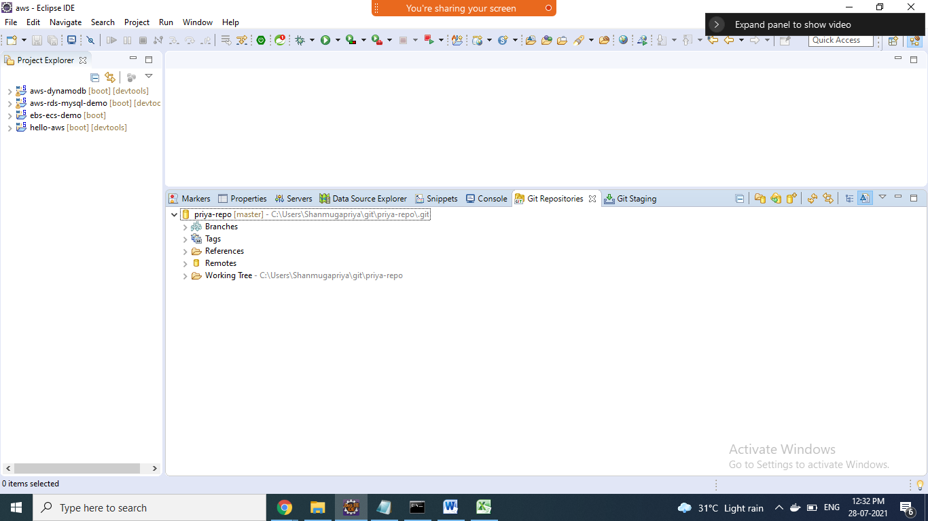

1. Add the project to ur repository by right-click ur project => team => share project

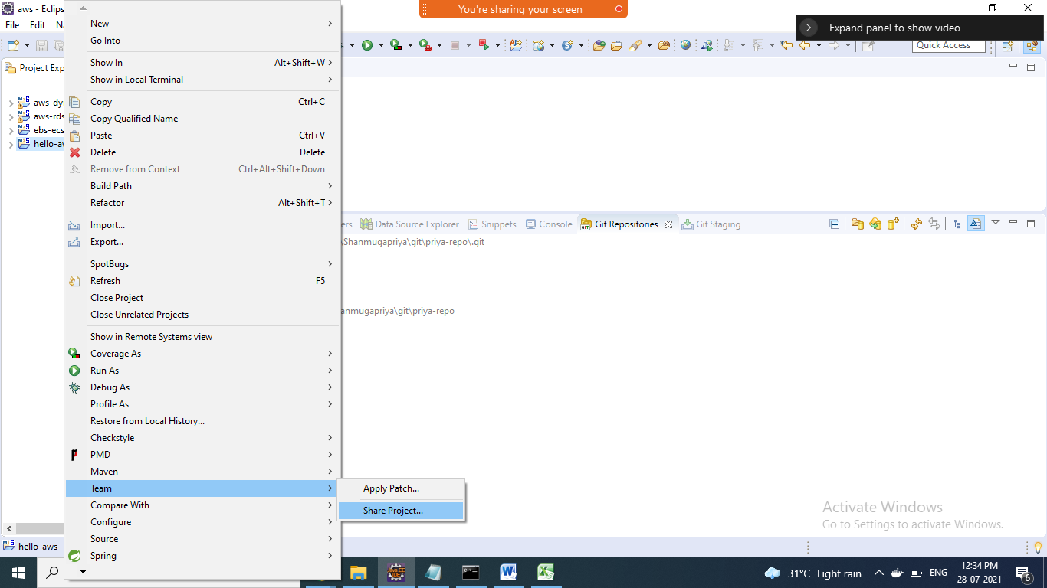

1. Choose repository and click finish

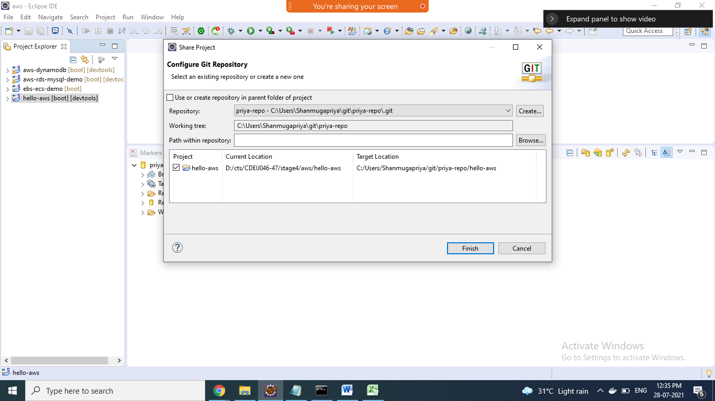

1. Go to git staging window, files added into unstaged chages section by clicking ++ button it will added to staged changes

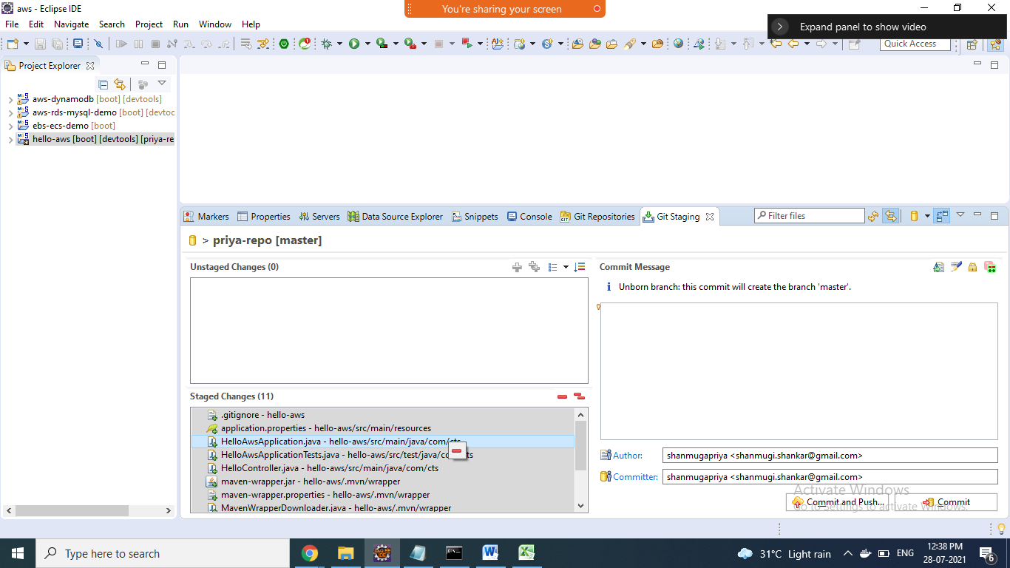

1. Give commit message in the text box and commit and push button

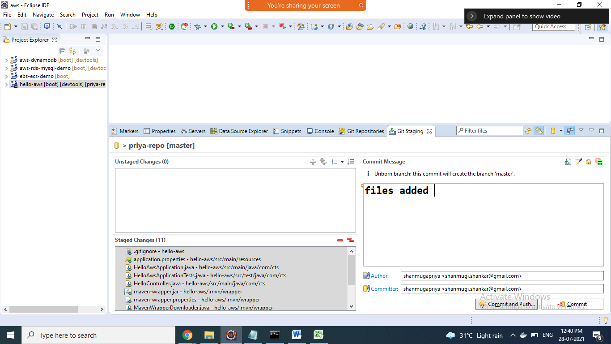

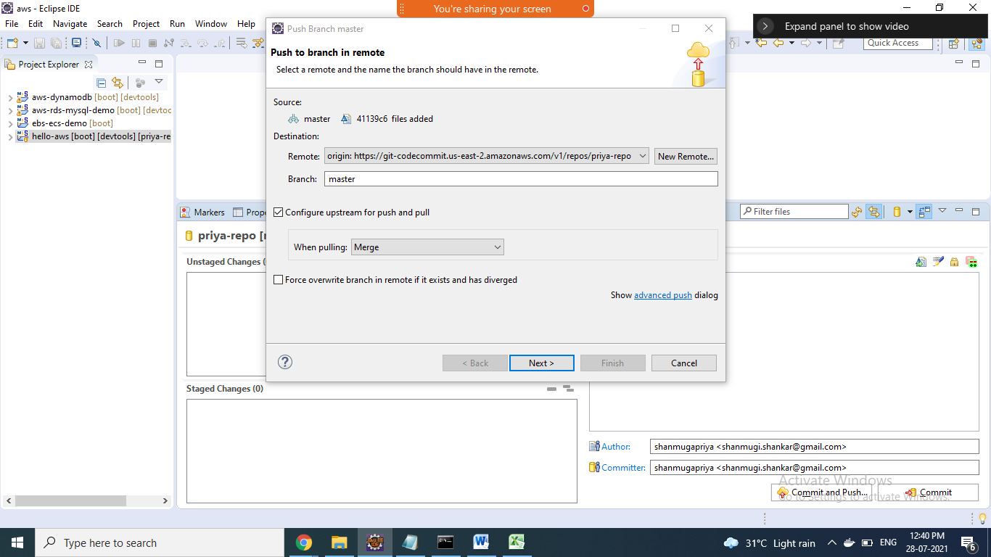

1. Click on next and click finish=> u see that yellow symbol in project it indicates ur project saved in repository
2. Goto ur aws console click ur repository check ur project is present

