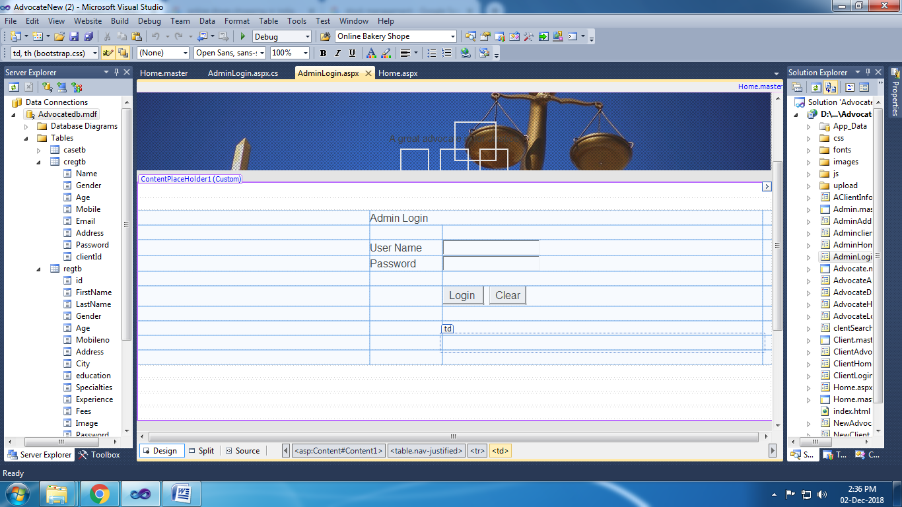

using System;

using System.Collections.Generic;

using System.Linq;

using System.Web;

using System.Web.UI;

using System.Web.UI.WebControls;

public partial class AdminLogin : System.Web.UI.Page

{

protected void Page_Load(object sender, EventArgs e)

{

}

protected void Button1_Click(object sender, EventArgs e)

{

if (TextBox1.Text == "admin" & TextBox2.Text == "admin")

{

Response.Redirect("AdminHome.aspx");

}

else

{

Response.Write("<Script> alert('Password Mismatch') </Script>");

}

}

}

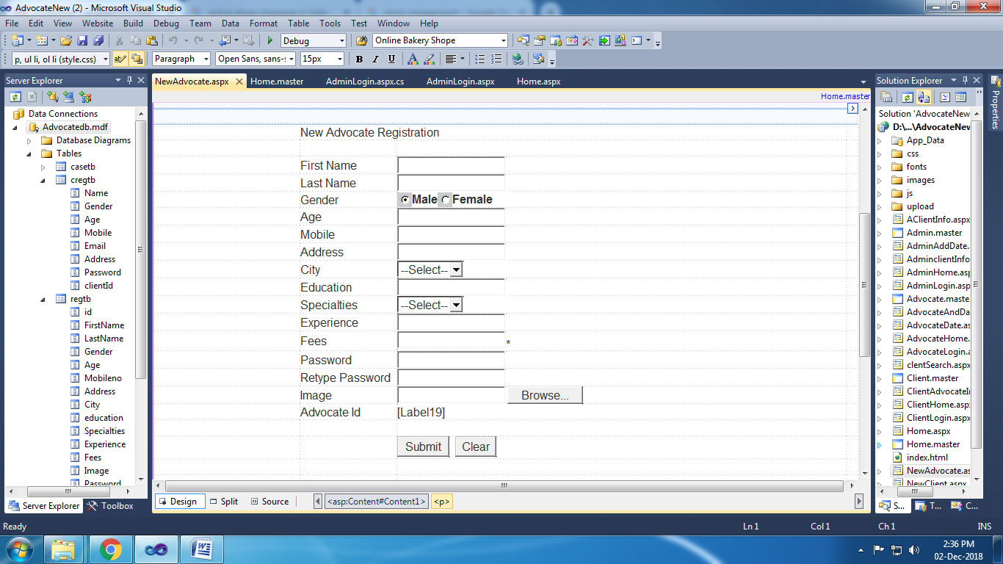

using System;

using System.Collections.Generic;

using System.Linq;

using System.Web;

using System.Web.UI;

using System.Web.UI.WebControls;

using System.Data;

using System.Data.SqlClient;

public partial class NewAdvocate : System.Web.UI.Page

{

SqlConnection con = new SqlConnection(@"Data Source=.\SQLEXPRESS;AttachDbFilename=|Datadirectory|\Advocatedb.mdf;Integrated Security=True;User Instance=True");

SqlCommand cmd;

protected void Page_Load(object sender, EventArgs e)

{

}

protected void Button1_Click(object sender, EventArgs e)

{

int i = 1;

con.Open();

cmd = new SqlCommand("select * from regtb", con);

SqlDataReader dr = cmd.ExecuteReader();

while (dr.Read())

{

i += 1;

}

con.Close();

Label19.Text = "ADVOCATEID00" + i;

string filename = System.IO.Path.GetFileName(FileUpload1.PostedFile.FileName);

FileUpload1.PostedFile.SaveAs(Server.MapPath("~/upload/" + filename));

string ss = "~/upload/" + filename;

cmd = new SqlCommand("insert into regtb values('" + TextBox1.Text + "','" + TextBox2.Text + "','" + RadioButtonList1.Text + "','" + TextBox3.Text + "','" + TextBox4.Text + "','" + TextBox5.Text + "','" + DropDownList1.Text + "','" +

TextBox6.Text + "','" + DropDownList2.Text + "','" + TextBox7.Text + "','" + TextBox8.Text + "','" + ss + "','" + TextBox9.Text + "','" + Label19.Text + "')", con);

con.Open();

cmd.ExecuteNonQuery();

con.Close();

Response.Write("<Script> alert('Record Save') </Script>");

}

protected void Button2_Click(object sender, EventArgs e)

{

TextBox1.Text = "";

TextBox2.Text = "";

TextBox3.Text = "";

TextBox4.Text = "";

TextBox5.Text = "";

TextBox6.Text = "";

TextBox7.Text = "";

TextBox8.Text = "";

TextBox9.Text = "";

TextBox10.Text = "";

}

}

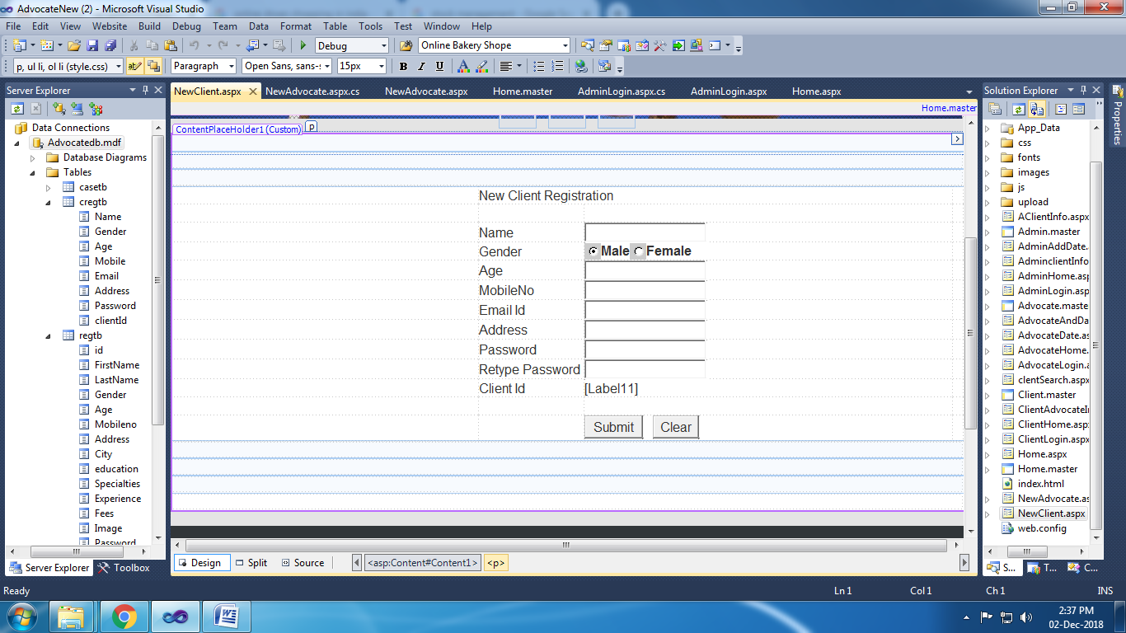

using System;

using System.Collections.Generic;

using System.Linq;

using System.Web;

using System.Web.UI;

using System.Web.UI.WebControls;

using System.Data;

using System.Data.SqlClient;

public partial class NewClient : System.Web.UI.Page

{

SqlConnection con = new SqlConnection(@"Data Source=.\SQLEXPRESS;AttachDbFilename=|Datadirectory|\Advocatedb.mdf;Integrated Security=True;User Instance=True");

SqlCommand cmd;

protected void Page_Load(object sender, EventArgs e)

{

}

protected void Button1_Click(object sender, EventArgs e)

{

int i = 1;

con.Open();

cmd = new SqlCommand("select * from cregtb", con);

SqlDataReader dr = cmd.ExecuteReader();

while (dr.Read())

{

i += 1;

}

con.Close();

Label11.Text = "CLIENT00" + i;

cmd = new SqlCommand("insert into cregtb values('" + TextBox1.Text + "','" + RadioButtonList1.Text + "','" + TextBox2.Text + "','" + TextBox3.Text + "','" + TextBox4.Text + "','" + TextBox5.Text + "','" + TextBox6.Text + "','" + Label11.Text + "')", con);

con.Open();

cmd.ExecuteNonQuery();

con.Close();

Response.Write("<Script> alert('Record Saved!') </Script>");

}

protected void Button2_Click(object sender, EventArgs e)

{

TextBox1.Text = "";

TextBox2.Text = "";

TextBox3.Text = "";

TextBox4.Text = "";

TextBox5.Text = "";

TextBox6.Text = "";

TextBox7.Text = "";

}

}

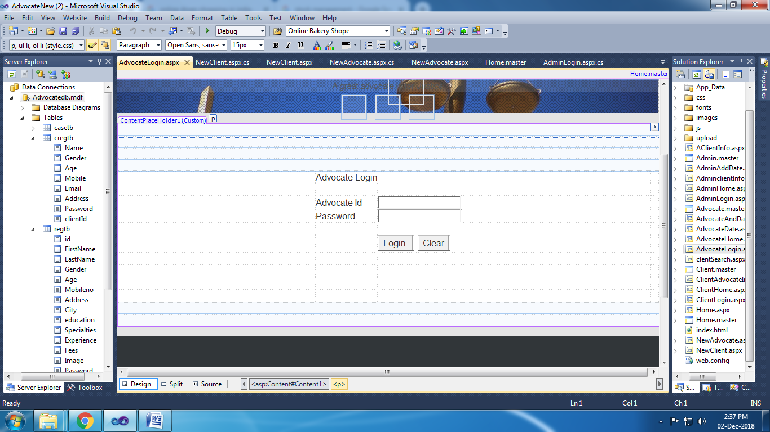

using System;

using System.Collections.Generic;

using System.Linq;

using System.Web;

using System.Web.UI;

using System.Web.UI.WebControls;

using System.Data.SqlClient;

public partial class AdvocateLogin : System.Web.UI.Page

{

SqlConnection con = new SqlConnection(@"Data Source=.\SQLEXPRESS;AttachDbFilename=|Datadirectory|\Advocatedb.mdf;Integrated Security=True;User Instance=True");

SqlCommand cmd;

protected void Page_Load(object sender, EventArgs e)

{

}

protected void Button1_Click(object sender, EventArgs e)

{

con.Open();

cmd = new SqlCommand("select * from regtb where Advocatid='" + TextBox1.Text + "' and Password='" + TextBox2.Text + "'", con);

SqlDataReader dr = cmd.ExecuteReader();

if (dr.Read())

{

Session["im"] = dr["Image"].ToString();

Session["Aid"] = TextBox1.Text;

Response.Redirect("AdvocateHome.aspx");

}

else

{

Response.Write("<Script> alert('Password Mismatch!') </Script>");

}

con.Close();

}

}

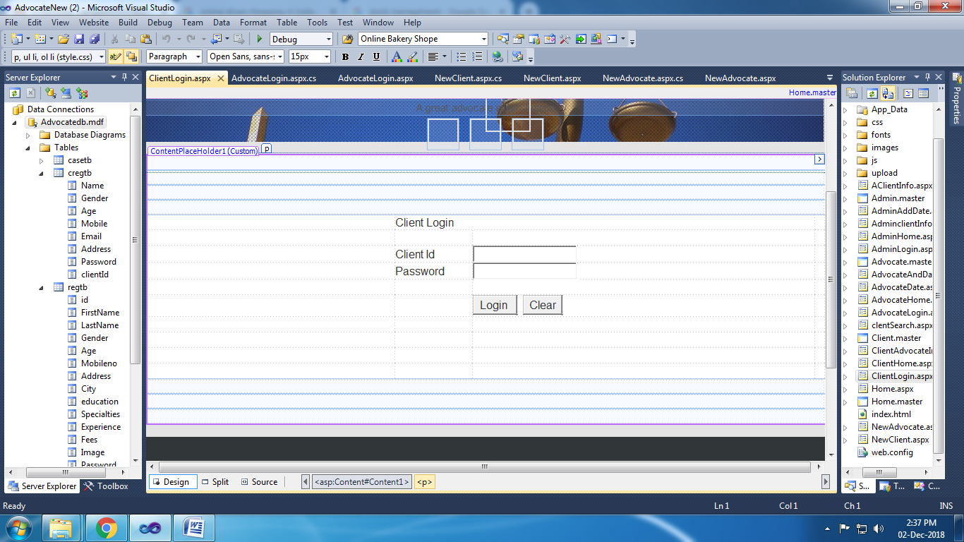

using System;

using System.Collections.Generic;

using System.Linq;

using System.Web;

using System.Web.UI;

using System.Web.UI.WebControls;

using System.Data;

using System.Data.SqlClient;

public partial class ClientLogin : System.Web.UI.Page

{

SqlConnection con = new SqlConnection(@"Data Source=.\SQLEXPRESS;AttachDbFilename=|Datadirectory|\Advocatedb.mdf;Integrated Security=True;User Instance=True");

SqlCommand cmd;

protected void Page_Load(object sender, EventArgs e)

{

}

protected void Button1_Click(object sender, EventArgs e)

{

con.Open();

cmd = new SqlCommand("select * from cregtb where clientId='" + TextBox1.Text + "' and Password='" + TextBox2.Text + "'", con);

SqlDataReader dr = cmd.ExecuteReader();

if (dr.Read())

{

Session["cid"] = TextBox1.Text;

Response.Redirect("ClientHome.aspx");

}

else

{

Response.Write("<Script> alert('Password Mismatch!') </Script>");

}

con.Close();

}

}