|  |  |
| --- | --- |
| **Name** | **SUGANYA J** |
| **Enrollment No** | **2482100270** |
| **Subject** | **Java Programming** |
| **Program Name** | **MCA** |
| **Year/Semester** | **2021-22 / Semester Two** |

**GREATEST OF THE GIVEN NUMBER**

PROGRAM 1

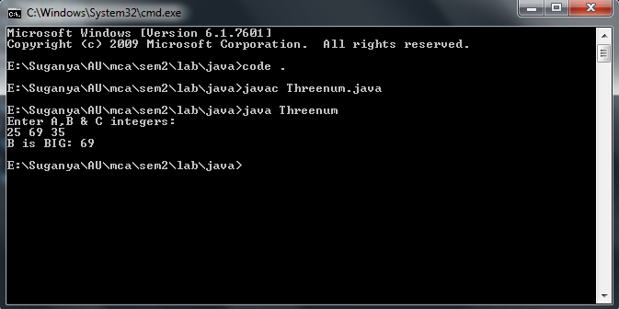

**PYRAMID FORMAT DESIGN**

PROGRAM 2

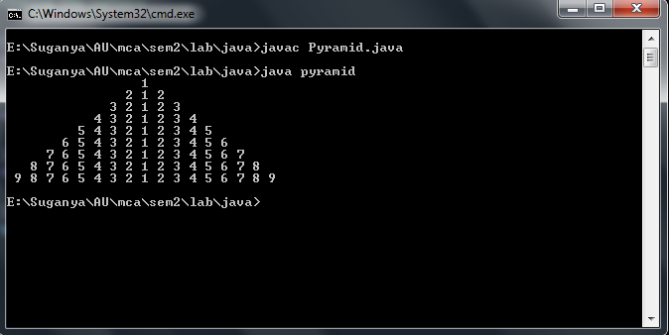

**PROGRAM FOR INTERFACE**

PROGRAM 3

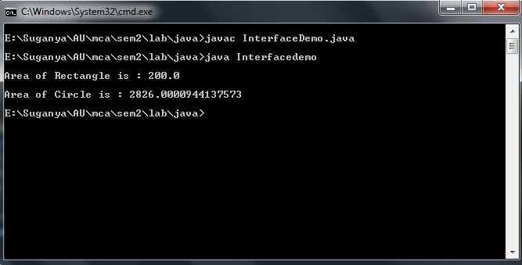

**APPLET**

PROGRAM 4

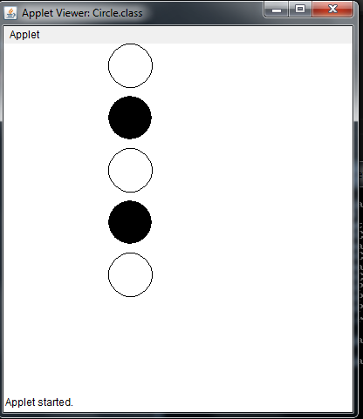

**CHECKBOX CONTROL IN AWT**

PROGRAM 5

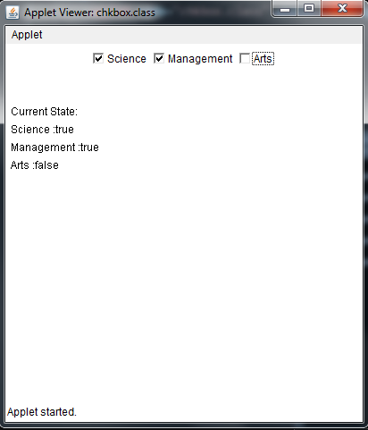

**CONTENT COPY FROM ONE FILE TO ANOTHER**

PROGRAM 7

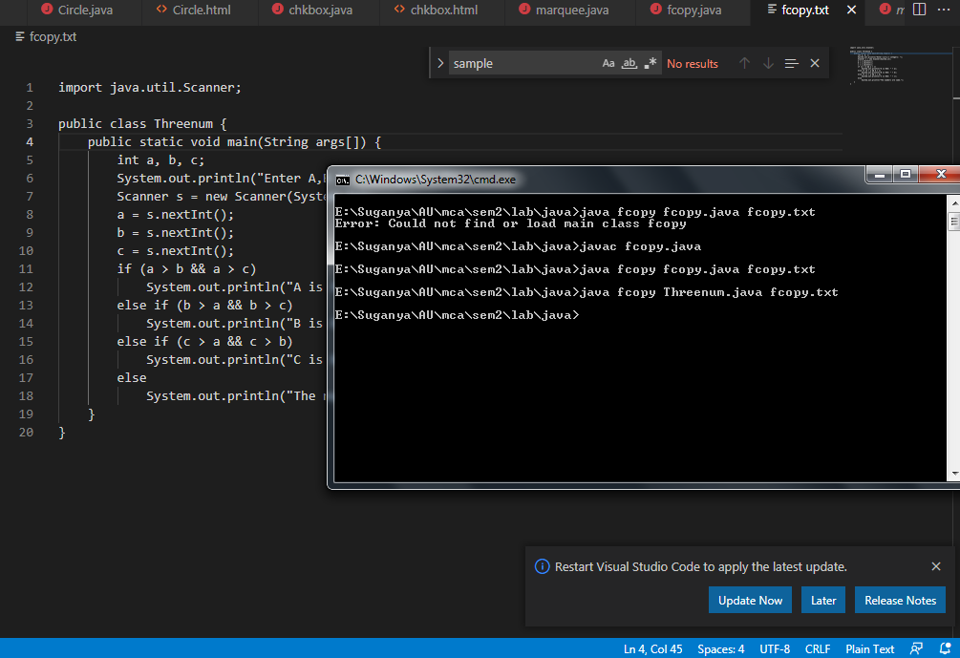

**PROGRAMS TO CREATE MULTIPLE THREADS**

PROGRAM 8

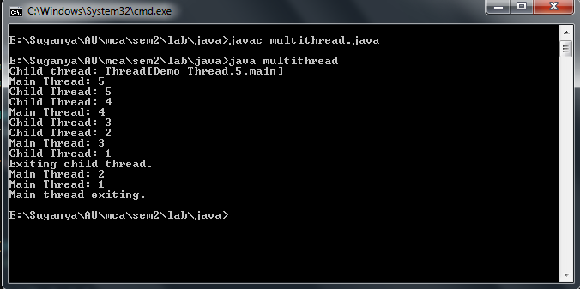

**PROGRAM TO DISPLAY URL AND IP DETAILS**

PROGRAM 9

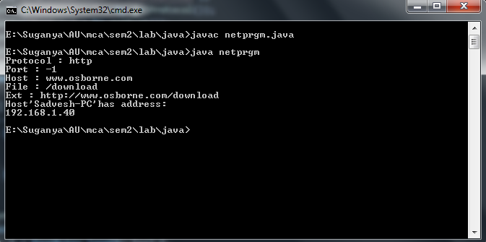

**SWING PROGRAM USING TABBED PANEL**

PROGRAM 10

