|  |  |
| --- | --- |
| **Name** | **SUGANYA J** |
| **Enrollment No** | **2482100270** |
| **Subject** | **IMAGE PROCESSING LAB** |
| **Program Name** | **MCA** |
| **Year/Semester** | **2021-22 / Semester Two** |

**CONVERT IMAGE INTO INTENSITY VALUE ARRAY**

PROGRAM 1

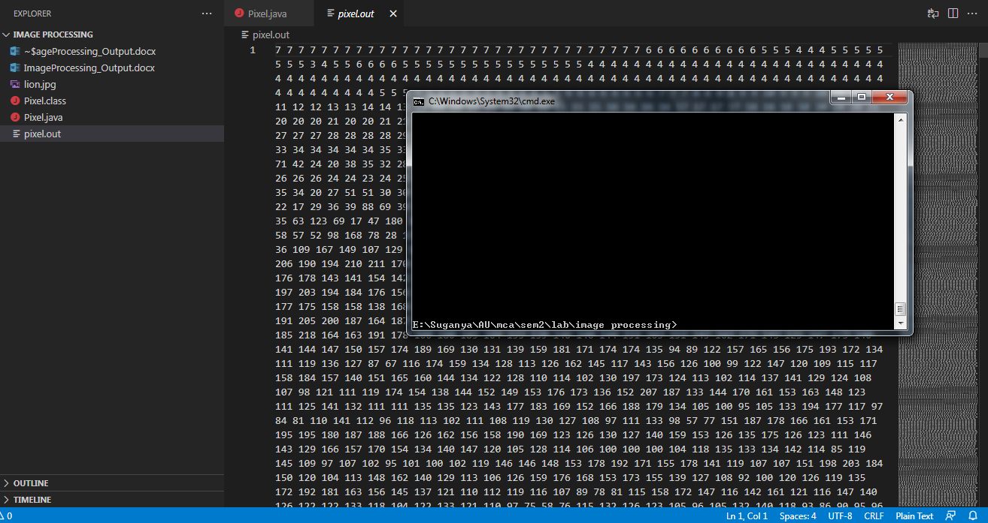

**CONVERT COLOR IMAGE INTO GRAYSCALE IMAGE**

PROGRAM 2

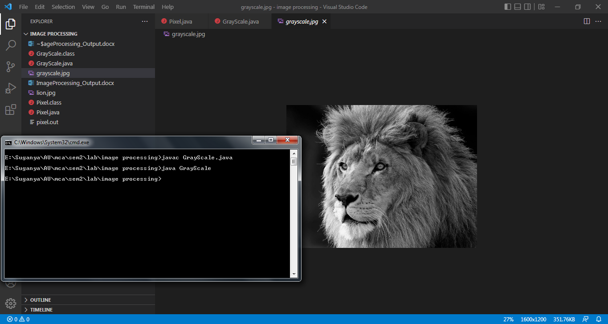

**CONVERT NEGATIVE IMAGE**

PROGRAM 3

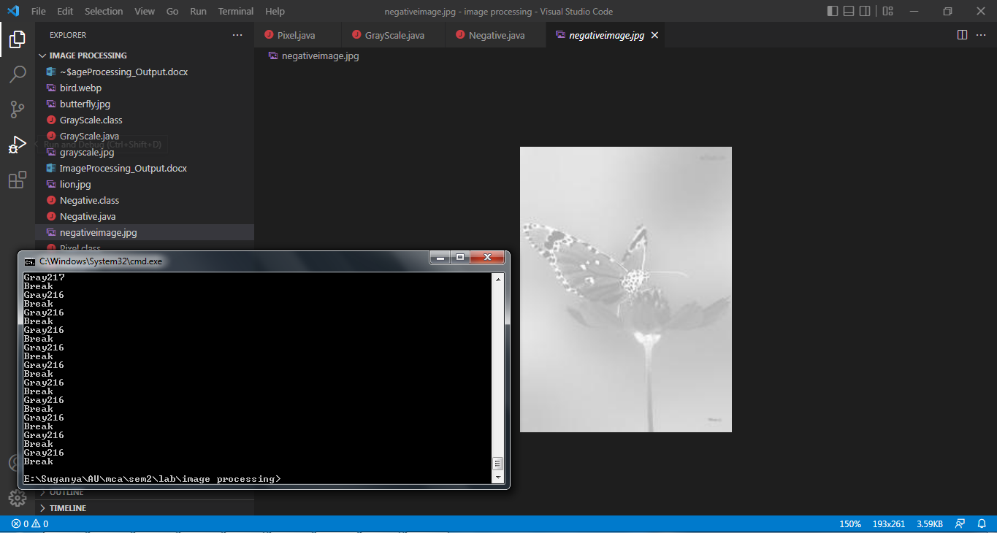

**SMOOTHING OPERATIONS ON AN IMAGE IN SPATIAL DOMAIN**

PROGRAM 4

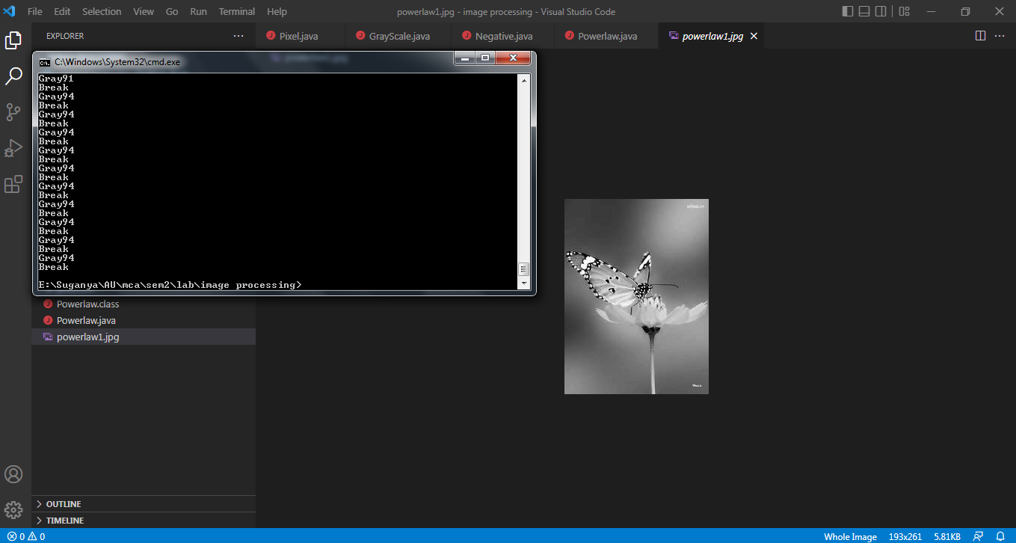

**SHARPENING OPERATIONS ON AN IMAGE IN SPATIAL DOMAIN**

PROGRAM 5

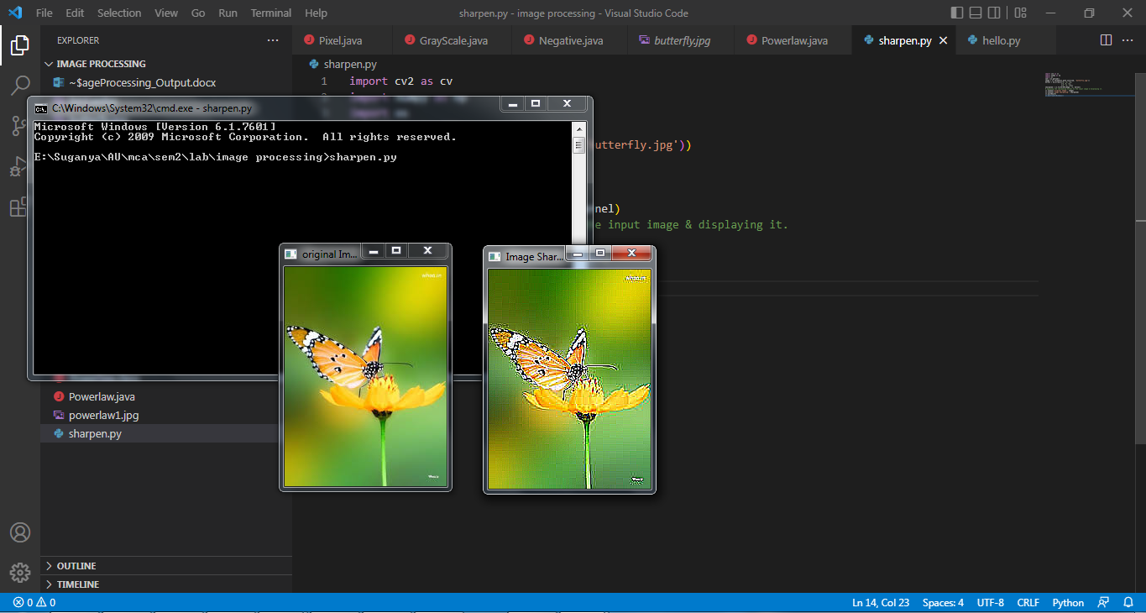

**TRANSFORM THE IMAGE INTO FOURIER TRANSFORM**

PROGRAM 6

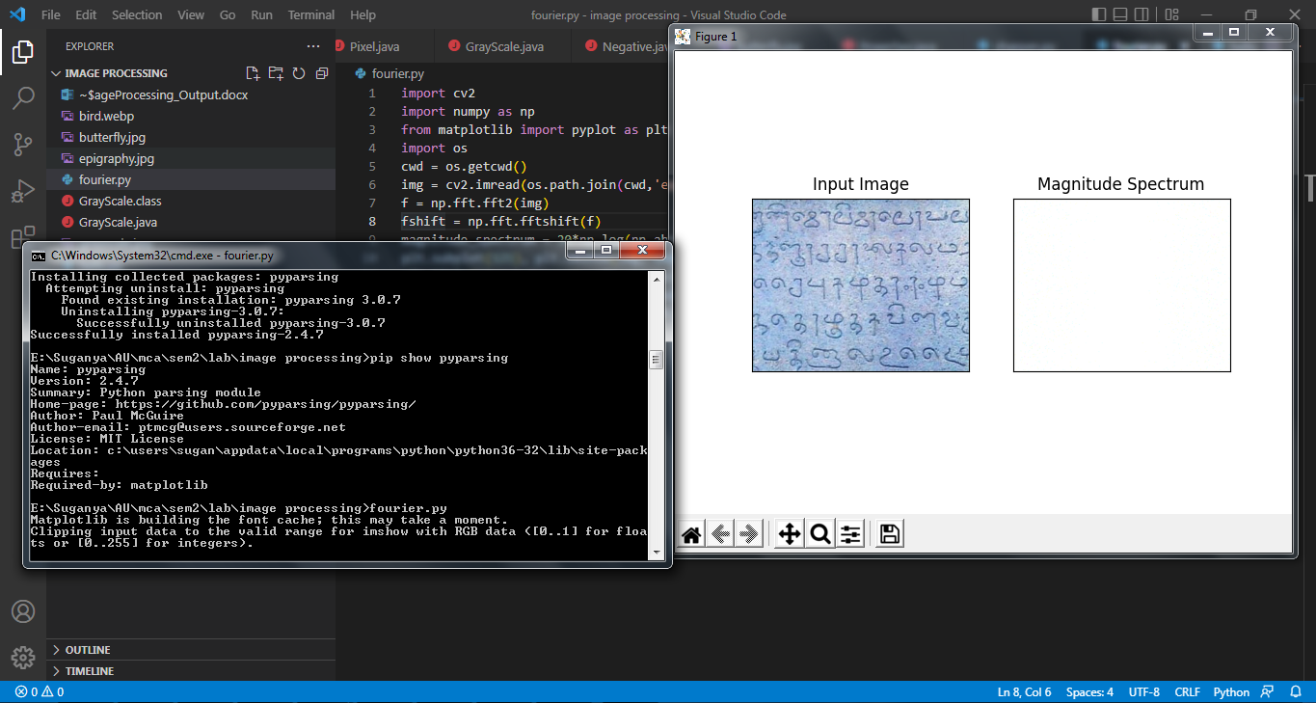

**PERFORMANCE OF GRADIENT OPERATIONS**

PROGRAM 7

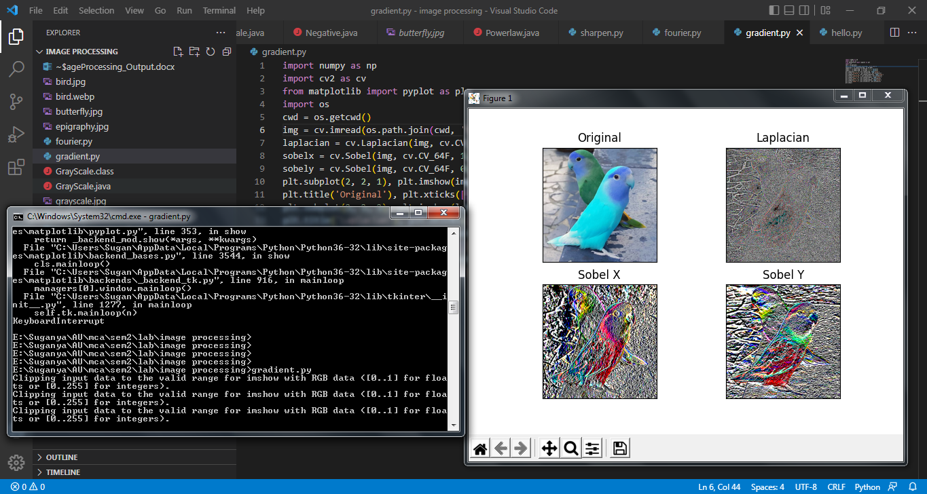

**PERFORM DCT IMAGE COMPRESSION METHOD**

PROGRAM 8

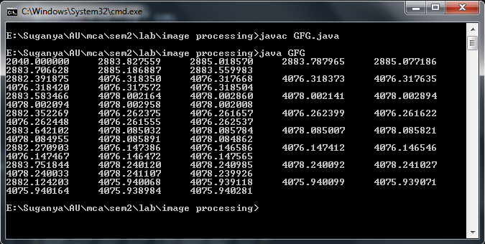

**IMAGE SEGMENTATION BASED ON COLOR**

PROGRAM 9

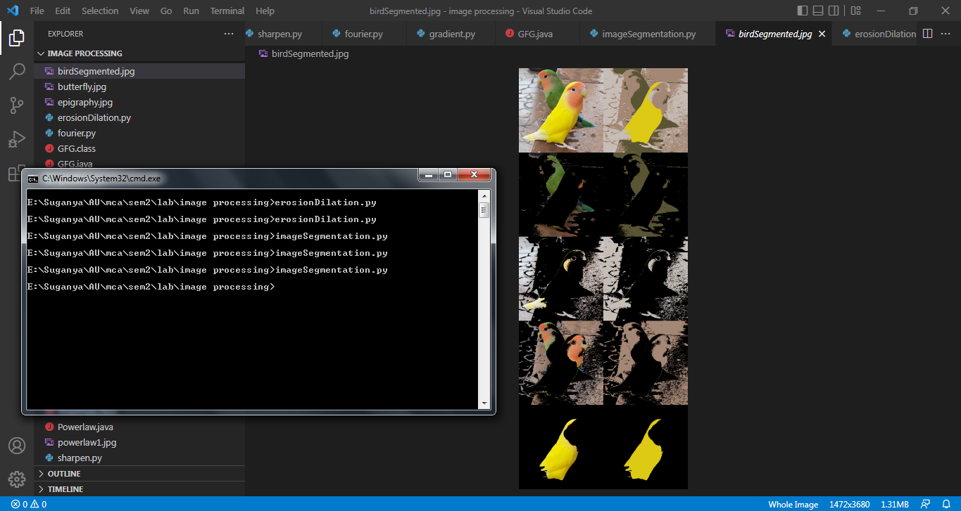

**EROSION AND DILATION OPERATIONS ON IMAGE**

PROGRAM 10

