|  |  |
| --- | --- |
| **Name** | **SUGANYA J** |
| **Enrollment No** | **2482100270** |
| **Subject** | **PHYTHON AND R PROGRAMMING** |
| **Program Name** | **MCA** |
| **Year/Semester** | **2022-23 / Semester Three** |

**PHYTHON PROGRAM TO CHECK IF A NUMBER IS POSITIVE, NEGATIVE OR ZERO**

PROGRAM 1

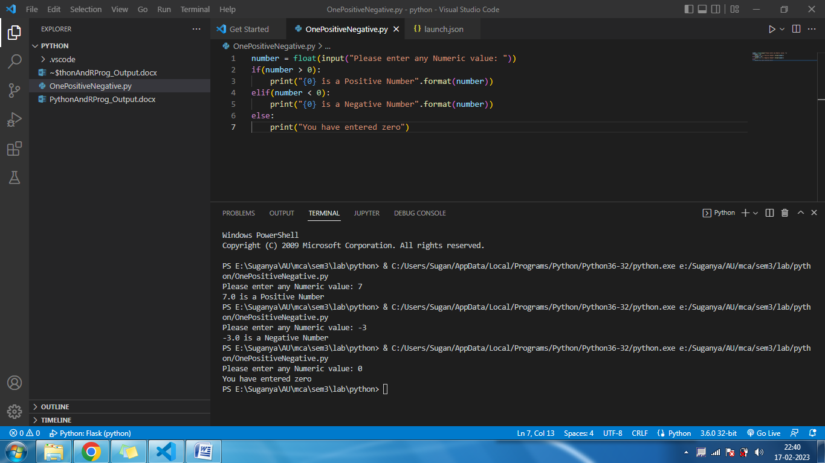

**PHYTHON PROGRAM TO CHECK PRIME NUMBERS**

PROGRAM 2

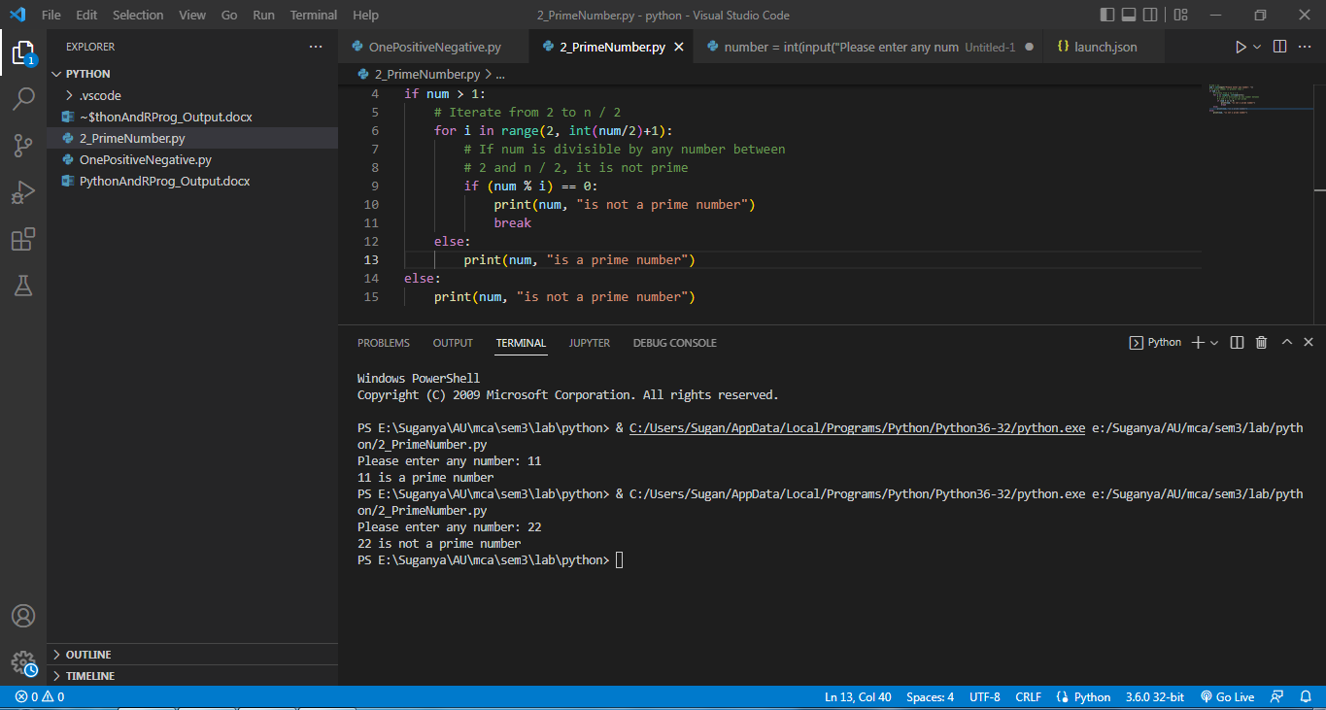

**PHYTHON PROGRAM TO CHECK ARMSTRONG NUMBER**

PROGRAM 3

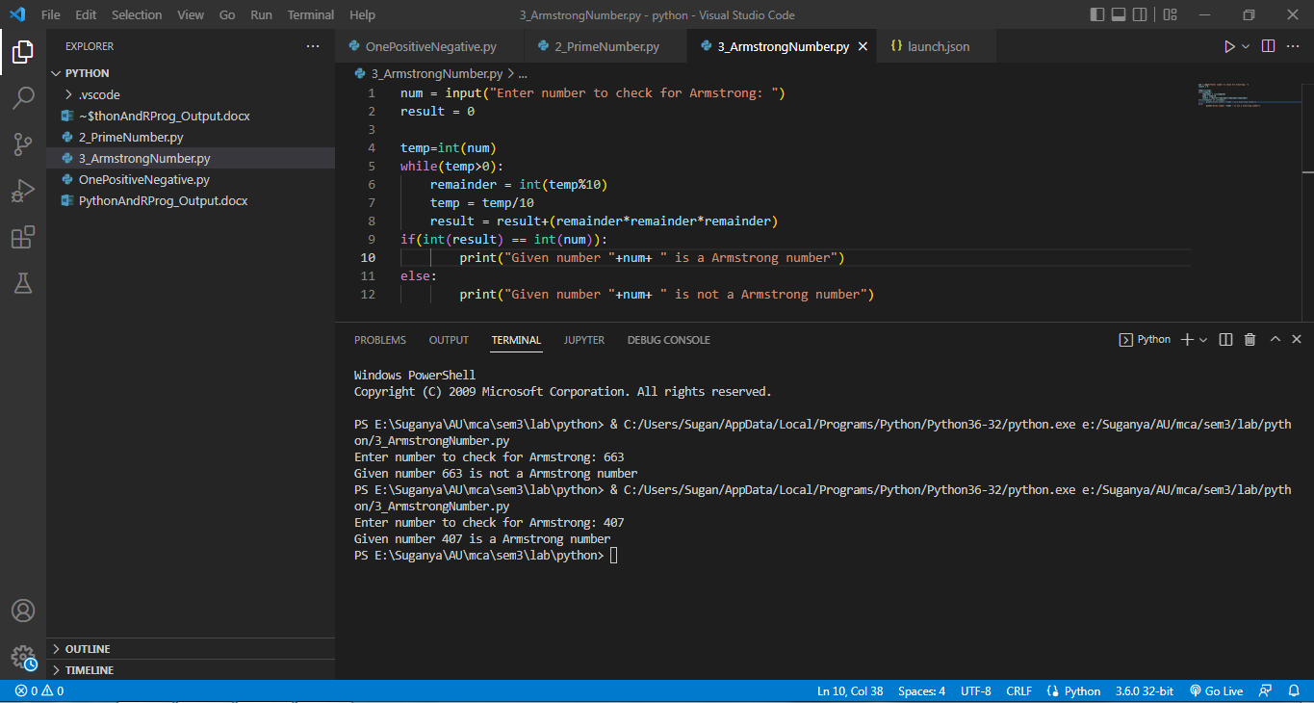

**PHYTHON PROGRAM TO FIND HASH OF FILE**

PROGRAM 4

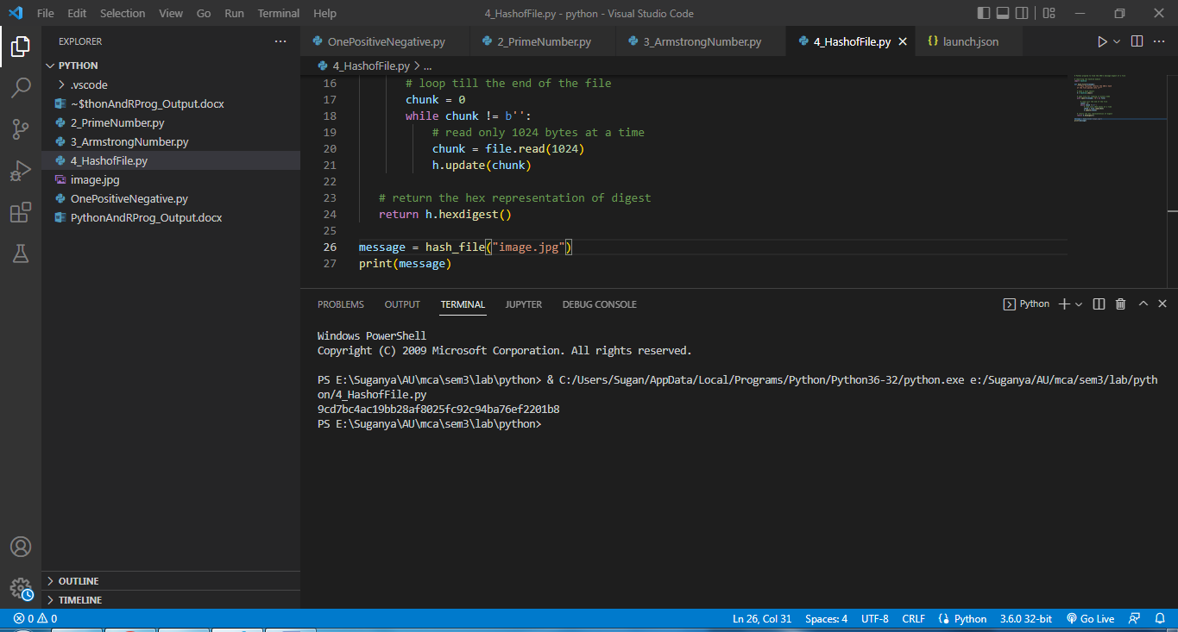

**PHYTON PROGRAM TO ROOT SEARCH**

PROGRAM 5

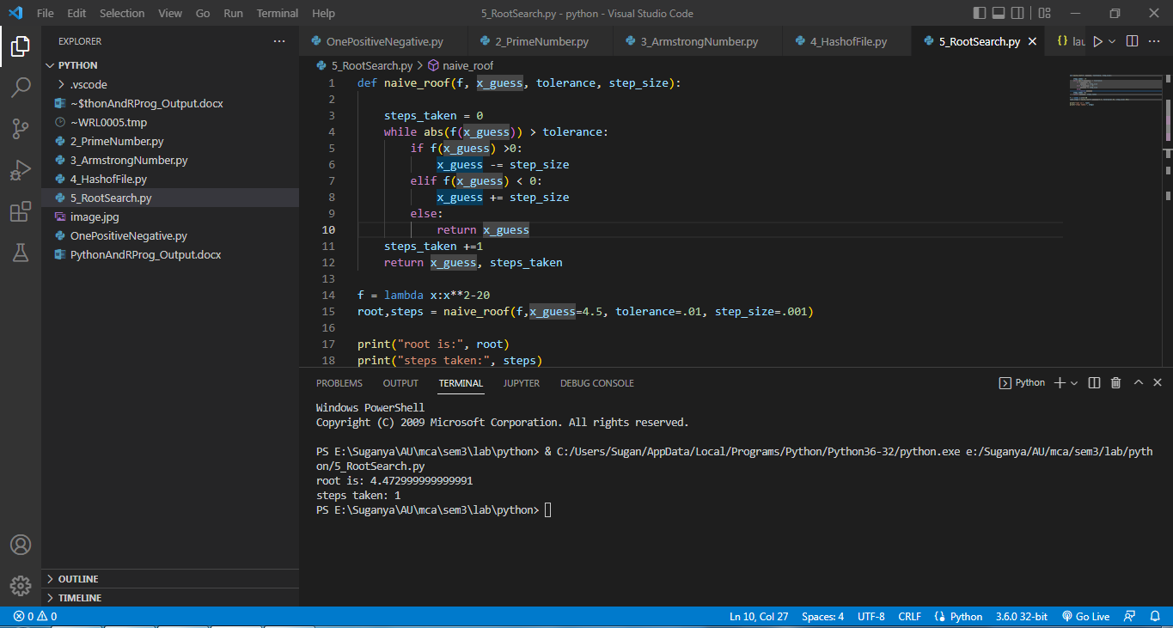

**PHYTHON PROGRAM TO CHECK IF A NUMBER IS ODD OR EVEN**

PROGRAM 6

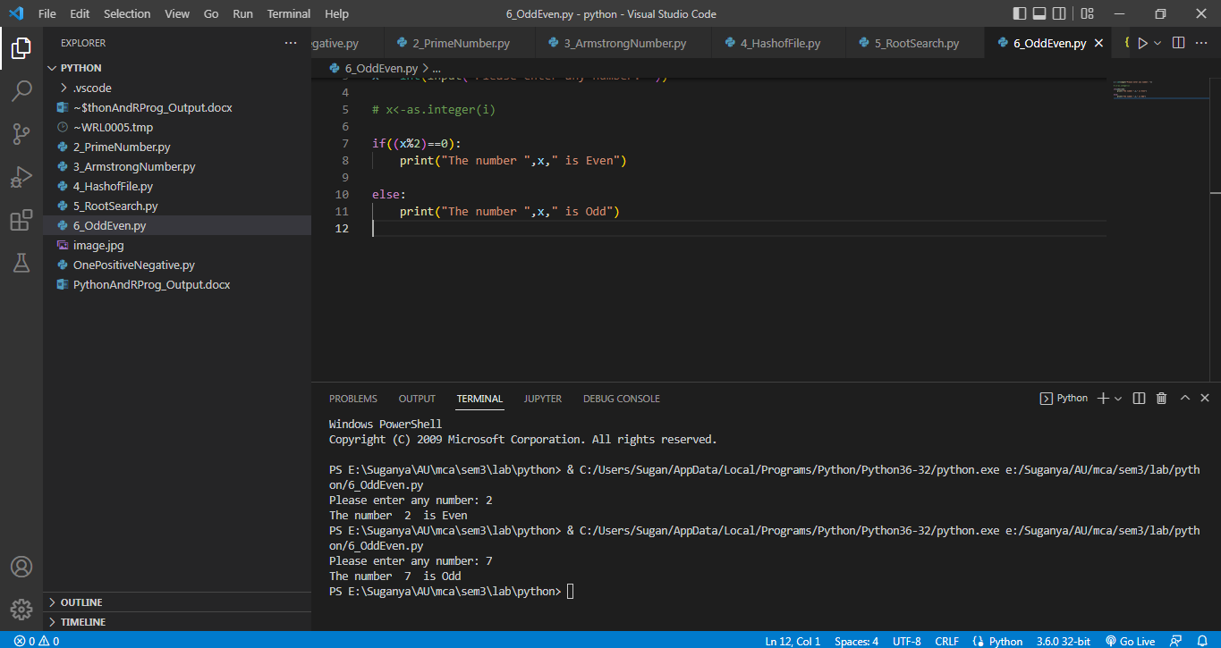

**R-PROGRAM TO FIND THE FACTORS OF A NUMBER**

PROGRAM 7

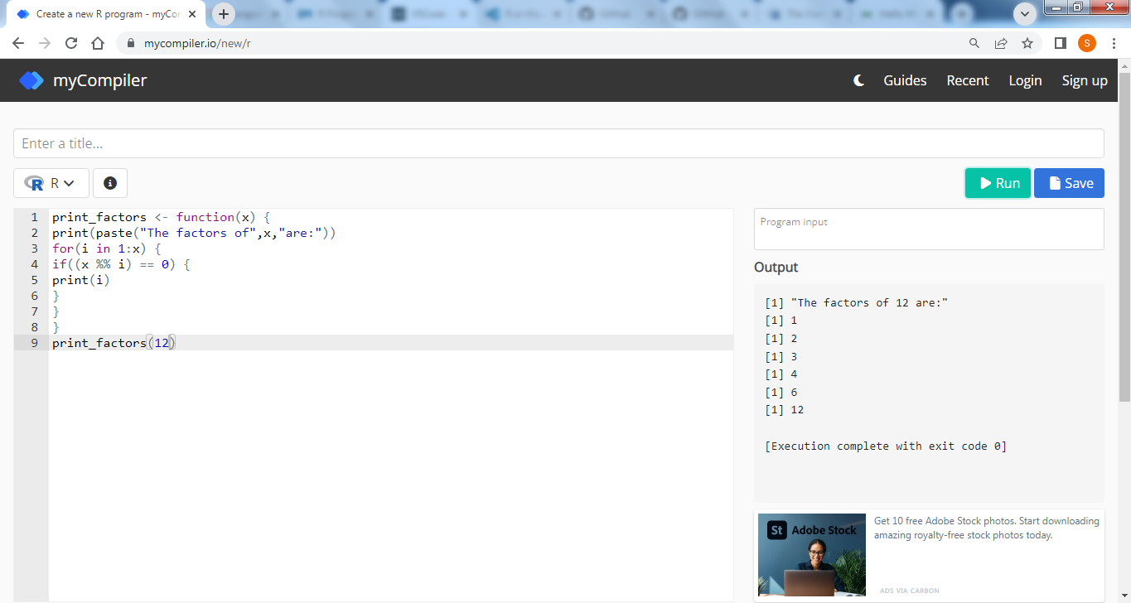

**R-PROGRAM TO CONVERT DECIMAL INTO BINARY USING RECURSION**

PROGRAM 8

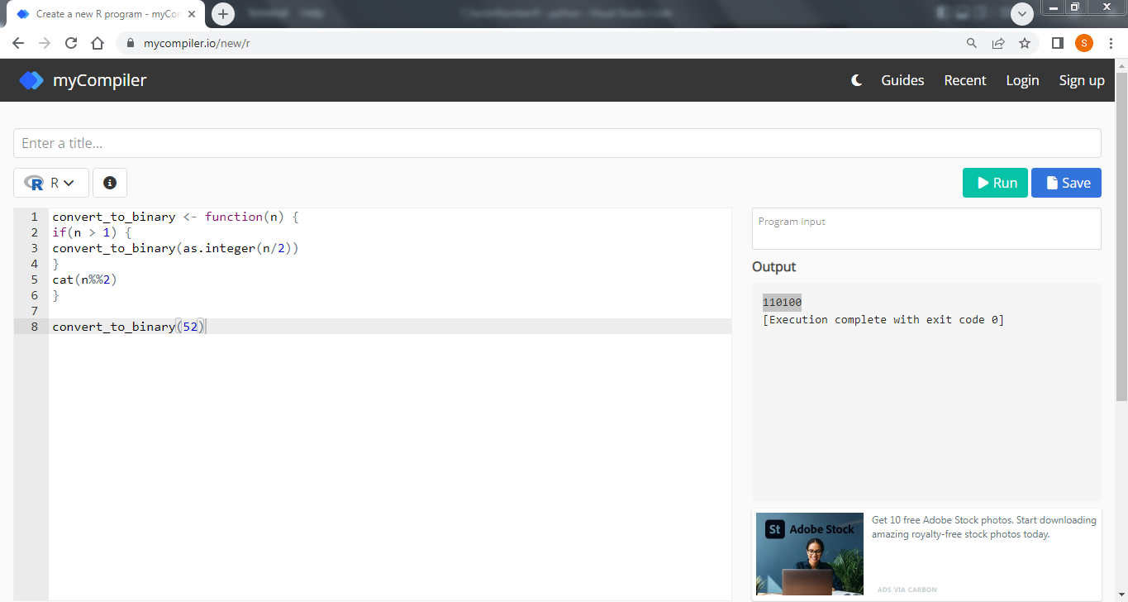

**R-PROGRAM TO FIND FIBONACCI SEQUENCE USING RECURSION**

PROGRAM 9

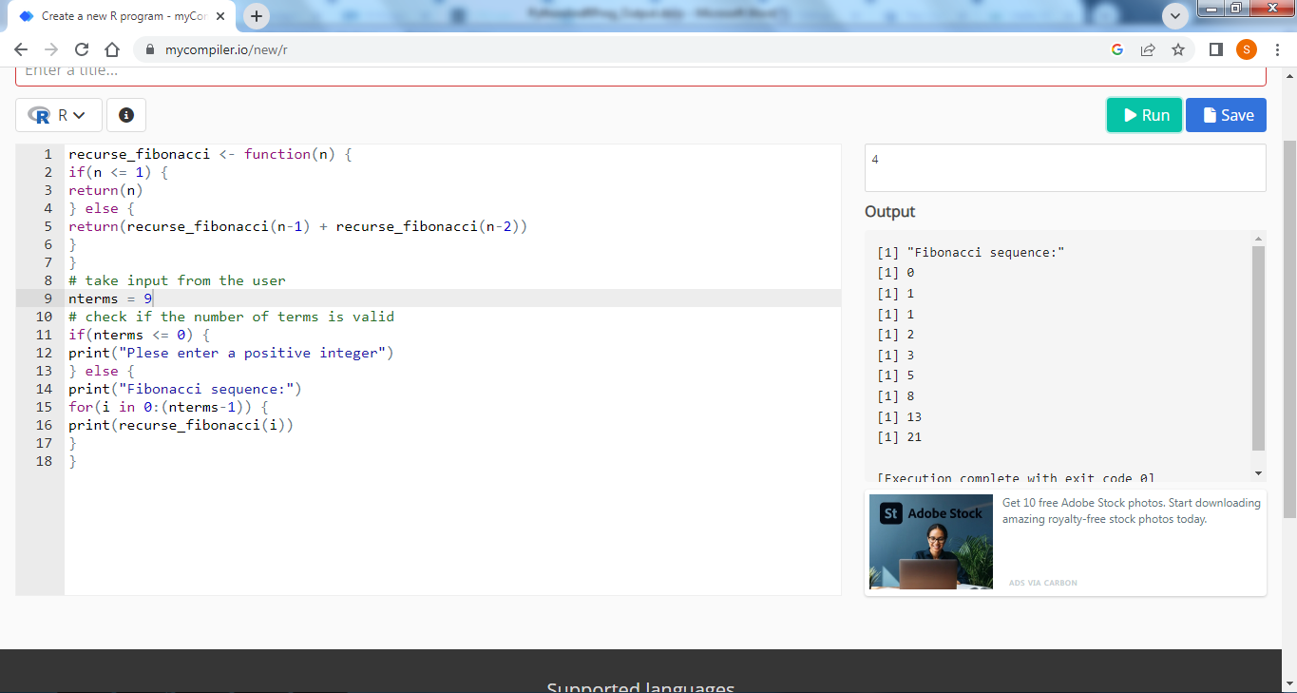

**R-PROGRAM TO FIND THE FACTORIAL OF A NUMBER USING RECURSION**

PROGRAM 10

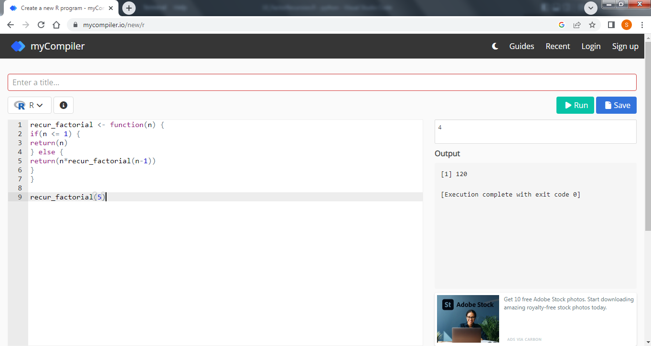

**INSERSION SORT**

PROGRAM 11

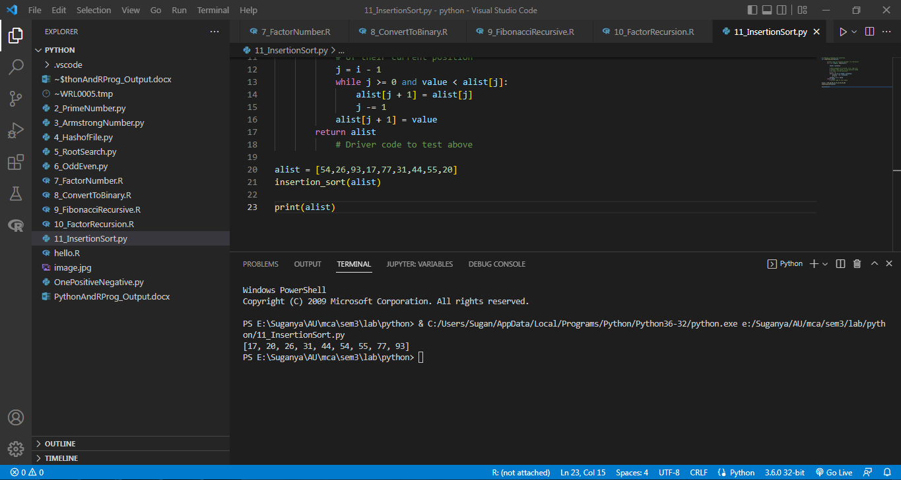

**EXPONENTIATION (POWER OF A NUMBER)**

PROGRAM 12

