|  |  |
| --- | --- |
| **Name** | **SUGANYA J** |
| **Enrollment No** | **2482100270** |
| **Subject** | **MOBILE APPLICATION DEVELOPMENT** |
| **Program Name** | **MCA** |
| **Year/Semester** | **2022-23 / Semester Three** |

**BUTTON, TEXT VIEW, EDIT TEXT**

PROGRAM 1

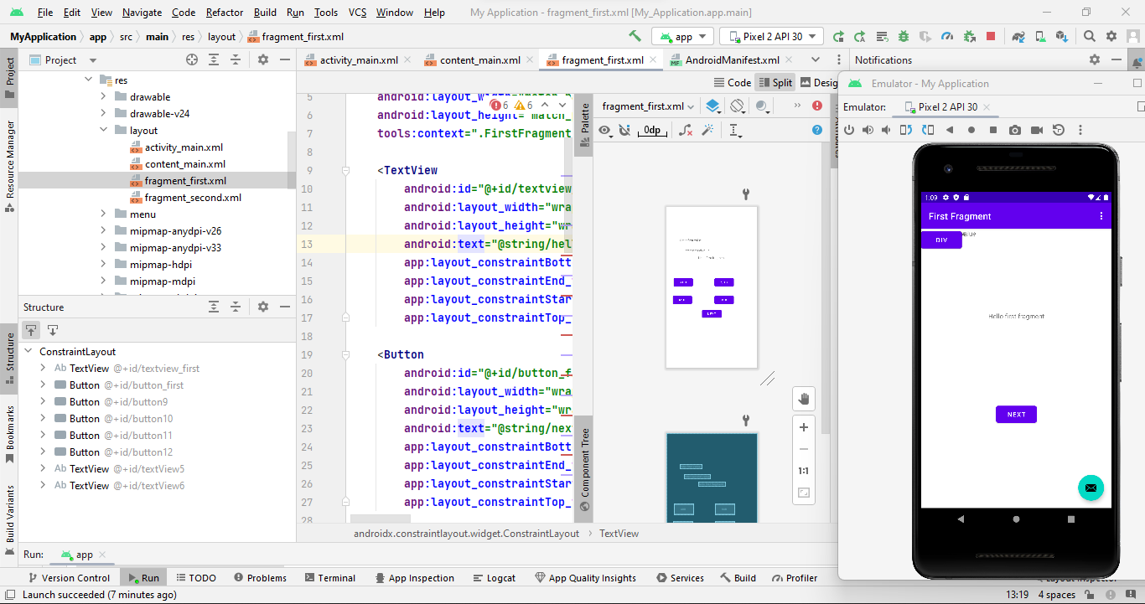

**RADIO BUTTON, RADIO GROUP**

PROGRAM 2

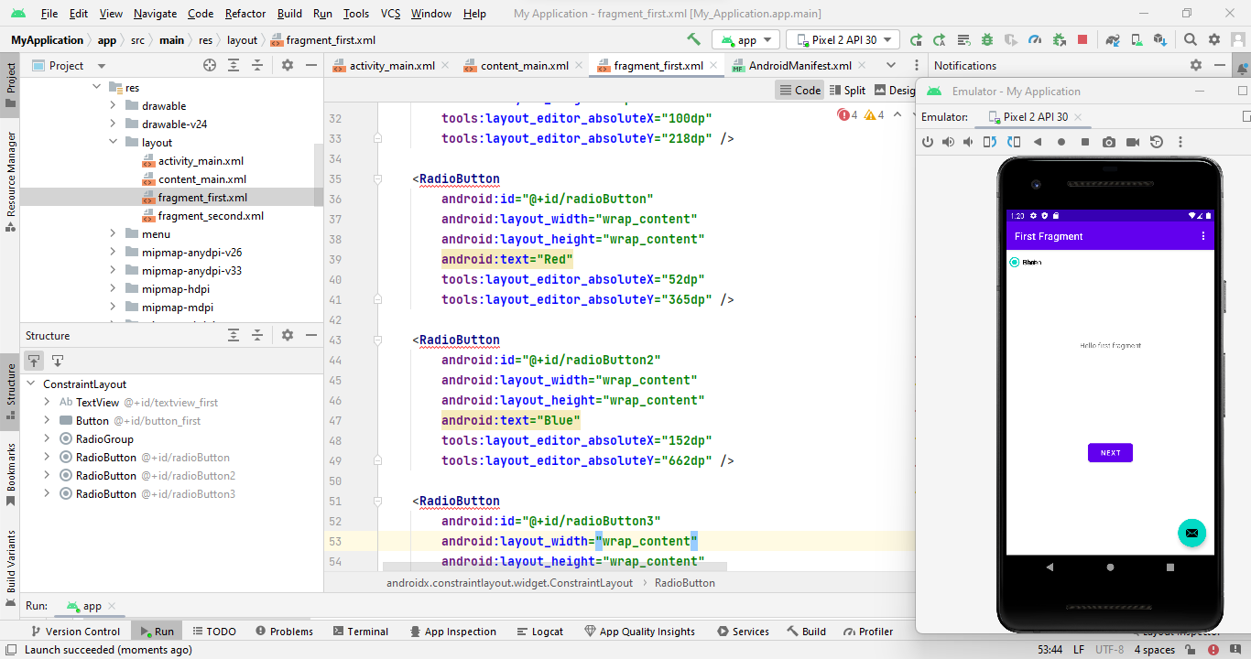

**CHECKBOX**

PROGRAM 3

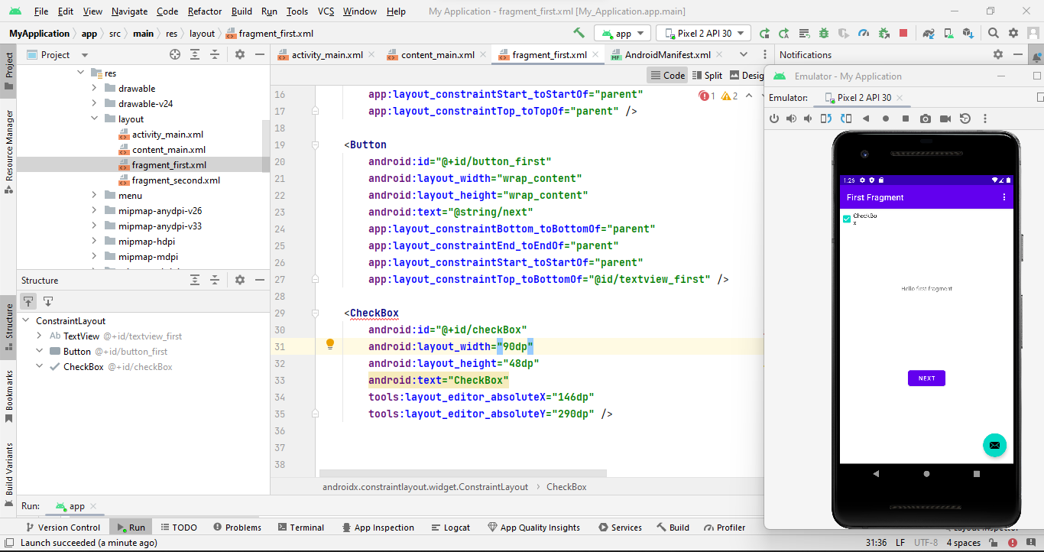

**DIALOG BOX**

PROGRAM 4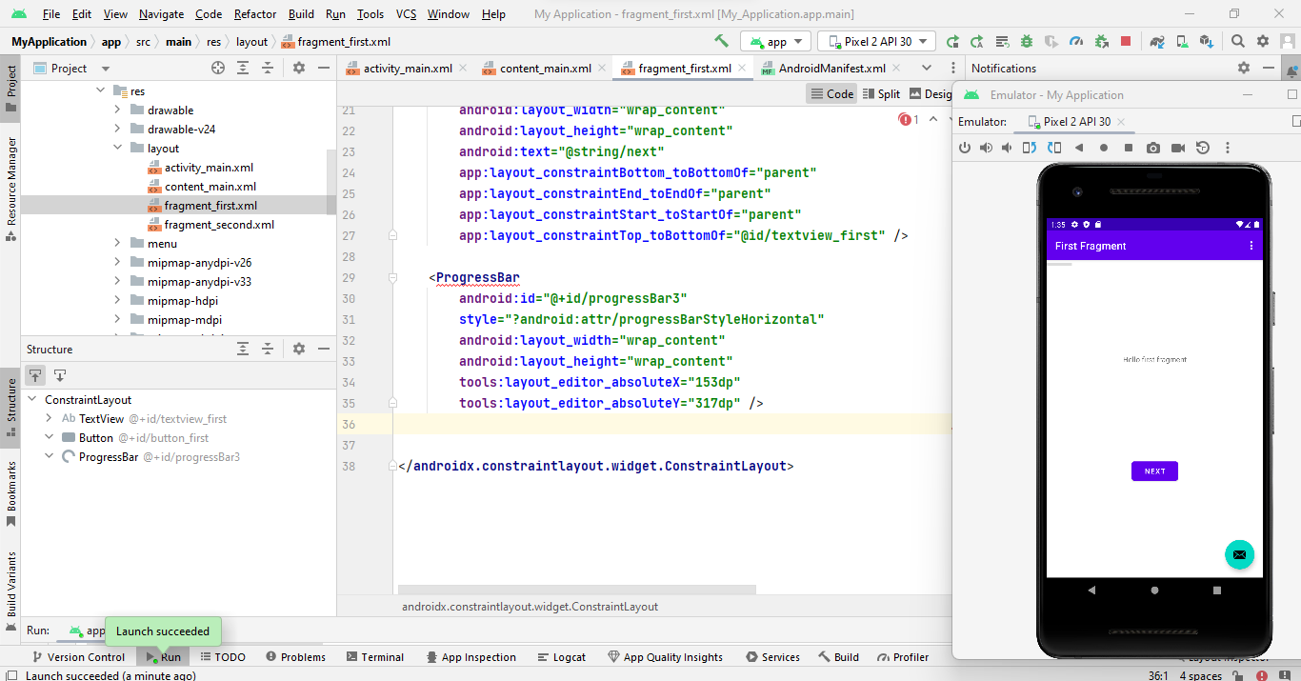

**DATE PICKER**

PROGRAM 5

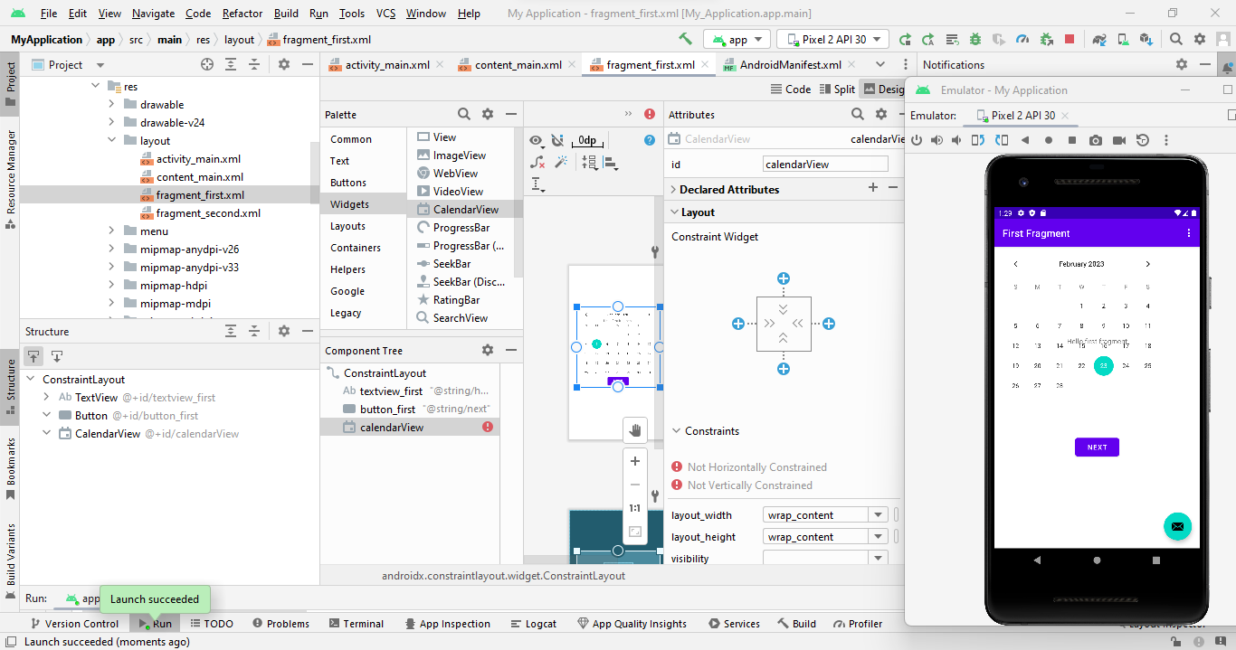

**PROGRESS BAR**

PROGRAM 6



**SPINNER**

PROGRAM 7

