ArchitecturE document
for
ITSS

Table of Contents
1. Document History 3
1.1. Revision History 3
1.2. Review and Approval 3
2. Introduction 4
2.1. System Overview 4
2.2. Definitions, Acronyms and Abbreviations 4
2.3. Architecture Strategies and Alternatives 5
2.3.1. Architectural Frameworks 5
2.3.1.1. JBoss Application Server 5
2.3.1.2. Spring – Lightweight Application Framework 5
2.3.1.3. Hibernate – Object-Relational Mapping Framework 6
2.3.1.4. JSF – Presentation layer framework 7
2.3.1.5. Security Framework (Spring NTLM) 8
3. Architecture Overview 9
3.1. Introduction 9
3.2. System Architecture Context Diagram 10
3.3. Directory Structure 11

- Document History

Revision History

Version | Date | Change Description
0.1 | 6/27/2011 | First draft

Review and Approval

Version | Date | Name | Author | Review | Approve
- Introduction

System Overview
ITSS is a simple web application which acts as an interface for the ITSM. It will be used by Natixis Associate to register Service Request with Tech Support. The system will interact with ITSM to create the incident. The system will pass an ID to the source field in ITSM to indicate the service request was received from ITSS. This system will be a link in the Global Net.

ITSS is intended to reduce the work of tech support. Since ITSM is high end tool and it is not understood by the business users it is not easy to create the incident. Tech support receives 700 and 1100 emails every month in which 75% of them are converted to ITSM incidents. This creates duplication effort and incorrect resource addressing issue. The Objective of this project is to reduce the inbound traffic to Tech support email box. Reduce the Tech Support time in creating ITSM incidents and put request control in the hand of the customer.

Definitions, Acronyms and Abbreviations

Sl No | Abbreviation/Definition | Explanation
 | ITSS | Information Technology Self Service
 | RIA | Rich Internet Application
 | AJAX | Asynchronous Javascript and XML
 | JMS | Java Messaging Service
 | XML | Extensible Markup Language
 | JBossAS | JBoss Application Server
 | POJO | Plain Old Java Objects
 | JDO | Java Data Objects
 | DAO | Data Access Objects
 | ORM | Object-Relational Mapping
 | JDBC | Java Database Connectivity
 | SQL | Structured Query Language
 | LDAP | Lightweight Directory Access Protocol
 | SSO | Single-Sign On
 | VO | Value Objects
 | JSF | Java Server Faces

Architecture Strategies and Alternatives

Architectural Frameworks

JBoss Application Server
JBoss is used as the J2EE application server for the system development/deployment. JBoss application server is an Open Source, standards compliant, J2EE application server implemented in 100% pure Java. JBossAS provides the full range of J2EE 1.4 features as well as extended enterprise services such as, clustering, caching, persistence, monitoring etc.

Spring – Lightweight Application Framework
The Spring Framework is an open-source lightweight Aspect-Oriented programming-based application container capable of providing application infrastructure services such as Service location, Interception, Invocation, Transaction Management, etc., using external configuration mechanisms. It is preferable to co-locate all closely related application components in a single server, to avoid costly remote calls between different layers of the application. This will minimize the complexity introduced by any remoting infrastructure and a distributed programming model. Logical layering is usually far more important than physical layering. However, provision for a separate physical web-tier can be decided on a case-by-case basis and will have minimal impact on the existing code base.

ITSS system is being developed using an iterative development model, which means that during every phase, new features are being added and earlier ones enhanced or re-factored. This necessitates a good and reliable application framework, which is less intrusive and provides maximum flexibility and modifiability. Ease of Unit testing is also a major factor here.

The Spring Framework also provides the following developmental and infrastructural advantages:

- Spring is a non-invasive framework. Whereas traditional frameworks such as EJB or Apache Avalon force application code to be aware of the framework by implementing framework-specific interfaces or extending framework- specific classes, the Spring Framework aims to minimize the dependence of application code on the framework.

- Lock-in to the Spring Framework is minimized. For example, we could migrate to another lightweight container, or possibly even reuse application objects in an EJB 3.0 –based container, which supports a subset of the Spring Framework’s Dependency Injection capability.

- Migration to future versions of the Spring Framework is easier since the business logic and associated code does not have a tight coupling with the framework.

- Spring aims to promote code reuse and aids in avoiding the need to make some important hard design and implementation decisions up front, like whether the application will use JTA or JNDI. Spring abstractions also allow easy deployment of code to different environments if required.

- Spring enables deferral of architectural choices, potentially delivering benefits such as the need to purchase an application server license only when you know exactly what your platform requirements are, following tests of throughput and scalability.

- Spring aims to facilitate Object-Oriented Design (OOD) in J2EE applications. Spring aims to remove some of the impediments of traditional OO designs. Spring aims to facilitate good programming practice, such as programming to interfaces, rather than classes.

- Spring facilitates the extraction of configuration values from Java code into XML or property files. Spring encourages developers to externalize configuration parameters that might otherwise have been inappropriately hard-coded in Java source code. More configurable code is typically more maintainable and reusable.

- The Spring Framework is an open-source project and hence free of cost.

- The Spring Framework provides good integration support to the Hibernate frameworks.

Hibernate – Object-Relational Mapping Framework
Database access would be implemented using an open source Object Relational Mapping (ORM) product called Hibernate. Hibernate provides a POJO-based access path to a relational database and hides the complexities of using JDBC. Hibernate features include intelligent loading and caching of data and automatic generation of complex join queries to optimally retrieve the data. It also provides a programmer-friendly and extensible API.
The decision to use Hibernate as the database access mechanism is influenced by the following factors:

1. Usage of an OR Mapping framework greatly simplifies design and development of object-oriented applications which depend extensively on Relational databases for persistent storage. Most developers are not skilled in writing complex SQL queries and understanding JDBC-related nuances. Hibernate hides the relational aspects of accessing data and allows developers to focus on object-oriented concepts and abstractions. Usage of the Spring Framework (which provides infrastructure to manage transactions) further shields the developers from the relational access complexities.

2. Usage of Entity EJBs was found to be far too complex for an application of this nature. In addition, EJB 3.0 has basically adopted the Hibernate database access methodology and has discontinued the heavy-weight Entity EJB access path. Performance issues with Entity beans were also a factor in tilting the decision towards a more simplified approach.

Other design options such as usage of hand-coded Data Access Objects (DAOs), or Java Data Objects (JDOs), etc., were also considered. On comparison and evaluation, it was found that Hibernate was more mature and already provided such features out of the box. Hibernate also has a very active developer community and provides good online documentation and support.
Benefits of using Hibernate are as follows:
- Hibernate Beans are easier to implement since interface coding is not necessary
- Dynamic query support is provided
- Provides an OO approach to mapping; allows mapping of IS-A relationships as subclasses
- Hibernate is a free open source framework

JSF – Presentation layer framework

Security Framework (Spring NTLM)
Security is a crucial aspect of most applications. An application should play no part in securing itself. It is better to keep security concerns separate from application concerns. So we have decided to use Spring NTLM. NTLM is a windows authentication protocol.
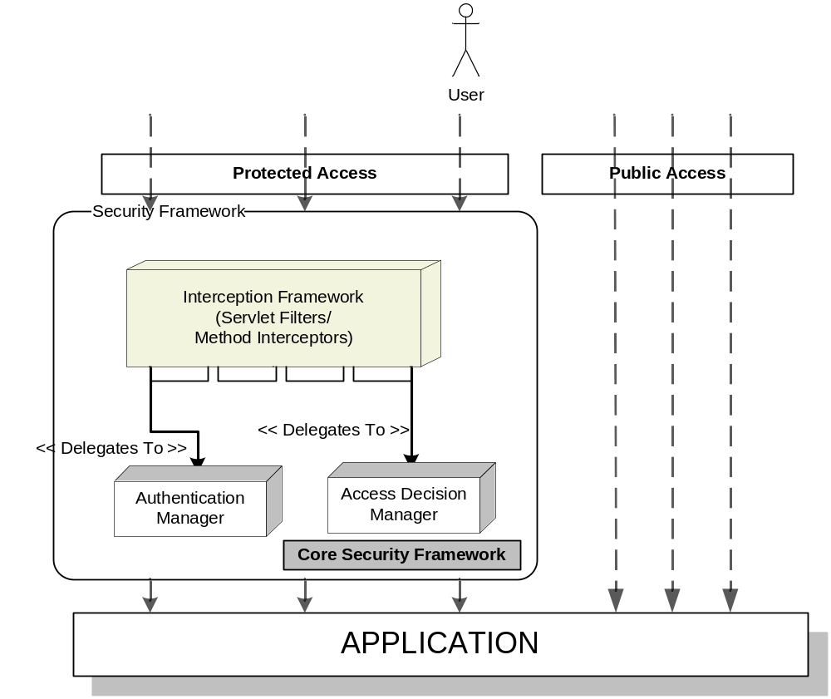

Each of the blocks in the above architecture represents a particular layer in the Security Framework lifecycle. If we were to look at them in the order in which they are activated during a typical security workflow:

Authentication Layer:
An authentication provider is responsible for authenticating the user against its configured authentication repository. We can have multiple authentication providers configured in an application with each provider typically talking to a different authentication repository. Most of the enterprise applications would fall under this category of an independently authenticated system.
However, for more distributed and complex applications, there is an additional form of authentication mechanism that comes in to play, viz. Single Sign On (SSO). The advantage of such an approach is that the user no longer needs to separately authenticate her to each of the systems. You just authenticate once to any one of the systems and, from there one, you are automatically recognized as an authenticated user even by the other systems. Typically, SSO is achieved by removing the core authentication responsibility from the individual systems and placing it on a central server. In such a scenario, the job of the individual authentication provider is reduced to that of communicating with the central server.

Authorization Layer:
Depending on the complexity and variety of the security requirements, this layer would have one or more authorization providers configured. An authorization provider itself represents the core of an authorization framework. It is the one that actually performs the access decision process, based on the configured authorization policies and the authorization data present in the corresponding authorization repository. Although it is left to the imagination of an application team to design the access decision process, for most of the applications the providers would be doing one of the following kinds of access decision process:

- Architecture Overview

Introduction
The overall approach to the architecture of the ITSS System is based on principles of Service-Oriented Architectures where loosely-coupled, fault-tolerant, scalable service components interact through well defined interface points, across synchronous and asynchronous message paths, and collaborate to provide overall itss services.
The key benefits of this approach is that individual services or components
- can be re-used by multiple systems and components whether existing or forthcoming,
- can be maintained and enhanced without impact to the overall system, and
- Allow for decoupled, rapid, standalone development of the services with integration being achieved through a standardized integration framework. Each service component provides a well-defined business contract or API to the external world so that orchestrating work among multiple service components can be done with ease.

System Architecture Context Diagram
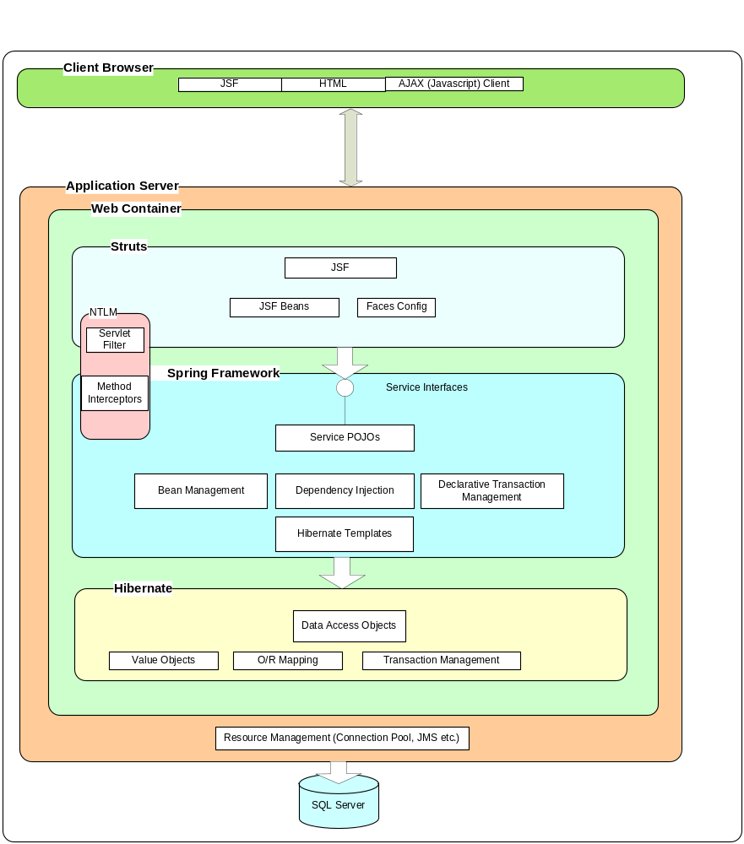

Directory Structure

Attached below is sample directory structure of ITSS project development.

