Week 9 Homework: Working with MongoDB and Compass
Objective
Create and manage a MongoDB database using both the MongoDB Shell (mongosh) and MongoDB Compass. You'll practice creating, reading, updating, and deleting documents, then explore how two different tools can interact with the same persistent database.

Part 1 — Working with mongosh (6 Points)

1. Create the Database and Collection (1 Point)
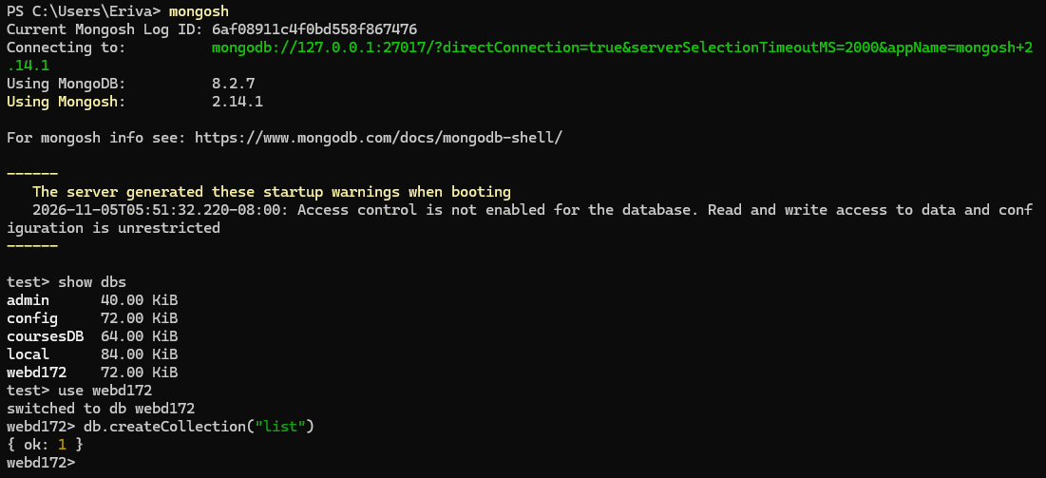

2. Insert Course Documents (2 Points)
Insert at least five course documents into the courses collection.
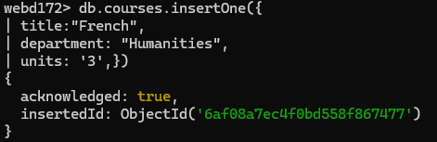

3. Retrieve and Filter Documents (1 Point)
Display all documents:
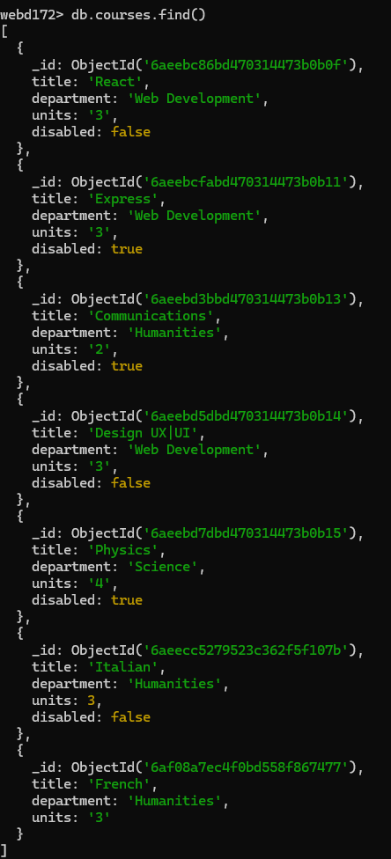

4. Update and Delete Documents (2 Points)
Use updateOne() to change at least one field in an existing course.
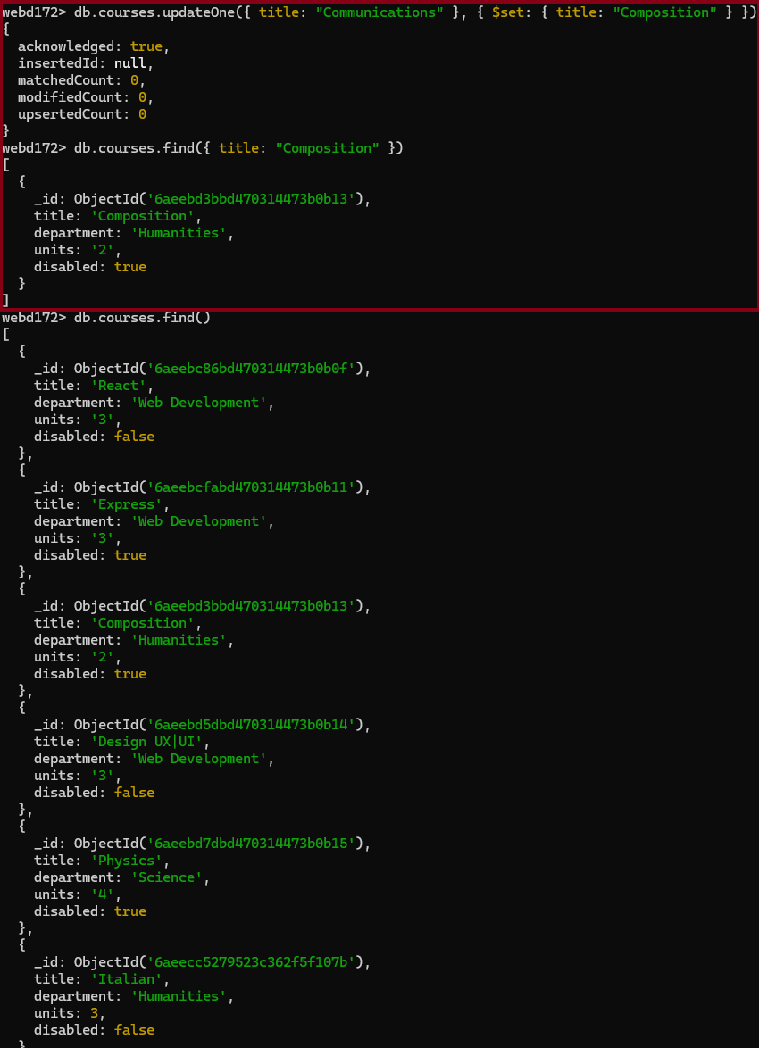Part 2 — Working with MongoDB Compass (3 Points)

5. Install and Connect to Compass (1 Point)
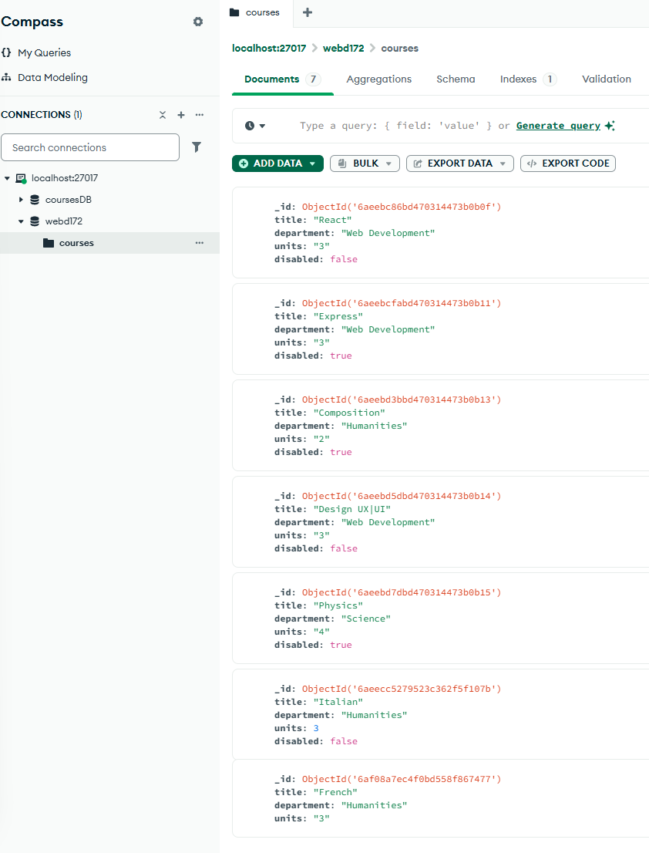

6. Explore and Filter Documents (1 Point)
Filter by: { department: "Web Development" }

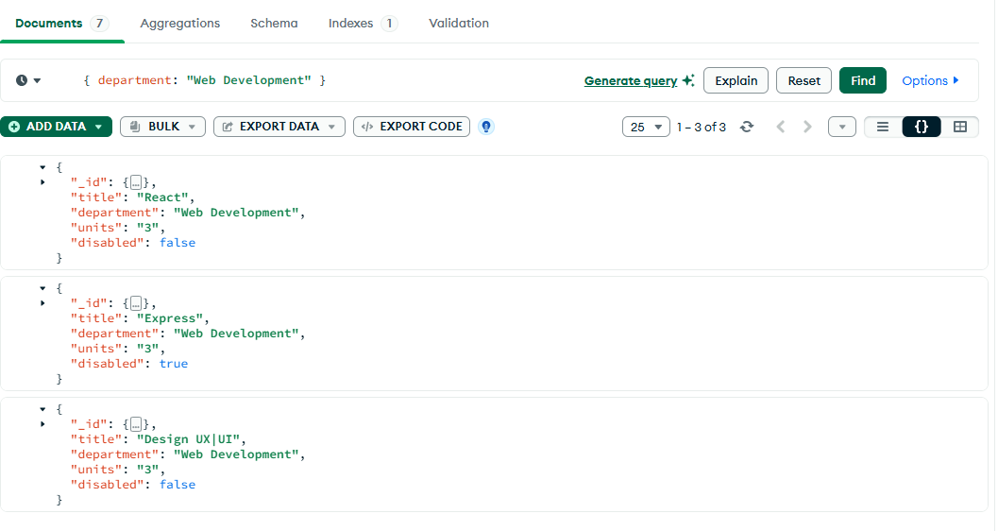

7. Insert and Edit Using Compass (1 Point)
Using the Compass interface:
- Insert one additional course document containing all four required fields.
- Find the document you just inserted.
- Edit its delivery field and save the change.
- Clear any active filters so you can see all your documents.
Now return to mongosh and run:
use webd172
db.courses.find()
Confirm that the new document and its updated delivery value appear.
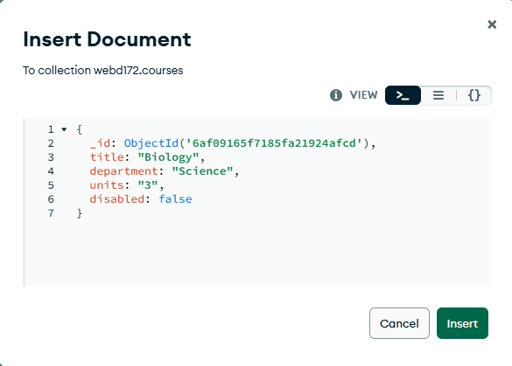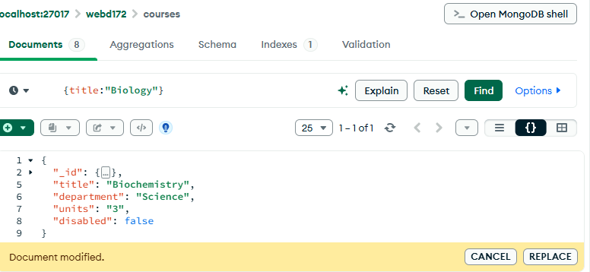

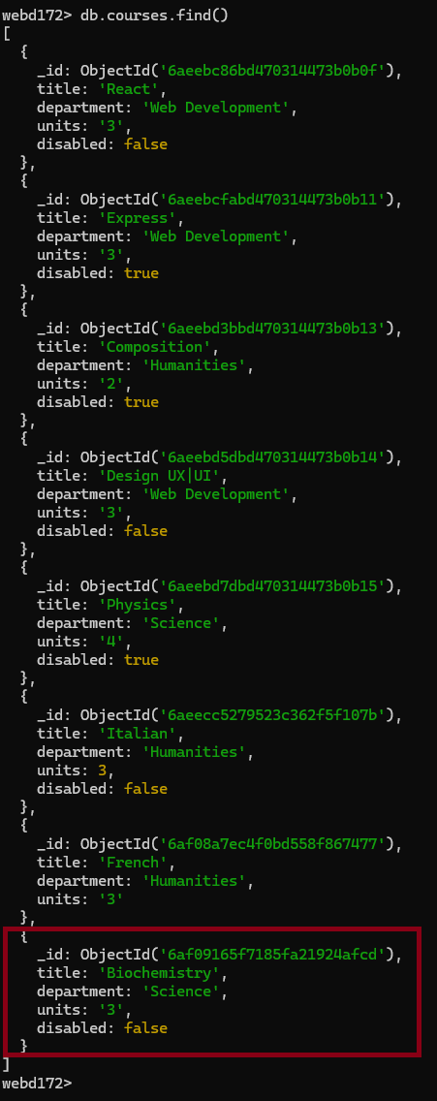

Part 3 — Document Your Work (1 Point)
Submit evidence of your completed work in Canvas.
Include screenshots or a text file demonstrating:
- Your database and collection.
- At least five inserted documents before deletion.
- A successful filtered query in mongosh.
- A successful update and deletion in mongosh.
- Your collection displayed in Compass.
- A filtered query in Compass.
- The new course inserted and edited in Compass.
- The updated Compass document visible in mongosh.
You may combine screenshots into one PDF or Word document. A text file containing commands and relevant results is also acceptable for the mongosh portion.

Server Running:
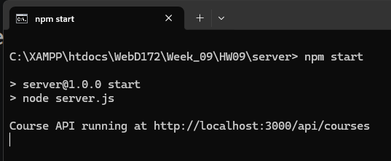
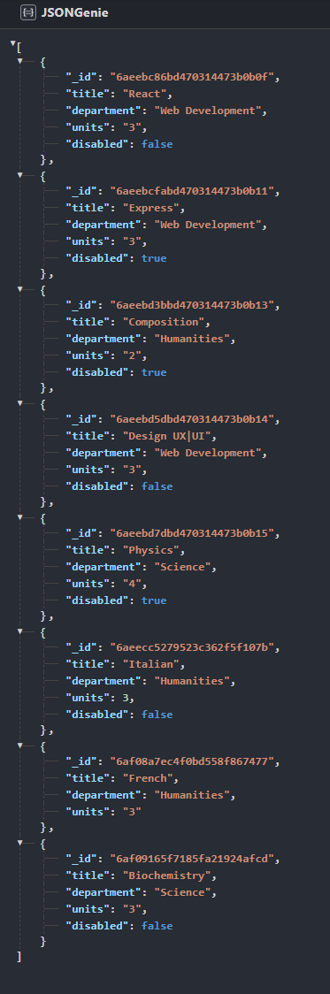

Client Running:
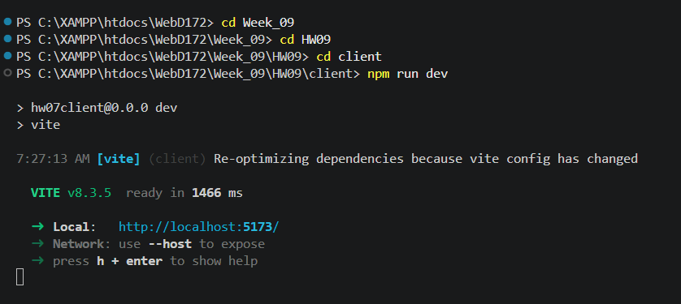

Full Application
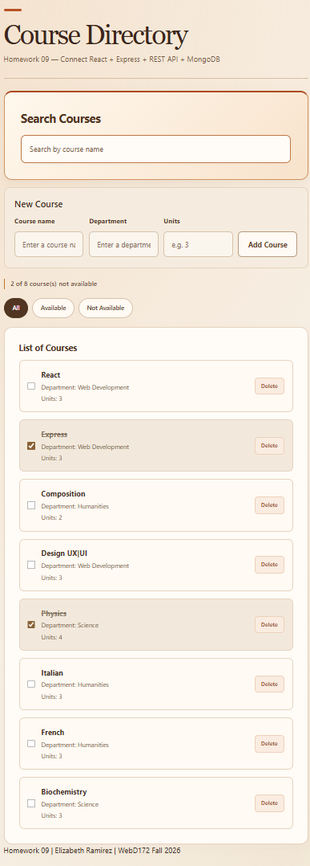

Filter: bio
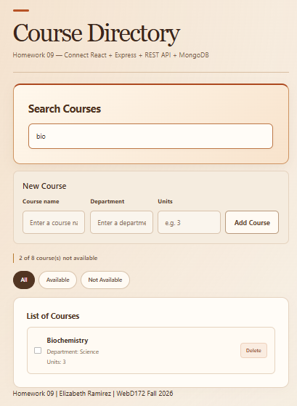

Disable Biochemistry:
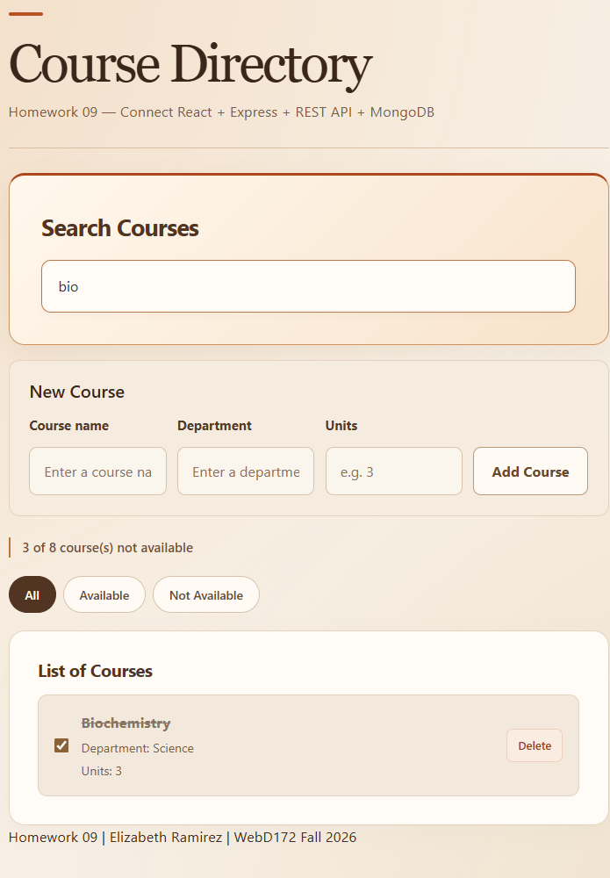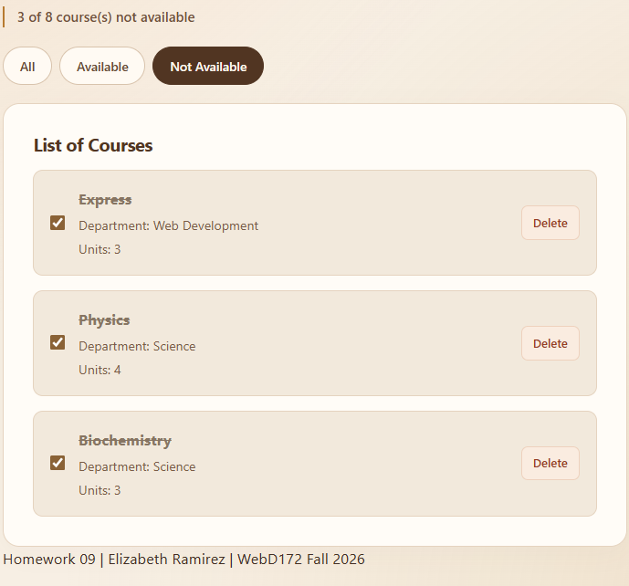

Add new:
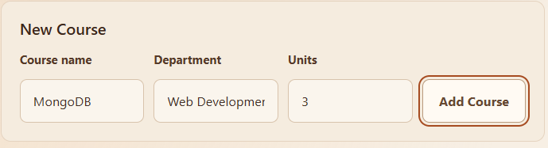
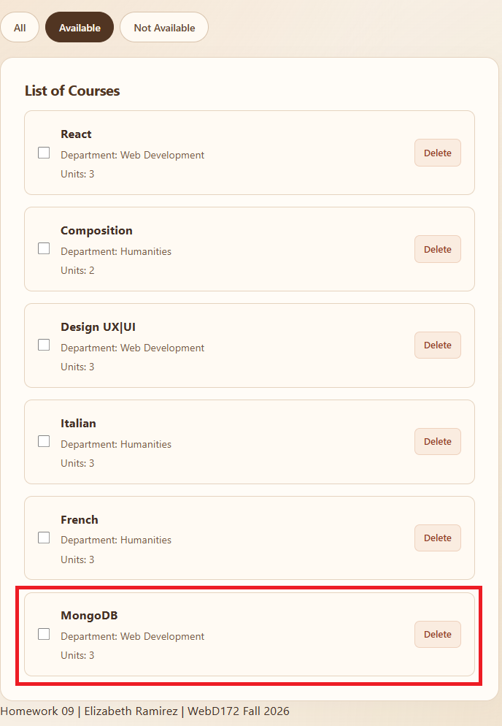

Delete Italian:
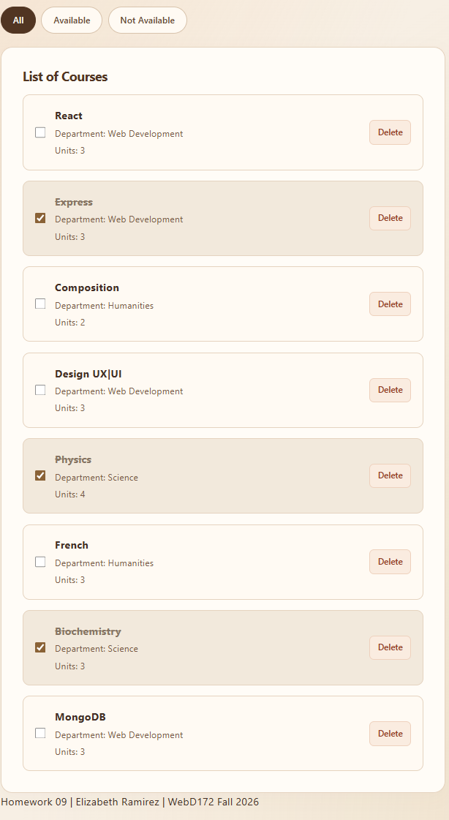
REPOSITORY: https://github.com/sugardressed/WebD172/tree/main/Week_09/HW09

