In 2015, an article was published in an online scientific journal discussing the results of a survey of the most significant problems concerning analysts in sample preparation techniques. The most concerning responses were related to the cost of the study, the time specialists spent preparing one sample, and the repeatability and efficiency of extracting compounds from different matrices (Fig. 1). Today, almost all these problems are covered by the rapid development of robotic sample preparation stations, followed by their miniaturization and economic accessibility to laboratories. Automation undoubtedly minimizes human error, guarantees sample uniformity, and allows the ease of applying different methodologies in practice.
At this rapid pace of development, mass spectrometry is no longer just an individual and expensive analytical method but becomes a link in a chain of sequential experiments of multifaceted sample profiling to collect comprehensive and informative data. This is especially observed in scientific research projects. On the one hand, this inevitably leads to an increased workload for MS systems, including more samples, new tasks, and a greater variety of obtained data. Contrarily, it starts to require continuous and thorough control over the correctness of data acquisition.
It is important to recognize that most laboratories today require instrumentation developers to provide systems that primarily guarantee long-term, stable operation without failure, simple operation, and the ability to quickly notify users of potential malfunctions. These systems are preferred over systems that reach enormous levels of sensitivity in strictly defined conditions and scanning modes.
In the era of artificial intelligence and machine learning, it is clear that MS systems can include visual self-testing tools to ensure the accuracy of obtaining data, even during periods of significant workload (Fig. 2). ML methods can provide continuous acquisition and processing of training data sets to build predictive models of potential system deviations over time. The capabilities of AI tools now allow for automatic smart decision-making (based on model-built assumptions) to maintain the stability and uniformity of spectral data over time. For example, these decisions could be to auto-recalibrate the MS or re-inject the sample or even automatically notify the analyst or service chatbot of a problem for immediate remote diagnostics (Fig. 3).
Meanwhile, the data sets should consist of not only the feedback from the electronic boards but also the characteristics of the continuous spectral signals. This will allow confirming the stability of operation over time, in each chromatographic second. For GC-MS instruments, indeed, the ideal data source is PFTBA, which is used for routine detector autotuning (attuning) (Fig. 4). If the designers realized its constant infusion at a lower intensity, it would fully provide the necessary online monitoring of spectral signal characteristics over a wide mass range (e.g., mass-scale stability, mass spectrum peak geometry, resolution, intensity, etc.). And, therefore, it would give analysts full control over visualizing data stability, controlling data stability in time, the ability to predict the timing of potential outliers, and planning long-term experiments based on predictive models of system stability.

Fig. 1. Sample prep perspective The most significant issue that arose during the sample prep period from 2013 to 2015 was identified. | Fig. 2. Combination of the sample prep automatization and auto system suitability control.
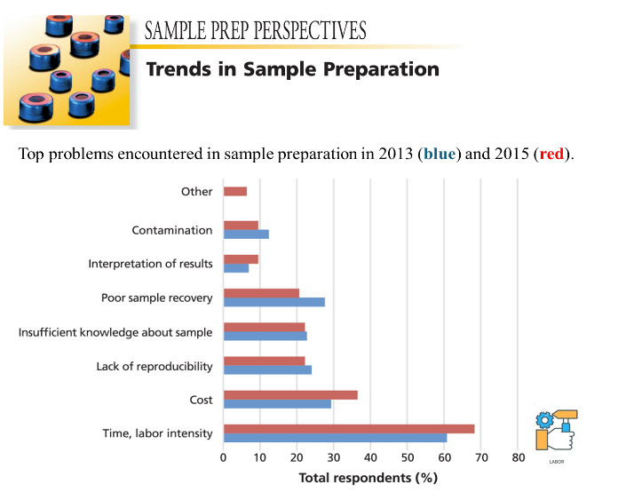 | 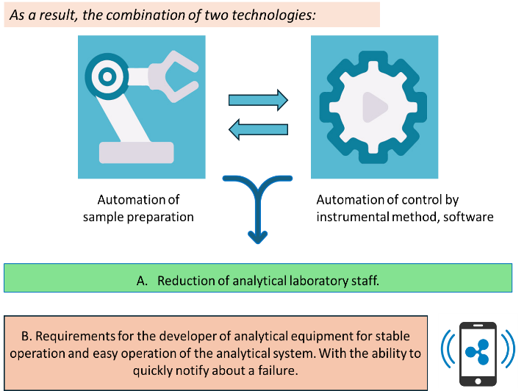
Fig. 3. Quick notification and command to action based on statistical analysis. | Fig. 4. Involving AI to monitor system performance and determine acceptable deviation limits.
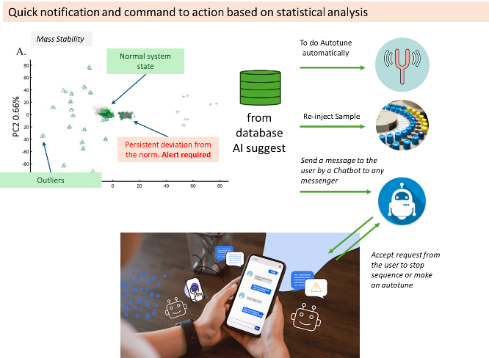 | 