Timbre Tweak Widget Mockup

License: I share this tutorial on Creative Commons Attribution – ShareAlike 4.0 International Public License.

Author: Ayush Kumar 2016, akumar5341@gmail.com

The purpose of this mockup is to enlist the design and code specifications for making a widget in Music Blocks that can help users tweak timbre of a sound. This mockup also makes use of tone.js (https://github.com/Tonejs/Tone.js) to add features to the widget.

What is timbre of an instrument?

Timbre or tone color of an instrument is a character of the sound that distinguishes it from other sounds. Timbre of different types of instruments are different, thus we are able to differentiate between the sounds produced by wind, string and percussion instruments.

How to modulate timbre in tone.js?

Timbre can be edited by modulating the following in tone.js:

- Synth
- Oscillator
- Amplitude Envelope
- Filter
- Effects

- Synth

There are many synth presets in tone.js including:
- AMSynth
- FMSynth
- DuoSynth
- MonoSynth
The purpose of each of the above presets is to create different timbre, such as for the drum or other instrument, in other words, to specify a certain type of modulation(Frequency/Amplitude).

II. Oscillator

Tone.js offers six different types of oscillators. The following are some of their basic characteristics and the defaults for the synths:

- Sine
- Square
- Triangle
- Sawtooth

III. Amplitude Envelope

The ADSR Envelope works on the principle of increasing, decreasing and sustaining a tone of a sound at a given amplitude. The parameters are - attack, decay, sustain, release.

- attack
- decay.
- sustain
- release
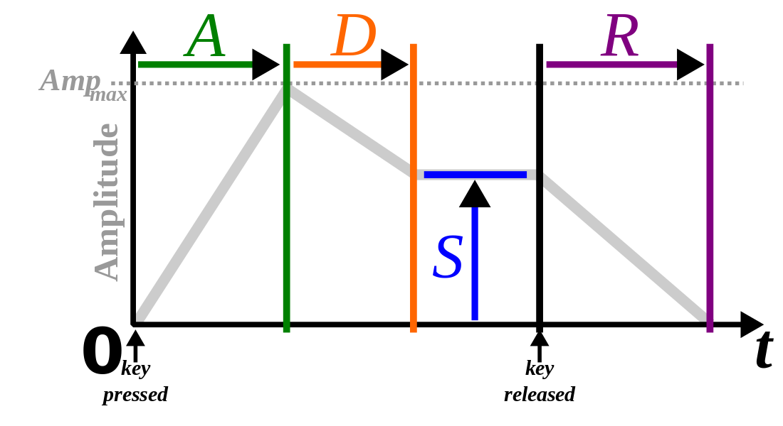
Image :https://upload.wikimedia.org/wikipedia/commons/e/ea/ADSR_parameter.svg

IV. Filters
Filters specify which sounds to cancel out, thus changing the resulting output - Using a filter would make the synth a subtractive synthesizer because it sculpts the sound by putting limits on certain timbal parameters. For example, most basses only exhibit low frequencies, so a lowpass filter might be appropriate to use if the user wishes to remove the bass or change its tone by limiting some aspects of the bass sound.

Parameters for adjusting the filters are:
- Frequency
- Type
- rolloff

V. Effects
Many effects are included included in tone.js and can be applied to a sound. Here are some common basics:
- Chorus
- Distortion
- Phaser
- Vibrato
- Tremolo
SUMMARY
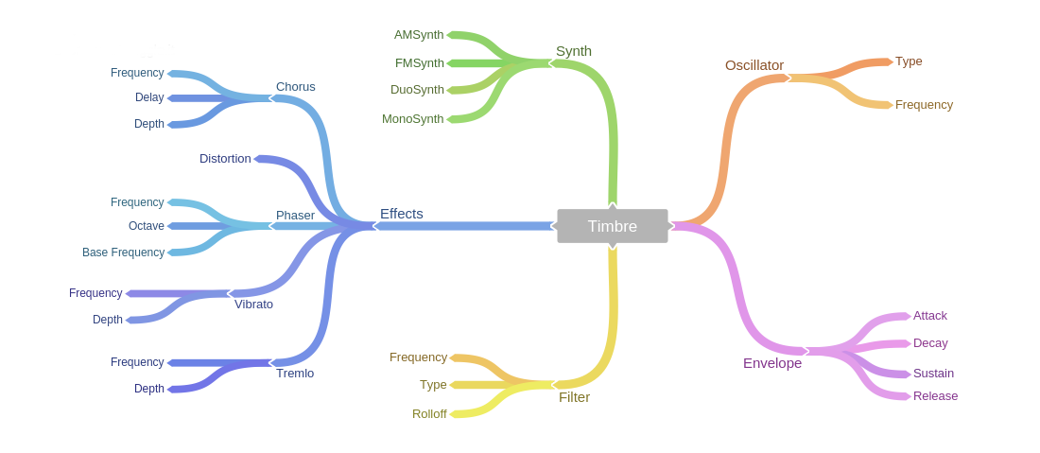
This is a chart I created using coggle.it to demonstrate Timbre Modulation and it’s types as well as its parameters. Checkout the full chart at https://goo.gl/0t8Ije . If you want to collaborate over coggle.it, email me at akumar5341@gmail.com for a collaboration link.

CODE API & DESIGN

Tone.js : https://github.com/Tonejs/Tone.js

Tone.js API: https://tonejs.github.io/docs/

- Synth Design for Music Blocks

Tone.js allows a multitude of synths with varying functions and properties. For this widget, I’ll limit it to the 4 important functions that we need.

- AMSynth
- FMSynth
- DuoSynth
- MonoSynth

1. AMSynth (Source: https://tonejs.github.io/docs/#AMSynth)

AMSynth is used for Amplitude Modulation(AM), which controls the sound by modulating the amplitude. AMSynth uses the output of one Tone.Synth to modulate the amplitude of another Tone.Synth. The harmonicity (the ratio between the two voices) affects the timbre of the output signal .

The only parameter we are concerned with is the Harmonicity. A harmonicity of 1 mean no change and a harmonicity of 2 means a change of an octave.

The way to change harmonicity is : synth.harmonicity.value = 0.5;

Syntax: new Tone.AMSynth()

var synth = new Tone.AMSynth().toMaster();
synth.triggerAttackRelease("C4", "4n");

The .triggerAttackRelease() function triggers the attack of the note for the specified duration.

Syntax of Function: .triggerAttackRelease([note][, time])

synth.triggerAttackRelease(“C4”, “4n”);
// 4n = quarter note
2. FMSynth (Source: https://tonejs.github.io/docs/#FMSynth)

FMSynth is used for Frequency Modulation(FM). FMSynth is composed of two Tone.Synths where one Tone.Synth modulates the frequency of a second Tone.Synth. In particular, a lot of spectral content can be explored using the modulationIndex parameter.

Although FMSynth has a lot of parameters, the most important one for us is the modulationIndex. The modulation index defines the depth and amount of the modulation by controlling the ratio of the frequency of the modulating signal frequency (mf) to the amplitude of the modulating signal (ma) -- as in ma/mf.

Syntax: new Tone.FMSynth()

var fmSynth = new Tone.FMSynth().toMaster();
fmSynth.triggerAttackRelease("C5", "4n");

The function .triggerAttackRelease() works the same way as in the AMSynth.

Since the modulationIndex is the ratio of the amplitude over frequency, more the amplitude, more is the intensity and more the frequency, lesser is the depth. Thus a higher modulationIndex gives a deep and loud sound.

3. DuoSynth (Source: https://tonejs.github.io/docs/#DuoSynth)

Tone.DuoSynth is a monophonic synth composed of two MonoSynths run in parallel with control over the frequency ratio between the two voices and vibrato effect.

In DuoSynth, the major parameters are vibratoRate and vibratoAmount.

vibratoRate: The frequency of the vibrato.
vibratoAmount: The intensity of the vibrato.

Syntax: new Tone.DuoSynth()

var duoSynth = new Tone.DuoSynth().toMaster();
duoSynth.triggerAttackRelease("C4", "2n");

The function .triggerAttackRelease() works the same way as in AMSynth and in FMSynth.
The rapid variations(vibrato) are contoleed by vibratoRate and vibratoAmount. Higher vibratoRate will make the variation more rapid, whereas higher vibratoAmount will make the variation more intense.

4. MonoSynth (Source: https://tonejs.github.io/docs/#MonoSynth)

Tone.MonoSynth is composed of one oscillator, one filter, and two envelopes. The amplitude of the Tone.Oscillator and the cutoff frequency of the Tone.Filter are controlled by Tone.Envelopes.
This type of synth includes parameters from other functions such as the envelope, oscillator and filter.

Syntax: new Tone.MonoSynth

var synth = new Tone.MonoSynth().toMaster();
synth.triggerAttackRelease("C4", "8n");

II. Oscillator (Source: https://tonejs.github.io/docs/#Oscillator)

The Oscillator function changes the frequency and type of an oscillation, which changes a sound's pitch. It takes 2 parameters - Frequency and Type.

Frequency: The higher the frequency, the higher the pitch, the lower the frequency, the lower the pitch. It’s input is specified in Hertz(Hz).

Type: Determines the type of wave of the sound. For example, a “sine” type in the parameter list would create a sound which has a wave similar to a sine function wave.

The possible values of the type parameter are:
- sine - pure sounds
- square - bass, reed instruments, pad
- triangle - a softer sound, for flute, pad, vocal
- sawtooth - string, bass, pad

Note: The type parameter can also set the first x partials(i.e. Harmonics, https://en.wikipedia.org/wiki/Harmonic) of a wave by specifying the number x after the oscillation wave type. For Example “sine6” would set the first 6 partials of the sine wave.

Syntax: new Tone.Oscillator([frequency][, type])

var osc = new Tone.Oscillator(440, “triangle”);
//This sets frequency = 440 Hz and wave type = “triangle”

var osc2 = new Tone.Oscillator(200, “sine12”);
// The frequency is set to 220 Hz and wave type to sine with 12 partials or harmonics
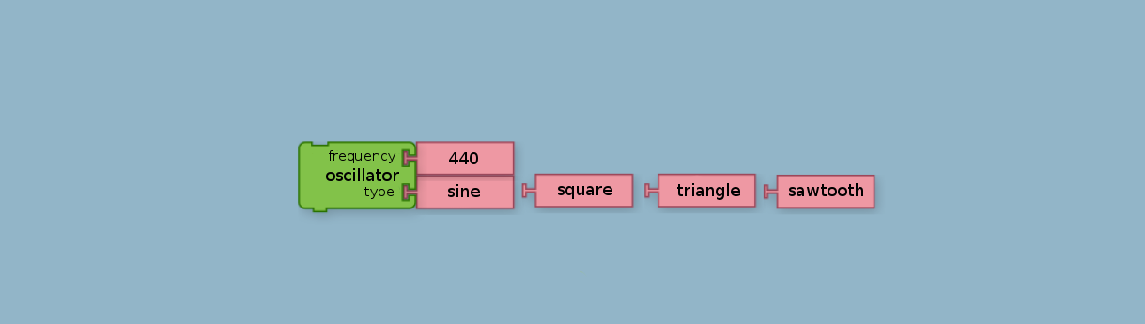

Modulation of the envelope of a sound requires an ADSR Envelope (attack-decay-sustain-release)

Attack: The amount of time it takes for the envelope to go from 0 to it's maximum value.
Decay: The period of time after the attack that it takes for the envelope to fall to the sustain value.
Sustain: The percent of the maximum value that the envelope rests at until the release is triggered.
Release: The amount of time after the release is triggered it takes to reach 0.

Syntax: new Tone.Envelope([attack][, decay][, sustain][, release])

var gainNode = Tone.context.createGain();
var env = new Tone.Envelope({
"attack" : 0.1,
"decay" : 0.2,
"sustain" : 1,
"release" : 0.8,
});
env.connect(gainNode.gain);


IV. Filter (Source: https://tonejs.github.io/docs/#Filter)

Lets users filter out sounds that they do not need. The parameters are frequency, type and rolloff.

Frequency: The cutoff frequency of the filter.

Type: The following are the various values the type parameter can accept.
- Lowpass
- Highpass
- Bandpass
- Lowshelf
- Highshelf
- Notch
- Allpass
- Peaking

Rolloff: The rolloff of the filter which is the drop in db per octave. Implemented internally by cascading filters. Only accepts the values -12, -24, -48 and -96 in decibels.

Syntax: new Tone.Filter([frequency][, type][, rolloff])

var filter = new Tone.Filter(200, "highpass");
// default rolloff = -12

V. Effects

1. Chorus (Source: https://tonejs.github.io/docs/#Chorus)

Tone.Chorus is a stereo chorus effect with feedback composed of a left and right delay with a Tone.LFO applied to the delayTime of each channel.

Frequency: The frequency of the LFO.
delayTime : The delay of the chorus effect in milliseconds.
Depth: The depth of the chorus.

Syntax: new Tone.Chorus([frequency][, delayTime][, depth])

var chorus = new Tone.Chorus(4, 2.5, 0.5);
var synth = new Tone.PolySynth(4, Tone.MonoSynth).connect(chorus);
synth.triggerAttackRelease(["C3","E3","G3"], "8n");

2. Distortion (Source: https://tonejs.github.io/docs/#Distortion)

Tone.Distortion is a simple distortion effect using Tone.WaveShaper. The only parameter is distortion.

Distortion: The amount of distortion (nominal range of 0-1)

Syntax: new Tone.Distortion([distortion])

var dist = new Tone.Distortion(0.8).toMaster();
var fm = new Tone.SimpleFM().connect(dist);
fm.triggerAttackRelease("A1", "8n");

3. Phaser (Source: https://tonejs.github.io/docs/#Phaser)

Tone.Phaser is a phaser effect. Phasers work by changing the phase of different frequency components of an incoming signal. The Parameters are Frequency, Octaves and baseFrequency.

Frequency: The speed of the phasing.
Octaves: The octaves of the effect.
baseFrequency: The base frequency of the filters.

Syntax: new Tone.Phaser([frequency][, octaves][, baseFrequency])
var phaser = new Tone.Phaser({
"frequency" : 15,
"octaves" : 5,
"baseFrequency" : 1000
}).toMaster();
var synth = new Tone.FMSynth().connect(phaser);
synth.triggerAttackRelease("E3", "2n");

4. Vibrato (Source: https://tonejs.github.io/docs/#Vibrato)

A Vibrato effect composed of a Tone.Delay and a Tone.LFO. The LFO modulates the delayTime of the delay, causing the pitch to fluctuate rapidly.

Frequency: The frequency of the vibrato.
Depth: The amount the pitch is modulated.

Syntax: new Tone.Vibrato(frequency, depth)

5. Tremolo (Source: https://tonejs.github.io/docs/#Tremolo)

Tone.Tremolo modulates the amplitude of an incoming signal using a Tone.LFO. The type, frequency, and depth of the LFO is controllable.

Frequency: The rate of the effect.
Depth: The depth of the effect.

Syntax: new Tone.Tremolo([frequency][, depth])
var tremolo = new Tone.Tremolo(9, 0.75).toMaster().start();
//route an oscillator through the tremolo and start it
var oscillator = new Tone.Oscillator().connect(tremolo).start();

WIDGET LAYOUT
The plan with this Timbre Tweak Widget is to have a window in the browser with controls that allow users to manually edit sounds and to experience the sound manipulations in real-time. The widget takes inputs from the user and uses them as parameters for the required functions of tone.js. The window will have controls such as sliders, graphs and buttons to modify and manipulate the sounds using functions from tone.js as specified in the API above.

The sounds start playing automatically when the user clicks the sliders or graphs or the buttons and the sounds will be edited in real-time to give the user an accurate measure of the modifications and tweaks. A ‘Done’ button at the top of the window will confirm the modifications and generate blocks in the Music Blocks Workspace with the parameter values filled-in according to the tweaks the user made in the widget window. The functions that are inactive in the pipeline sound player are not generated as blocks in the Music Blocks environment.

The entire layout can be created using HTML and CSS and the functionality of the sound effects will be generated through tone.js. The user can select the desired option from the piperline sound player or the Combo Boxes or the checkboxes and the respective parameters are displayed automatically. This widget allows users to add more parameters from tone.js for advanced timbre tweaking.
WINDOW LAYOUT
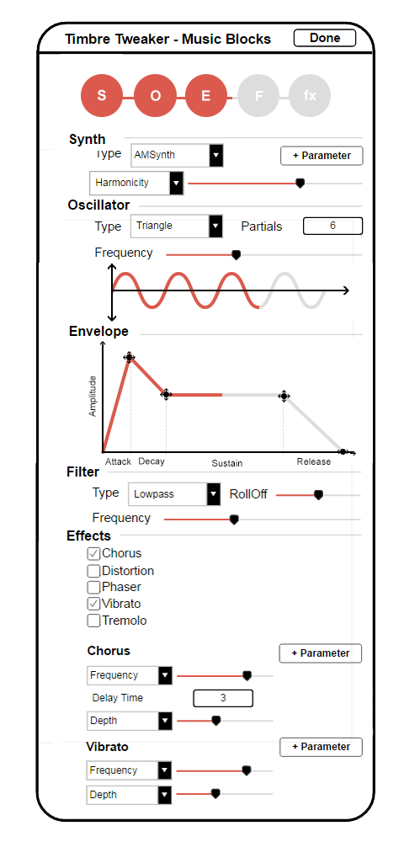
EXPLANATION

- The sequence of orbs at the top is the sound player. It works like a pipeline with the timbre adjustment functions(Synth, Oscillator, Envelope, Filter and Effects). A user can drag the orbs of their respective functions around in the pipeline to adjust their sequence or click to activate or deactivate them(Red is active, Gray is inactive). The sound player plays the sound when the “S” button is clicked and the sounds are produced according to the modifications taking place in the widget.

For clarification, S stands for Synth, O stands for Oscillator, E stands for Envelope, F stands for Filter and fx stands for Effects.

- In the Synth tab, Type sets the synth type to the option from the combo box. A Parameter for Harmonicity appears automatically along with its slider. However the user can change the parameter though the combo box and it’s parameter modulation appears automatically with a default value.
- The Oscillator allows the user to visually see the wave type as well as the partials. Moreover, a user can also intuitively understand the frequency of the oscillations from the graph. Since the widget works in real-time, the red portion on the graph is a playback bar showing the user which sounds are being played at a specific moment and how they are related to values and parameters of the function.
- The ADSR Envelope allows users to manipulate Attack, Decay, Sustain and Release values in real-time directly from the graph. All values are in seconds. The user can use the movement-handles and modify the amplitude or the time to get different results. Similar to the Oscillator, the Envelope also has a playback bar showing the user which sounds are being played at a specific moment
- The Filter tab allows user to filter out undesirable sounds by specifying the type of filer and specifications of the filter parameters.
- The Effects tab allows users to apply specific effects using tone.js. More parameters can be added for highly specific needs.

Highlights: The Highlights of the widget are the pipeline sound player that allows users to change sequence and types of functions, the Oscillator graph that shows the wave type and wave parameters and the ADSR Envelope that allows users to interact with the sounds directly using the ADSR graph.

