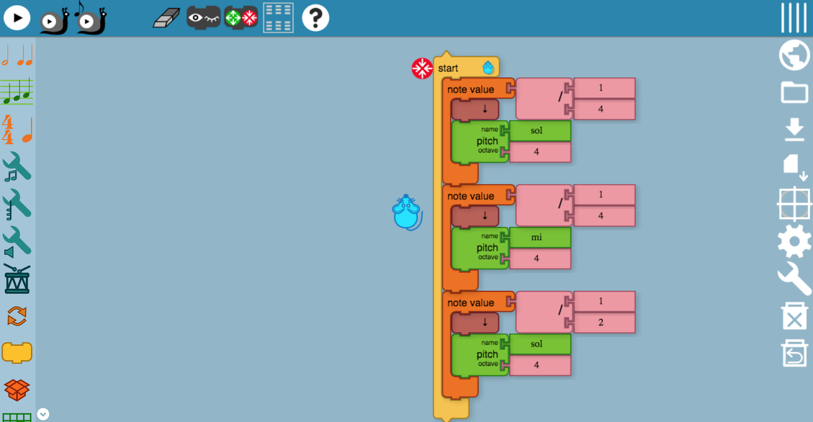

So first there's the home screen. And on the screen is a mouse and some codes to tell the mouse what to do.

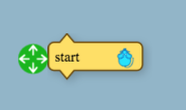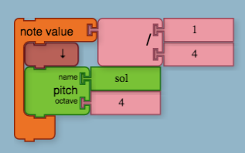

This a a start button you can click it to start your sounds or movement of the mouse.

The note value is the block that makes the pitch the speed and the octave is the thing controls the frequency of the sound. The 1 and 4 control the speed so the 1 is if you want to make the sound slower, and the 4 is if you want to make the sound go faster.

https://lh4.googleusercontent.com/9MV-qFZLKbH-JcNsFC1YiQxOMANNttivP7kpVIhFQrRdKwOP_O9n5GcmH7a4p6Z7yXuinR9waIAOm3tP3fqT8388GCdvGJPCuj8kn_mTXdTY1u-vGfd5LnW546jPpb8sTYZ7u8ws

this is most of the tool you will be able to get but i will only be showing you a few.

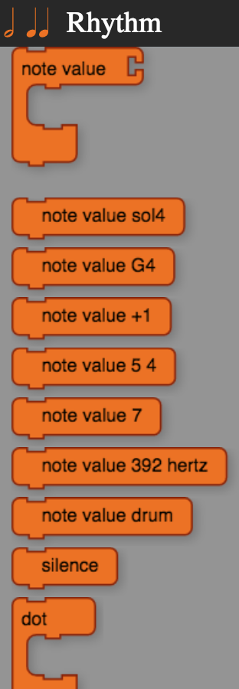this is some of the things you will get in the first box which is rhythm you will get a note value which make a sort of piano sound by you can add things too it and when you put it in it will automatically give you some things to make it easier for you

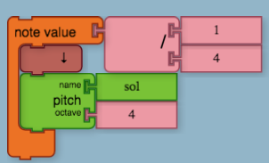

The note value sol4 gives you a block with sol and 4 octave

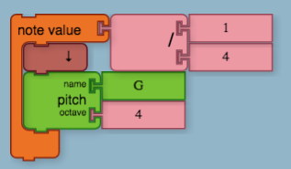

The note value G4 gives you the pitch name G with octave. And so on

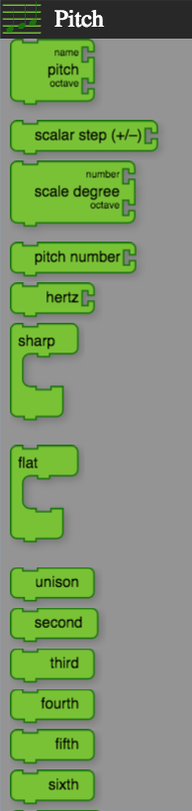

Okay the green one witch it the pitch has obviously the pitch which i explained above and then theres scale step (+/-)  which i am not totally sure what it does so then there the scale degree which gives you more choice for the name which can change the tone of the sound, so basically it is just pitch number. Then there's the actual pitch number. The hertz doesn't do much, so the sharp make it a bit higher and the flat makes it lower. And that most of the basic’s in this one.

https://lh5.googleusercontent.com/VWSjGMyNRkZ2tbx1o_qdQYDHKSPpBp9mG_KXSUMGv-MHNNgeKTtXO-fCNNbWqUL-ivdzPnySDuThrECkmGOK4n7BW2GdbMFG_5HbaHK4wZAqwT-GnzXahBt_uj4hOHitYENJbf0Dthe meter is mostly things that count note like to see how many notes are played.

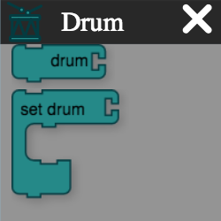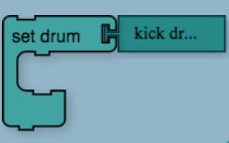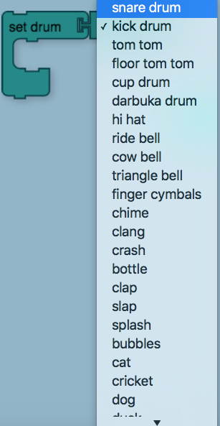

this is the drum there are more but all you need to do it click on the drum things so there's all kinds of drum sounds so you can make a cool beat dude.

The flow is the thing that makes you able to repeat make it go forever and more cool things like that.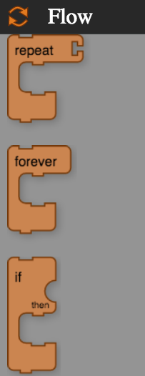

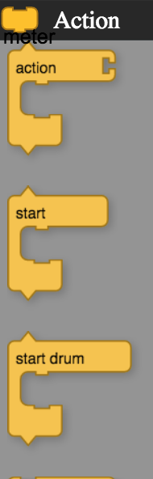this is the action which gives you ability to get another start block and it's full of starters so it's easier for you to start different things.