***Turtle Art with Turtle Blocks***

Turtle art chosen:

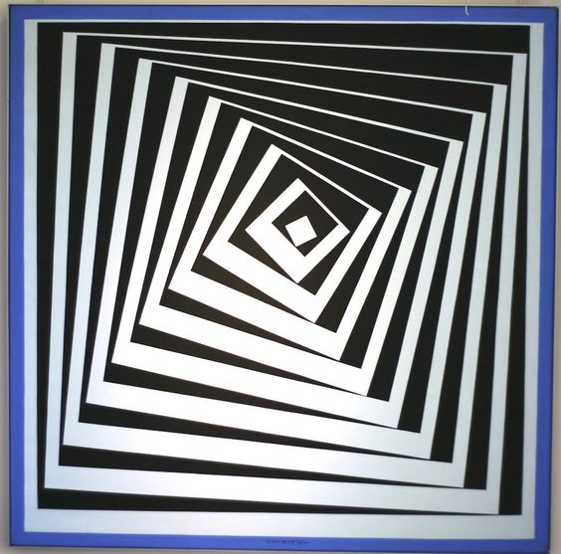

Project :

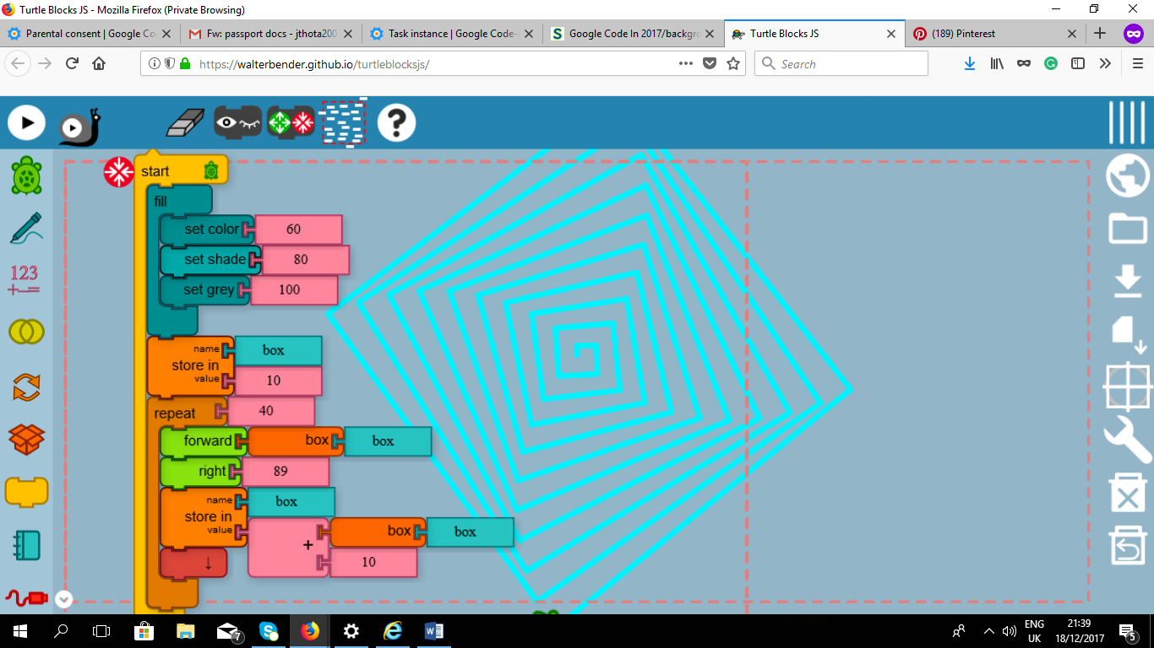

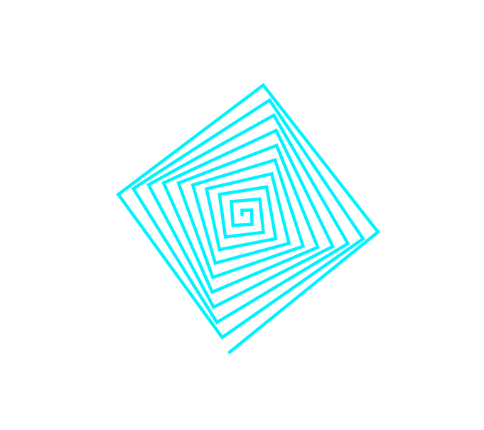

Source code:

[[0,["start",{"collapsed":false,"xcor":-26.21568853697005,"ycor":-287.3212785525784,"heading":320,"color":60,"shade":80,"pensize":5,"grey":100}],138.83333333333337,51.225,[null,1,null]],[1,["fill",{}],152.33333333333337,91.725,[0,3,2]],[2,["hidden",{}],152.33333333333337,249.225,[1,9]],[3,["setcolor",{}],165.83333333333337,123.225,[1,4,5]],[4,["number",{"value":60}],252.83333333333337,123.225,[3]],[5,["setshade",{}],165.83333333333337,154.725,[3,6,7]],[6,["number",{"value":80}],260.33333333333337,154.725,[5]],[7,["setgrey",{}],165.83333333333337,186.225,[5,8,null]],[8,["number",{"value":100}],248.33333333333337,186.225,[7]],[9,["storein",{}],152.33333333333337,249.225,[2,24,10,11]],[10,["number",{"value":10}],231.83333333333337,280.725,[9]],[11,["repeat",{}],152.33333333333337,312.225,[9,12,13,null]],[12,["number",{"value":40}],224.33333333333337,312.225,[11]],[13,["forward",{}],165.83333333333337,343.725,[11,14,16]],[14,["box",{}],245.33333333333337,343.725,[13,15]],[15,["text",{"value":"box"}],345.83333333333337,343.725,[14]],[16,["right",{}],165.83333333333337,375.225,[13,17,18]],[17,["number",{"value":89}],239.33333333333337,375.225,[16]],[18,["storein",{}],165.83333333333337,406.725,[16,25,19,21]],[19,["plus",{}],245.33333333333337,438.225,[18,22,20]],[20,["number",{"value":10}],330.83333333333337,469.725,[19]],[21,["vspace",{}],165.83333333333337,469.725,[18,null]],[22,["box",{}],330.83333333333337,438.225,[19,23]],[23,["text",{"value":"box"}],431.33333333333337,438.225,[22]],[24,["text",{"value":"box"}],231.83333333333337,249.225,[9]],[25,["text",{"value":"box"}],245.33333333333337,406.725,[18]],[26,3,[0,"fill"]],[27,3,[0,"setcolor",60]],[28,3,[0,"setshade",80]],[29,3,[0,"setgrey",100]],[30,3,[0,"fill"]],[31,3,[0,"forward",10]],[32,3,[0,"right",89]],[33,3,[0,"forward",20]],[34,3,[0,"right",89]],[35,3,[0,"forward",30]],[36,3,[0,"right",89]],[37,3,[0,"forward",40]],[38,3,[0,"right",89]],[39,3,[0,"forward",50]],[40,3,[0,"right",89]],[41,3,[0,"forward",60]],[42,3,[0,"right",89]],[43,3,[0,"forward",70]],[44,3,[0,"right",89]],[45,3,[0,"forward",80]],[46,3,[0,"right",89]],[47,3,[0,"forward",90]],[48,3,[0,"right",89]],[49,3,[0,"forward",100]],[50,3,[0,"right",89]],[51,3,[0,"forward",110]],[52,3,[0,"right",89]],[53,3,[0,"forward",120]],[54,3,[0,"right",89]],[55,3,[0,"forward",130]],[56,3,[0,"right",89]],[57,3,[0,"forward",140]],[58,3,[0,"right",89]],[59,3,[0,"forward",150]],[60,3,[0,"right",89]],[61,3,[0,"forward",160]],[62,3,[0,"right",89]],[63,3,[0,"forward",170]],[64,3,[0,"right",89]],[65,3,[0,"forward",180]],[66,3,[0,"right",89]],[67,3,[0,"forward",190]],[68,3,[0,"right",89]],[69,3,[0,"forward",200]],[70,3,[0,"right",89]],[71,3,[0,"forward",210]],[72,3,[0,"right",89]],[73,3,[0,"forward",220]],[74,3,[0,"right",89]],[75,3,[0,"forward",230]],[76,3,[0,"right",89]],[77,3,[0,"forward",240]],[78,3,[0,"right",89]],[79,3,[0,"forward",250]],[80,3,[0,"right",89]],[81,3,[0,"forward",260]],[82,3,[0,"right",89]],[83,3,[0,"forward",270]],[84,3,[0,"right",89]],[85,3,[0,"forward",280]],[86,3,[0,"right",89]],[87,3,[0,"forward",290]],[88,3,[0,"right",89]],[89,3,[0,"forward",300]],[90,3,[0,"right",89]],[91,3,[0,"forward",310]],[92,3,[0,"right",89]],[93,3,[0,"forward",320]],[94,3,[0,"right",89]],[95,3,[0,"forward",330]],[96,3,[0,"right",89]],[97,3,[0,"forward",340]],[98,3,[0,"right",89]],[99,3,[0,"forward",350]],[100,3,[0,"right",89]],[101,3,[0,"forward",360]],[102,3,[0,"right",89]],[103,3,[0,"forward",370]],[104,3,[0,"right",89]],[105,3,[0,"forward",380]],[106,3,[0,"right",89]],[107,3,[0,"forward",390]],[108,3,[0,"right",89]],[109,3,[0,"forward",400]],[110,3,[0,"right",89]]]