The following is a URL to my project:

<https://walterbender.github.io/turtleblocksjs/index.html?file=hexagon.tb&run=True>

Description:

The following image was my reference image for this project, which I found on pinterest, under “walterbender’s” “turtle-art”.

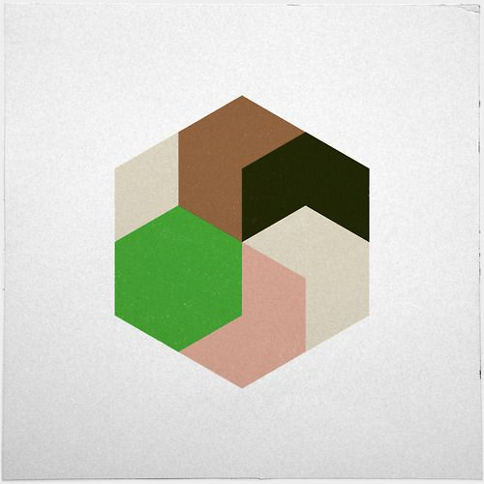

In my code, I recreated this image using loops and actions (functions) to manage complexity using abstractions. I also randomized the colors used in the drawing.